1、必要扩展报安装

**最重要的包，必须安装：libxml2-devel**

[root@localhost httpd-2.4.38]# yum -y install libxml2-devel

2、c语言编译包

[root@localhost httpd-2.4.38]# yum -y install gcc*

3、下载工具

[root@localhost httpd-2.4.38]# yum -y install wget

要是还缺少包（library）进行安装

**安装包准备**

4、apache下载：选择自己的包进行安装

<http://httpd.apache.org/download.cgi>

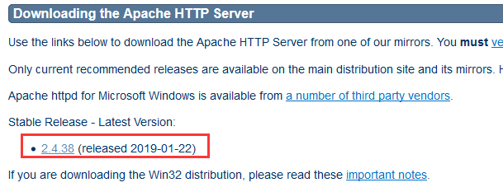

<http://httpd.apache.org/download.cgi#apache24>

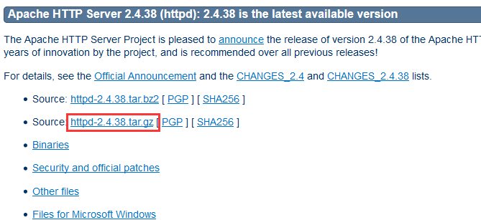

[root@localhost ~]# wget <http://mirrors.tuna.tsinghua.edu.cn/apache//httpd/httpd-2.4.38.tar.gz>

5、apr包下载

<http://apr.apache.org/download.cgi>

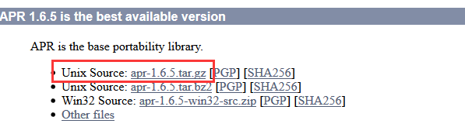

[root@localhost ~]# wget <http://mirrors.shu.edu.cn/apache//apr/apr-1.6.5.tar.gz>

6、apr-util包下载

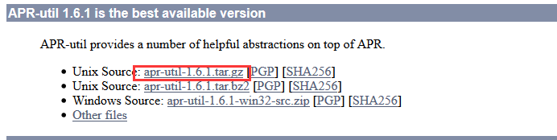

[root@localhost ~]# wget <http://mirrors.shu.edu.cn/apache//apr/apr-util-1.6.1.tar.gz>

7、pcre包下载

<http://www.pcre.org/>

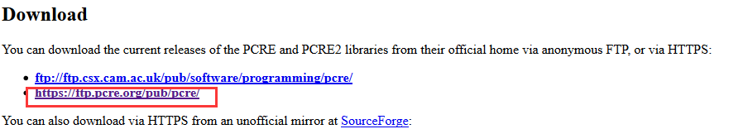

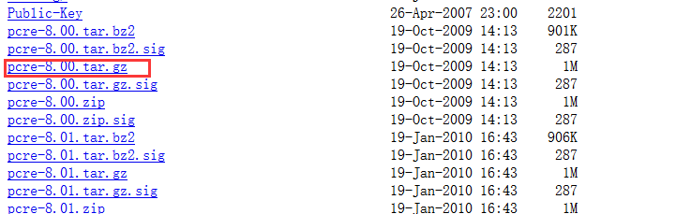

[root@localhost ~]# wget https://ftp.pcre.org/pub/pcre/pcre-8.00.tar.gz

8、安装基础包

解压包：

[root@localhost ~]# tar -zxvf apr-1.6.5.tar.gz

[root@localhost ~]# tar -zxvf apr-util-1.6.1.tar.gz

[root@localhost ~]# tar -zxvf httpd-2.4.38.tar.gz

[root@localhost ~]# tar -zxvf pcre-8.00.tar.gz

建立安装目录：

[root@localhost ~]# mkdir -p /home/study/apr /home/study/apr-util /home/study/httpd /home/study/pcre

9、编译基础包

**1：apr**

[root@localhost apr-1.6.5]# ./configure --prefix=/home/study/apr

会出现如下错误：rm: cannot remove 'libtoolT': No such file or directory

解决方法：vi configure

默认RM='$RM' 更改成为 RM='$RM  -f'

然后重新运行配置文件：

[root@localhost apr-1.6.5]# ./configure --prefix=/home/study/apr

[root@localhost apr-1.6.5]# make

[root@localhost apr-1.6.5]# make install

**2：apr-util**

[root@localhost apr-util-1.6.1]# ./configure --prefix=/home/study/apr-util/ --with-apr=/home/study/apr

[root@localhost apr-util-1.6.1]# make

可能出现如下错误：xml/apr_xml.c:35:19: 致命错误：expat.h：没有那个文件或目录

解决方法：[root@localhost apr-util-1.6.1]# yum -y install expat-devel

然后继续运行：

[root@localhost apr-util-1.6.1]# make

[root@localhost apr-util-1.6.1]# make install

**3：pcre**

[root@localhost pcre-8.00]# ./configure --prefix=/home/study/pcre/

[root@localhost pcre-8.00]# make

[root@localhost pcre-8.00]# make install

**4：apache**

[root@localhost httpd-2.4.38]# ./configure --prefix=/home/study/httpd/ --with-apr=/home/study/apr --with-apr-util=/home/study/apr-util/ -with-pcre=/home/study/pcre/

[root@localhost httpd-2.4.38]# make

可能会出现错误：

collect2: error: ld returned 1 exit status

make[2]: *** [htpasswd] 错误 1

make[2]: 离开目录“/root/httpd-2.4.38/support”

make[1]: *** [all-recursive] 错误 1

make[1]: 离开目录“/root/httpd-2.4.38/support”

make: *** [all-recursive] 错误 1

解决办法：

[root@localhost httpd-2.4.38]# yum -y install libxml2-devel

重新编译apr-util，然后进行继续操作

[root@localhost httpd-2.4.38]# make

[root@localhost httpd-2.4.38]# make install

10、测试apache是否安装成功

[root@localhost ~]# /home/study/httpd/bin/apachectl start

可能报如下错误：

AH00558: httpd: Could not reliably determine the server's fully qualified domain name, using getlnx05.gfg1.esquel.com. Set the 'ServerName' directive globally to suppress this message

解决办法：编辑httpd.conf

[root@localhost ~]# vi /home/study/httpd/conf/httpd.conf

/ServerName

n

#ServerName www.example.com:80

ServerName 192.168.1.1:80

[root@localhost ~]# /home/study/httpd/bin/apachectl start 启动命令

httpd (pid 126106) already running

[root@localhost ~]# /home/study/httpd/bin/apachectl restart 重启命令

[root@localhost ~]# ps -ef|grep httpd 查看apache的端口号

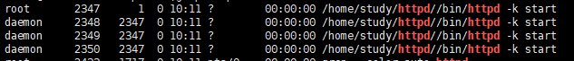

11、配置apache环境变量

[root@localhost ~]# vi /etc/profile

最后一行添加内容：export PATH=$PATH:/home/study/httpd/bin

保存退出

[root@localhost ~]# source /etc/profile 设置立即生效

[root@localhost ~]# apachectl stop|start|restart 简化命令

虚拟域名配置：

打开如下文件：[root@test httpd]# vi /home/work/httpd/conf/httpd.conf

# Virtual hosts

#Include conf/extra/httpd-vhosts.conf

Include conf/extra/my-hosts.conf

打开conf/extra/httpd-vhosts.conf进行配置：[root@test httpd]# vi conf/extra/httpd-vhosts.conf

<VirtualHost *:80>

ServerAdmin test.swoole.com

DocumentRoot "/home/work/swoole/server"

ServerName test.swool.com

ServerAlias www.dummy-host.example.com

ErrorLog "logs/test.swoole.com"

CustomLog "logs/test.swoole.com" common

</VirtualHost>

403错误：

<Directory />

Options FollowSymLinks

AllowOverride None

Order deny,allow

allow from all

</Directory>

端口开放：[root@test ~]# firewall-cmd --zone=public --add-port=80/tcp --permanent

重启防火墙：[root@test ~]# firewall-cmd –reload

TYPE="Ethernet"

PROXY_METHOD="none"

BROWSER_ONLY="no"

BOOTPROTO="static"

DEFROUTE="yes"

IPV4_FAILURE_FATAL="no"

IPV6INIT="yes"

IPV6_AUTOCONF="yes"

IPV6_DEFROUTE="yes"

IPV6_FAILURE_FATAL="no"

IPV6_ADDR_GEN_MODE="stable-privacy"

NAME="ens33"

UUID="b65fc576-1d26-4faa-adac-3361aacb4e76"

DEVICE="ens33"

ONBOOT="yes"

IPADDR="192.168.1.101"

#IPADDR="192.168.0.107"

NETMASK="255.255.255.0"

#GATEWAY="192.168.0.1"

GATEWAY="192.168.1.1"

DNS1="211.162.78.1"

DNS2="211.162.78.2"

#DNS1="202.99.224.67"

#DNS2="202.99.224.68"

HWADDR="00:0c:29:08:27:c3"

ZONE=public

~

硬盘扩展：

磁盘已成功扩展。您必须从客户机操作系统内部对磁盘重新进行分区和扩展文件系统

12、防火墙操作

关闭防火墙命令：systemctl stop firewalld.service

开启防火墙：systemctl start firewalld.service

关闭开机自启动：systemctl disable firewalld.service

开启开机启动：systemctl enable firewalld.service