1、安装：curl -sS https://getcomposer.org/installer | php

报如下错误：

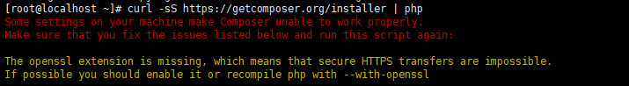

通过下载器安装

安装openssl：

[root@localhost openssl]# cd php-7.3.1/ext/openssl/

[root@localhost openssl]# /home/study/php7.3.1/bin/phpize

[root@localhost openssl]# ./configure --with-openssl --with-php-config=/home/study/php7.3.1/bin/php-config

[root@localhost openssl]# make && make install

[root@localhost ~]# vi /home/study/php7.3.1/lib/php.ini

安装zlib：

zlib.output_compression = On //开启

zlib.output_compression_level = 6 //压缩比例

[root@localhost ~]# vi /home/study/php7.3.1/lib/php.ini

安装：[root@localhost ~]# php -r "readfile('https://getcomposer.org/installer');" | php

[root@localhost ~]# cp composer.phar /usr/local/bin/composer.phar

国内镜像源：

"repositories": {

"packagist": {

"type": "composer",

"url": "https://packagist.phpcomposer.com"

}

}

**composer.phar 安装**

C:\Users\username>cd C:\bin

C:\bin>php -r "readfile('https://getcomposer.org/installer');" | php

C:\bin>echo @php "%~dp0composer.phar" %*>composer.bat

C:\Users\username>composer -V

Composer version 27d8904

资源包管理插件（css，js等）：安装好这个其他的资源管理才可以下载

composer require fxp/composer-asset-plugin