1、下载：<https://www.oracle.com/technetwork/java/javase/downloads/index.html>

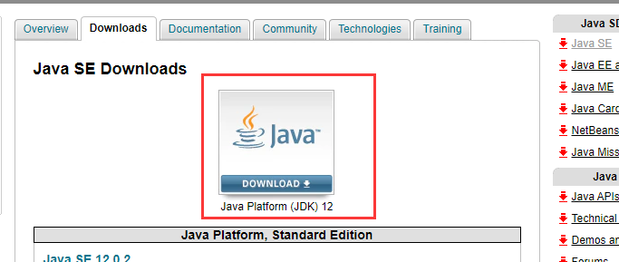

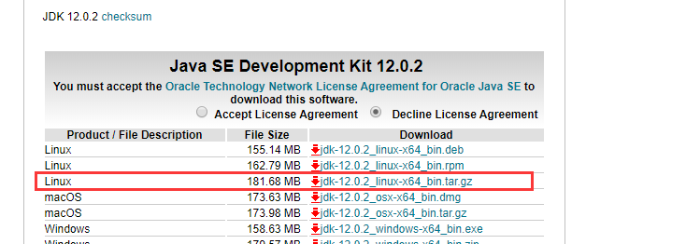

2、安装

[root@localhost ~]# tar -zxvf jdk-12.0.2_linux-x64_bin.tar.gz

[root@localhost ~]# mkdir -p /usr/java

[root@localhost ~]# mv jdk-12.0.2/* /usr/java/

[root@localhost ~]# vim /etc/profile

set java environment

JAVA_HOME=/usr/java/

JRE_HOME=/usr/java/jre

CLASS_PATH=.:$JAVA_HOME/lib/dt.jar:$JAVA_HOME/lib/tools.jar:$JRE_HOME/lib

PATH=$PATH:$JAVA_HOME/bin:$JRE_HOME/bin

export JAVA_HOME JRE_HOME CLASS_PATH PATH

[root@localhost ~]# source /etc/profile

[root@localhost ~]# java -version

