1、安装前提编译工具：

[root@localhost pcre-8.00]# yum -y install make zlib zlib-devel gcc-c++ libtool openssl openssl-devel

2、pcre包下载

<http://www.pcre.org/>

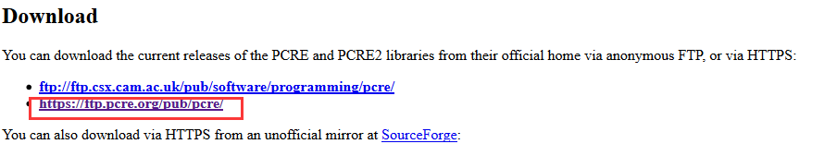

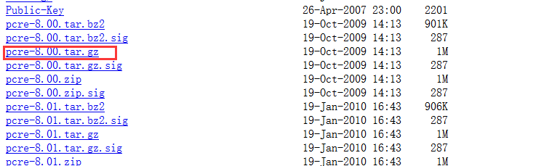

[root@localhost ~]# wget <https://ftp.pcre.org/pub/pcre/pcre-8.00.tar.gz>

3、nginx下载地址：

下载地址：<http://nginx.org/download/>

[root@localhost]# wget <http://nginx.org/download/nginx-1.9.9.tar.gz>

[root@localhost]# tar -zxvf nginx-1.9.9.tar.gz

[root@localhost nginx-1.9.9]# ./configure --prefix=/usr/local/nginx --with-http_stub_status_module --with-http_ssl_module --with-pcre=/root/pcre-8.00 ---》pcre目录为源码目录，不是安装目录

[root@localhost nginx-1.9.9]# make && make install

4、nginx配置：

[root@localhost nginx-1.9.9]# /usr/sbin/groupadd www

[root@localhost nginx-1.9.9]# /usr/sbin/useradd -g www www

5、配置nginx.conf

检查配置文件是否正确：[root@localhost nginx-1.9.9]# /usr/local/nginx/sbin/nginx -t



6、启动nginx：[root@localhost nginx-1.9.9]# /usr/local/nginx/sbin/nginx

7、查看是否启动：[root@localhost nginx-1.9.9]# ps -ef|grep nginx

命令: nginx -c /usr/local/nginx/conf/nginx.conf

重启服务： service nginx restart

2. 快速停止或关闭Nginx：nginx -s stop

3. 正常停止或关闭Nginx：nginx -s quit

4. 配置文件修改重装载命令：nginx -s reload

8、web访问关闭防火墙

关闭防火墙命令：systemctl stop firewalld.service

开启防火墙：systemctl start firewalld.service

关闭开机自启动：systemctl disable firewalld.service

开启开机启动：systemctl enable firewalld.service

9、支持php解析

[root@localhost ~]# vi /usr/local/nginx/conf/nginx.conf

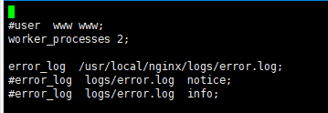

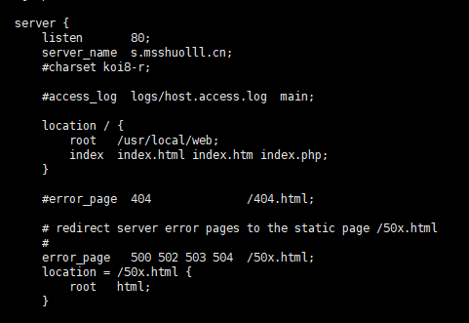

支持解析php

