**依赖包安装：**

[root@localhost php-7.3.1]#yum install -y gcc* 依赖文件自动安装，最好联网安装

报这个错误，安装如下

configure: error: libxml2 not found. Please check your libxml2 installation.

[root@localhost php-7.3.1]# yum -y install libxml2*

**php安装：**

网址：<http://php.net/get/php-7.3.1.tar.gz/from/a/mirror>



[root@localhost ~]# wget <http://hk2.php.net/get/php-7.3.1.tar.gz/from/this/mirror>

[root@localhost ~]# tar -zxvf mirror

[root@localhost ~]# mkdir /home/study/php7.3.1

[root@localhost php-7.3.1]# ./configure --prefix=/home/study/php7.3.1/

[root@localhost php-7.3.1]# make

[root@localhost php-7.3.1]# make install

**测试安装是否成功：**

查看安装成功后的扩展：[root@localhost php-7.3.1]# /home/study/php7.3.1/bin/php -m

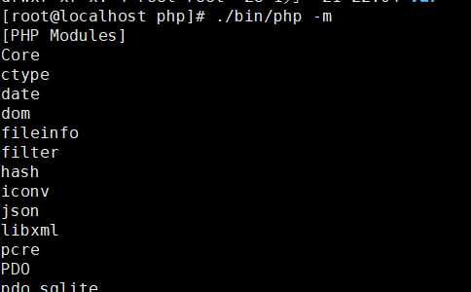

执行文件：[root@localhost php]# ./bin/php test.php



**迁移配置文件：**

[root@localhost php-7.3.1]# cp php.ini-development /home/study/php7.3.1/etc/

[root@localhost php-7.3.1]# mv /home/study/php7.3.1/etc/php.ini-development /home/study/php7.3.1/etc/php.ini

**环境变量配置【全局】：**

[root@localhost php7.3.1]# vi /etc/profile

export PATH=$PATH:/home/study/httpd/bin:/home/study/php7.3.1/bin

[root@localhost php7.3.1]# source /etc/profile

**查看ini文件实际位置：**

[root@localhost etc]# php -i|grep php.ini

Configuration File (php.ini) Path => /home/work/php/lib

放到正确的位置：[root@localhost php]# mv ./etc/php.ini ./lib/

**环境变量配置【个人】：**

[root@localhost ~]# vi ~/.bash_profile

alias php=/home/work/php/bin/php

[root@localhost ~]# source ~/.bash_profile

[root@localhost ~]# php -v

