Exploratory Data Analysis
FIFA World Cup Match Prediction Dataset

Hybrid Graph-Text Architecture for Sports Match Outcome Prediction
May 2026

Table of Contents

1. Executive Summary

This report presents a comprehensive exploratory data analysis of the FIFA World Cup dataset assembled for the Hybrid Graph-Text Architecture project. The dataset spans all 22 FIFA World Cup editions from 1930 to 2022 (964 matches total) and includes 105 engineered numeric features, FIFA ranking histories from 1992, and 994 pre-match news articles sourced exclusively from The Guardian.

The primary modelling dataset (match_dataset_1994_2022, 500 matches) covers only the FIFA ranking era to ensure complete feature coverage. A text-enriched version adds coverage flags for 329 of those matches.

Key Findings at a Glance
Finding | Detail
Class Balance | 43.8% home wins, 32.6% away wins, 23.6% draws. Moderate imbalance requires stratified splits or weighted loss.
FIFA Rankings Signal | Strongest predictor: F-stat = 80.9, Pearson r = -0.499. When home team ranked 20+ places better they win 88% of matches.
Home Advantage Decline | Home win rate dropped from 84.1% (1930-1970) to 43.0% (2002-2022). Competition is far more balanced in the modern era.
Text Coverage | 65.8% of 1994-2022 matches have at least one pre-match article (329/500). Guardian is the sole source.
Most Common Scoreline | 1-0: 118 occurrences (12.2% of all matches). Average goals per match: 2.82.
Missing Data | Rankings absent before 1994 (466/964 rows). Rest days null for first match per tournament (~25% of rows).
Best Feature Group | FIFA Ranking features dominate ANOVA. Form Last-10 outperforms Last-5 and Last-3 for class separability.
Highest Attendance | Uruguay vs Brazil, 1950 Maracana - 173,850 spectators. Lowest: Chile vs France 1930 - 2,000.
Table 1 - Summary of key EDA findings

2. Dataset Overview

The processed data is organized across ten datasets stored in both Parquet and CSV formats. The primary modelling dataset is match_dataset_1994_2022 (500 matches, 105 features). A supplementary version with text availability flags adds four columns for the text-modality branch of the model architecture.

Dataset | Rows | Cols | Years | Description
match_dataset | 964 | 105 | 1930-2022 | All WC matches, full feature set
match_dataset_1994_2022 | 500 | 105 | 1994-2022 | FIFA-era matches with ranking features
match_dataset_with_text | 500 | 109 | 1994-2022 | Above + text availability columns
fifa_rankings_clean | 13,128 | 10 | 1992-2024 | Biannual FIFA rankings, 226 nations
worldcup_matches_clean | 964 | 25 | 1930-2022 | Base match facts (no engineered features)
team_tournament_features | 489 | 11 | - | Pre-tournament team stats per edition
teams | 86 | 3 | - | Reference table of team names
tournaments | 22 | 7 | 1930-2022 | One row per World Cup edition
articles_with_flags | 994 | 26 | - | Guardian articles, leakage-flagged
pre_match_articles | 994 | 26 | - | Confirmed pre-match articles only
Table 2 - Summary of all processed datasets

Matches are drawn from 22 FIFA World Cups across 92 years. Tournament size grew from 18 matches (1930) to 64 matches (from 1998 onwards) as the competition expanded from 13 to 32 qualifying nations.
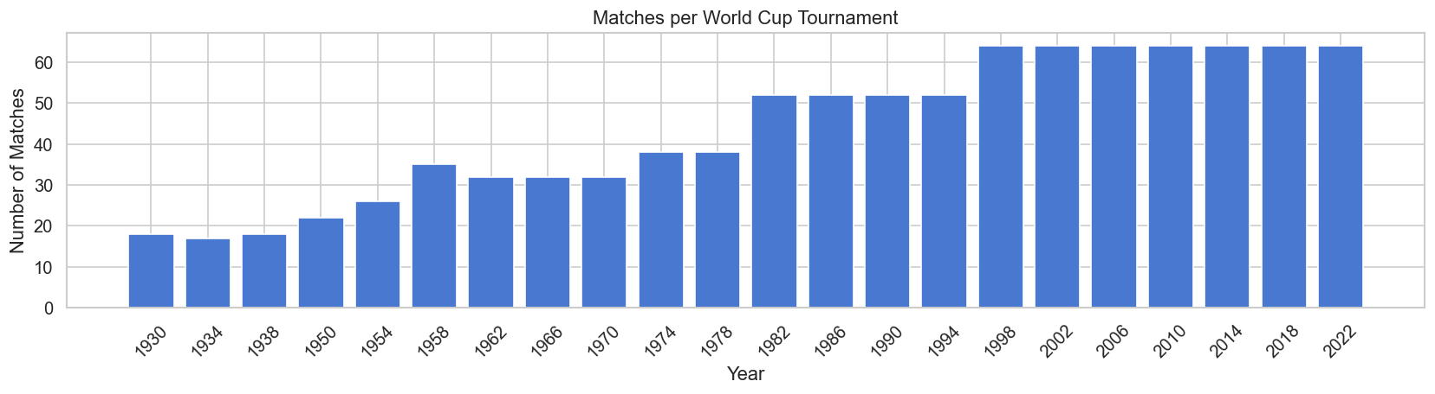
Figure 1 - Number of matches per World Cup edition

3. Match Outcomes & Target Variable

The target variable encodes three outcomes: home win (0), draw (1), away win (2). Across all 964 matches the dataset is moderately imbalanced, with home wins the most frequent outcome. The imbalance is less pronounced in the 1994-2022 era as the game became more globally competitive.

All matches (1930-2022): Home win 55.2% | Away win 22.6% | Draw 22.2%
1994-2022 subset: Home win 43.8% | Away win 32.6% | Draw 23.6%

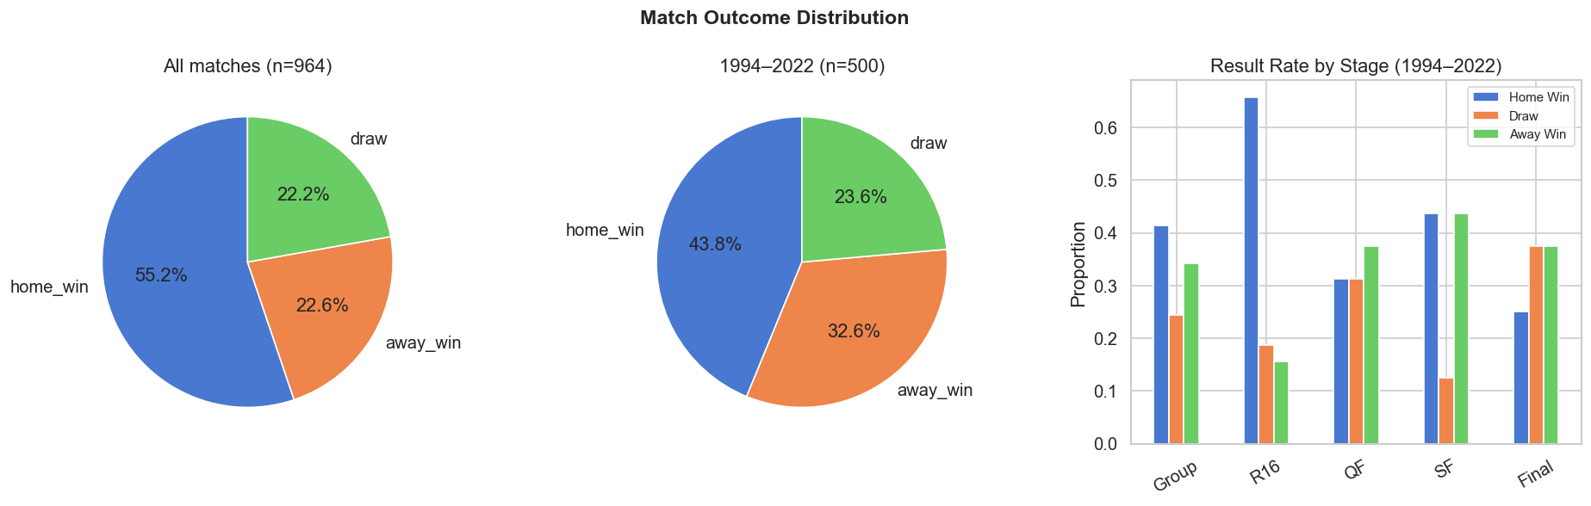
Figure 2 - Match outcome distribution across all WCs, the 1994-2022 subset, and by tournament stage
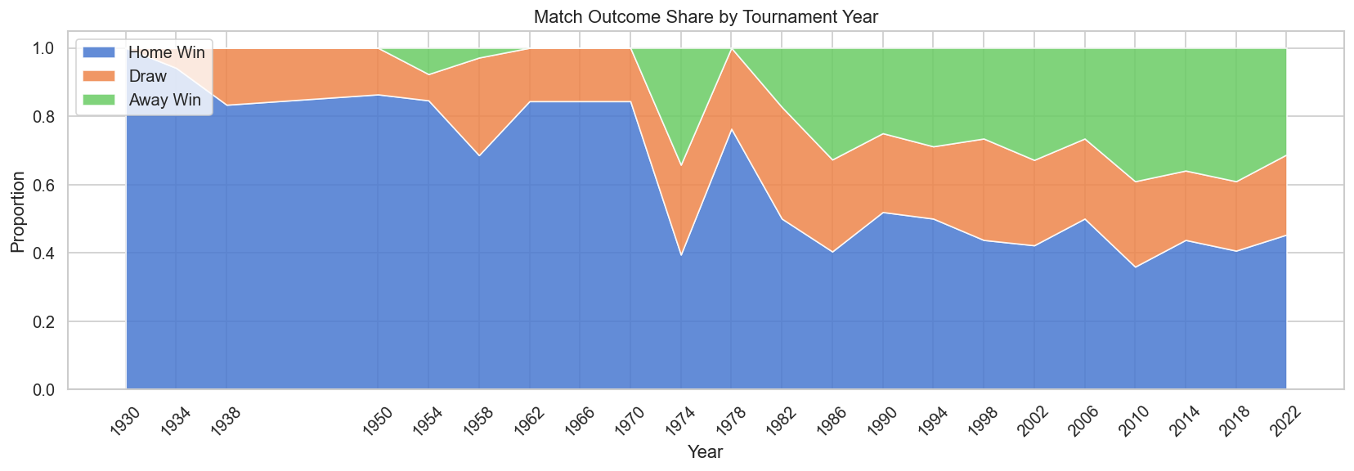
Figure 3 - Stacked outcome share by year. Home-win dominance has declined sharply since the 1970s.
Home win rate fell from over 80% in early tournaments to approximately 43% in the modern era (2002-2022). This reflects the professionalization of football globally, more balanced squad quality across nations, and expanded fields bringing more competitive parity.

4. Goals & Score Patterns

Home teams score a mean of 1.78 goals per match versus 1.04 for away teams, producing an overall mean of 2.82 goals per match. The most common scoreline is 1-0, recorded 118 times (12.2% of all matches). The 1954 tournament had the highest average goals per match (~5.4), while the 1990 tournament had the lowest (~2.2).
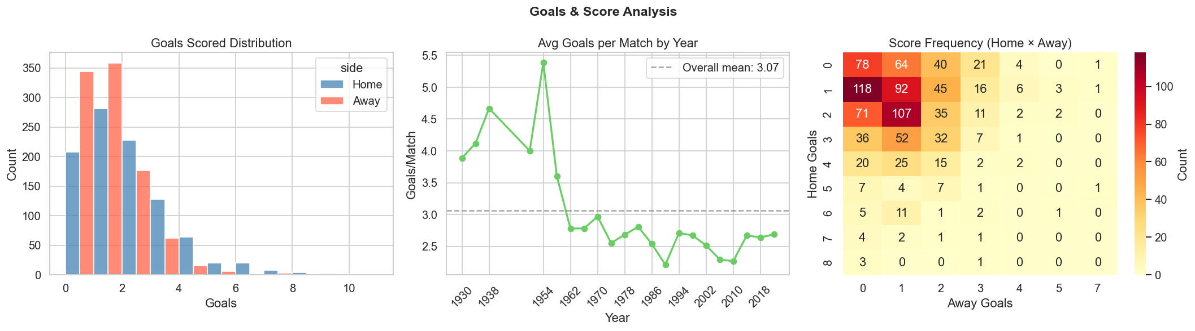
Figure 4 - Goals distribution (home vs away), average goals per year, and score-frequency heatmap
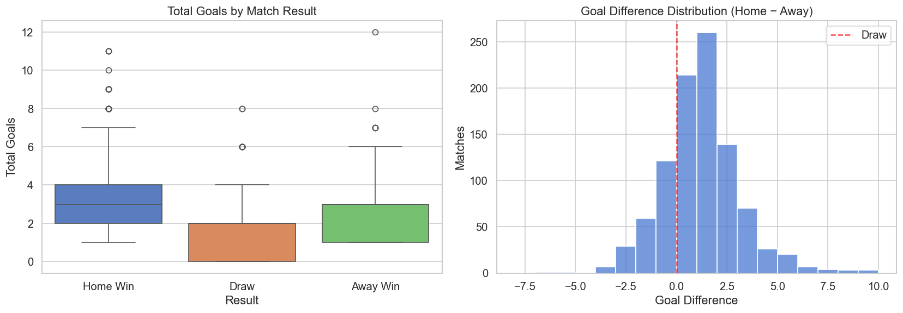
Figure 5 - Total goals by result (left) and goal-difference distribution (right)
- Home wins produce significantly more goals (mean 3.30) than draws (1.79) or away wins (2.88)
- Goalless draws (0-0) occur in only 5.3% of matches
- High-scoring matches (>5 total goals) account for 8.4% of the dataset, mostly from early tournaments

5. FIFA Rankings Analysis

FIFA rankings are available from 1992 onwards (biannual snapshots), covering 226 nations across 13,128 records. Rankings are matched to the closest snapshot before each match date. Coverage is 100% for 1994-2022 tournaments with minor gaps in 1998 and 2002.
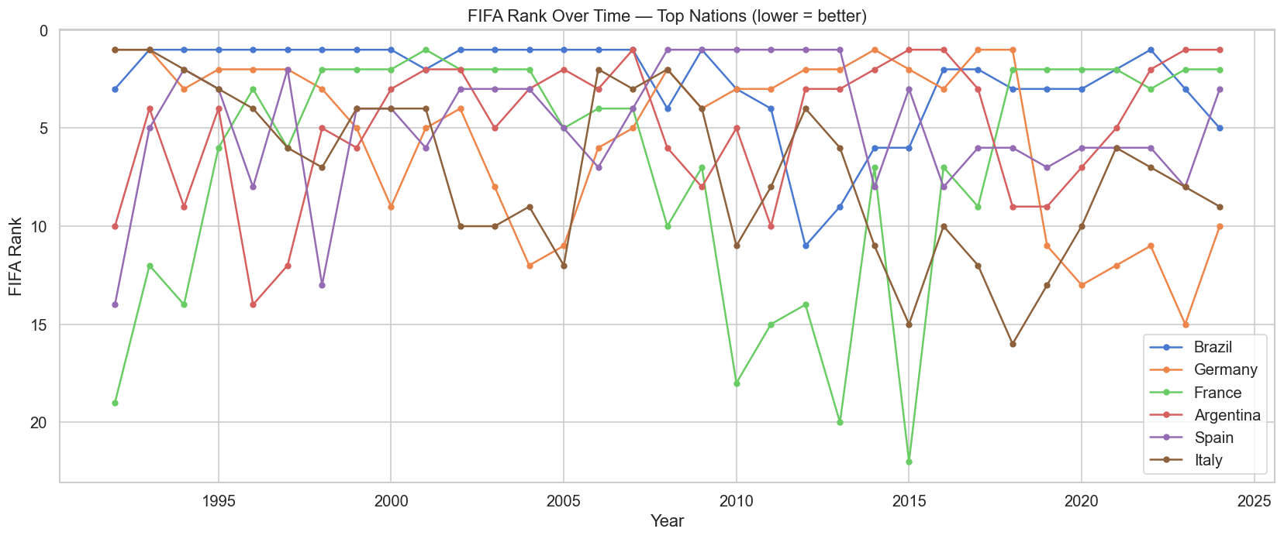
Figure 6 - FIFA rank trajectories for six top nations (1992-2024). Lower rank = better.
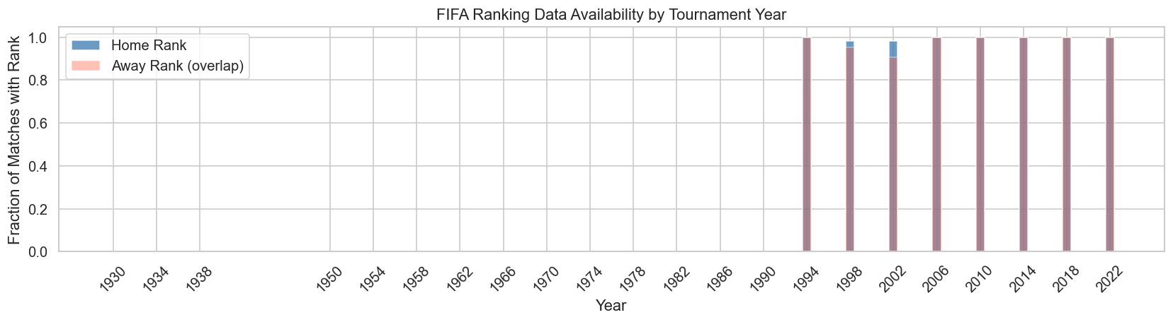
Figure 7 - Fraction of matches with valid FIFA ranking data by tournament year

Predictive Power of FIFA Rankings
The rank difference (home rank minus away rank) is the single strongest predictor of match outcome: Pearson correlation of -0.499 and ANOVA F-statistic of 80.9 - more than four times higher than the next-best feature group.
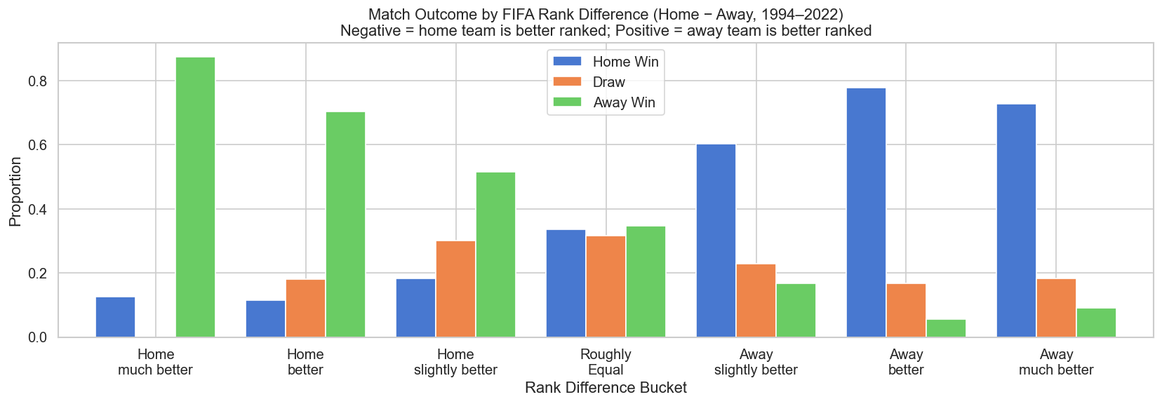
Figure 8 - Match outcome rates across rank-difference buckets. Heavily favoured teams win 70-88% of the time.
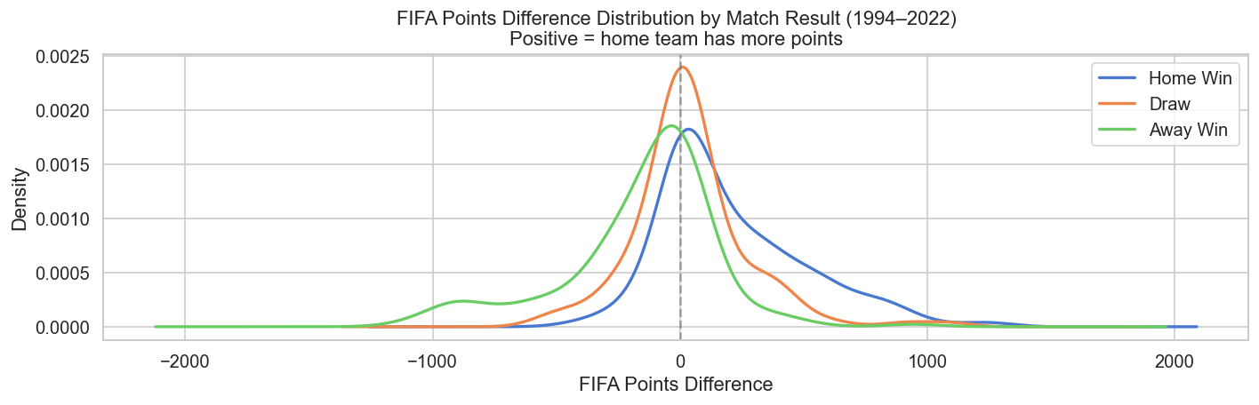
Figure 9 - FIFA points difference distribution by result. Distributions are clearly separated.
When the home team is ranked more than 50 places better, they win 88% of matches. However, upsets are common in the "slightly better" range (5-20 rank places), where draw rates peak and outcome is genuinely uncertain.

6. Team Form Features

Form features capture recent performance using rolling windows of 3, 5, and 10 matches, plus cumulative World Cup history. Home teams show systematically higher win rates across all windows (mean last-5: 42.3% vs 33.4% for away), partly reflecting selection effects.
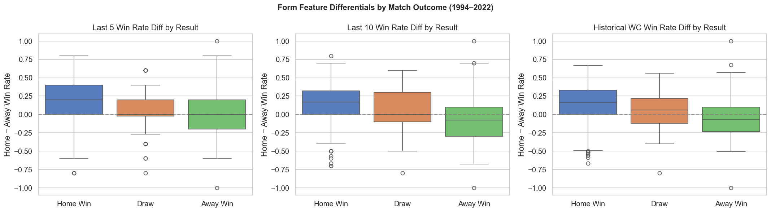
Figure 10 - Win-rate differentials (home minus away) by match result for three form windows
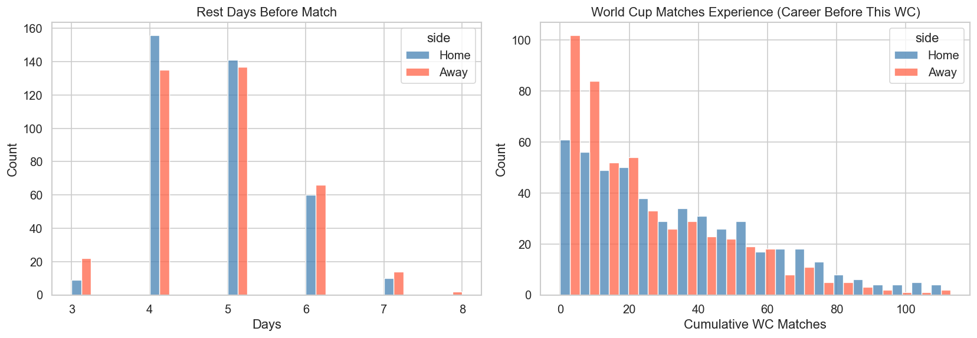
Figure 11 - Rest days distribution and cumulative World Cup match experience
- Last-10 win rate features show consistently higher ANOVA F-statistics than last-3 features
- WC historical win rate is particularly informative - long-term pedigree matters in tournament play
- Rest days are null for first-match-in-tournament rows (~245 missing values); the binary flag already encodes this
- Teams with more cumulative World Cup experience consistently outperform those with fewer appearances

7. Missing Data Analysis

Missing data is systematic rather than random, falling into three distinct categories that require specific imputation strategies:
- FIFA ranking features: absent for all pre-1994 matches (466/964 rows). By design - the model uses only 1994-2022 for this branch.
- Rest days: null for each team's first match per tournament (~245 rows). A binary flag (home_first_match_in_tournament) already encodes this pattern.
- Win rate features: null when a team has never won in the relevant window (35 home rows, 51 away rows). Impute with 0.

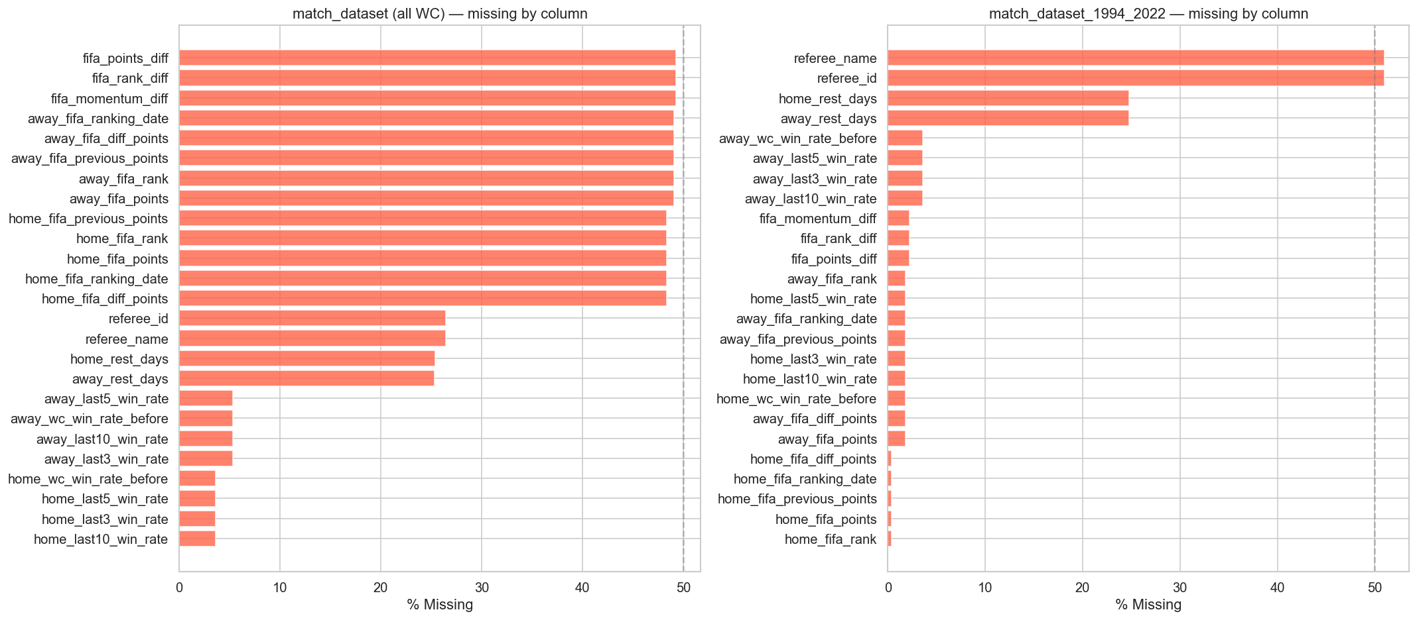
Figure 12 - Missing value rates by column for the full dataset (left) and 1994-2022 subset (right)

8. Feature Correlations with Target

Pearson correlations with the three-class target (0=home win, 1=draw, 2=away win) reveal a clear hierarchy. FIFA ranking features dominate, followed by long-window form features, then World Cup history. Raw score columns are excluded as post-match leakage.
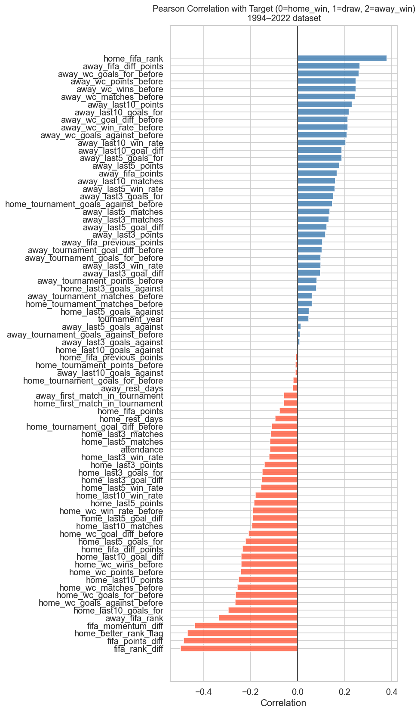
Figure 13 - Pearson correlation of all numeric features with the target variable
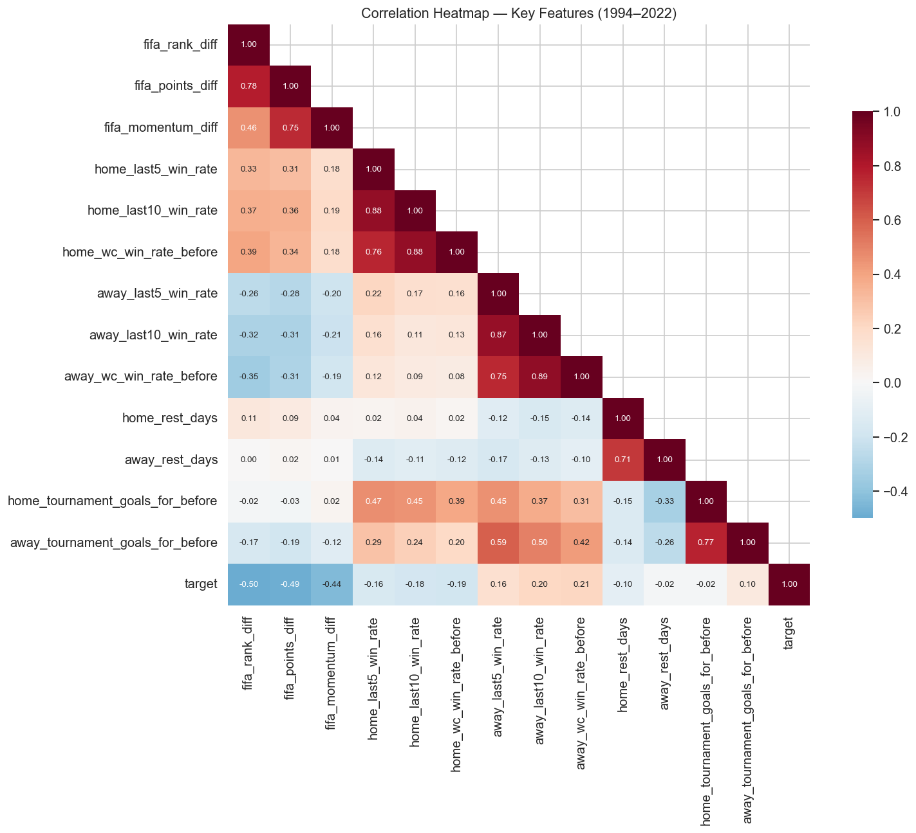
Figure 14 - Correlation heatmap across key feature groups. Strong within-group correlations exist for FIFA features.
- fifa_rank_diff: -0.499 (strongest predictor)
- fifa_points_diff: -0.485
- home_better_rank_flag: -0.470
- fifa_momentum_diff: -0.438
- home_fifa_rank: +0.381 (positive because higher rank number = weaker team)

Within-group collinearity is high for FIFA ranking features (rank_diff, points_diff, and momentum_diff correlate ~0.8+), suggesting dimensionality reduction may reduce redundancy before modelling.

9. Feature Importance (ANOVA)

One-way ANOVA F-statistics measure how much each feature's distribution differs across the three outcome classes. Higher F-statistics indicate stronger separation between home wins, draws, and away wins.
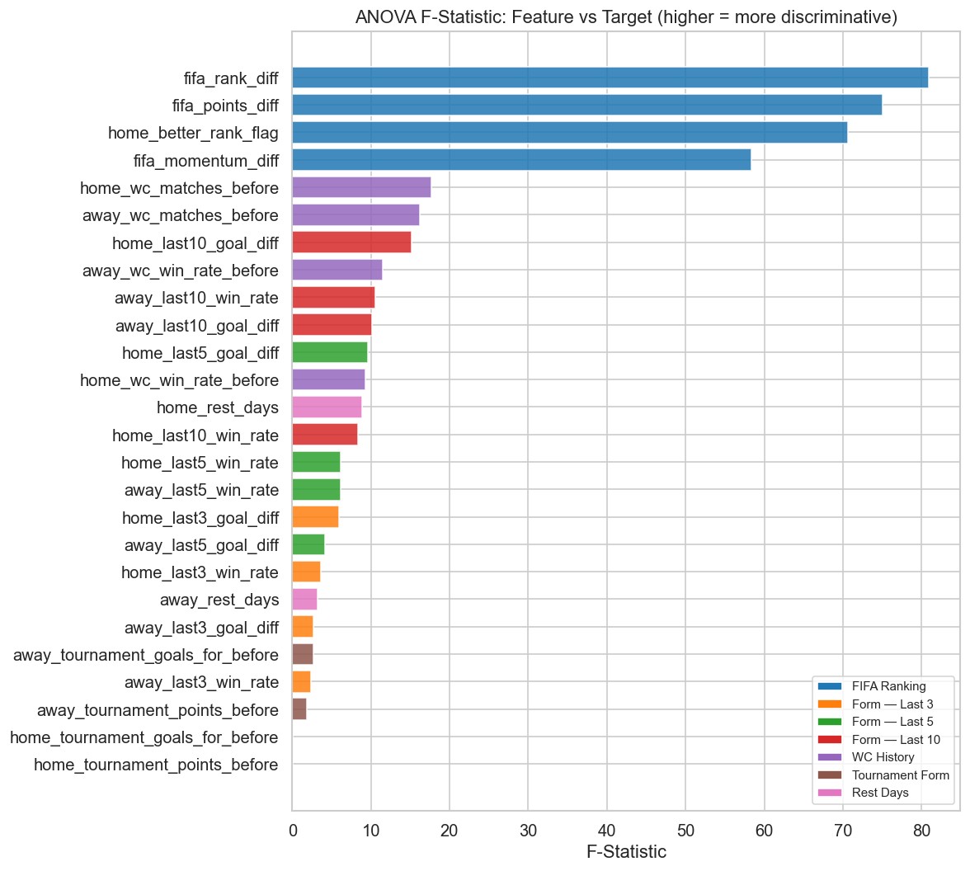
Figure 15 - ANOVA F-statistic per feature, coloured by feature group

Top 10 Most Discriminative Features
Feature | Group | F-Statistic | p-value
fifa_rank_diff | FIFA Ranking | 80.90 | 4.7e-31
fifa_points_diff | FIFA Ranking | 75.09 | 3.8e-29
home_better_rank_flag | FIFA Ranking | 70.64 | 1.0e-27
fifa_momentum_diff | FIFA Ranking | 58.36 | 1.9e-23
home_wc_matches_before | WC History | 17.65 | 3.9e-08
away_wc_matches_before | WC History | 16.18 | 1.6e-07
home_last10_goal_diff | Form - Last 10 | 15.22 | 3.8e-07
away_wc_win_rate_before | WC History | 11.54 | 1.3e-05
away_last10_win_rate | Form - Last 10 | 10.54 | 3.3e-05
away_last10_goal_diff | Form - Last 10 | 10.15 | 4.8e-05
Table 3 - ANOVA results. All p-values are highly significant (< 0.001).

FIFA ranking features occupy the top 4 positions by a wide margin. The next tier comprises WC History features (cumulative match counts and win rates), followed by Form Last-10 features. This hierarchy is consistent with the correlation analysis and validates the feature engineering strategy: competition-specific experience matters more than recent form for World Cup prediction.

10. Team-Level Analysis

86 distinct teams have participated in at least one World Cup match. Brazil and Germany have the most appearances (both over 100 matches). Win rates above 60% reflect consistent elite-level performance across the history of the competition.
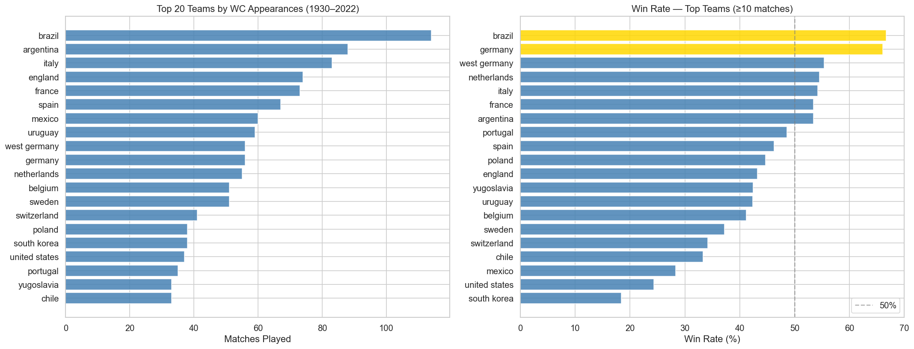
Figure 16 - Top 20 teams by appearances (left) and win rates for teams with 10+ matches (right)
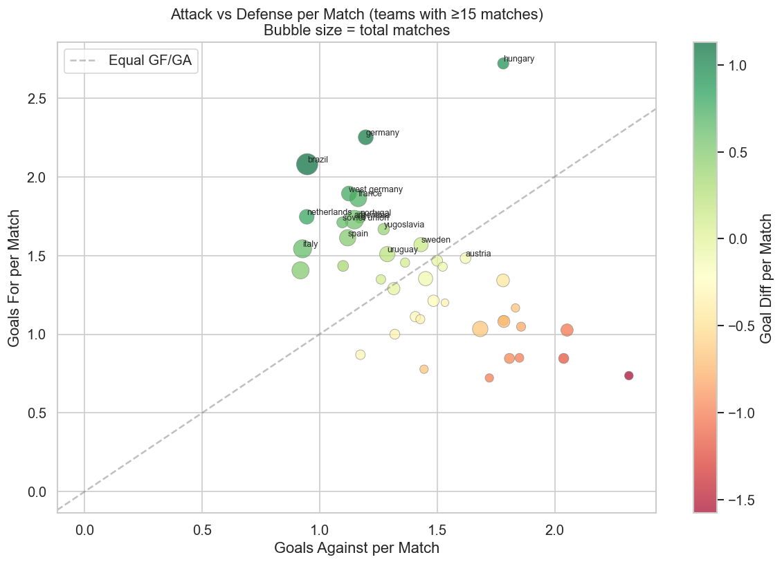
Figure 17 - Goals-for vs goals-against per match. Bubble size = total matches. Teams above the diagonal score more than they concede.

11. Attendance Analysis

Attendance records exist for all 964 matches. The 1994 US World Cup stands out with the highest average attendance (~68,991 per match) thanks to large American stadium capacities. The highest-attended single match was Uruguay vs Brazil at the 1950 Maracana (173,850 spectators).
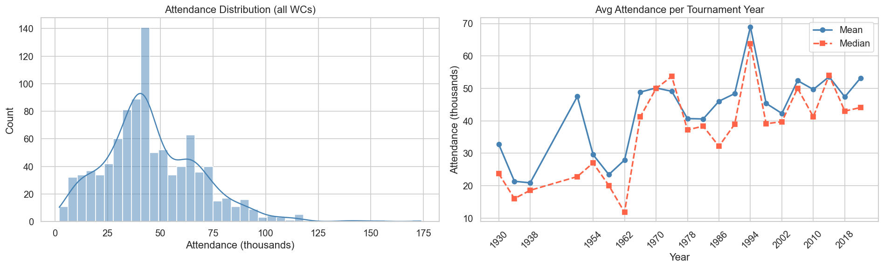
Figure 18 - Attendance distribution (left) and average attendance trend by tournament year (right)

12. Text Data Coverage

Pre-match news articles were collected exclusively from The Guardian. All 994 articles are confirmed pre-match with no leakage risk. Of 500 matches in the 1994-2022 subset, 329 (65.8%) have at least one pre-match article. Coverage rises sharply from 2002 as online Guardian archives become comprehensive.
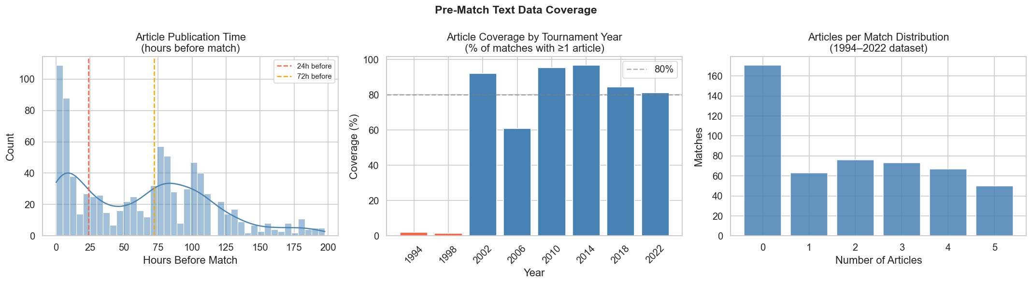
Figure 19 - Article timing (left), coverage by tournament year (centre), and articles-per-match distribution (right)
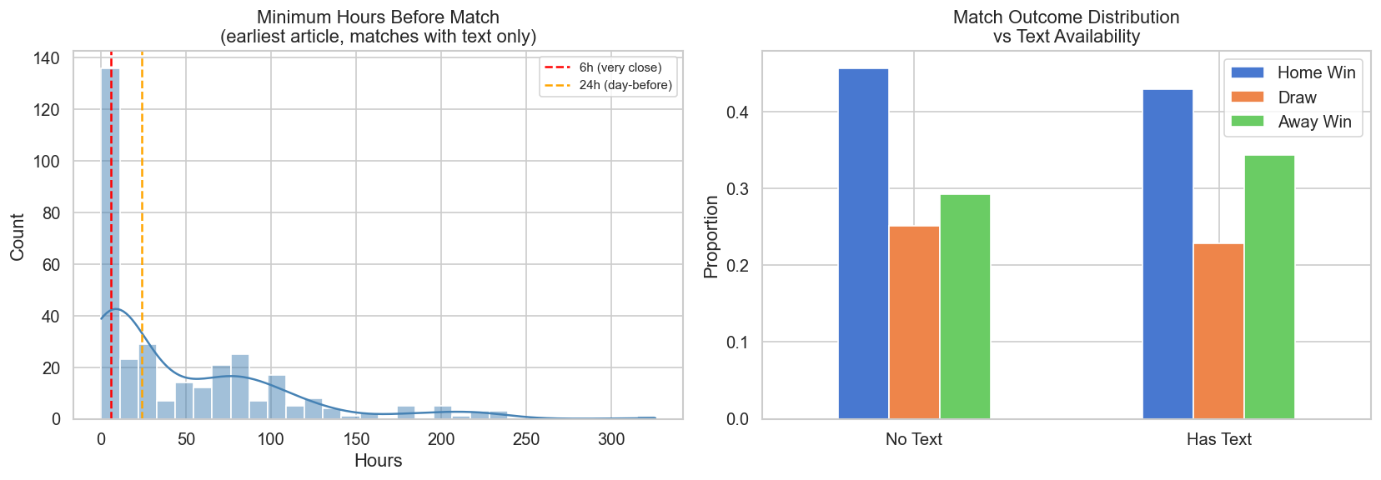
Figure 20 - Earliest article timing per match (left) and outcome distribution by text availability (right)
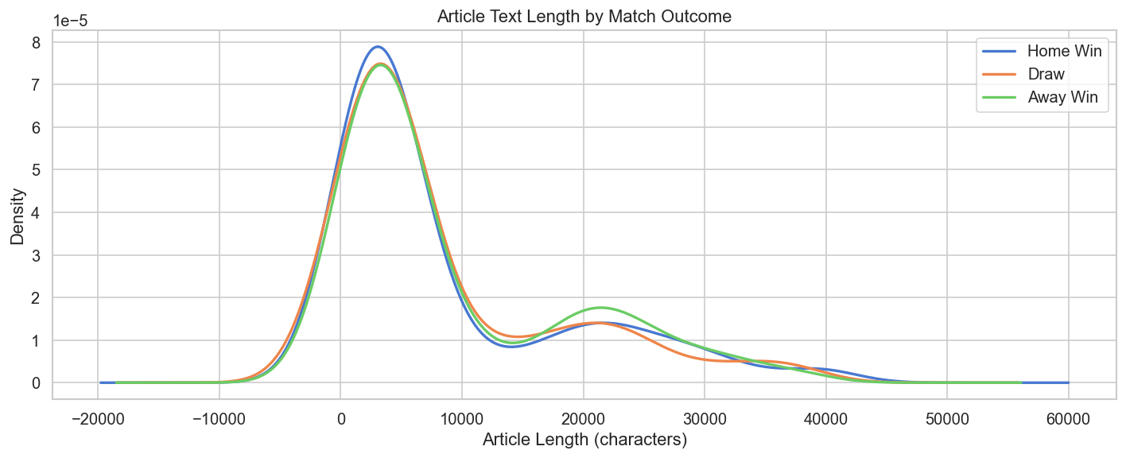
Figure 21 - Article length distributions by match outcome. No meaningful length bias detected.
- Single source (Guardian) - model may learn source-specific writing patterns rather than general football sentiment
- Mean article length: 8,853 characters (median 4,540) with high variance (std 9,926)
- Mean earliest article: 47.6 hours before kick-off; 127 articles within 6 hours may contain late team news
- Outcome distribution is similar between text-available and no-text matches - no sampling bias detected

13. Stage & Tournament Analysis

Knockout-round matches produce fewer goals than group stage matches, consistent with tactical conservatism when elimination is at stake. Upsets (lower-ranked team winning) are most frequent in Group Stage and rarest in Quarter-Finals, where preparation time and scouting reduce surprise outcomes.
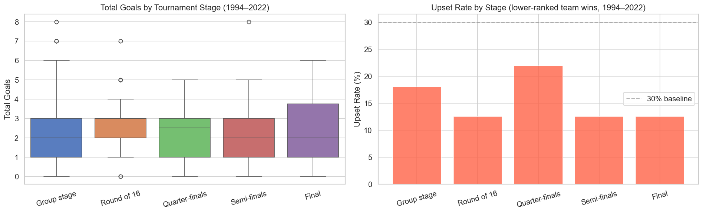
Figure 22 - Total goals by tournament stage (left) and upset rates by stage for 1994-2022 (right)

14. Class Balance & Stratification

Class balance is consistent across tournament years in the 1994-2022 period. Matches with pre-match text coverage show a similar class distribution to those without, confirming article availability is not correlated with outcome type.
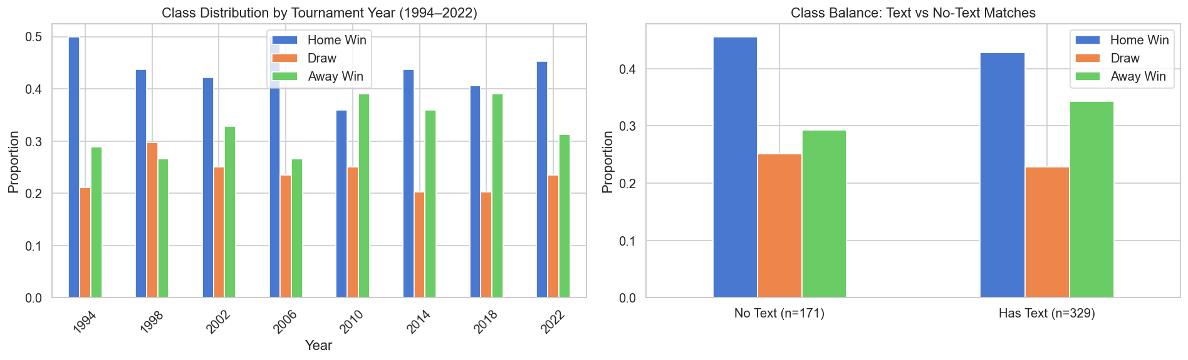
Figure 23 - Class distribution per tournament year (left) and by text availability (right)
The 43.8% / 23.6% / 32.6% split warrants class-weighted cross-entropy or stratified k-fold splits. Draws are the hardest class to predict and the most underrepresented, yet critically important for evaluation realism in a multiclass setting.

15. Modelling Recommendations

Based on this EDA, the following actions are recommended before model training:

Data Preparation
- Use match_dataset_1994_2022 as the primary training frame - complete FIFA feature coverage across 500 samples
- Impute rest_days with 0 for first-match rows; retain home_first_match_in_tournament as a binary indicator feature
- Impute win-rate nulls with 0 (teams with no wins - not missing at random)
- Apply stratified k-fold by tournament year to prevent train/test contamination across editions

Feature Engineering
- Reduce FIFA ranking collinearity: consider PCA on {rank_diff, points_diff, momentum_diff} or select the most informative one
- Prefer last-10 win rate over last-3 for tournament prediction - longer history is more stable
- Add log(text_count + 1) alongside the binary text_available flag

Text Modality
- Restrict text features to articles published at least 6 hours before kick-off to avoid late team-news leakage
- Be aware of Guardian single-source bias when interpreting text-branch performance vs numeric-only baselines
- Use text for 2002-2022 matches only (pre-2002 coverage is under 5%)

Modelling
- Apply class weights approximately (home_win: 1.0, away_win: 1.35, draw: 1.86) to compensate for imbalance
- Evaluate with macro-F1 in addition to accuracy - draws are rare but important
- Train ablation baselines: (a) ranking-only, (b) form-only, (c) text-only, (d) combined - to isolate each modality's contribution

