**金融计量学 作业1**

**何天舒 171098111**

**主要任务：**

1. 熟悉Stata介面及操作；
2. 复习相关数学基础知识；
3. 利用统计软件Stata完成数据导入、查看、描述性统计、全概率公式验证；
4. 利用统计软件Stata完成Normal distribution, Chi-square distribution, T-distribution and F-distribution的构造。

-------------------------------------------------------------

**Use the data**

. use "课件数据\数据\grilic.dta", clear

**Check the data**

. d

Contains data from 课件数据\数据\grilic.dta

obs: 758

vars: 12 1 Feb 2016 09:2

> 5

size: 16,676

-------------------------------------------------------------

storage display value

variable name type format label variable label

-------------------------------------------------------------

rns byte %8.0g south = 1

mrt byte %8.0g married = 1

smsa byte %8.0g big cities =1

med byte %8.0g mother's

education

iq int %8.0g IQ

kww byte %8.0g KWW

age byte %8.0g age

s byte %8.0g schooling

expr float %9.0g experience

tenure byte %8.0g tenure

lnw float %9.0g ln(wage)

wage float %9.0g wage

-------------------------------------------------------------

Sorted by:

**Descriptive statistics**

. sum

Variable | Obs Mean Std. Dev. Min

> Max

-------------+-----------------------------------------------

> ----------

rns | 758 .2691293 .4438001 0

> 1

mrt | 758 .5145119 .5001194 0

> 1

smsa | 758 .7044855 .456575 0

> 1

med | 758 10.91029 2.74112 0

> 18

iq | 758 103.8562 13.61867 54

> 145

-------------+-----------------------------------------------

> ----------

kww | 758 36.57388 7.302247 12

> 56

age | 758 21.83509 2.981756 16

> 30

s | 758 13.40501 2.231828 9

> 18

expr | 758 1.735429 2.105542 0

> 11.444

tenure | 758 1.831135 1.67363 0

> 10

-------------+-----------------------------------------------

> ----------

lnw | 758 5.686739 .4289494 4.605

> 7.051

wage | 758 323.9161 148.6858 99.98299

> 1154.012

. sum lnw, detail

ln(wage)

-------------------------------------------------------------

Percentiles Smallest

1% 4.804 4.605

5% 5.011 4.605

10% 5.165 4.654 Obs 758

25% 5.38 4.718 Sum of Wgt. 758

50% 5.684 Mean 5.686739

Largest Std. Dev. .4289494

75% 5.991 6.786

90% 6.252 6.844 Variance .1839976

95% 6.399 6.869 Skewness .1744968

99% 6.706 7.051 Kurtosis 2.73237

**Drawing histogram**

. hist lnw, width(0.1)

(bin=25, start=4.605, width=.1)

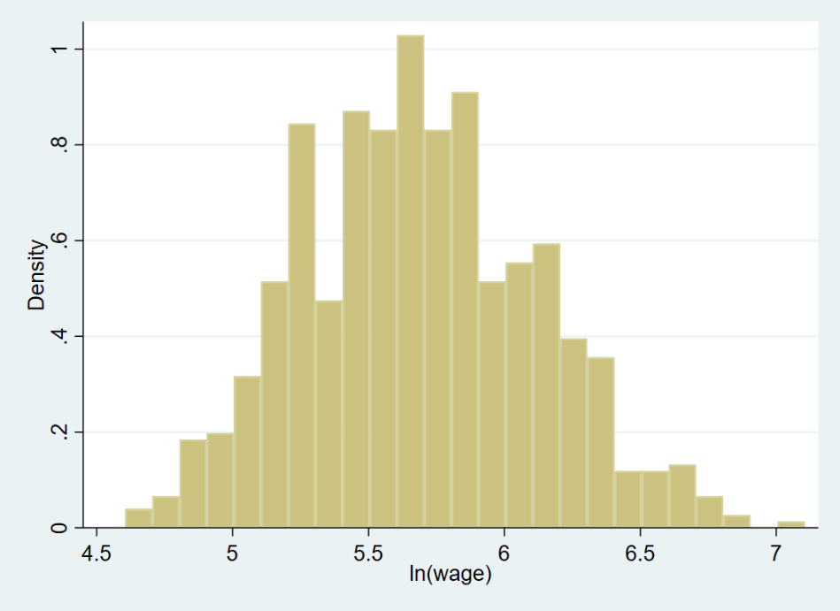

. graph export "log/hist_lnw.png", replace

(note: file log/hist_lnw.png not found)

(file log/hist_lnw.png written in PNG format)

**Kernel density estimate**

. . kdensity lnw, normal normop(lpattern(dash))

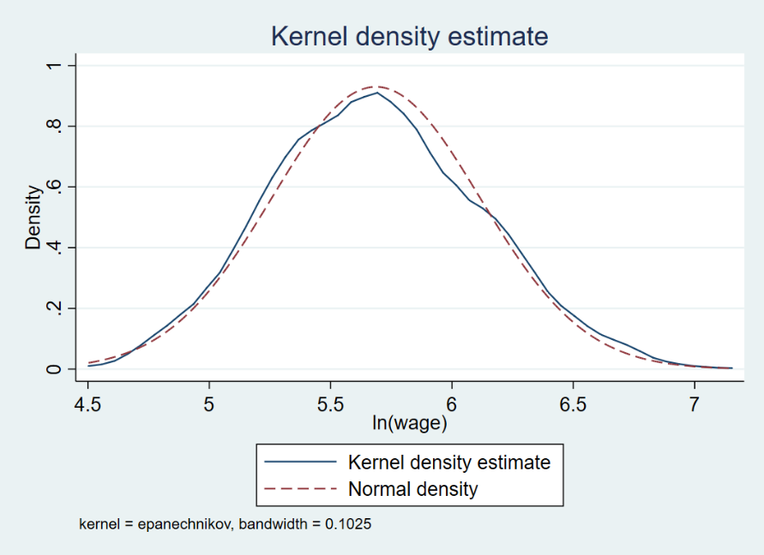

. graph export "log/kdensity_est.png", replace

(note: file log/kdensity_est.png not found)

(file log/kdensity_est.png written in PNG format)

. kdensity wage

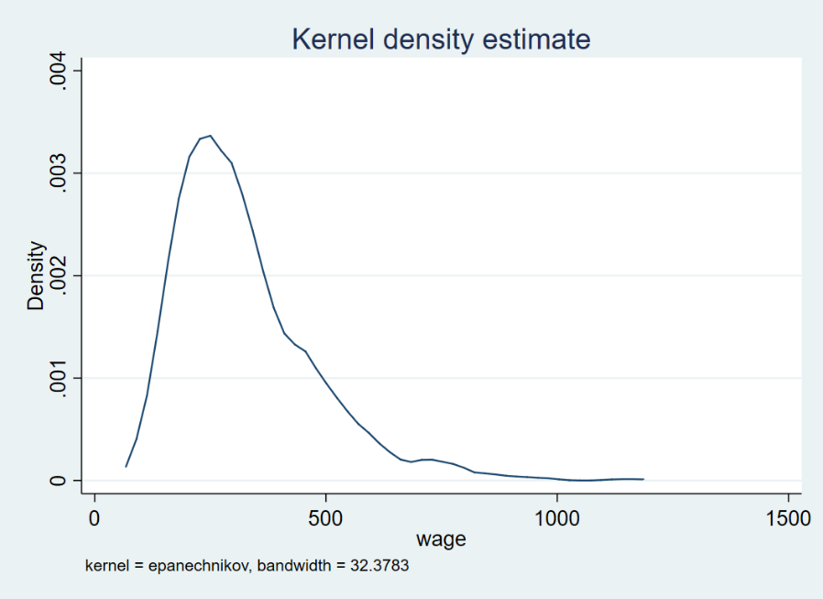

. graph export "log/kdensity_wage.png"

(file log/kdensity_wage.png written in PNG format)

**Kernel density estimate under some condition**

. kdensity lnw if s == 16

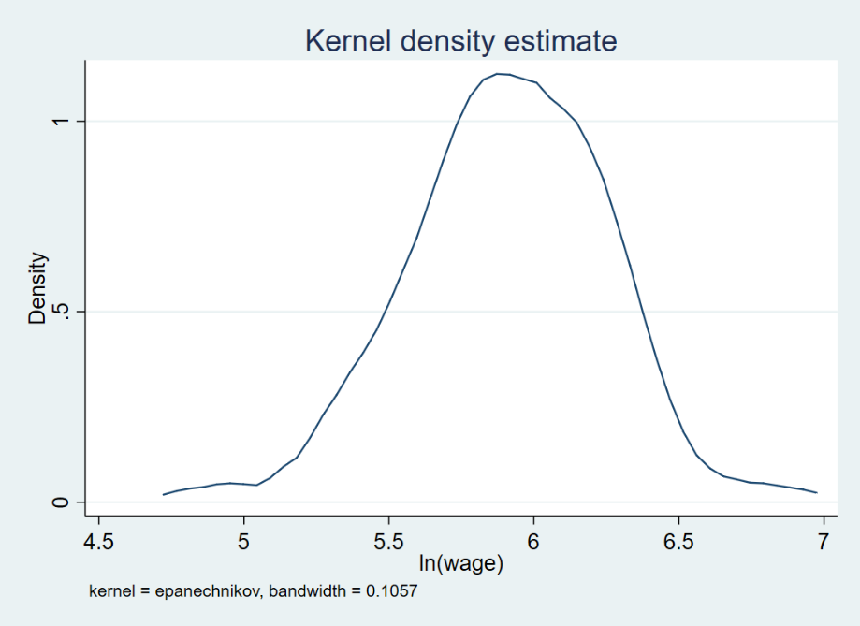

. graph export "log/kdensity_lnw_sis16.png"

(file log/kdensity_lnw_sis16.png written in PNG format)

. twoway kdensity lnw || kdensity lnw if s==16, lpattern(dash

> )

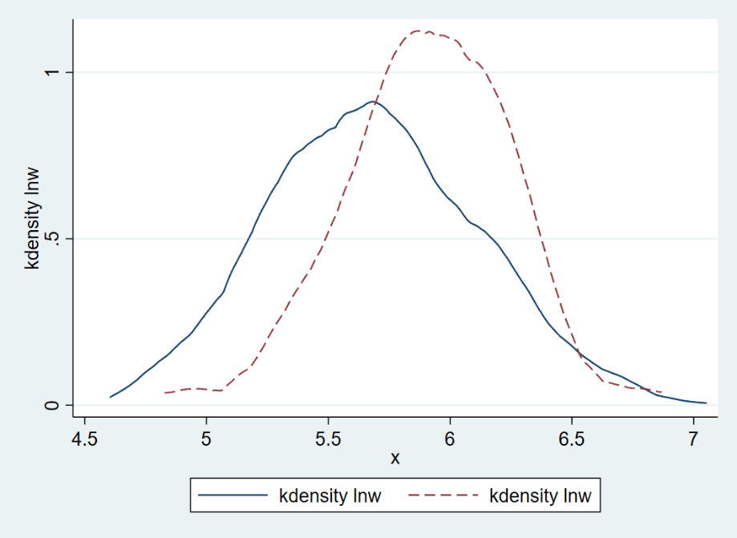

. graph export "log/twoway.png"

(file log/twoway.png written in PNG format)

**Total probability formula**

. sum lnw

Variable | Obs Mean Std. Dev. Min

> Max

-------------+-----------------------------------------------

> ----------

lnw | 758 5.686739 .4289494 4.605

> 7.051

. sum lnw if s==16

Variable | Obs Mean Std. Dev. Min

> Max

-------------+-----------------------------------------------

> ----------

lnw | 151 5.907338 .3396442 4.828

> 6.869

. sum lnw if rns==0

Variable | Obs Mean Std. Dev. Min

> Max

-------------+-----------------------------------------------

> ----------

lnw | 554 5.725644 .4129207 4.605

> 7.051

. sum lnw if rns==1

Variable | Obs Mean Std. Dev. Min

> Max

-------------+-----------------------------------------------

> ----------

lnw | 204 5.581083 .4542189 4.718

> 6.844

. dis 5.725644*(554/(554+204)) + 5.581083 *(204/(204+554))

5.6867384

. sum lnw

Variable | Obs Mean Std. Dev. Min

> Max

-------------+-----------------------------------------------

> ----------

lnw | 758 5.686739 .4289494 4.605

> 7.051

. dis normal(1.96)

.9750021

**PDF of normal distribution**

. twoway function y=normalden(x), range(-

> 5 5)xline(0) ytitle(pdf)

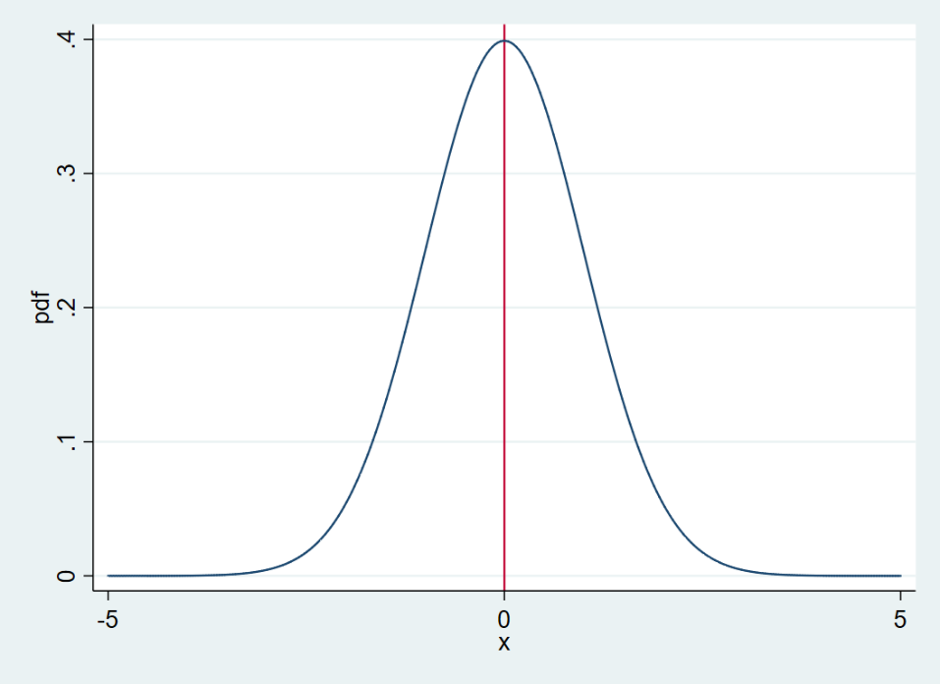

. graph export "log\normalpdf.png"

(file log\normalpdf.png written in PNG fo

> rmat)

**Two normal distribution**

. twoway function y=normalden(x),range(-5

> 10) || function z=normalden(x,1,2),ran

> ge(-5 10) lpattern(dash) ytitle(概率密

> 度)

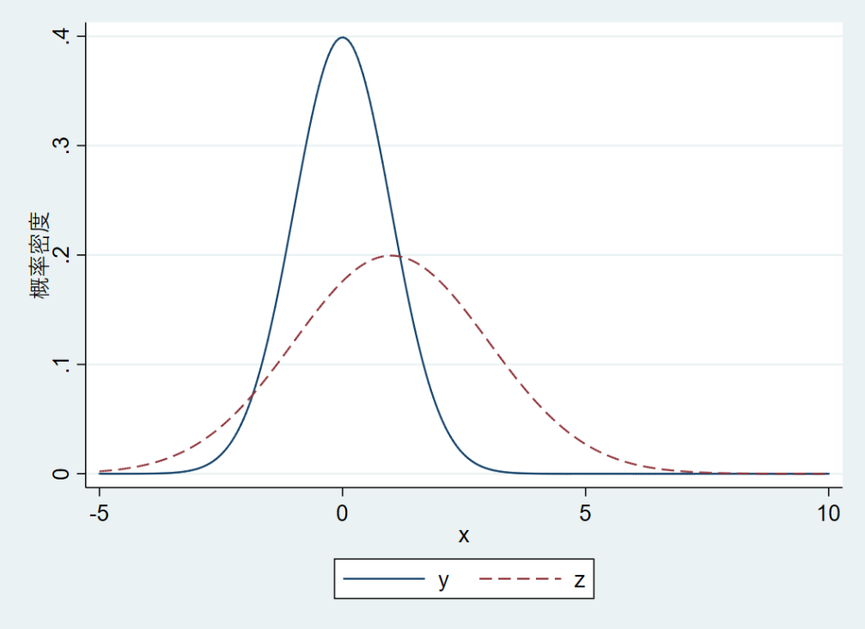

. graph export "log/normal2.png"

(file log/normal2.png written in PNG form

> at)

**Chi-square distribution with free degree of 3 and 5**

. twoway function chi3=chi2den(3,x),range

> (0 20) || function chi5=chi2den(5,x),ra

> nge(0 20) lpattern(dash) ytitle(概率密

> 度)

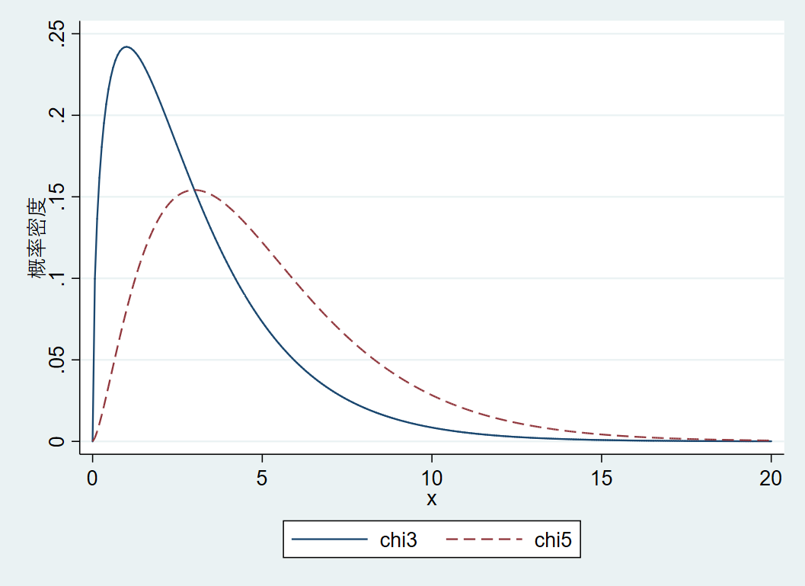

. graph export "log\chi3chi5_pdf.png"

(file log\chi3chi5_pdf.png written in PNG

> format)

**T-distribution with free degree of 1 and 5**

. twoway function t1=tden(1,x),range(-5 5

> ) || function t5=tden(5,x),range(-5 5)

> lpattern(dash) ytitle(概率密度)

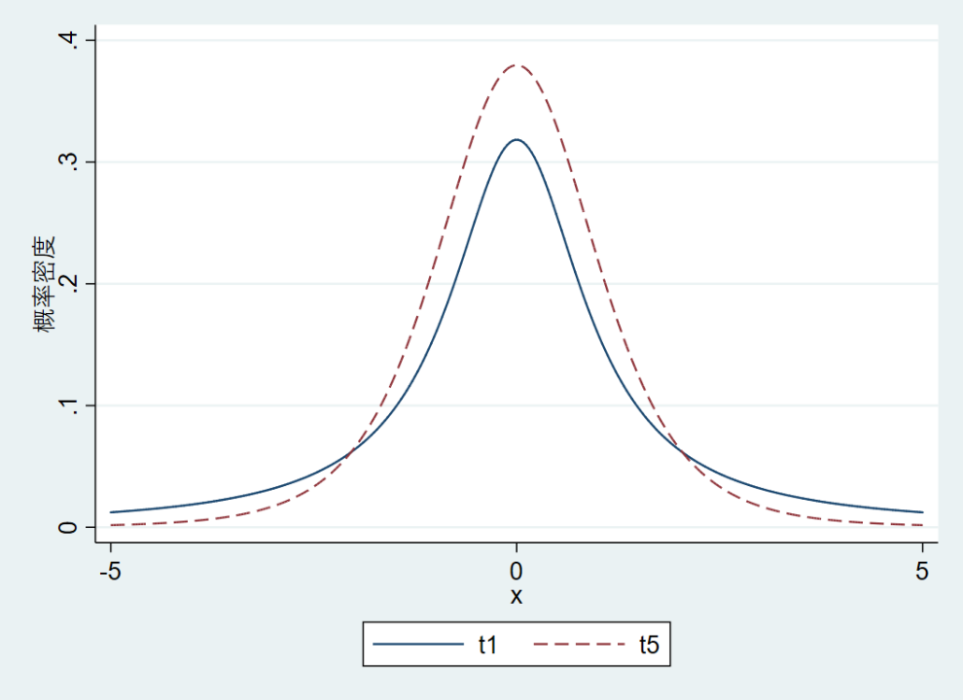

. graph export "log/t1t5_pdf.png"

(file log/t1t5_pdf.png written in PNG for

> mat)

**F distribution with degree of 10,20 and 10,5**

. twoway function F20=Fden(10,20,x),range

> (0 5) || function F5=Fden(10,5,x),range

> (0 5) lpattern(dash) ytitle(概率密度)

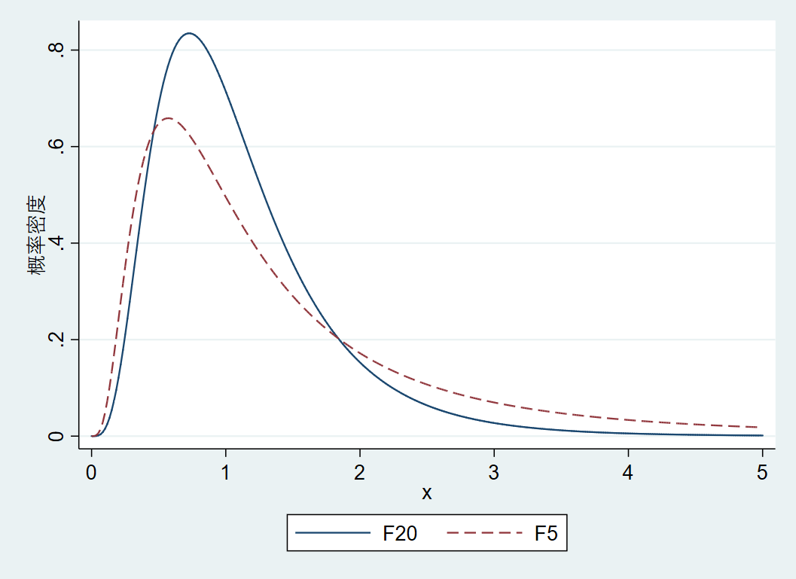

. graph export "log\f20f5_pdf.png"

(file log\f20f5_pdf.png written in PNG fo

> rmat)