YUVA INTERN
Week 6 Capstone Project
A Complete Data Science Pipeline for Employee Attrition
Dataset: HR Analytics.xlsx | Integrating Weeks 1–4 of the internship into one pipeline

1. Problem Statement
Across this internship, I worked with the HR Analytics dataset in pieces — cleaning it, exploring it, segmenting employees, and building a predictive model — but always as separate weekly exercises. For this capstone, I brought all of that together into one connected pipeline that answers a single real business question: which employees are most likely to leave the company, and what does that group actually look like?
This matters because employee attrition is expensive — recruiting, onboarding, and lost productivity all cost money and time. A company that can identify at-risk employees and understand why they're at risk can act early instead of reacting after someone has already resigned.

2. Methodological Approach
I structured this as a full data science pipeline with five connected stages:
- Data acquisition and cleaning (recap of Week 1)
- Exploratory data analysis to understand attrition patterns (recap of Week 2)
- Unsupervised learning: segmenting employees into natural groups using K-Means (extending Week 3's approach to this dataset)
- Supervised learning: predicting individual attrition risk using classification models (recap of Week 4)
- A new integrative step: combining the segments and the predictive model to see whether they agree with each other, and what that combination reveals
That last step is the actual “capstone” part — it's new analysis that didn't exist in any single previous week, and it only became possible because I had both the clustering and classification pieces already built.

3. Data Collection and Cleaning
df = pd.read_csv('HR_Analytics_analysis_ready.csv')
print(df.shape) # (1470, 31)
print(df.isna().sum().sum()) # 0 (already cleaned)
print(df.duplicated().sum()) # 0
This is the same cleaned dataset from Week 1: 1,470 employee records, 31 columns, with the original Total/summary row removed, the empty artifact column dropped, distance converted to numeric with the missing value median-imputed, and the missing employee ID explicitly coded as -1 rather than guessed.

4. Exploratory Data Analysis (Recap)
Before modeling, I recapped the three strongest attrition signals identified in Week 2's EDA:
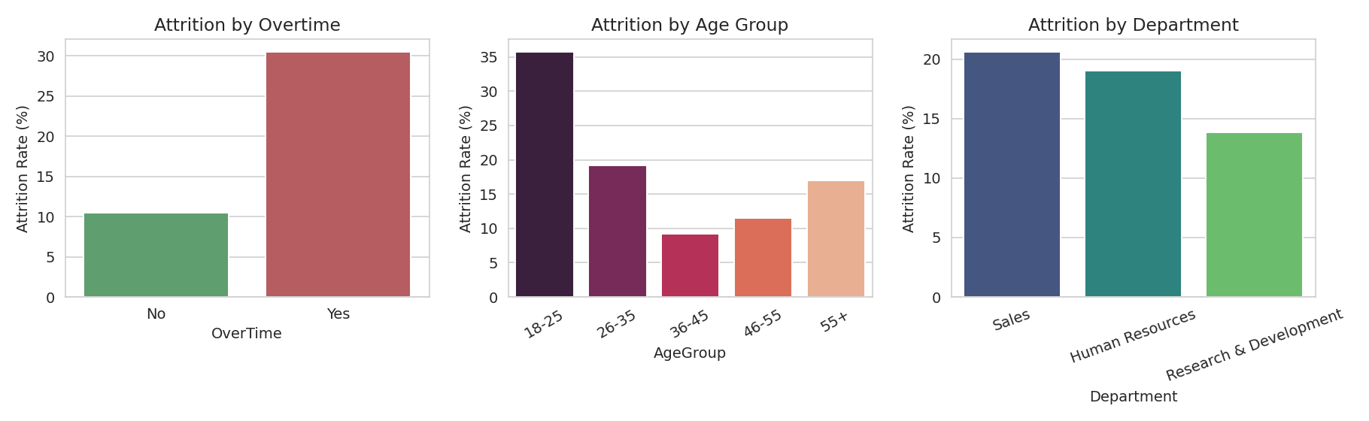
Figure 1: Attrition rate by overtime, age group, and department.
- Overtime: 30.53% attrition vs. 10.44% for those who don't work overtime — the single strongest signal in the dataset.
- Age group: 18-25 has the highest attrition (35.77%), dropping sharply for older employees.
- Department: Sales has the highest departmental attrition (20.63%), R&D the lowest (13.84%).
Overall attrition across the whole dataset is 16.12%. These three patterns became the foundation for both the modeling stages that follow.

5. Unsupervised Learning: Employee Segmentation
To understand employee structure beyond just individual attrition, I used K-Means to group employees by their overall profile — age, income, satisfaction, distance from home, salary hike, and job involvement — without using the Attrition label at all.
features = ['Age', 'MonthlyIncome', 'DistanceFromHome (km)',
'JobSatisfaction', 'EnvironmentSatisfaction',
'NumCompaniesWorked', 'PercentSalaryHike', 'JobInvolvement']
X_scaled = StandardScaler().fit_transform(df[features])

kmeans = KMeans(n_clusters=4, random_state=42, n_init=10)
df['Segment'] = kmeans.fit_predict(X_scaled)
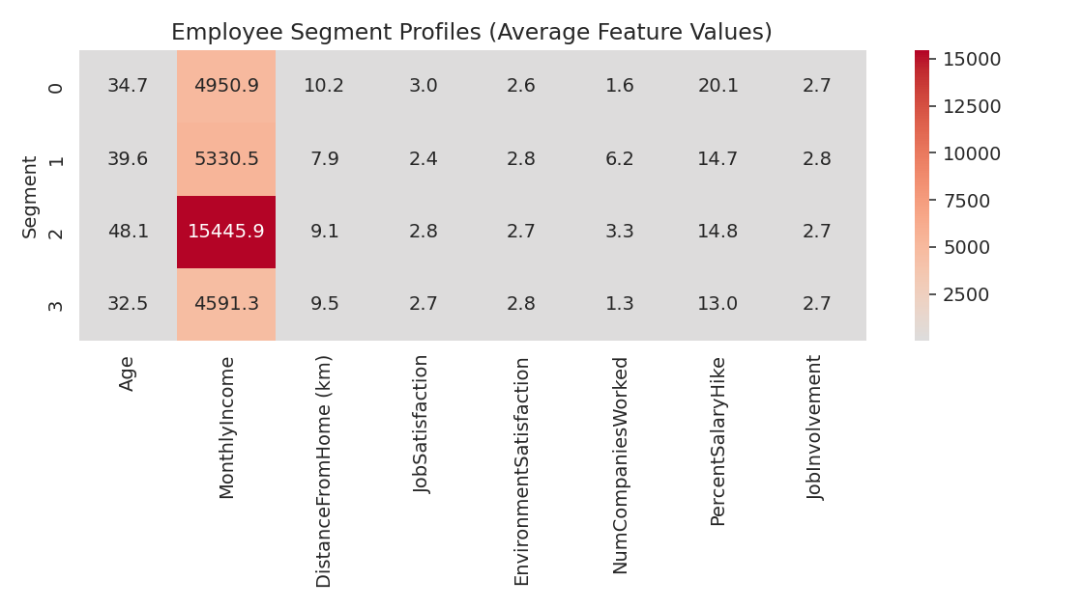
Figure 2: Average feature values per employee segment.
This produced 4 segments (silhouette score 0.134, similar to what I found when I first explored clustering on this dataset in Week 3): a loyal, recently-rewarded group (Segment 0), an experienced but less satisfied group with a lot of job-hopping (Segment 1), a senior high-earning group (Segment 2), and a large early-career group (Segment 3).
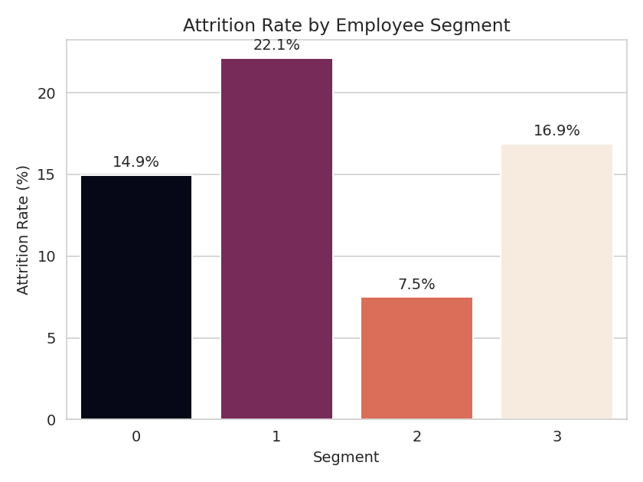
Figure 3: Actual attrition rate for each segment.
Segment 1 (experienced job-hoppers, lower satisfaction) has the highest actual attrition rate at 22.12%, while Segment 2 (senior, high earners) is the most stable at just 7.49%.

6. Supervised Learning: Predicting Individual Risk
Separately, I trained two classification models to predict each individual employee's attrition risk, using the same approach as Week 4: Logistic Regression as an interpretable baseline, and Random Forest for potentially stronger raw performance.
X_train, X_test, y_train, y_test = train_test_split(
X, y, test_size=0.25, random_state=42, stratify=y)

log_reg = LogisticRegression(class_weight='balanced', max_iter=1000)
rf = RandomForestClassifier(n_estimators=300, max_depth=8,
class_weight='balanced')
Metric | Logistic Regression | Random Forest
Accuracy | 0.707 | 0.864
Precision (Yes) | 0.307 | 0.714
Recall (Yes) | 0.661 | 0.254
F1 Score (Yes) | 0.419 | 0.375
ROC-AUC | 0.752 | 0.778

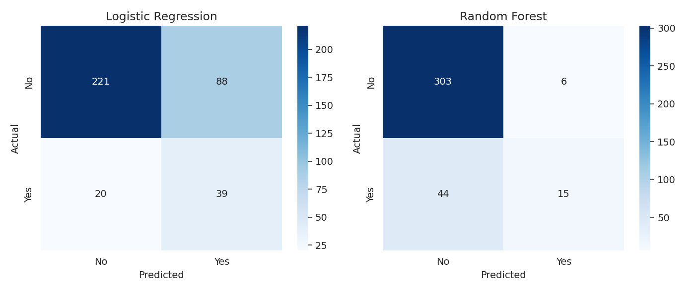
Figure 4: Confusion matrices for both models on the test set.
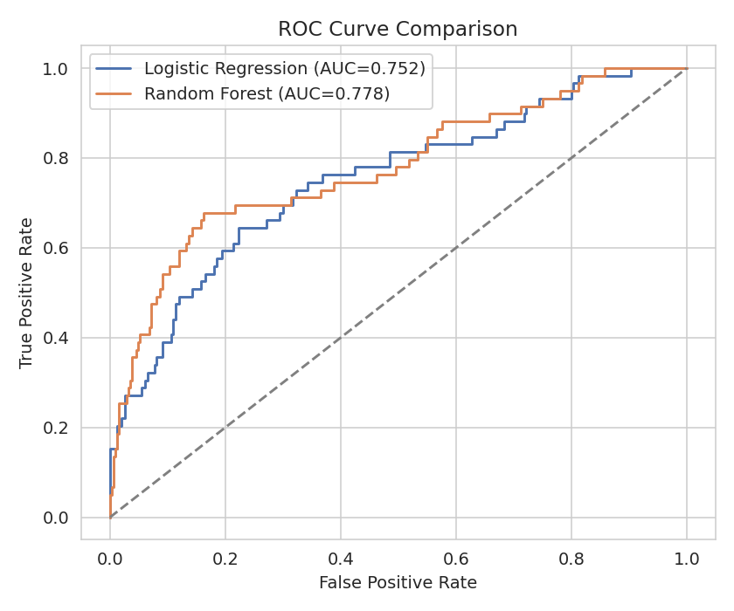
Figure 5: ROC curves — both models rank risk similarly well overall (AUC ≈ 0.75-0.78).
As I found in Week 4, Random Forest wins on raw accuracy and precision, but Logistic Regression catches far more of the employees who actually leave (66.1% recall vs. 25.4%). For an early-warning HR system, recall matters more than accuracy, since missing an at-risk employee is more costly than a false alarm.

7. New Analysis: Do Segments and Predictions Agree?
This is the integrative step that ties the two modeling approaches together. I took the Random Forest's predicted attrition probability for every employee and averaged it within each segment, to see whether the model (which never saw the segment labels) independently agrees with the clustering.
full_prob = rf.predict_proba(X_encoded)[:, 1]
df['PredictedAttritionRisk'] = full_prob

risk_by_segment = df.groupby('Segment')['PredictedAttritionRisk'].mean()
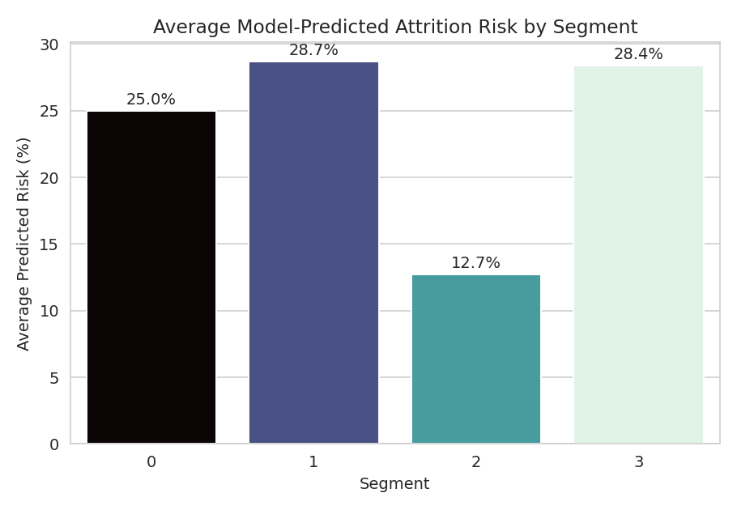
Figure 6: Average model-predicted attrition risk for each segment.
The two independent methods agree well: Segment 2 (senior, high earners) has both the lowest actual attrition (7.49%) and the lowest average predicted risk (12.7%). Segments 1 and 3 both show elevated predicted risk (28.7% and 28.4%), which lines up with Segment 1's high actual attrition and suggests Segment 3 (the largest group, early-career employees) may be a bigger hidden risk than its moderate actual attrition rate (16.89%) alone would suggest — the model is picking up on risk factors within that segment beyond what the simple average shows.

8. Evaluation and Critical Discussion
- The clustering and classification approaches are complementary, not redundant: clustering describes who employees are, while classification predicts what they'll do. Combining them gave a genuinely new insight (Segment 3's underlying risk) that neither method surfaced on its own.
- Both classification models are limited by class imbalance (only 237 attrition cases in 1,470 employees) and a small dataset for the deep learning-style techniques explored in Week 5 to matter much here.
- The clustering silhouette scores are all fairly low (~0.13), meaning employee segments overlap somewhat rather than being cleanly separated — this is realistic for human behavior data, but means resulting segments should be treated as useful approximations, not hard categories.

9. Business Recommendations
- Prioritize retention efforts on Segment 1 (experienced, low satisfaction, high job-hopping history) — both the actual data and the independent model agree this group is highest risk.
- Investigate Segment 3 (largest group, early-career) more closely despite its moderate average attrition rate — the model's higher predicted risk for this group suggests underlying factors worth a deeper look, such as onboarding quality or early career growth paths.
- Use Logistic Regression (or a threshold-adjusted Random Forest) rather than a default Random Forest for any real early-warning system, since recall matters more than raw accuracy for this use case.
- Treat overtime as the single highest-leverage intervention point — it's the strongest predictor across every stage of this analysis, from the raw EDA to the model's feature importance.

10. Reflection: Challenges and Successes

Challenges
- Connecting the unsupervised and supervised results in a meaningful way took more thought than either piece alone — it would have been easy to just present them side by side without actually asking whether they agreed with each other.
- The class imbalance that limited Week 4's models carried through to this capstone too; no amount of pipeline integration fixes a fundamentally small positive class.
- Keeping the different stages consistent (same cleaned dataset, same encoding approach) across a longer combined script required more careful bookkeeping than any single week's task.

Successes
- The segment-vs-prediction comparison in Section 7 genuinely produced a new insight (Segment 3's hidden risk) that wouldn't have been visible from either the clustering or the classification model alone — this is the clearest evidence that combining techniques adds real value, not just extra complexity.
- Every number in this report is grounded in the same real, cleaned dataset used throughout the internship, so the whole six-week arc tells one consistent, traceable story rather than disconnected exercises.

11. Conclusion
This capstone combined data cleaning, exploratory analysis, unsupervised segmentation, and supervised prediction into a single pipeline addressing one real business question: which employees are at risk, and what do they look like? The two independent techniques — clustering and classification — largely agreed with each other, which builds confidence that the patterns found (overtime, career stage, income) are real signals rather than coincidences in one particular analysis. The clearest practical output is a short, prioritized list of where HR should focus first: Segment 1 for immediate risk, Segment 3 for closer investigation, and overtime reduction as the single highest-leverage lever across the whole workforce.

Appendix – Files
- HR_Analytics_analysis_ready.csv — the cleaned dataset used as the pipeline's starting point.
- HR_Analytics_capstone_final.csv — the final dataset with both Segment and PredictedAttritionRisk columns added.
- week6_capstone.py — the full Python script covering all five pipeline stages.
- capstone_model_comparison.csv — summary metrics table for both classification models.
- charts/ — all chart images used as figures in this report.

