Full Stack Development with MERN Project Documentation

Project Title: ShopSmart - Your Digital Grocery Store Experience

Project Title: ShopSmart - Your Digital Grocery Store Experience
Team Leader : Shafi Shaik
Team member : Sakulji Pulugu
Team member : Sundar Kumar Gunje
Team member : Sneha Latha Garaka

Purpose:
ShopSmart is a grocery web application designed to provide a seamless online shopping experience. Users can browse products, add items to cart, and place orders securely. Admins can manage products, users, and orders efficiently.

Features:
- User Registration and Login
- Product Browsing and Search
- Shopping Cart Management
- Order Placement and History
- Admin Dashboard
- Product Add/Update/Delete
- Role-Based Access Control
- Secure Authentication using JWT

Frontend:
Developed using modern frontend framework (React/Angular). Handles UI rendering, routing, API calls, and responsive design.

Backend:
Developed using Node.js and Express.js. Implements RESTful APIs, business logic, authentication, and middleware.

Database:
MongoDB used as NoSQL database with Mongoose ODM. Collections include Users, Products, Orders, and Cart.

Prerequisites:
- Node.js and npm
- MongoDB
- Git
- VS Code
- Web Browser (Chrome/Firefox)

Installation Steps:
- Clone the repository from GitHub.
- Navigate to project directory.
- Run npm install to install dependencies.
- Start backend using npm run dev.
- Start frontend using npm start.
- Open http://localhost:5100 in browser.

Client Folder:
Contains src, components, pages, services, App.js, index.js.

Server Folder:
Contains models, routes, controllers, middleware, config, server.js.

- POST /api/register - Register user
- POST /api/login - Login user
- GET /api/products - Get products
- POST /api/products - Add product (Admin)
- PUT /api/products/:id - Update product
- DELETE /api/products/:id - Delete product
- POST /api/orders - Place order
- GET /api/orders - Get orders

Authentication is handled using JWT tokens. Passwords are hashed using bcrypt. Role-based authorization is implemented for Admin and User access control.

API testing performed using Postman. Manual testing conducted for user flows including registration, login, cart management, and order placement.

Demo link provided in project documentation Google Drive link:-

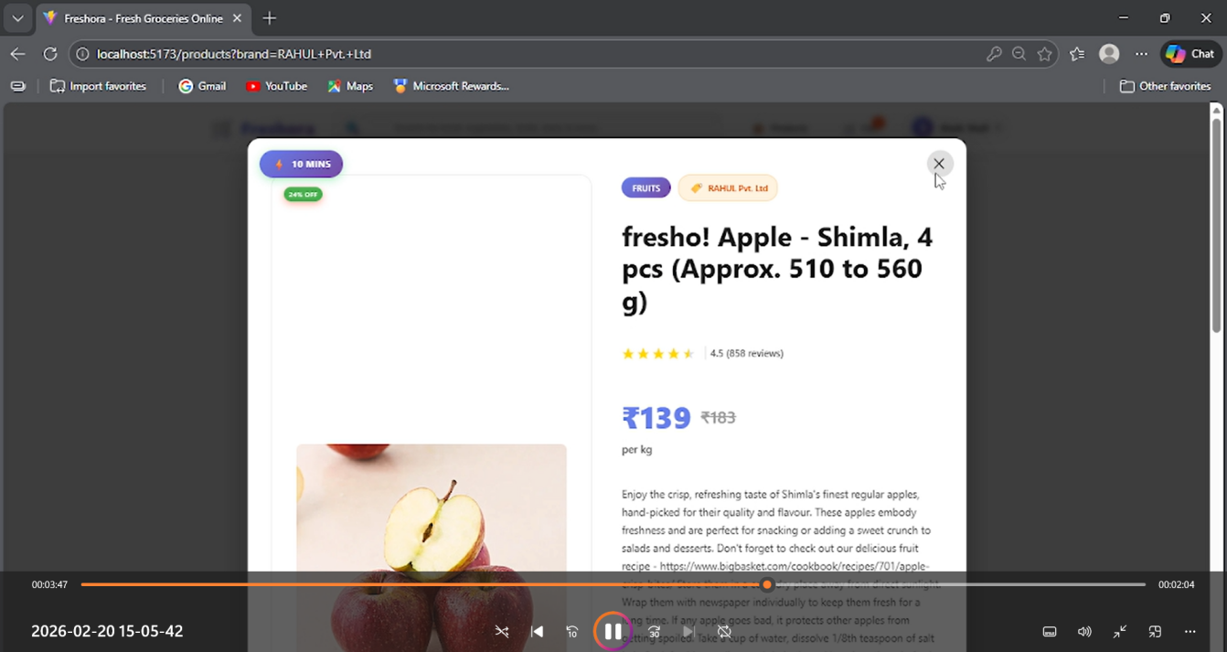

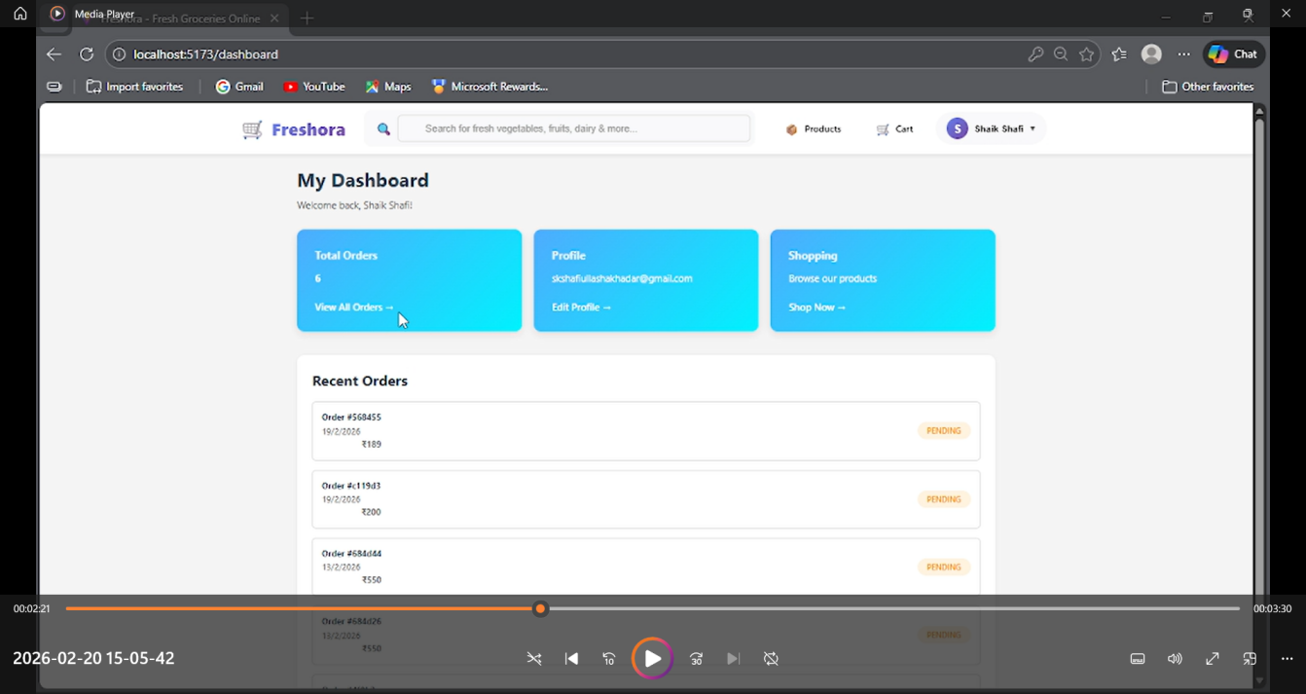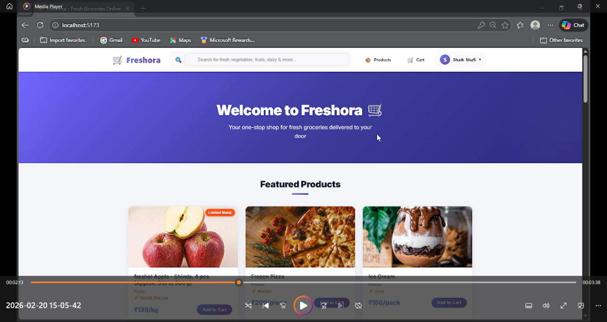

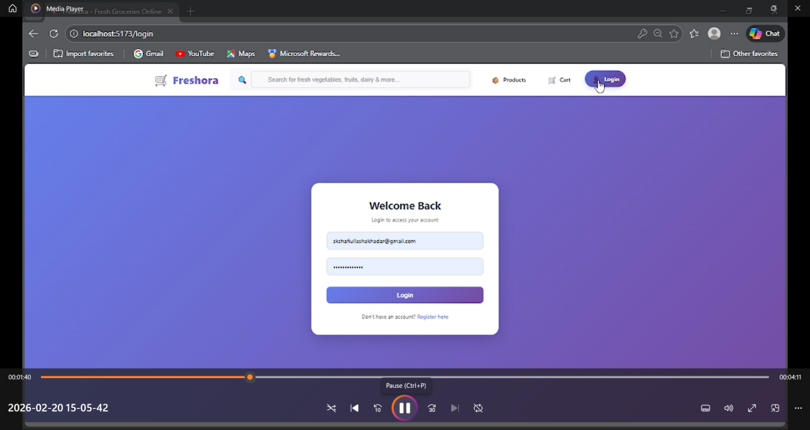

Minor UI responsiveness issues. Payment gateway not fully integrated.

- Online Payment Integration
- Email Notifications
- Product Reviews and Ratings
- Mobile Application Version
- Performance Optimization

