AeroPulse-NG — Executive Project Summary
NDAIE 2026 | Flight Planning & Air Traffic Management

Entry Information
Field | Value
Primary category | Flight Planning & Air Traffic Management
Competition | NDAIE 2026 National Innovation Pitch Challenge
Word count | 285 words of the 300-word limit
Development stage | Working prototype; field hardware integration pending

Problem
Nigeria's airspace is monitored largely through expensive imported primary and secondary surveillance radar — installations costing millions of dollars, demanding specialist maintenance, yet still leaving low-altitude corridors, secondary aerodromes and terrain-shadowed sectors under-covered. When connectivity or a radar head fails, controllers lose the traffic picture precisely when harmattan haze, diversion surges or military activity raise risk. Non-cooperative and transponder-silent aircraft widen the gap further.

Proposed solution
AeroPulse-NG is an air-gapped surveillance engine that turns commodity software-defined radios (about USD 150 of hardware) plus a standard PC into a working tactical radar display. It ingests over-the-air aviation telemetry with zero internet or cloud dependency, giving civil air traffic management (NAMA) and tactical command (NAF) a sovereign, locally maintainable traffic picture at a fraction of conventional cost.

Technical approach
A Rust/Tauri backend demodulates 1090 MHz Mode S ADS-B, resolving positions through Compact Position Reporting; a six-state Kalman filter (constant-velocity, linear; module ekf.rs historic) smooths jitter and dead-reckons tracks through 30-second RF dropouts. An R*-tree spatial index drives continuous Short-Term Conflict Alerting against ICAO Doc 4444 separation minima (rendered 9.26 km / 305 m) within a 120-second lookahead. A triple-fusion weather matrix merges AWOS serial telemetry, ACARS D-ATIS broadcasts and Mode S BDS 4,4/4,5 downlinks into an offline 3D wind/temperature model tuned for harmattan operations. Defence overlays flag dark targets, squawk emergencies and geofence incursions, and compute intercept geometry. A hardware-accelerated display layer renders HF-STD-010A-compliant screens across dual operator monitors, in SI metric units per NCAA / ICAO Annex 5 policy.

Likely impact
Operational: conflict alerting and fused weather at aerodromes that cannot justify radar. Economic: over 99% capital reduction per station. Sovereignty: fully offline national capability. Educational: an engineering reference for Nigerian avionics talent. Development stage: prototype core verified by automated checks; dual-display operator interface complete; RF front-end and field-trial hardware integration next.

Verification Snapshot
Area | Result | Evidence
Rust engine | 108 tests passed | Decoder, CPR, Kalman filter, R*-tree, STCA and engine integration
Python sidecar | 21 tests passed | AWOS codec, METAR parser and DuckDB durability
Frontend | TypeScript clean | Strict typecheck and Vite multi-page build
Desktop shell | Build verified | Tauri v2 host linked on Linux with webkit development files

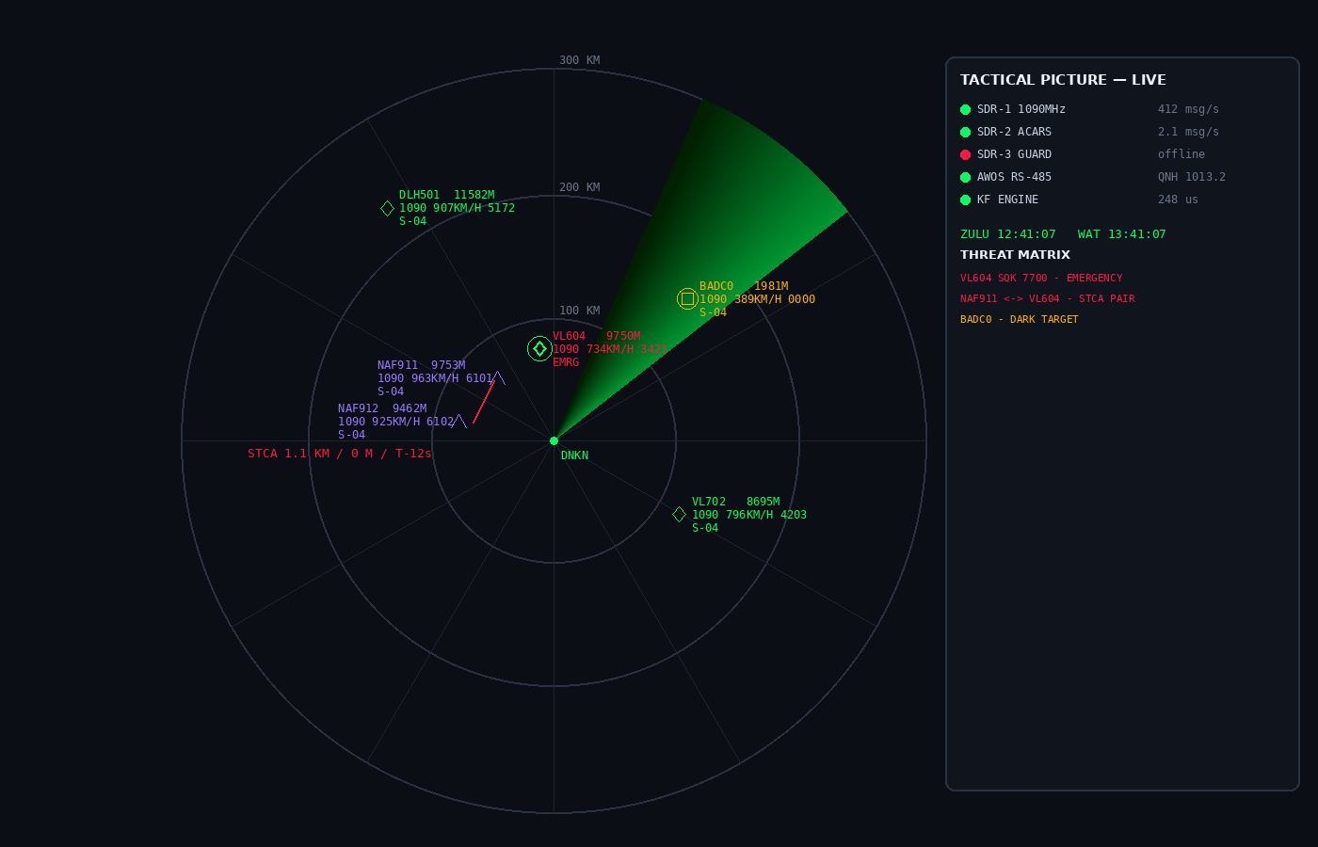

Integrity Declaration
The project includes significant declared generative-AI assistance. External sources and dependencies must be credited in the final submission. The team remains responsible for validating all performance, safety, cost and regulatory claims before presenting or operating the system.

