AeroPulse-NG — System Architecture
Design, data flow and implementation boundaries

1. System Overview
AeroPulse-NG is an air-gapped surveillance workstation. Software-defined radio channels feed a Rust fusion engine; a Python sidecar records data and reads optional AWOS serial observations; two operator displays receive a 60 Hz telemetry snapshot. The design separates deterministic signal and safety calculations from asynchronous desktop I/O.
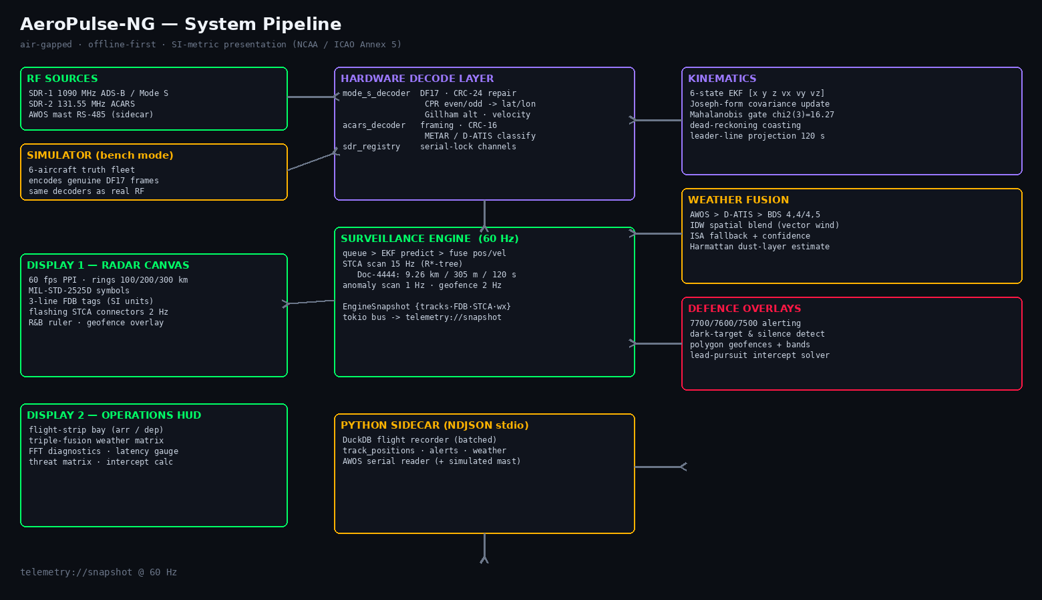

2. Pipeline
Stage | Input | Output
Ingestion | 1090 MHz, 131.55 MHz, VHF and simulator | Raw frame and weather events
Decode | Mode S / ACARS bytes | Identity, position, velocity and reports
Filter | Geodetic observations | ENU state and covariance
Assess | Predicted tracks | STCA, anomaly and geofence events
Publish | Engine state | EngineSnapshot on telemetry bus
Present | Snapshot | Radar canvas and operations panels

3. Core Design Decisions
- The simulator creates genuine DF17 frames and sends them through the same decoder used by the future RF path.
- The engine queues observations, predicts once per tick, then fuses measurements against the current epoch.
- The Kalman filter (CV) uses metres and metres per second internally; operator displays convert to SI presentation units in one utility module.
- Safety thresholds remain ICAO constants internally: 5 NM horizontal and 1,000 ft vertical, displayed as 9.26 km and 305 m.
- Optional persistence and simulated weather degrade independently and must not stop the surveillance engine.

4. Runtime and IPC
The Tauri runtime owns the 60 Hz clock, feeds simulator or hardware events into the engine, emits telemetry://snapshot to both windows and sends batched track records to the sidecar. Tauri commands provide snapshot pulls, weather queries, geofence administration, emergency override and intercept calculation. The sidecar uses one JSON object per line over standard input and output.

5. Limitations and Roadmap
- The real RTL-SDR I/Q and DSP front-end remains the next hardware integration task.
- The diagnostics spectrum is a visual prototype until live FFT bins are connected.
- BDS register codecs are implemented; live Comm-B interrogation scheduling remains pending.
- Operational deployment requires formal safety assessment, frequency coordination, licensing and authority approval.

