Andrew Garcia

ACS560 – Homework 5

1. List the major modules of the application and the connections between them.

The major modules are the Android application, the Node.JS backend, and the MongoDB server. The Android application displays the UI and communicates with Node.JS to send and receive information from the server.

1. Class Diagram – UserAccount, UserDBAdapter, UserData, and DataDBAdapter are on the backend. The rest of the classes are on the front end.

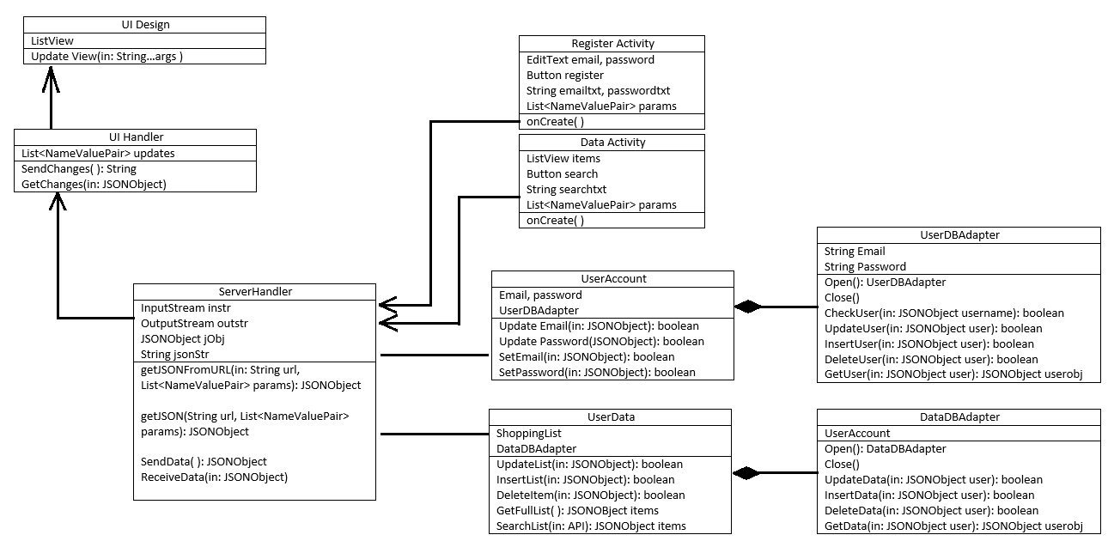

1. Sequence Diagram 1 – The registration process

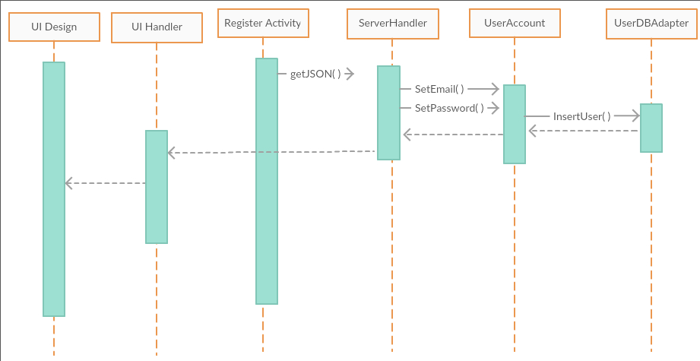

Sequence Diagram 2 – The product search process

