Garcia, Mykle Efren

2ECE-B

Experiment 9:Data Wrangling

Proofs:

Problem 1

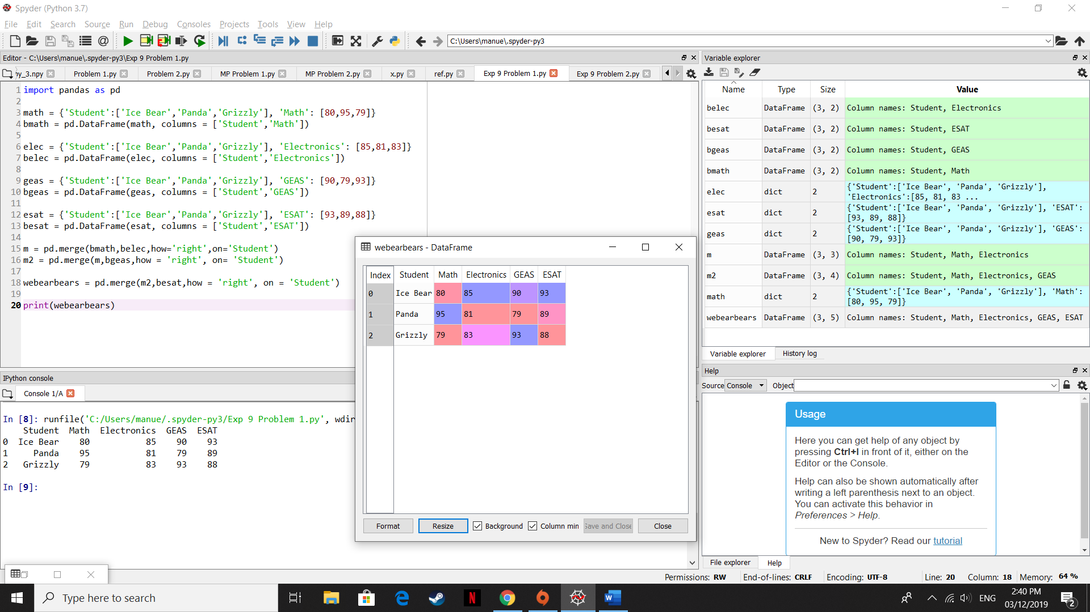

Problem 2

