

**Asia Pacific College**

**The Escape Escapade**

Mobile Programming

MI - 141

**Members**

Patricia Jean Garcia

Maica Belchez

**Professor**

Engr. Noel Quizon Anonas

**Table of Contents**

Overview I ………………………………………………………………page 1

* Description
* Target Audience and Market
* Project Objectives
* Scope and Limitation

Overview II ……………………………………………………………page 2

* Review of Related Literature
* Story Board/ Case Study Background
* Problem
* Solution

Game………………...............................................page 3

* Game Mechanics
* Game Instruction
* Game Map

Game II…………………………………………………………………page 4

* Scoring
* Reward System
* Posting to Social Media

Technical Requirements……………………………………….page5

* Technologies used for App
* Screenshot each page
* Use case of the application
* Flowchart
* Java code snippets

Graphics Asses and Artwork Samples………………….page 6

* Graphic sample

Glossary of Terms………………………………………………….page 7

Lessons Learned…………………………………………………….page 8

Resume of each Member……………………………………….page 9

**Description**

The application is about strategic game on how long will the bird stay alive. We are supporting to spread awareness and protect any bird that is found in the Philippines. Nowadays the population of the birds in the Philippines decrease, they are often use as domestic pet in the home. Eventually they die because some owner doesn’t know how to take good care of a bird. They haven’t realize or value the life of an animal.

The purpose of the application the bird’s mindset, to see how hard is it to avoid tranquilizer guns or guns. Their goal is to avoid anything that could damage or kill a bird.

**Target Audience and Market**

The Target Audience are age 13 years old and above. Since this age group is suitable application game. Once they play the game they player would keep in mind how to survive incoming challenges ahead.

The Market will be place in the mobile ads. Because google offers mobile advertisement which benefits for the marketing, while they are searching on their mobile devices it would display google advertisements.

**Project Objective**

The objective of the project is to test how long they would survive by not getting hit by the tranquilizer shots or bullets. It’s also our objective and to figure out to place the back ground properly and also character.

Our main objective is how to run the animation properly without having any error in our program and sync file. We want to depend our animation base on one character for the moment. If we able to program and run our program without having any error we could probably add more character.

**Scope and Limitation**

The game will have a scoring depending how far they could go, dodge

any incoming tranquilizers or bullets towards the bird.

Our limitation is the game would be applicable for android user only. We will be using one character.

**Review of related literature**

|  |  |
| --- | --- |
| Introduction | We relate our program in the following 2 application that inspire us.   * Jetpack Joyride * Flappy Bird |
| Features | Jetpack Joyride   * The animation of the loop background   Flappy bird   * The tapping motion |

**Story Board/ Case Study Background**

We still stick in the story a bird is trap, It was looking it’s way to escape. When it finally escape the bird is being chase by the humans. Since they couldn’t catch it, The humans use the tranquilizer guns or bullets to shoot the bird.

**Problem**

Our first target back then was 1st person perspective but then since none of the ABMA students or GD would help us or volunteer for the program. We couldn’t find any sprite sheet of a cacatua bird, therefore we decide to use any bird spreadsheet available that we could find. It has to be seen in the Philippines.

**Solution**

We decided to use sprite sheet and 3rd person perspective for the program. We could like any available source we could find to begin our program.

**Game Mechanics**

To reach the high score, you should taught of a strategic method on how long would u survive, this is a survival game and thing you should avoid is bullets and tranquilizer shots. The objective is fly far as you can and this is an endless game. It will be game over if you die. Then your score will appear. We are also planning if we also gonna put the time on how long you’ve been playing.

**Game Instruction**

To play this time by depending on how the way you tap your thumb against the mobile screen using it’s sensor. It controls the character the more you tap the character will fly higher and if you tap less the character will fly down.

**Game Instruction**

For every level the background changes if the bird character reaches 1000 meters for surviving the longer you survive the number of shooter towards the bird will also increase.

**Gaming Map**

This is an example of the gaming level of the program. That Maica and I have done so far

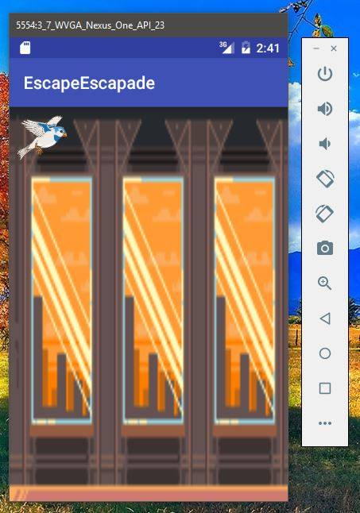

**Scoring**

The scores will be place upper left side of the corner and to see how long you’ve been running and that is also the user’s score how long they survive without being killed.

**Reward System**

We haven’t thought so far because we focus on the control of the animation and how we will run it smoothly. If the progress is better, I believe we would put small over ups for the game or reward them but unlock a different bird character of the game.

**Posting to Social Media**

We plan to share the game they are planning and so submit the scores in their facebook, twitter etc. To advertise it to their own friends so they will be amuse and try the game.

**Technologies used for App Development**

We use Photoshop to edit the color, background and spacing.

Also Ms Painting to identify the location of the image. Android studio to run the java programming and debug it on our own phones to see the progress of the game. Freeonlinelogomaker for the inspired logo design for the

program.

**Screenshots**

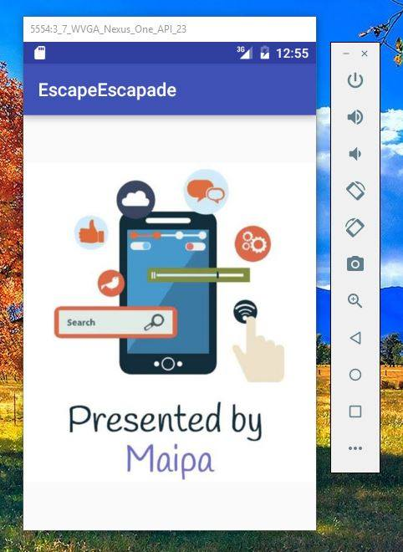

When you open the application the first thing you will see is this photo. Why MaiPa?   
It is shortcut and a combination of Maica and Patricia. We are inspired to pick this design because it applies and relates to our subject mobprog.

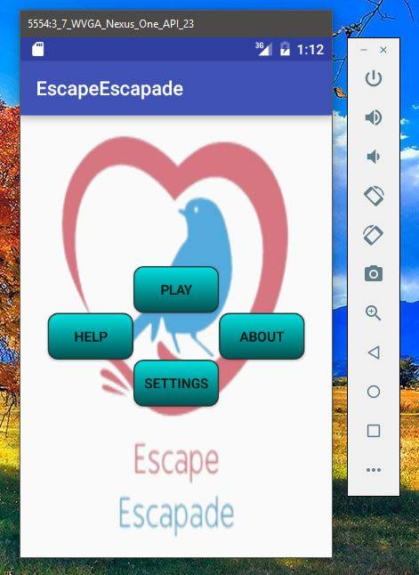

Then after the maipa appears you will see the home page of the game ‘Escape Escapade’. We also planned about the design to choose this design it describe our spreading aware of the program.

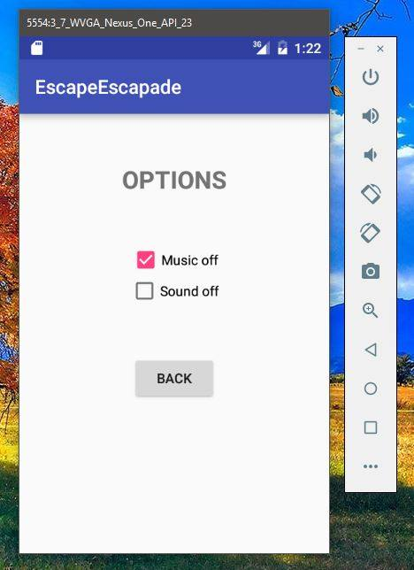

When you click setting button the options will appear and it’s the users choice to pick if he/ she is more focus to play with sounds on or they prefer quiet.

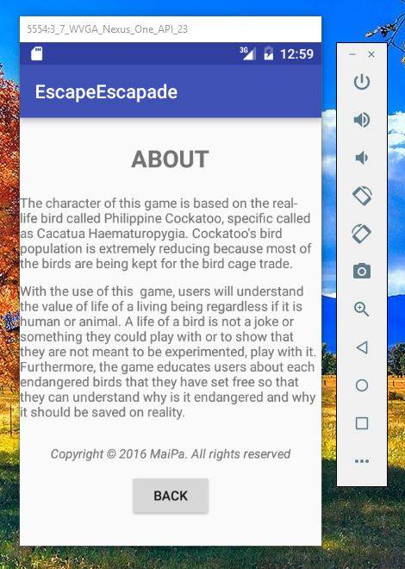

If you click the about it will show about the game ‘ Escape Escapade

/* Forgive we haven’t updated our about

*/



When the user clicks the play a short video will appear and the user is now ready to play

**Graphic Samples**

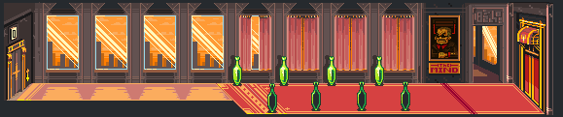

Back ground

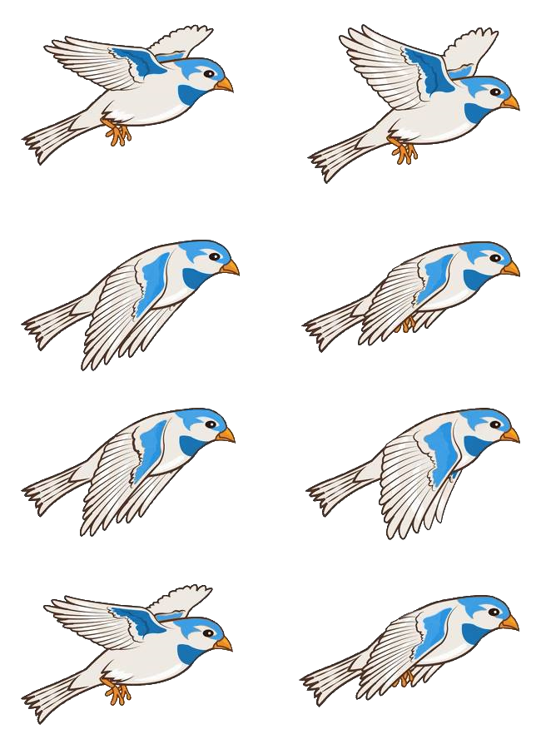

Blue Bird the main character

**Use Case Diagram**

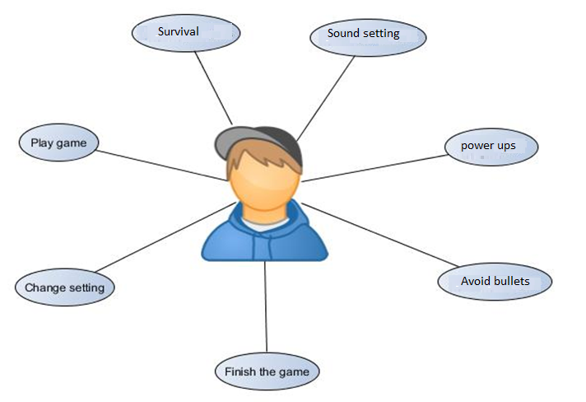

**Patricia Jean D. Garcia**Block 31 Lot 36 Nightingale Bend, Bay Breeze, Taguig City, Metro Manila.  
Garciapatriciajean@yahoo.com  
+639165697502

**Objective/s:**

To expose myself in IT/Computer-related Activities and organization for added experience and to feed my passion for computer programming, developing application, software development and security; and to furthermore enhance communication skills to sharpen people management skills.

**Education:**

College Bachelor of Science in Information Technology  
Major in Mobile and Internet Technology  
Asia Pacific College  
#3 Humabon Place, Magallanes Makati City  
Anticipated date of graduation: 2018

High School 51 Diego Silang Street AFPOVAI Phase 2   
Fort Bonifacio, Taguig City  
2010-2014

Elementary 20 Bayani Road AFPOVAI,Phase 5 Fort Bonifacio,  
Taguig City  
2004-2010

**Organization/s:**

2016 Junior Information Systems Security Association   
 Director of Operations

2016 Junior Philippine Computer Society  
 member

2014 Junior Information Systems Security Association  
member

2014 Microsoft Community  
 member

2014 Junior Philippine Computer Society  
 membe

**Personal Data:**

January 31, 1997

Taguig City

Filipino

Single

**MAICA LUCERO BELCHEZ**123 V. Cruz St., Malibay Pasay City  
aciambelchez@gmail.com  
09153743329

**Objective/s:**

To take a challenging and managerial role in the field of computer programming and experience gained in this field to develop complex projects with efficiency and quality.

**Education:**

College Bachelor of Science in Information Technology  
Major in Mobile and Internet Technology  
Asia Pacific College  
#3 Humabon Place, Magallanes Makati City  
Anticipated date of graduation: 2018

High School Pasay City Science High School  
2888 Vergel St., Pasay City  
2010-2014

Elementary Grace Community Christian School  
754 Vitales St., Malibay Pasay City  
2004-2010

**Organization/s:**

2016 Junior Philippine Computer Society  
 Member

2016 Microsoft Community  
 Documentation Committee

2015 Junior Information Systems Security Association  
Operations Committee

**Research Project:**

A Study on the Effects of Participating Non-Organization to the Academic Performance of Third Year Students of Asia Pacific College, 2015-2016  
Belchez, M.L., Carpio, A.A., & Haboc, F.G.

**Personal Data:**

October 21, 1997

Makati City

Filipino

Single