**CMIS 495 - Current Trends and Projects in Computer Science Project**

**Emergency Medical Reference (EMR) User Guide**

**(Current as of Jul 16, 2017)**

**1. Instructions for using the system** - Depending on the device, this application will present you with a different interface. Let's start with mobile devices:

|  |
| --- |
| **NOTE** - If you have any problems or encounter any errors while using this application, please contact us at rgarcia92@student.umuc.edu |

**1.1 Mobile Devices - All Users**

|  |
| --- |
| **NOTE** - Administrative functions are not accessible on mobile devices |

1.1.1 Visit [<http://sample-env.h3tq4n7wkp.us-east-1.elasticbeanstalk.com/>] through your Internet browser:

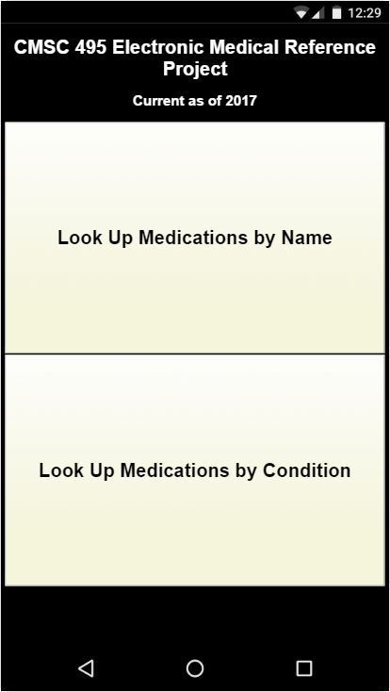

1.1.2 When you reach the landing page, you can select "**Look Up Medications by Name**" or "**Look Up Medications by Condition**". Select "**Look Up Medications by Name**" for now:

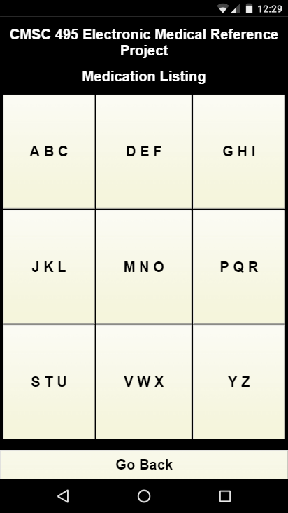

1.1.3 Select the button with the first letter of the medication for which you are searching, in this case "**ABC**" for "**Clopidogrel**":

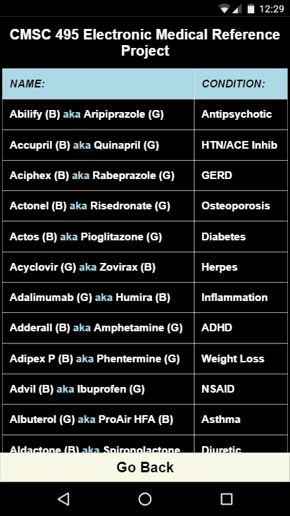

1.1.4 The application presents all the medications in the database that start with the letters A, B, or C, as well as the conditions the medication treats. Using a finger, scroll down until you reach "**Clopidogrel**":



1.1.5 When you reach "**Clopidogrel (G)**", you see that it's brand name is "**Plavix (B)**", it is an **Anti-Platelet** medication, and it is highlighted in red. This means the medication is a blood-thinner which may exacerbate a patient's emergency (e.g., Clopidogrel may prevent a patient's head wound from clotting, etc.) At this point, you have three options:

* You may select "**Clopidogrel (G) aka Plavix (B)"** to see additional information about the medication.
* You may select **Anti-Platelet** to see a list of the medications that treat that condition (similar to the "**Look Up Medications by Condition**" option)
* You may select "**Go Back"** to return to the previous screen.

Select "**Clopidogrel (G) aka Plavix (B)"** to see additional information about the medication:

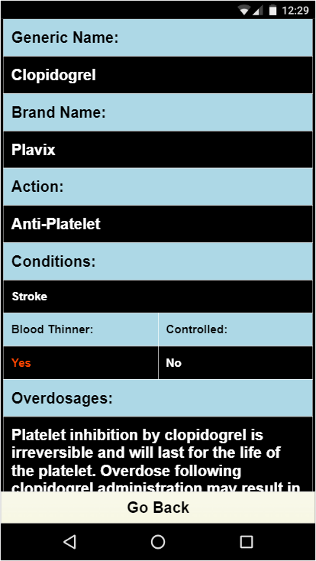

1.1.6 Here you see additional information about Clopidogrel, such as overdosages, interactions, and warnings. In addition, you can select **Stroke** to find out more information about the condition and other medications that can treat it. Once you are done exploring the details page, select **Go Back** until you reach the landing page:



1.1.7 Once you have returned to the landing page, select "**Look Up Medications by Condition**":

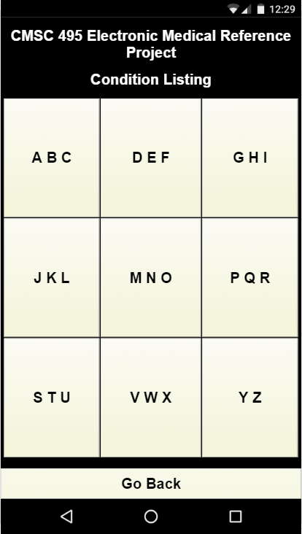

1.1.8 Select the button with the first letter of the condition for which you are searching, in this case "**DEF**" for "**Diabetes**":

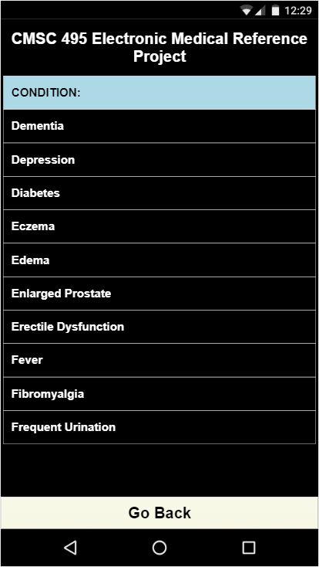

1.1.9 Select "**Clopidogrel (G) aka Plavix (B)"** to see additional information about the medication:

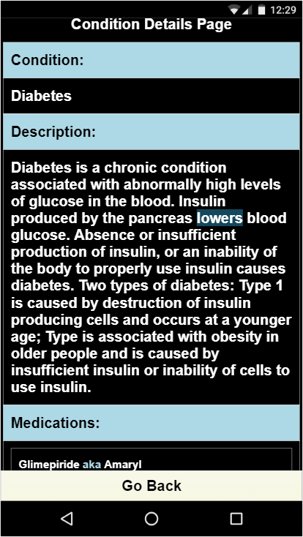

1.1.10 Here you see additional information about Diabetes, such as a description and medications that can treat the condition. In addition, you can select **Glimepiride aka Amaryl** to find out more information about the medication.

1.1.11 You have now reviewed all the mobile functionality of the application. Feel free to continue exploring the application to become familiar with its use.

**1.2 Desktop Browser - Provider**

|  |
| --- |
| **NOTE** - Administrative functions are not accessible on mobile devices |

1.2.1 Visit [<http://sample-env.h3tq4n7wkp.us-east-1.elasticbeanstalk.com/>] through your Internet browser. When you reach the landing page, you will notice three columns - **Generic Name, Brand Name, and Condition:**

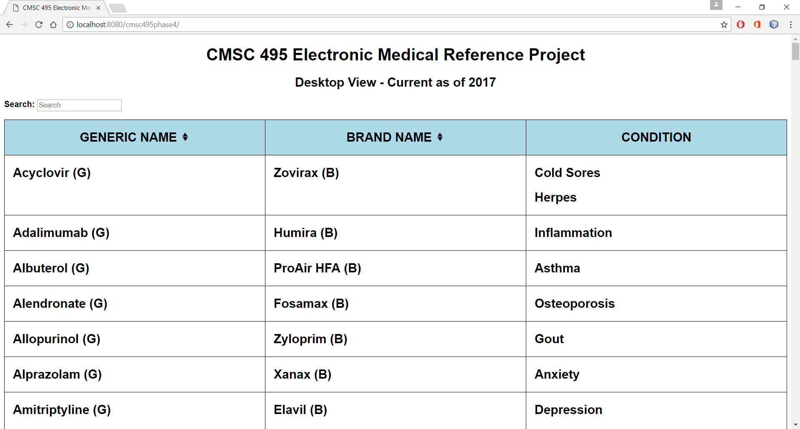

1.2.2 This table is sortable. For example, if you click on BRAND NAME, the table will resort its contents by the medication's brand name in ascending order:

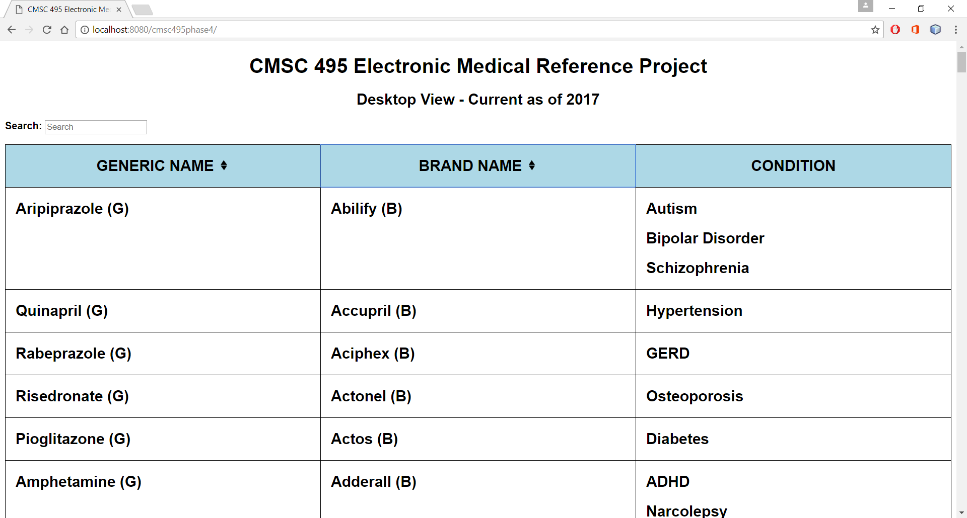

1.2.3 In addition, the table is searchable. For example, if you type in Stroke in the search box, the table will find all instances of stroke:

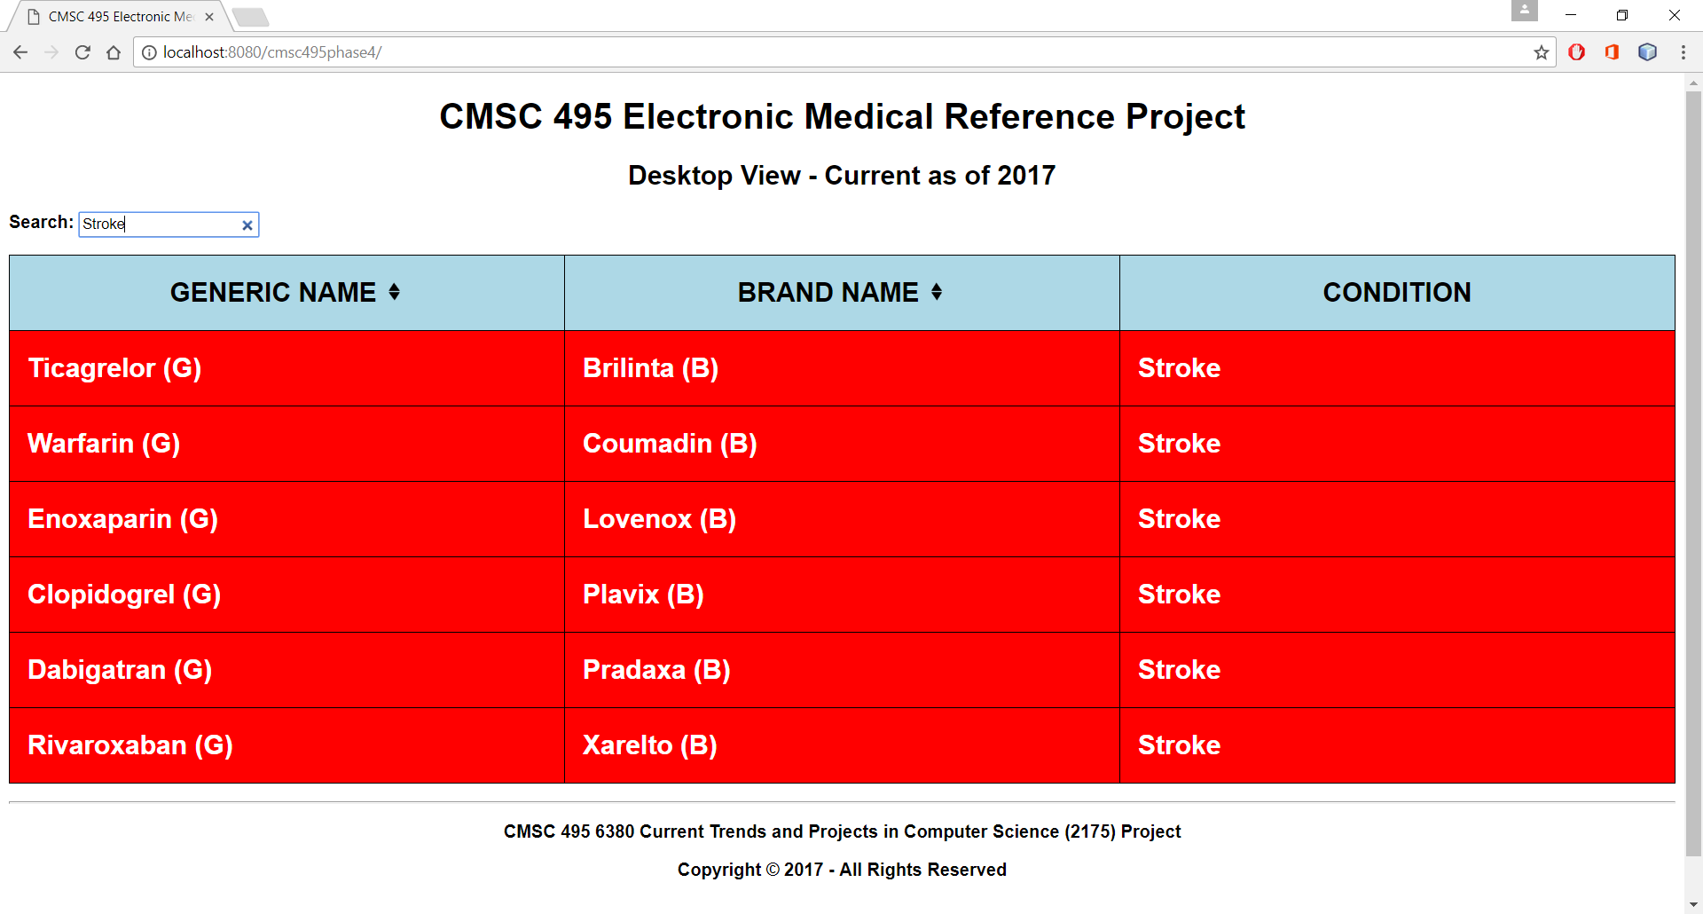

1.2.4 If you click on the medication's name, you can learn more details about the medication, such as overdosages, interactions, and warnings:

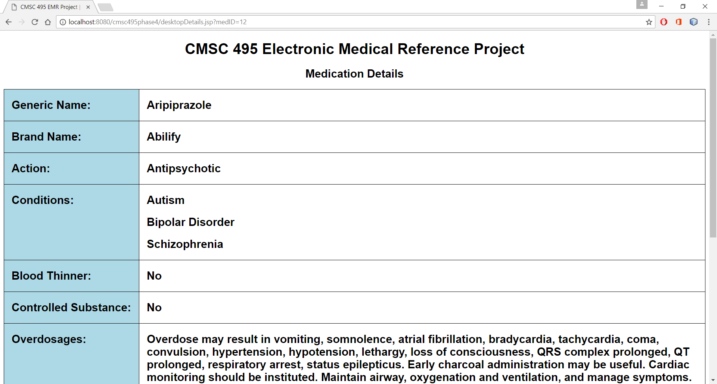

1.2.5 If you select **Autism**, you can find out more information about the condition and other medications that can treat it:

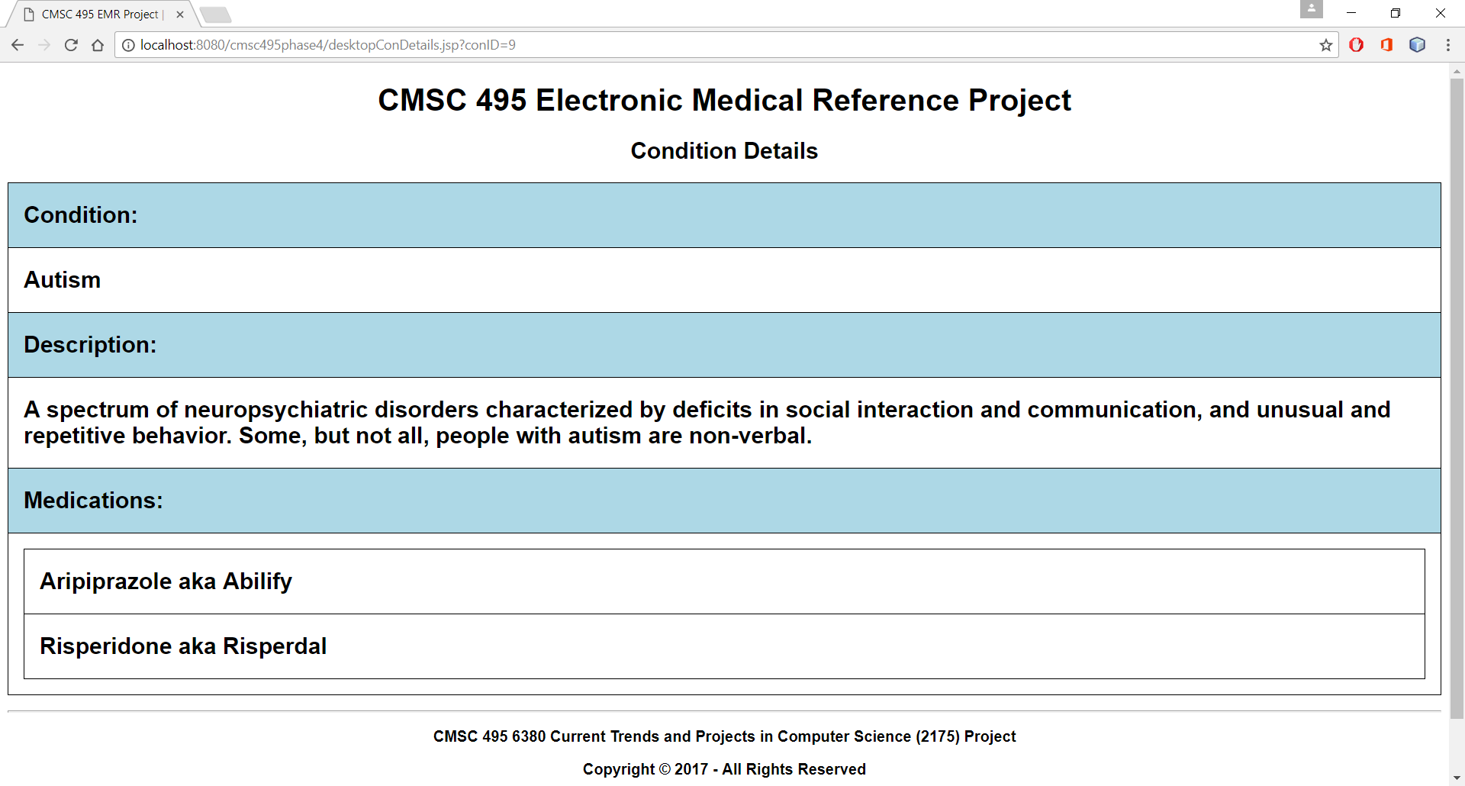

1.2.6 To return to the home page, click on the title, "CMSC 495 Electronic Medical Reference Project".

1.2.7 You have now reviewed all the non-administrative desktop functionality of the application. Feel free to continue exploring the application to become familiar with its use.

**1.3 Desktop Browser - Medication Administration**

1.3.1 Visit [<http://sample-env.h3tq4n7wkp.us-east-1.elasticbeanstalk.com/>] through your Internet browser. Scroll down to the bottom of the page and you will see a skeleton key. This is how you access the login screen to edict medication information:

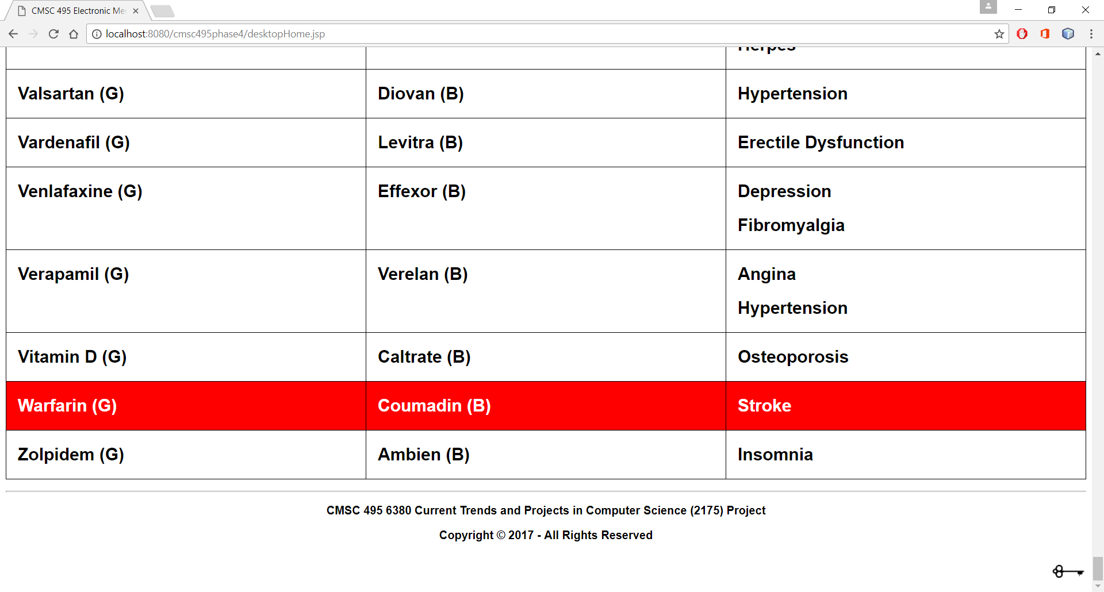

1.3.3 Click on the key to reach the **Login** page:

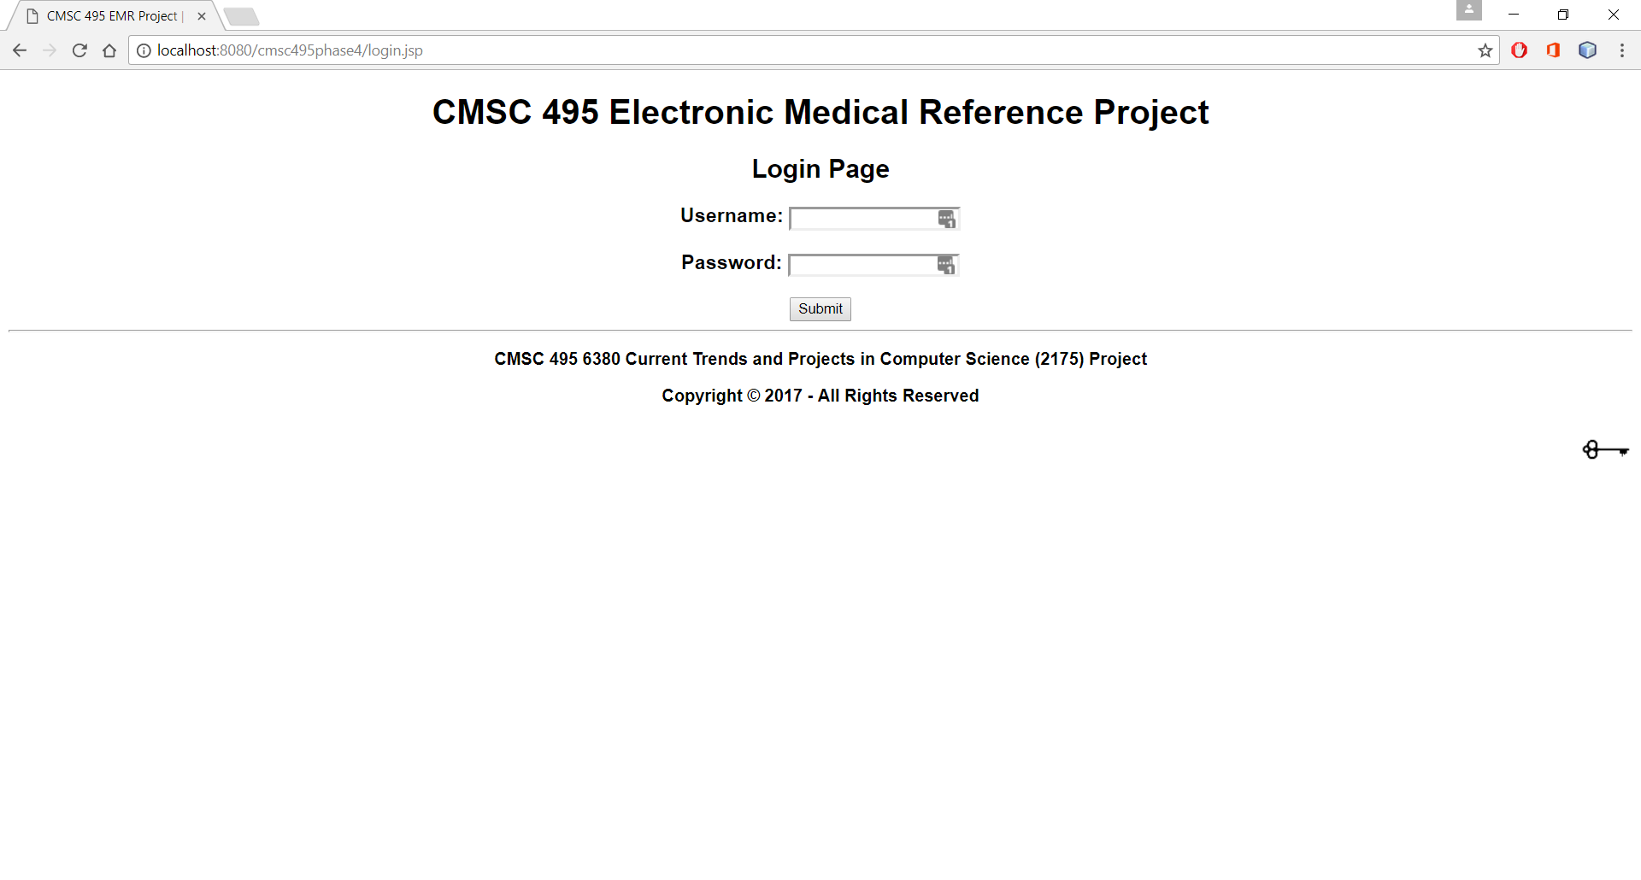

1.3.4 There are three administrative levels: User, Editor, and Administrator. For our purposes, we will describe the Administrator level. Once you have logged in, you will reach the **Admin Menu** page:

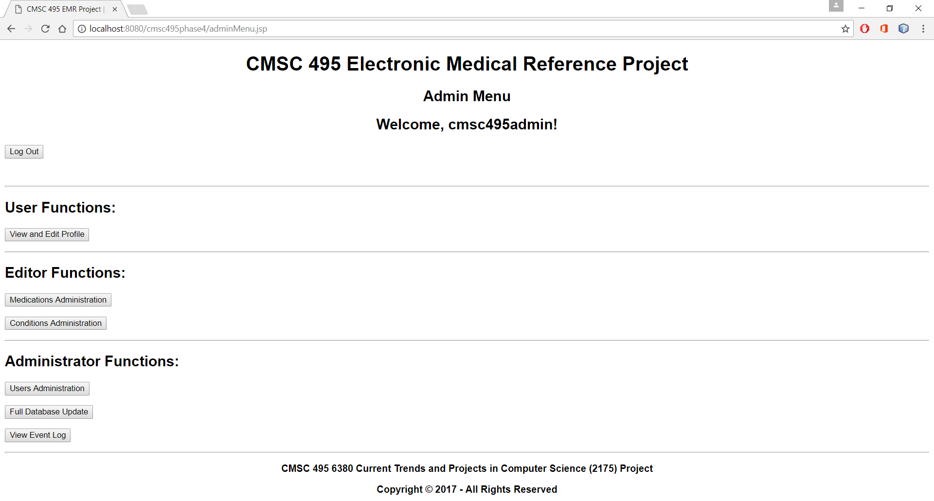

1.3.5 The first level is **User Functions**. Press **View and Edit Profile** to view your last login date/time or to change your password:

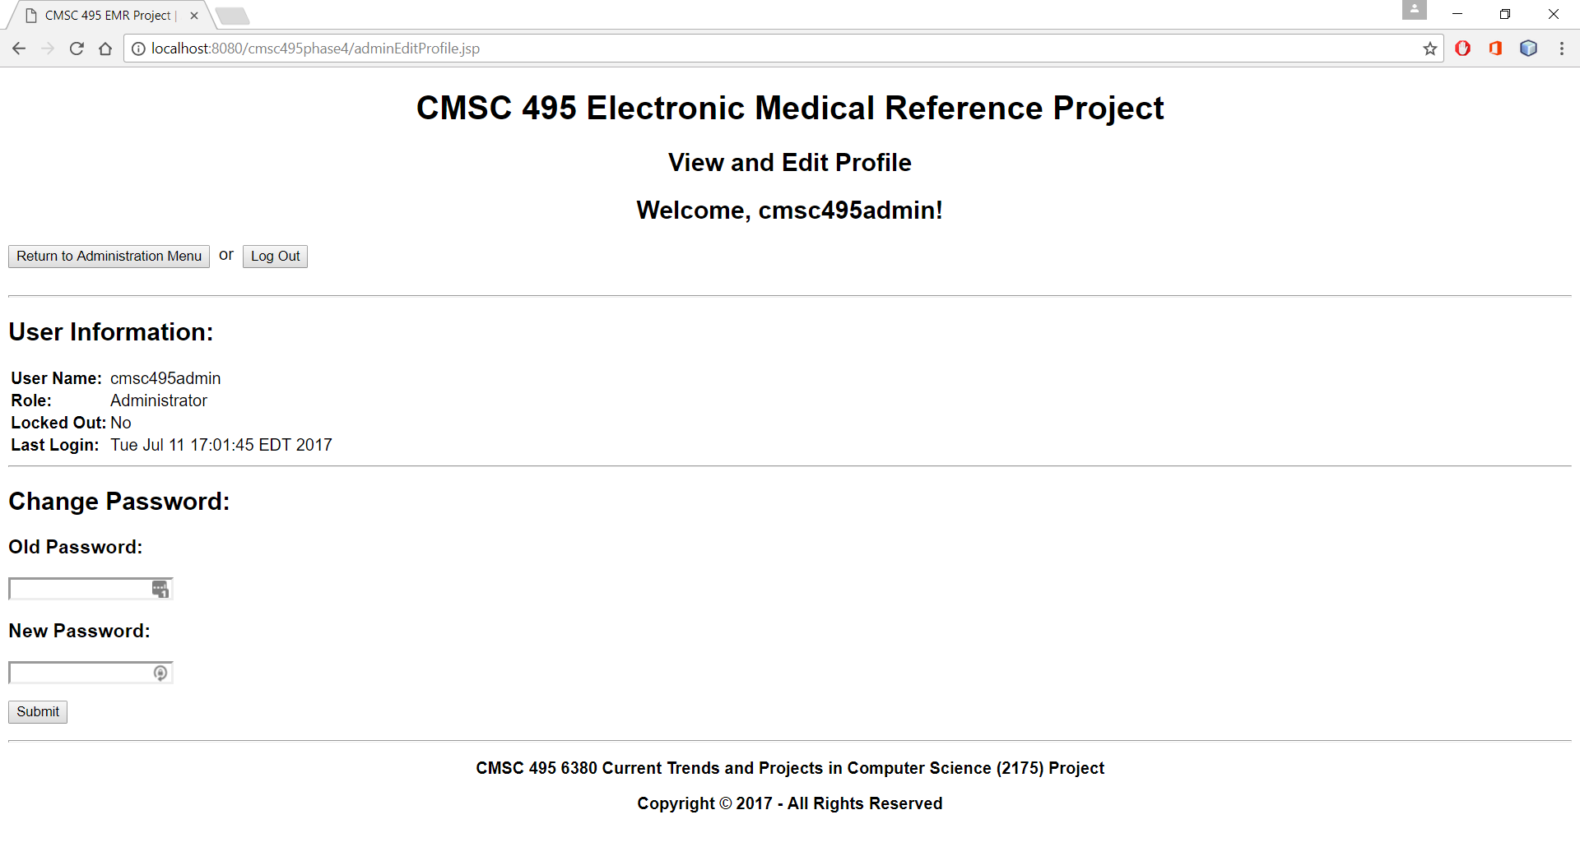

1.3.6 Once you have finished exploring this page, press **Return to Administration Menu**.

1.3.7 The next level is **Editor Functions**. Press **Medications Administration** to add, update, or delete a medication:

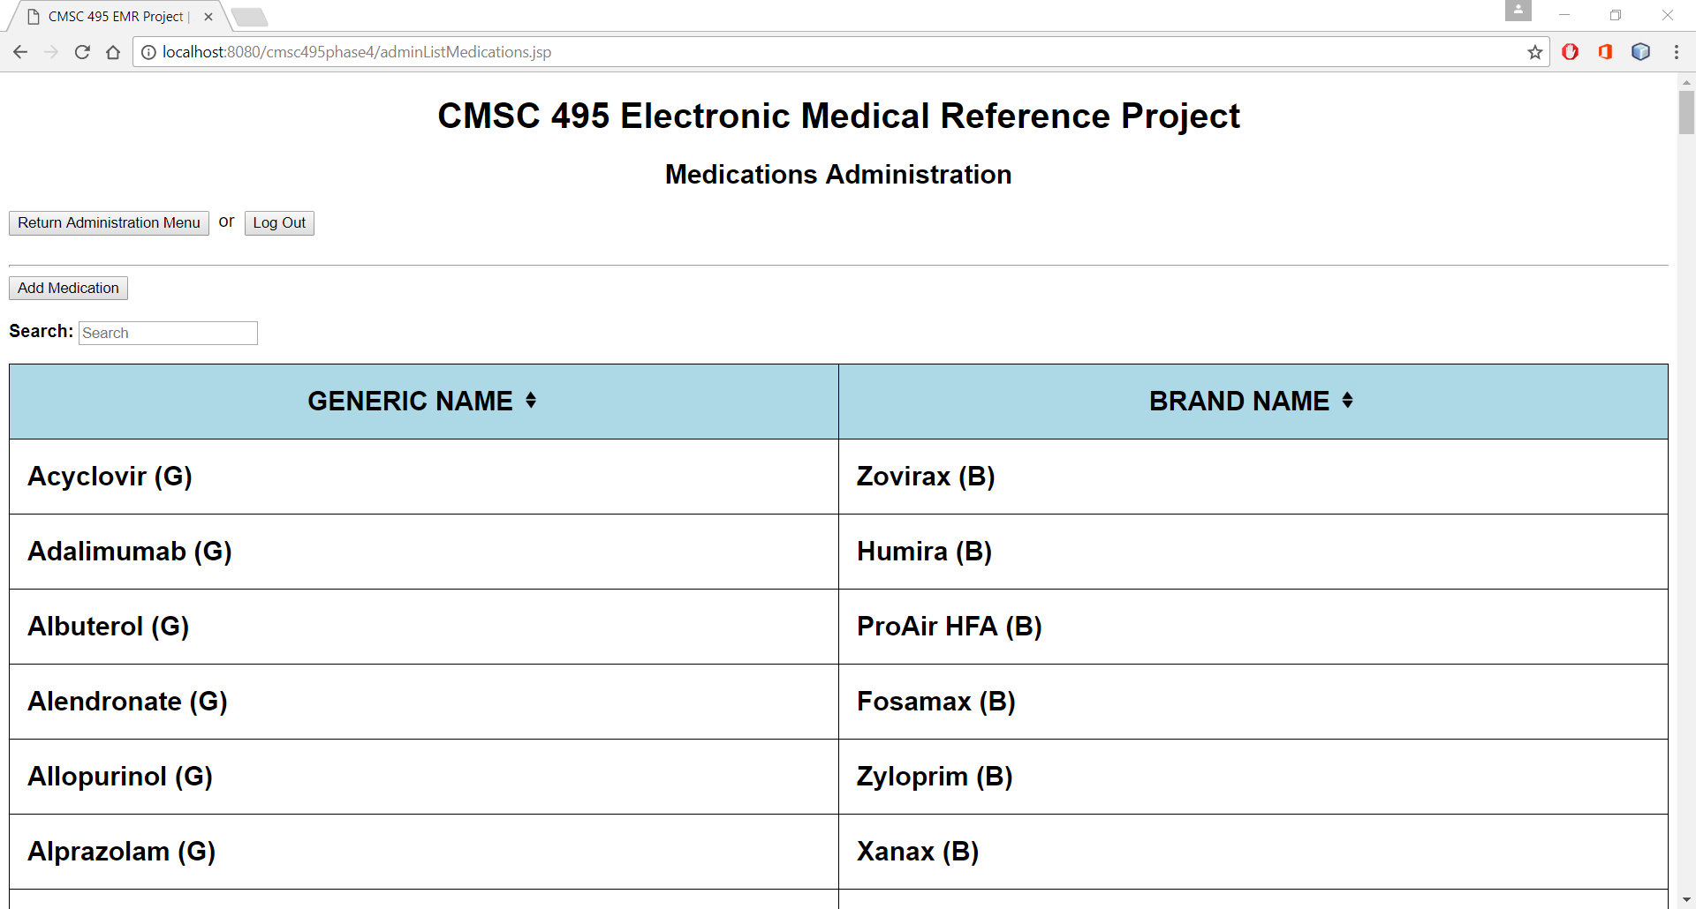

1.3.8 Once again, this table is sortable and searchable. Right now, click on **Add Medication**:

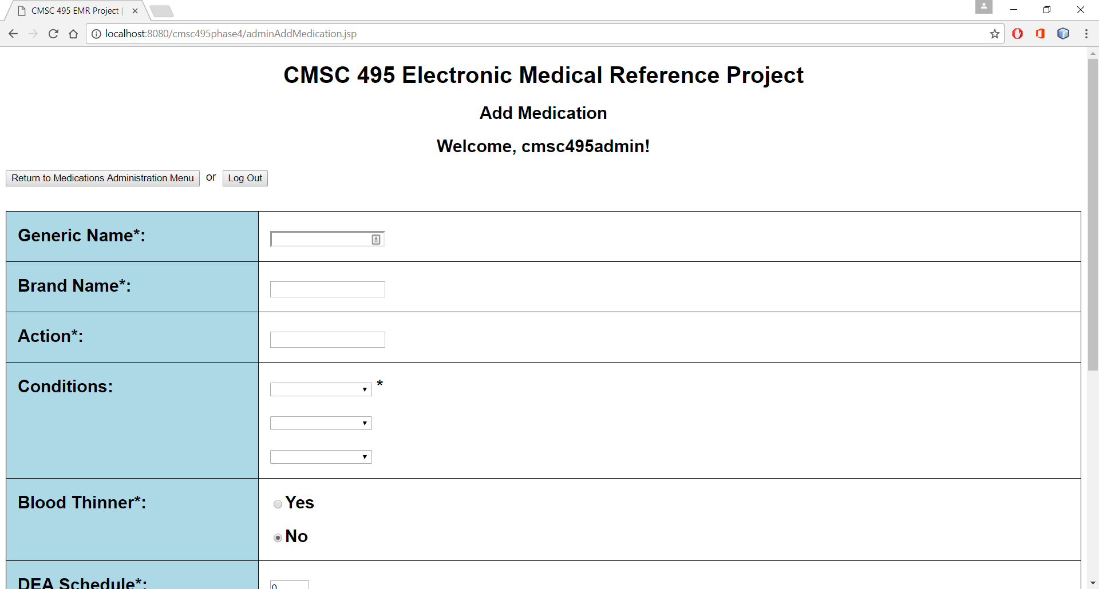

1.3.9 Here you can add medications to the database. For now, press **Return to Medications Administration Menu**, then select **Alprazolam** to edit the medication:

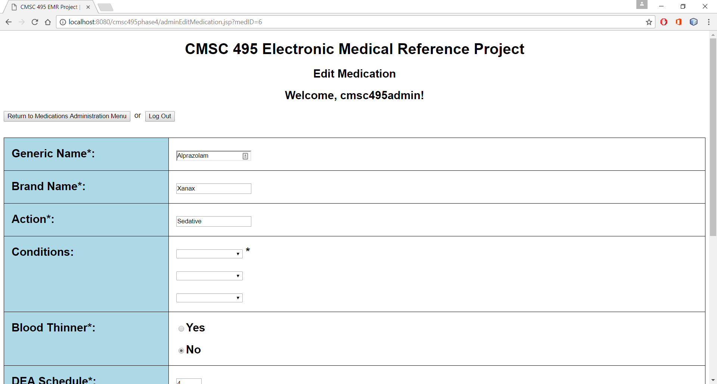

1.3.10 Here you can edit the medication's details, as well as delete the medication from the database:

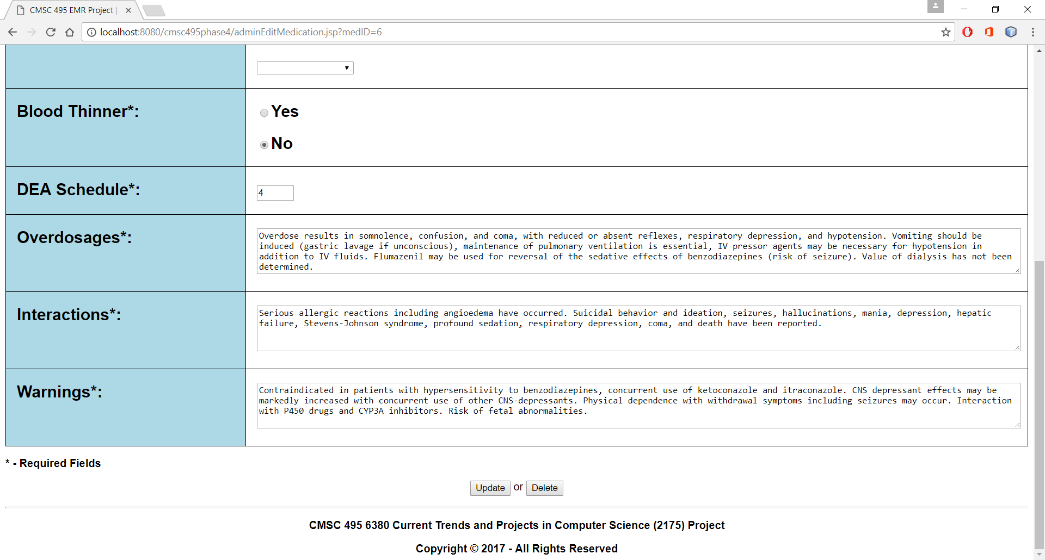

1.3.10 For now, press **Return to Medications Administration Menu**, followed by **Return to Administration Menu**. Press **Conditions Administration** to add, update, or delete a condition:

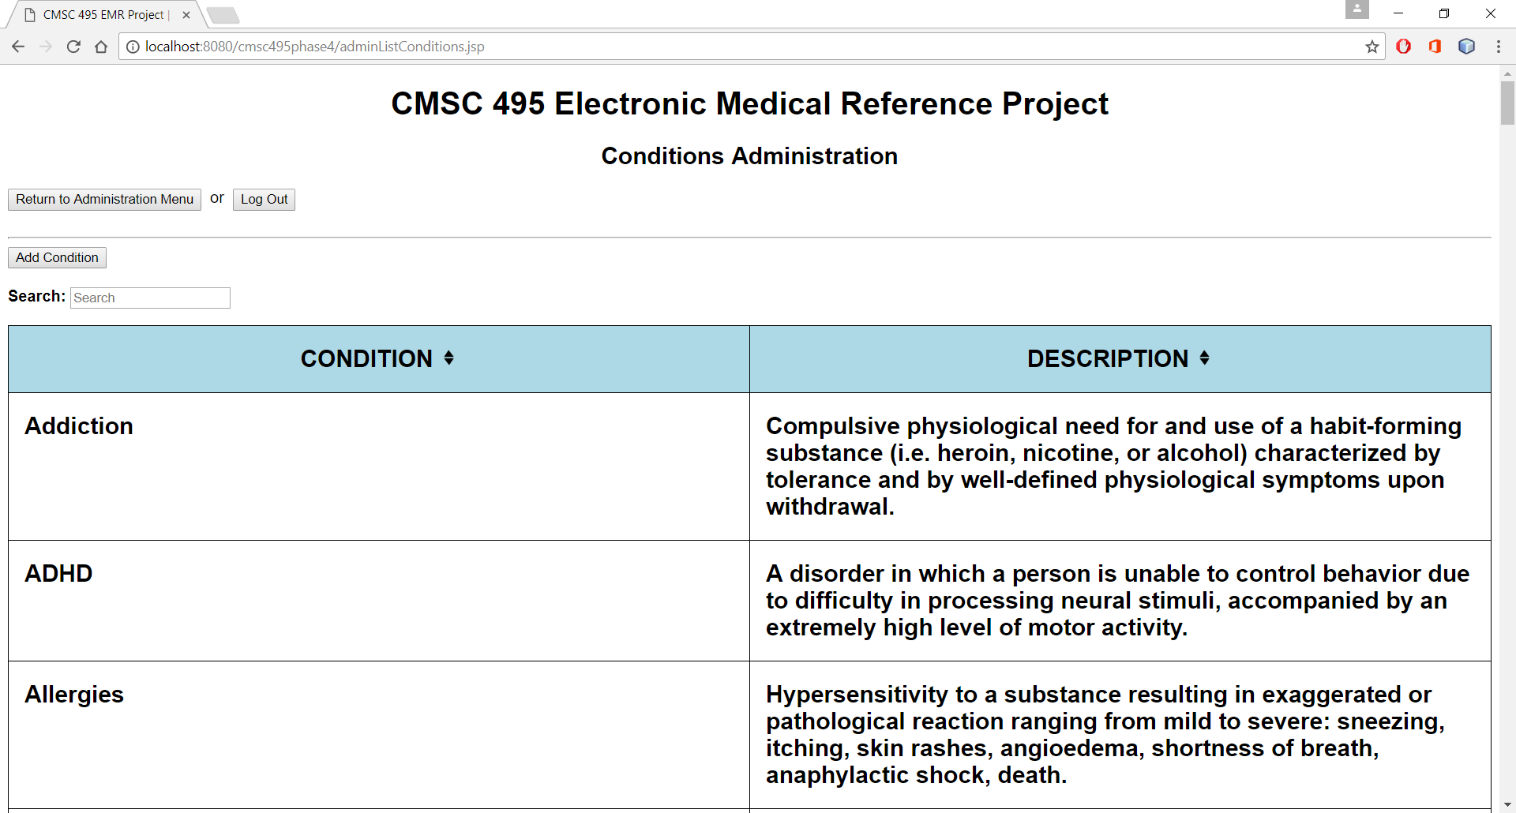

1.3.11 Once again, this table is sortable and searchable. Right now, click on **Add Condition**:

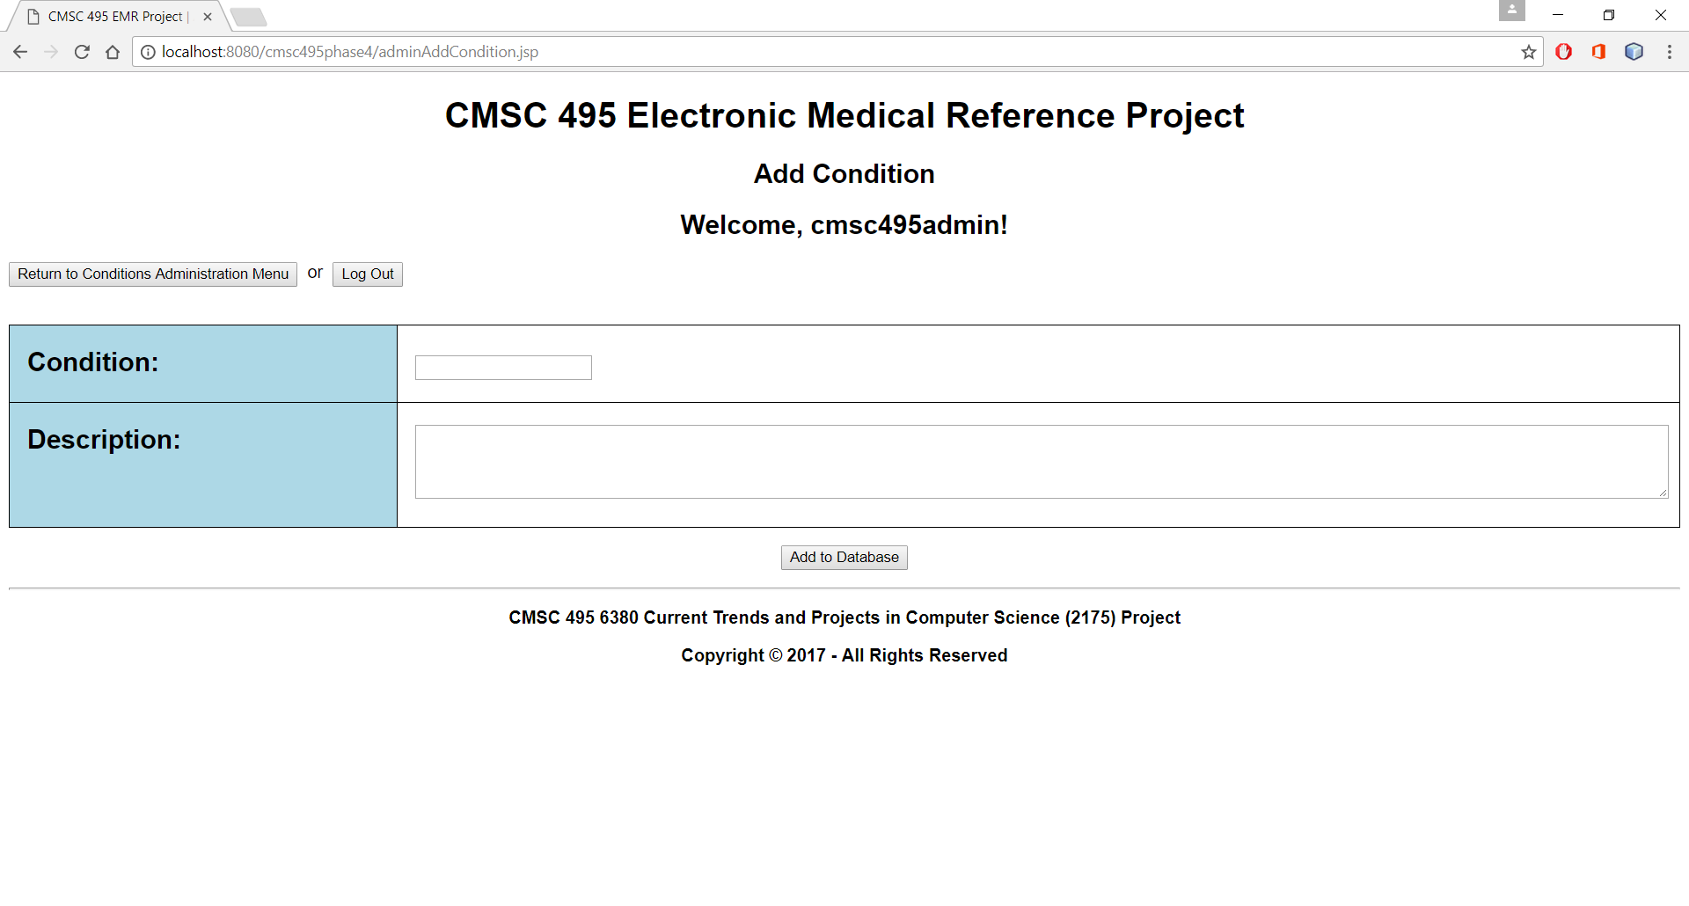

1.3.12 Here you can add conditions to the database. For now, press **Return to Conditions Administration Menu**, then select **ADHD** to edit the medication:

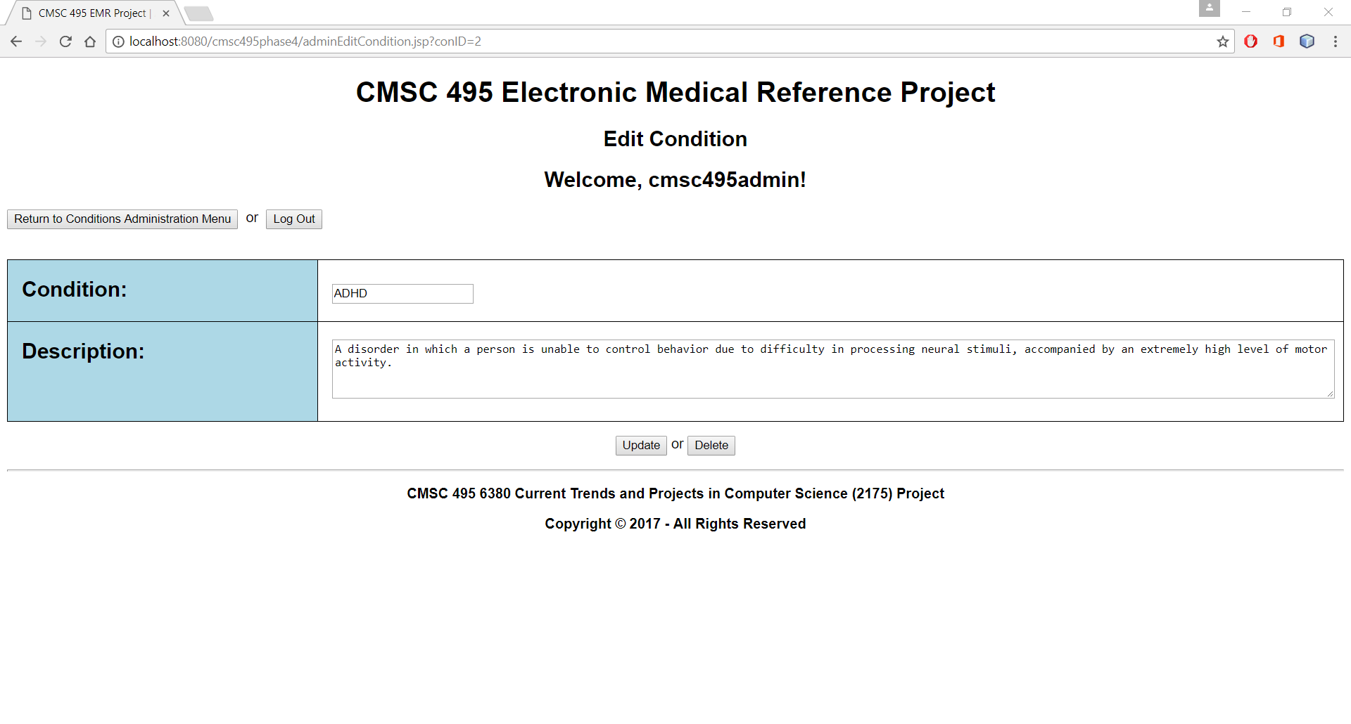

1.3.13 Here you can edit the medication's details, as well as delete the medication from the database. For now, press **Return to Conditions Administration Menu**, followed by **Return to Administration Menu**.

1.3.14 The next level is **Administrator Functions**. Press **Users Administration** to add, update, or delete a user:

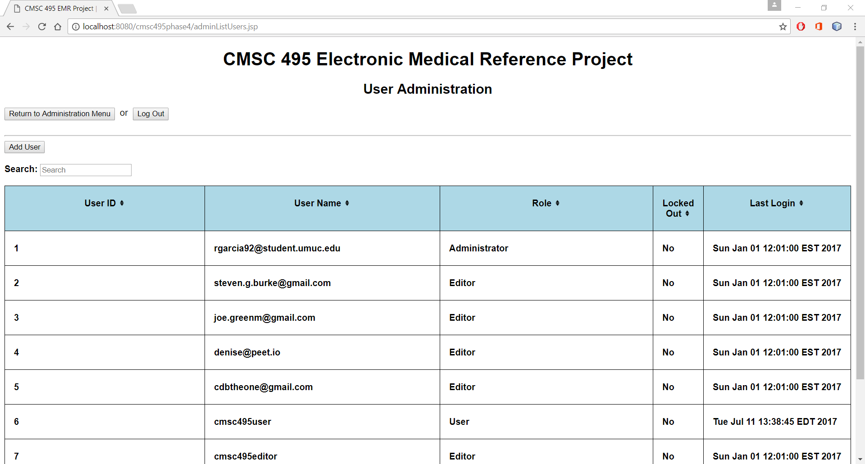

1.3.15 Once again, this table is sortable and searchable. Right now, click on **Add User**:

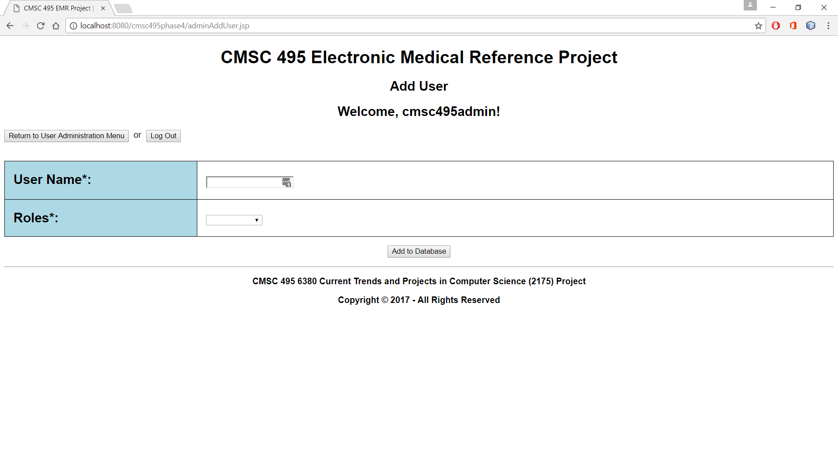

1.3.16 Here you can add users to the database. For now, press **Return to Users Administration Menu**, then select **cmsc495user** to reset the user's password or to delete the user from the database:

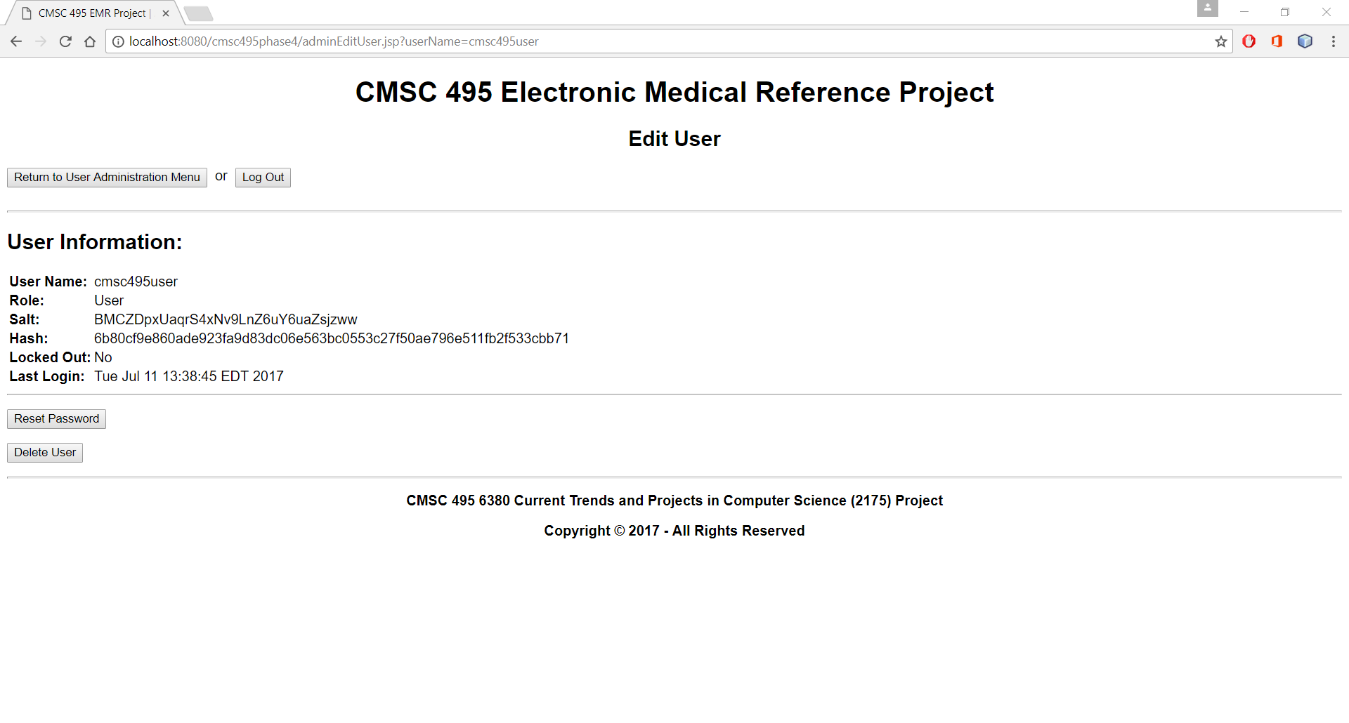

1.3.17 For now, press **Return to Users Administration Menu**, followed by **Return to Administration Menu**. Once there, you will notice a button named Full Database Update. While it is disabled right now for use on AWS' Elastic Beanstalk, database administrators will use this to upload databases that have been updated using SQL instead of the administrative interface:

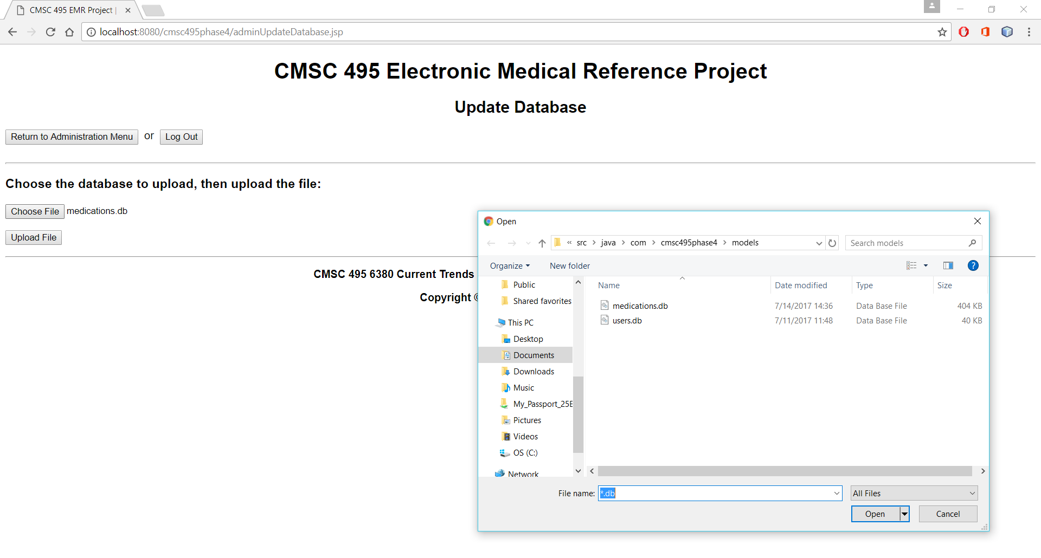

1.3.19 Press View Event Log. Here you will be able to see all user events, such as logging in, as well as any problems (This is disabled for use on AWS' Elastic Beanstalk):

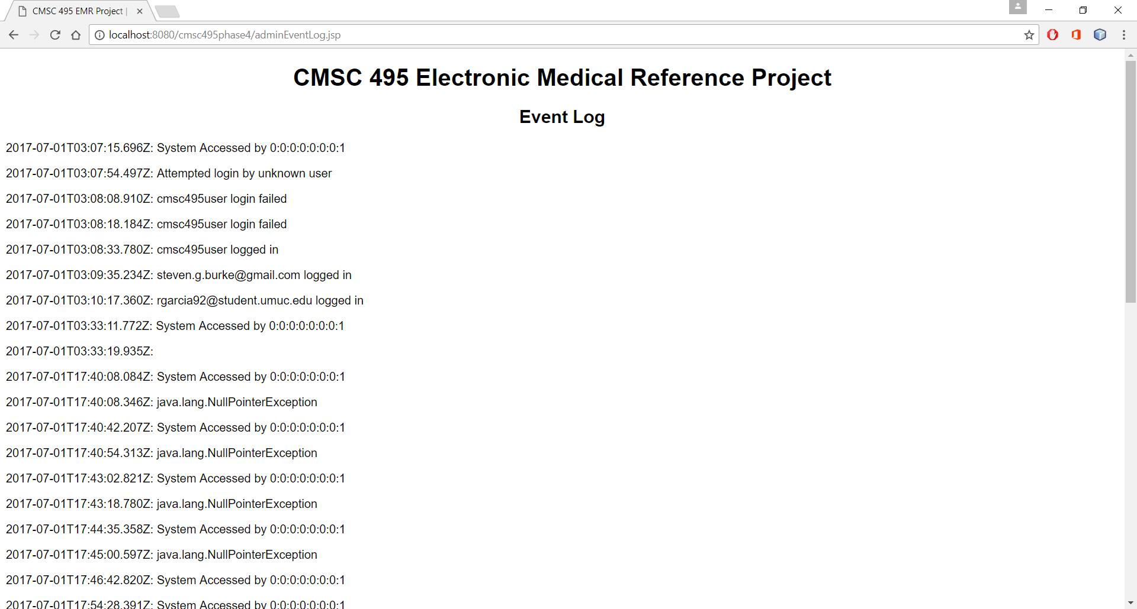

1.3.20 You have now reviewed all the administrative functionality of the application. Feel free to continue exploring the application to become familiar with its use.