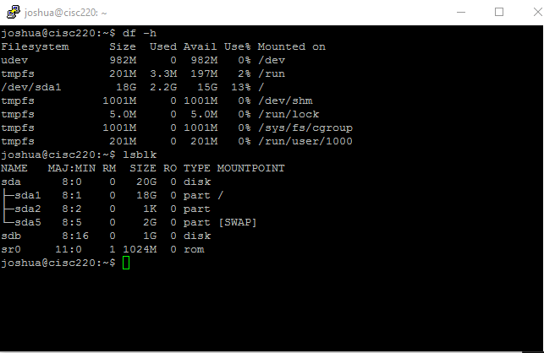

‘lsblk’ shows the new hard disk, and its name sdb

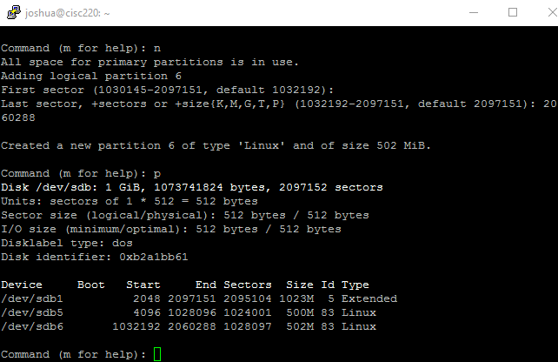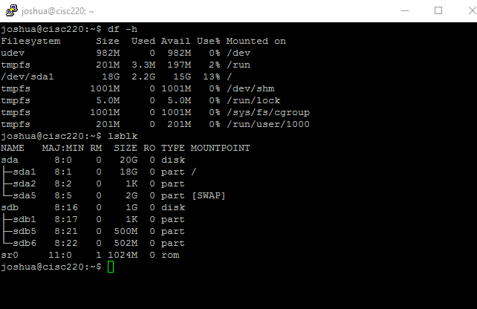

‘lsblk’ shows the new partitions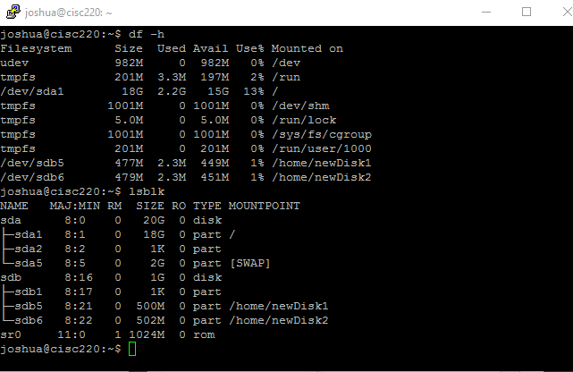

‘df -h’ shows the now-mounted hard disks