

Windows User | [Course Title] | [Date]

[Report Title]

[Report Subtitle]

## List of figures

Figure 3:1 This is a caption 4

Figure 3:2 5

Figure 6:1 Shit is going down ii

Table of Contents

List of figures 2

2 Get started right away 4

2.1 I shall add an heading here 4

2.1.1 I’m Alive 4

2.1.2 That’s better 4

3 Time for a new section 5

3.1 5

3.2 A little something something 5

4 Heres something i

5 Header again ii

# Get started right away

Is there a point to using Word?

There is a quote to be read here and I wish to give it proper justice by looking at reference and formatting that is automatically available. Thank you.

This is BS that’s why I always write in Bacchanalian Language! Do you hear me

## I shall add an heading here

Does this have the potential of looking better than my latex texts?

### I’m Alive

### That’s better

(Rowling, 2005)

Figure 3:1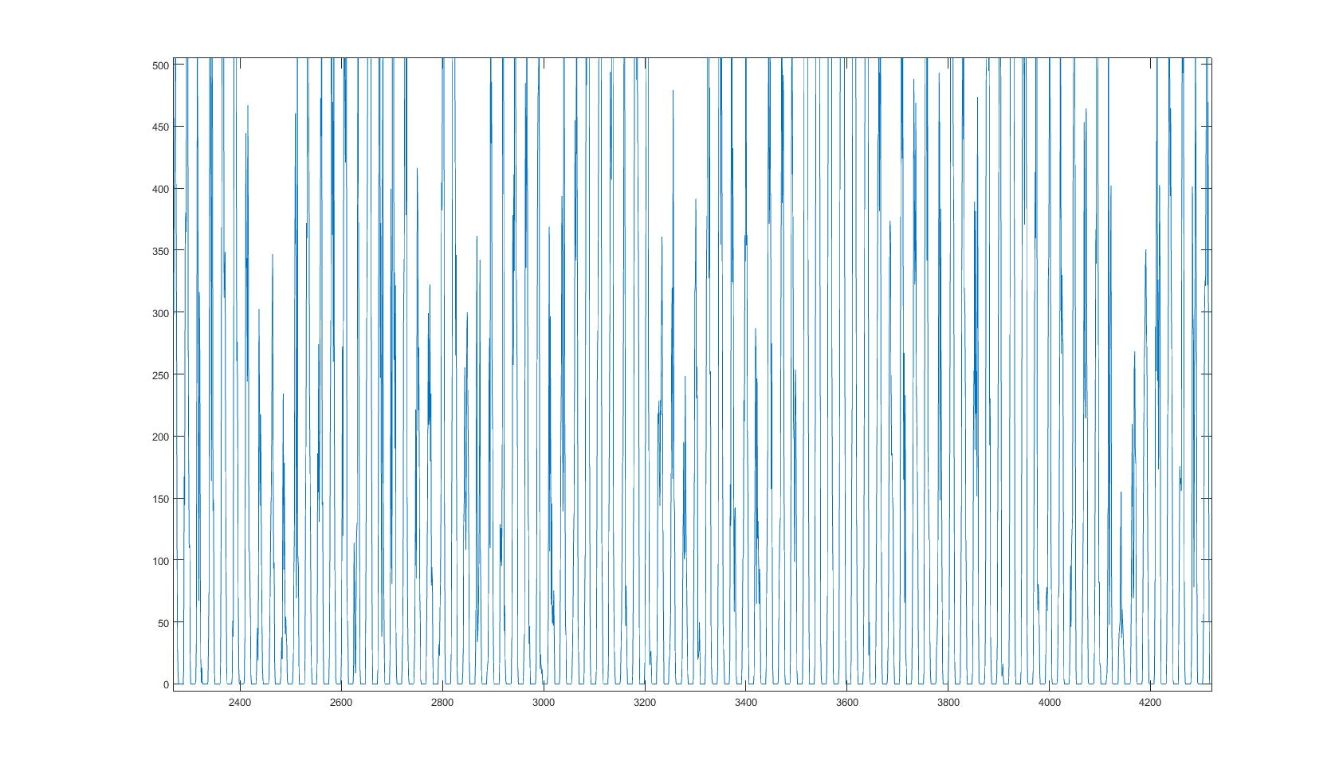

Figure 3:1 This is a caption

, this is a longer explanation.[1]

But does this look better?[2]



Figure 3:2

Heres a figure bro~!

# Time for a new section

Hello, hello Figure 3:1

## 

## A little something

What page is this – reference to a section : section

# Here’s something

(Rowling, 2005)

# Header again

|  |
| --- |
| Figure 6:1 Shit is going down |

# Bibliography

Rowling, J. (2005). *Harry Potter and the Goblet of Fire.* London: Pingvin.

# References

Rowling, J. (2005). *Harry Potter and the Goblet of Fire.* London: Pingvin.

# Works Cited

Rowling, J. (2005). *Harry Potter and the Goblet of Fire.* London: Pingvin.

stress

1. Nice u nice u.
2. sadasdasdasd