  MANAGER TRAINING GUIDE  Setting up staff, access and ward settings  A practical manager route manual for signing in, creating permanent staff records, writing NFC staff tags and configuring ward modules safely.  Manager/admin access  NFC and PIN sign-in  Ward module switches  Session timeout  Staff rota visibility | 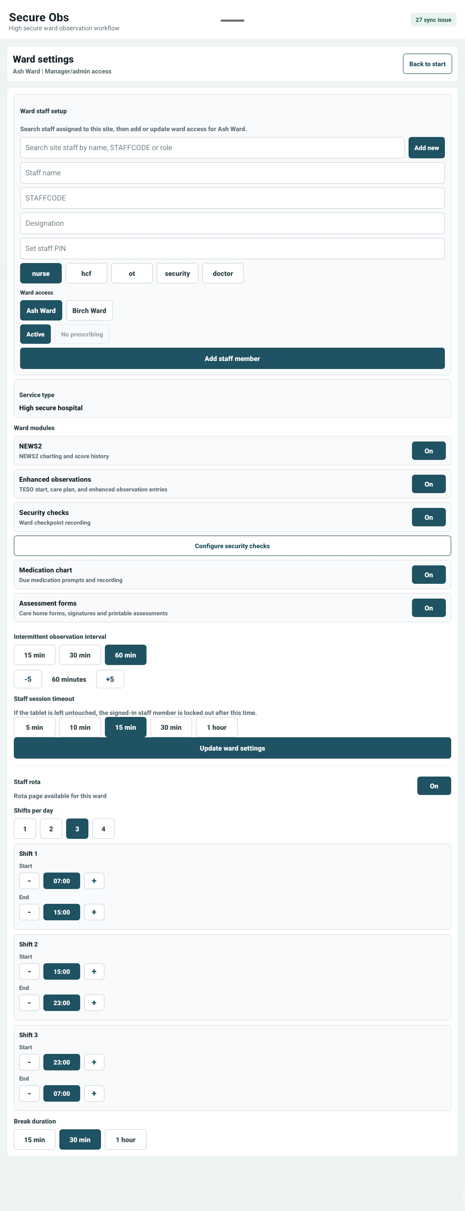
Version 1.0 • July 2026 • For SecureObs managers, ward managers and system administrators

1. What this manager manual covers
Manager route purpose
The manager route is used to control access, staff records, ward module switches and the operational settings that shape what staff can see and do on a ward tablet.
Item | Manager guidance
Who should use this guide | Ward managers, managers with admin rights, super admins and implementation leads.
Before starting | Confirm the site and ward exist, agree local STAFFCODE format, and prepare any blank NFC staff tags.
Important safety point | Create staff with the minimum access they need. Inactivate records promptly when a staff member leaves or no longer needs access.

2. Manager sign-in route
1 | Open SecureObs  The first screen is the staff access area. The current session strip shows selected staff, site and ward.
2 | Sign in with NFC or STAFFCODE/PIN  Use Scan card for a written NFC staff tag, or enter STAFFCODE and PIN. Permanent staff can use the PIN route when NFC is not available.
3 | Change PIN if prompted  If the app says PIN change required, enter the current PIN, then the new 4–6 digit PIN twice before continuing.
4 | Choose site and ward  Managers with wider access can select the correct site and ward before opening settings or starting the ward workflow.
5 | Open settings  Use SecureObs admin for organisation-level setup, or Ward settings for staff access, modules and ward-specific controls.
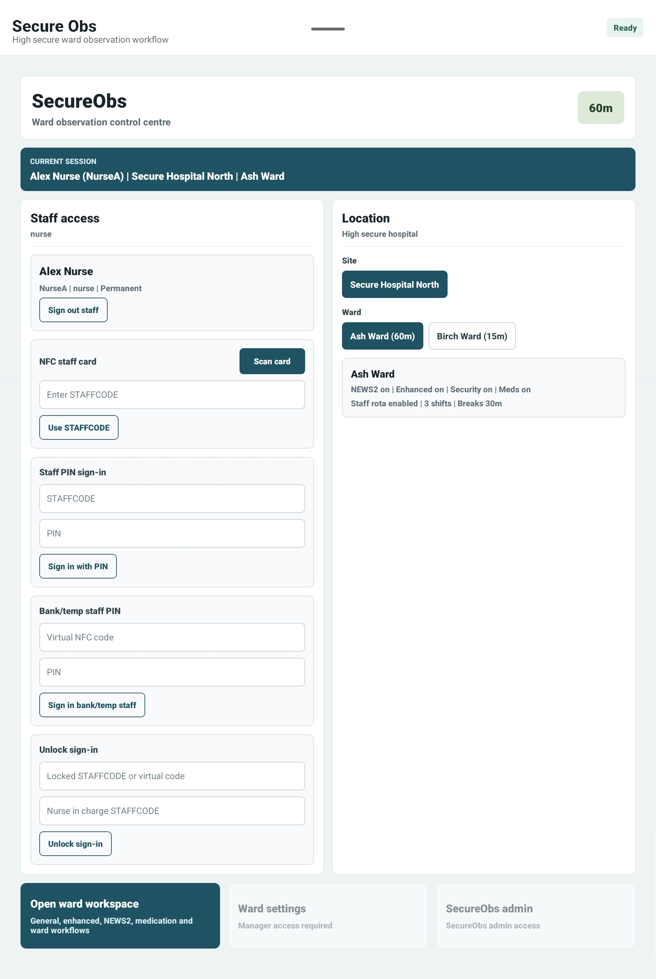
Staff access screen: NFC, STAFFCODE/PIN and current session selection.

3. SecureObs admin screen
Admin section | What it does
Audit log | Search staff lookups, observation saves, medication activity, settings changes and failed access.
Company branding | Upload or remove the organisation logo shown in the app header.
NFC staff card format | Controls how staff cards are read. Keep {STAFFCODE} in the format, e.g. passcode={STAFFCODE}.
Sites | Create site or care home records. Select a site before adding wards beneath it.
Wards | Create ward records, assign service type, set the initial observation interval and optionally create a manager account at the same time.
Service type | Helps identify the setting type and supports local configuration decisions.
Observation interval | Sets the starting intermittent observation frequency for new wards.
NFC format warning
Only change the NFC staff card format if you understand the tag data being written. Existing fallback formats and plain STAFFCODE still work, but a mismatched format can stop scans from resolving cleanly.

4. Adding or updating staff
1 | Search before adding  Search site staff by name, STAFFCODE or role. If the person already exists, select them and update ward access instead of creating a duplicate.
2 | Choose Add new  Use Add new to clear the draft and create a permanent staff record.
3 | Enter identity details  Complete Staff name, STAFFCODE, Designation and optional initial PIN. If no initial PIN is entered, the default is 1111.
4 | Select role  Choose nurse, HCF, OT, security or doctor. The role controls which features the staff member can use.
5 | Set ward access  Select at least one ward. Multi-ward staff can be given access to more than one ward at the same site or organisation.
6 | Set status  Active staff can sign in. Inactive staff should not be able to continue working from that record.
7 | Doctor prescribing  Only doctor records can be marked Can prescribe. Leave this off unless prescribing access is intended.
8 | Save the record  Tap Add staff member or Update staff member. A confirmation appears once the save has been accepted locally and queued/synced as needed.
Role | Typical use
nurse | Clinical nursing access. Can use core ward workflows and manager-permitted clinical screens.
hcf | Healthcare/support worker access. Cannot be Nurse in Charge or Medication Nurse in rota assignment.
ot | Occupational therapy role where enabled by the service.
security | Security-focused access for security checks and related ward activity.
doctor | Medical role. Can be granted prescribing access with the Can prescribe control.
manager / super admin | Higher access roles used for settings, setup and governance controls.

5. Writing NFC staff tags
Permanent staff only
NFC staff tags are intended for permanent staff records. Save the staff member first, then use Write NFC tag from the confirmation prompt or the NFC staff tag panel.
1 | Save staff first  Enter staff details and save the staff member. The app needs the staff record before writing the tag.
2 | Tap Write NFC tag  The panel shows the payload that will be written, using the organisation NFC format.
3 | Hold the blank tag to the device  Keep the tag still until the app confirms it has been written.
4 | Test the tag  Sign out and scan the card on the staff access screen to confirm it selects the correct staff member.

6. Ward settings map
Setting | Manager explanation
Landing page after login | Choose whether staff first see Ward overview or Patient checks after selecting the ward.
NEWS2 | Shows NEWS2 charting and score history.
Enhanced observations | Enables TESO start, plan of care and enhanced observation recording.
Security checks | Enables ward checkpoint recording and security check workflows.
Configure security checks | Opens the setup screen for the ward’s security check areas/items.
Medication chart | Enables medication due prompts, prescribing and administration recording where roles permit.
Assessment forms | Enables care-home style forms, signatures and printable assessments.
Food and fluid chart | Enables meal, snack and drink intake monitoring.
Intermittent observation interval | Sets the default routine observation frequency. Quick buttons are 15, 30 and 60 minutes, with -5/+5 controls.
Staff session timeout | Controls the lock countdown after inactivity. The countdown starts after 2 minutes without touch or typing.
Staff rota | Shows or hides the staff rota page for that ward.

7. Recommended manager workflow
- Start with organisation setup: add the logo, confirm NFC format, create sites and create wards.
- Create or update manager accounts before wider staff onboarding.
- Add permanent staff records, assign ward access and set active status.
- Write and test NFC tags while the staff member is present.
- Turn on only the modules the ward is ready to use.
- Set observation interval and session timeout according to local policy.
- Enable staff rota only once the ward is ready to allocate roles inside SecureObs.
- Use the audit log when checking sign-ins, failed access or settings changes.

8. Safety checks before go-live
Check | What good looks like
Sites and wards | Every live ward exists under the correct site.
Manager access | At least two appropriate managers or admins can access settings.
Staff access | Permanent staff have correct roles, ward access and active status.
NFC tags | Tags are written, tested and labelled according to local process.
Session timeout | Timeout is agreed locally. Minimum effective lock is 2 minutes grace plus the selected timeout.
Modules | Only approved modules are enabled for the ward.
Rota | Rota is enabled only if staff are expected to use it.
Audit | Managers know where to view audit events and failed access.

9. Troubleshooting
Issue | Manager action
Staff cannot sign in | Check active status, STAFFCODE spelling, PIN, ward access and whether the staff member is locked after failed attempts.
NFC tag reads the wrong code | Check the organisation NFC staff card format and rewrite the tag after confirming STAFFCODE.
Manager cannot edit settings | Confirm the signed-in staff member has manager or admin access and has completed any required PIN change.
Rota save does not appear | Check the staff member has manager/nurse/super admin access and that the tablet sync queue is clear.
Feature is missing | Open Ward settings and confirm the module is switched on for that ward.
App locks after inactivity | This is expected. Any touch or typing resets the countdown. The minimum effective timeout is currently 17 minutes.

