  NURSE ROUTE TRAINING GUIDE  Working a safe SecureObs shift  A practical nurse workflow manual for recording observations, managing overdue checks, using clinical modules and completing evidence-based handover.  Start-of-shift dashboard checks  General observations and missed reasons  NEWS2, food/fluid and enhanced observations  Patient notes, care plans and tasks  Safety escalation and shift handover | 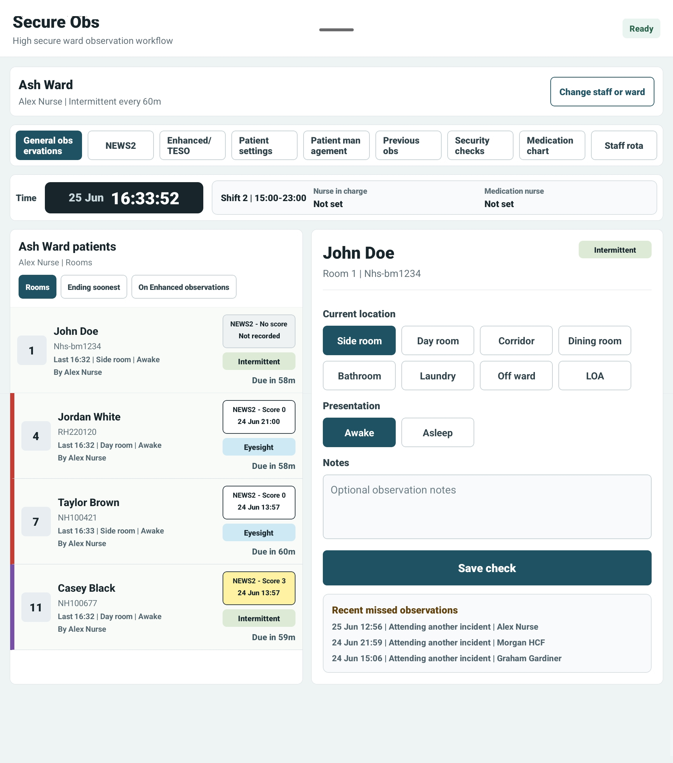
Version 1.0 • July 2026 • For nurses, nurse in charge, ward staff and clinical trainers

1. What the nurse route covers
Nurse route purpose
The nurse route is designed around a live ward shift: seeing what is due, recording patient checks, adding clinical context, escalating safety concerns and handing over clearly.
Item | Guidance
Who should use this guide | Nurses, nurse in charge, clinical support staff and trainers introducing SecureObs on the ward.
Before starting | Confirm you are on the correct site and ward, and that the patient list matches the ward board or local process.
Clinical record rule | Record what you observe at the time. Use notes and handover for clinical context, not to replace required observations.

2. Start of shift
1 | Sign in  Use NFC staff card or STAFFCODE/PIN. If prompted to change PIN, complete this before starting clinical work.
2 | Check current session  Confirm your name, site and ward are correct. Change staff or ward if the wrong context is showing.
3 | Review ward overview  Look at due/overdue observations, NEWS2 concerns, incidents, patient tasks, security checks and sync issues.
4 | Check role allocation  If rota is enabled, confirm nurse in charge, medication nurse and enhanced observation cover are correct.
5 | Open patient checks  Move into General observations when ready to begin recording patient checks.

General observations: patient list, due times and selected patient check panel.

3. Recording general observations
Action | Nurse guidance
Select patient | Choose the patient from the list. Check room number and hospital number before saving.
Current location | Record where the patient was seen: side room, day room, corridor, dining room, bathroom, laundry, off ward or LOA.
Presentation | Record whether the patient was awake or asleep.
Notes | Add brief relevant context. Longer clinical narrative should go into Patient notes.
Save check | Tap Save check. Confirm the patient row updates and the due time resets.
If the check is overdue | Choose the missed/overdue reason where prompted and add context if required.
Observation timing
The due time is based on the ward observation interval or the patient’s enhanced observation plan. If the app shows a check as overdue, record the reason honestly and escalate according to local policy.

4. Clinical modules during the shift
Module | How nurses use it
NEWS2 | Record observations and review score history when NEWS2 is enabled for the ward.
Food and fluid | Record meal, snack and drink intake. Low intake or refusal appears in summaries and handover.
Enhanced observations / TESO | Use for patients needing higher support, enhanced observation plans or TESO governance.
Medication chart | Record administration where your role allows. Review due prompts, allergies/ADRs and medication history.
Patient notes | Add longer clinical notes, filter by staff/date and export selected notes as PDF when authorised.
Care plans | Create or review structured care plans with needs, risks, goals, interventions, patient preferences and review date.
Patient dashboard | Review patient progress and visual summaries across clinical activity.
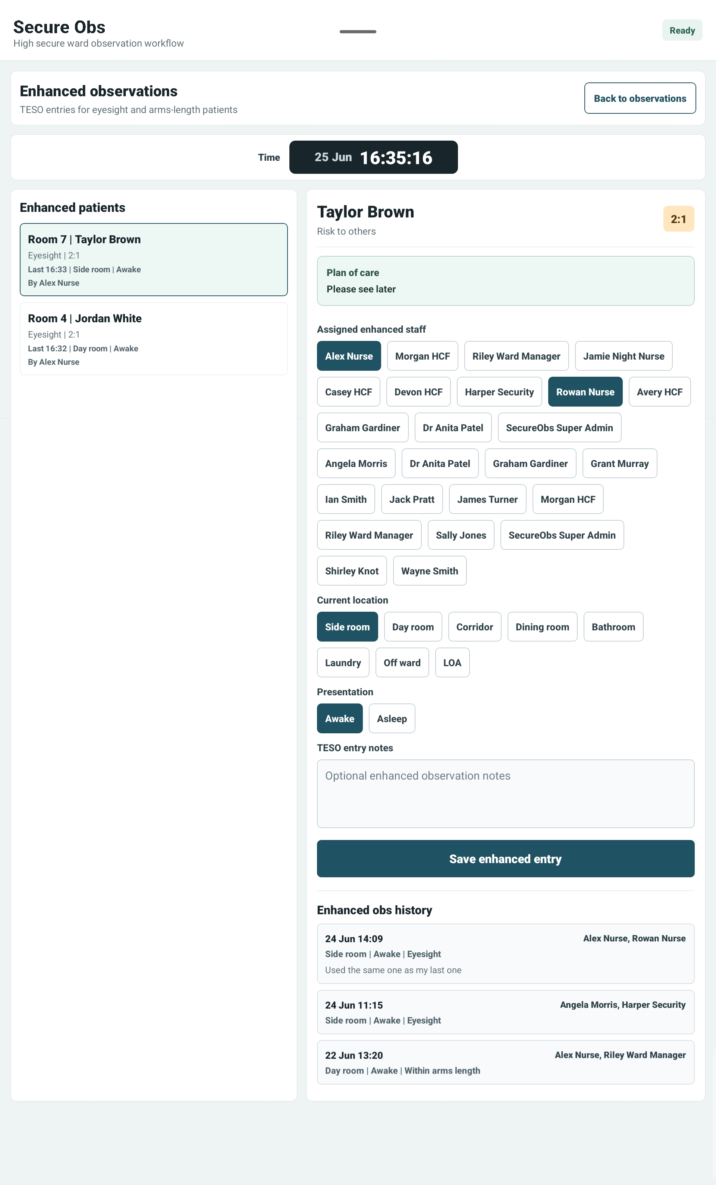
Enhanced observations and TESO: higher-support observation workflow.

5. Safety, escalation and patient tasks
1 | Record safety incidents promptly  Use the Safety and escalation centre for incidents, injuries, safeguarding concerns or significant risks.
2 | Choose severity  Use RAG severity to make immediate risk visible: red for immediate/serious risk, amber for review, green for monitor.
3 | Use body map if relevant  Select affected body areas for injury or physical concern. Add facts and immediate action taken.
4 | Assign ownership  Allocate follow-up to a staff member where required.
5 | Create patient tasks  Use tasks for clear follow-up actions such as reviews, checks, contact or clinical actions.
6 | Review and close  Acknowledge, resolve or complete items only when the action has genuinely been done.
Escalation reminder
SecureObs records and highlights risk. It does not replace emergency response, safeguarding policy, nurse-in-charge escalation or local clinical judgement.

6. End-of-shift handover
1 | Open Shift handover  The handover screen generates evidence from recorded observations, food/fluid, medication, incidents and tasks.
2 | Read each patient summary  Check movement, presentation, food/fluid, NEWS2, medication, incidents and outstanding tasks.
3 | Add staff handover notes  Add clinical context for the incoming shift. Keep it factual, relevant and concise.
4 | Review ward summary  Confirm the overall summary reflects the shift and any unresolved risks or tasks.
5 | Print draft if needed  Use Print draft for review or local paper processes.
6 | Review and sign  Only sign when the handover is accurate. Signed handovers are retained as clinical records and can be printed/shared as PDF.
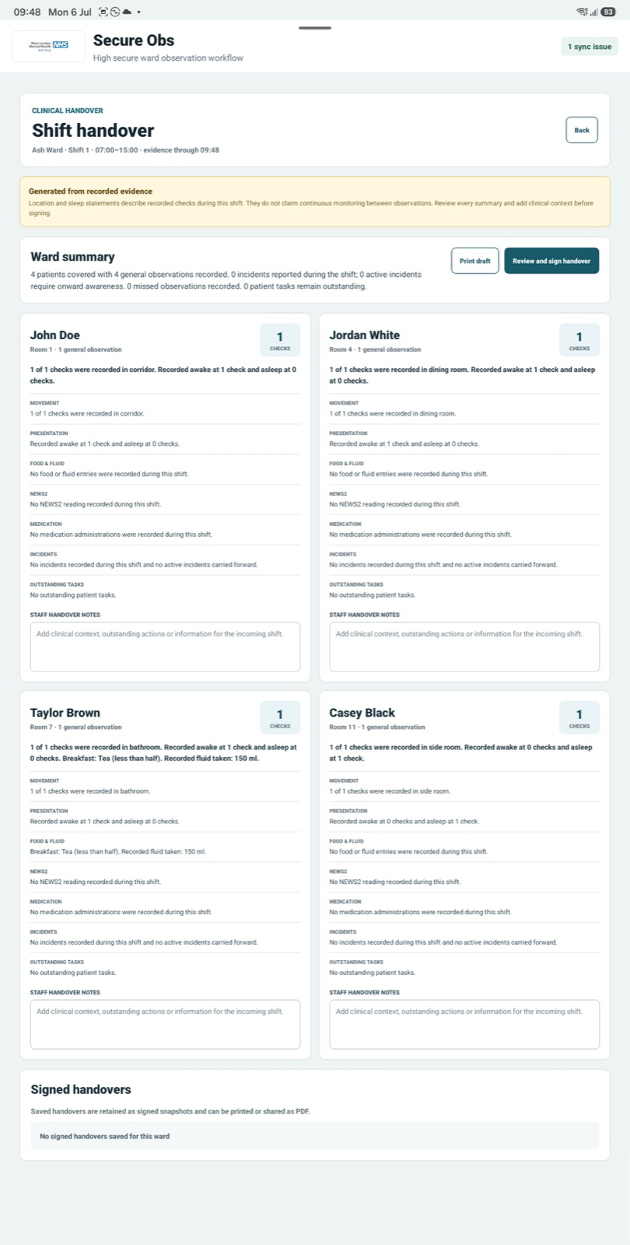
Shift handover: evidence-based patient summaries with staff handover notes.

7. Sync, session lock and safe working
Area | Nurse action
Sync issues | If the sync badge shows pending items, open it before leaving the tablet. Retry or review failed uploads according to local process.
Offline use | SecureObs can queue failed saves locally. Continue to check that items eventually upload once connection returns.
Session lock | If the tablet is unused, it locks after the ward timeout. Activity resets the countdown.
Wrong patient selected | Stop before saving, reselect the correct patient and confirm room/hospital number.
Shared tablet | Sign out or let the session lock before handing the tablet to another staff member.
Clinical disagreement | Record facts and escalate to nurse in charge rather than editing around a concern.

8. Nurse shift checklist
- Sign in and confirm the correct ward.
- Check ward overview for overdue checks, active incidents, tasks and sync issues.
- Record each observation against the correct patient.
- Use missed/overdue reasons when required.
- Complete NEWS2, food/fluid, enhanced observations or medication records where needed.
- Record safety incidents and patient tasks promptly.
- Add patient notes or care-plan updates when clinical context is needed.
- Review and sign shift handover before leaving the shift.
- Check there are no unresolved sync issues before closing the app.

9. Troubleshooting
Issue | What to do
Patient not visible | Check ward selection and patient list. Ask manager/admin to check patient setup if still missing.
Feature missing | The ward module may be switched off. Ask a manager to check Ward settings.
Observation saved but sync issue appears | Open sync status, retry when online, or escalate if it needs review.
Cannot access medication | Check role permissions and whether Medication chart is enabled for the ward.
Handover looks incomplete | Check that observations and related records were saved during the shift; add staff notes for context.
Locked out | Sign in again with NFC or STAFFCODE/PIN. If locked after failed attempts, ask nurse in charge/manager to unlock access.

