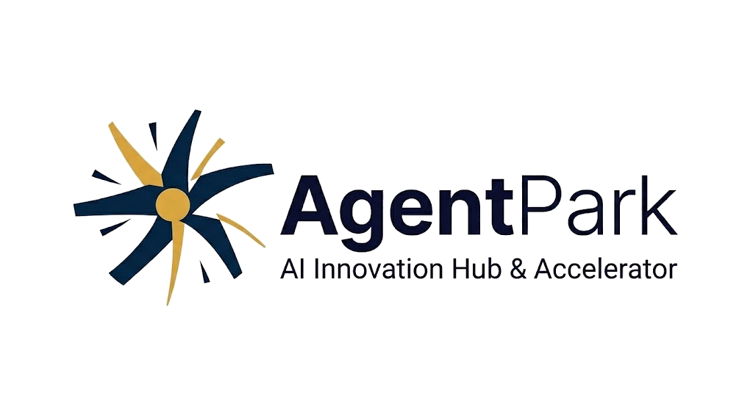

BRAND GUIDELINES
Identity Standards & Design Specifications

AgentPark Ltd. · Yerevan, Armenia · brand@agentpark.ai
Version 1.0 · February 2026 · Confidential

01 — BRAND OVERVIEW

AgentPark is Armenia's premier AI innovation hub and accelerator, purpose-built to connect, grow, and launch AI-native ventures into global markets. The brand identity reflects the organization's dual mandate: deep technological rigor and an open, collaborative spirit.

These guidelines govern every application of the AgentPark brand — from digital products and presentations to print materials and merchandise. Consistent application of these standards builds recognition, trust, and credibility across all audiences.

Mission Statement
To accelerate the development and global reach of AI-driven companies by providing world-class infrastructure, mentorship, and strategic capital — grounded in the vibrant innovation ecosystem of Yerevan, Armenia.

02 — LOGO & LOGOMARK

The Symbol: Dynamic Starburst
The AgentPark logomark is a kinetic, asymmetric starburst composed of eight tapered blades radiating outward from a central golden orb. Six blades are rendered in Midnight Navy; two opposing blades are finished in Amber Gold — creating deliberate visual tension between structural mass and accent energy.

The asymmetry is intentional: it evokes a turbine, a compass rose, and a neural spark simultaneously. The central golden orb serves as a gravitational anchor, representing the convergence of ideas, talent, and technology at the heart of the AgentPark ecosystem.


Primary Lockup — Full Color on White
The Wordmark
"Agent" is set in a heavy-weight sans-serif with tight tracking, projecting authority and technical precision. "Park" follows in a lighter weight of the same typeface, softening the composition and evoking the open, collaborative nature of an innovation campus.

The descriptor "AI Innovation Hub & Accelerator" appears beneath the wordmark in medium-weight sans-serif with generous letter-spacing, positioning the brand mission without competing with the primary name.

Logo Configurations
Configuration | Application
Full Lockup (Horizontal) | Logomark + Wordmark + Tagline — primary brand communications, presentations, letterheads
Compact Lockup | Logomark + Wordmark (no tagline) — space-constrained applications
Logomark Only | App icons, favicons, social avatars, branded merchandise
Wordmark Only | Inline text references, partnerships, co-branding scenarios

Clear Space & Minimum Size
Rule | Specification
Clear Space | Minimum 1.5× the diameter of the central golden orb on all sides; 24px minimum padding in digital use
Full Lockup — Print | Minimum width: 40mm (1.57 in)
Full Lockup — Digital | Minimum width: 160px
Logomark Only — Print | Minimum width: 12mm (0.47 in)
Logomark Only — Digital | Minimum width: 32px; favicon minimum: 16px

03 — LOGO MISUSE

The following modifications are strictly prohibited to protect brand integrity:

- Do not rotate, skew, or distort the logomark or wordmark
- Do not alter the proportional relationship between symbol and wordmark
- Do not recolor the logo outside approved variants (full color, reversed white, mono black, mono navy)
- Do not place the full-color logo on visually busy or low-contrast backgrounds
- Do not add drop shadows, gradients, outlines, or other effects to the logo
- Do not rearrange the blades of the starburst or alter the position of the golden orb
- Do not substitute the typeface in the wordmark
- Do not crop any part of the starburst blades

Approved Color Variants
Variant | Application
Full Color | Navy blades + gold accents on white or light backgrounds (preferred)
Reversed / White | All-white logo on Midnight Navy or dark backgrounds
Mono Black | Solid black for single-color print: fax, stamps, engraving
Mono Navy | Solid Midnight Navy for two-color print applications

04 — COLOR PALETTE

The primary palette anchors all brand communications. Midnight Navy is the dominant brand color conveying authority and technological depth. Amber Gold is used as an accent, sparingly, to create moments of warmth and draw the eye.

Primary Colors
Midnight Navy | Amber Gold | Deep Ink
#0D2740 | #CBA14B | #0D1027
R13 G39 B64 · C100 M63 Y0 K75 | R203 G161 B75 · C0 M21 Y63 K20 | R13 G16 B39 · C95 M85 Y45 K55

Secondary & Support Colors
Pure White | Gold Tint | Navy Tint | Warm Gray
#FFFFFF | #F5EDD8 | #D6DEE5 | #F5F5F5
R255 G255 B255 | R245 G237 B216 | R214 G222 B229 | R245 G245 B245

Secondary tints are used for backgrounds, card surfaces, and UI elements. They should never compete with the primary navy-and-gold palette — they exist to create breathing room and hierarchy.

05 — TYPOGRAPHY

Primary Typeface
Attribute | Value
Primary Family | Inter (Google Fonts)
System Fallback | Helvetica Neue, Arial, system-ui, sans-serif
Heading Weight | Bold / 700
Subheading Weight | SemiBold / 600
Body Weight | Regular / 400
Caption / Tag Weight | Medium / 500, uppercase, 4–6% letter-spacing

Wordmark Typography
Element | Specification
"Agent" weight | Bold / 700 — conveys technical authority
"Park" weight | Regular / 400 — conveys openness and accessibility
Tagline weight | Medium / 500 with 4–6% letter-spacing

Type Scale
Element | Desktop · Mobile
Display / Hero | 48–64px Bold · 32–40px Bold
H1 | 36–40px Bold · 28–32px Bold
H2 | 28–32px SemiBold · 22–26px SemiBold
H3 | 22–24px SemiBold · 18–20px SemiBold
Body | 16–18px Regular · 15–16px Regular
Caption | 12–14px Medium · 11–12px Medium

06 — SUPPORTING DESIGN ELEMENTS

Graphic Motifs
The starburst's radiating blade geometry may be abstracted into supporting graphic patterns for use in backgrounds, section dividers, and presentation templates. Blades can be isolated, enlarged, and cropped at canvas edges to create dynamic, asymmetric compositions that echo the logo's energy without reproducing it in full.

Photography Direction
- Innovation spaces and collaborative environments
- Human faces engaged in creative or technical work
- Armenian architectural landmarks and Yerevan cityscapes
- High-contrast lighting with warm amber and cool blue tonal ranges that echo the brand palette

Iconography Style
Custom icons follow a dual-tone system: Midnight Navy for primary strokes at 2px weight, with Amber Gold accent details. Icons use rounded terminals and 24px grid alignment. The style should feel technical yet approachable, consistent with the logomark's balance of precision and dynamism.

UI Component Palette
Component | Specification
Primary Buttons | Midnight Navy fill, white text, 8px radius
Secondary Buttons | Gold outline, Navy text, 8px radius
Accent / CTA | Amber Gold fill, Deep Ink text
Cards & Surfaces | White with 1px Navy Tint border, 12px radius, subtle shadow
Focus Ring | 2px Amber Gold outline, 2px offset

07 — DELIVERABLE FILE FORMATS

All logo files are available in the following formats to support every use case. Always use the highest-quality format appropriate to the medium.

Format | Use Case
.AI / .EPS — Vector | Master files for print, signage, and large-format production
.SVG — Vector | Web, digital UI, and responsive applications
.PDF — Vector/Print | Print-ready files, press kits, and documents
.PNG — Raster | Digital use with transparency (web, social media, apps)
.JPG — Raster | Photo-based applications, email signatures
.ICO / .ICNS — Icon | Favicons and desktop application icons

For brand inquiries: brand@agentpark.ai
AgentPark Ltd. · AI Innovation Hub & Accelerator · Yerevan, Armenia

