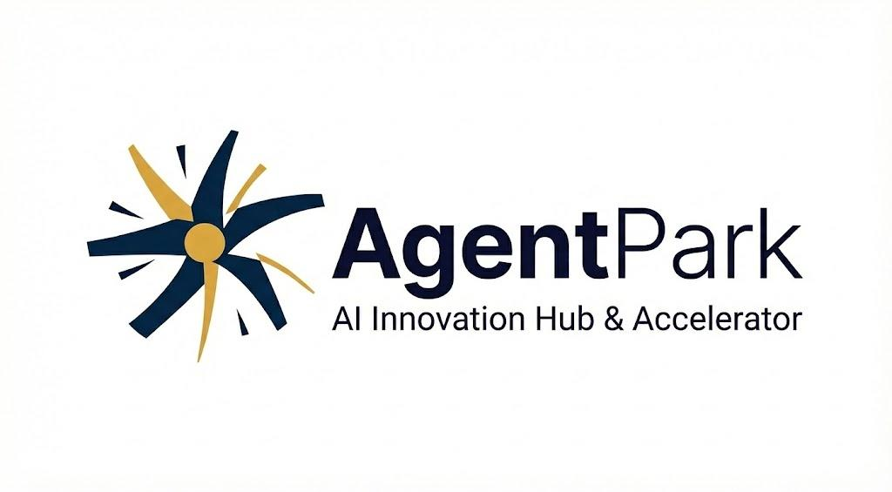

BRAND IDENTITY & DESIGN SPECIFICATIONS

Confidential | Version 1.0 | February 2026

Prepared for AgentPark Ltd.
1. LOGOMARK DESCRIPTION


The Symbol: Dynamic Starburst
The AgentPark logomark is a kinetic, asymmetric starburst composed of eight tapered blades radiating outward from a central golden orb. Six blades are rendered in deep midnight navy, while two opposing blades are finished in warm amber-gold, creating a deliberate visual tension between the dominant structural mass and the accent energy.
The blades vary in length, width, and rotational angle, producing a sense of perpetual motion and organic dynamism. This is not a static emblem; it evokes a turbine, a compass rose, and a neural spark simultaneously. The asymmetry is intentional, suggesting innovation that cannot be contained by rigid geometry.
At the center sits a solid golden circle, a gravitational anchor point that grounds the composition and represents the convergence of ideas, talent, and technology at the heart of the AgentPark ecosystem.
Symbolic Meaning
The starburst communicates multi-directional acceleration, mirroring AgentPark’s role as a launchpad that propels AI ventures outward across sectors, industries, and borders. The interplay between navy and gold symbolizes the balance between deep technological rigor (navy) and creative ambition and human warmth (gold). The central orb represents the Park itself: a nucleus of gravity around which innovation orbits.
The Wordmark
“Agent” is set in a heavy-weight sans-serif with tight tracking, projecting authority and technical precision. “Park” follows in a lighter weight of the same typeface, softening the composition and evoking the open, collaborative, and inviting nature of a physical innovation campus. This weight contrast creates a visual rhythm that reinforces the brand’s dual identity: technologically formidable yet accessible.
The Tagline
The descriptor “AI Innovation Hub & Accelerator” is set beneath the wordmark in a refined, medium-weight sans-serif with generous letter-spacing, clearly positioning AgentPark’s mission without competing with the primary brand name.

2. PRIMARY COLOR PALETTE

Midnight Navy  #0D2740  R13 G39 B64  C100 M63 K42 Y0 | Amber Gold  #CBA14B  R203 G161 B75  C0 M21 Y63 K20 | Deep Ink  #0D1027  R13 G16 B39  C95 M85 Y45 K55

3. SECONDARY & SUPPORT COLORS

Pure White  #FFFFFF  R255 G255 B255 | Gold Tint  #F5EDD8  R245 G237 B216 | Navy Tint  #D6DEE5  R214 G222 B229 | Warm Gray  #F5F5F5  R245 G245 B245

The primary palette anchors all brand communications. Midnight Navy serves as the dominant brand color, conveying authority and technological depth. Amber Gold is the accent, used sparingly to draw the eye and create moments of warmth. Secondary tints are used for backgrounds, cards, and UI surfaces.

4. TYPOGRAPHY SYSTEM

Primary Typeface
Family | Inter (Google Fonts) or Helvetica Neue (system fallback)
Headings | Inter Bold / 700 weight
Subheadings | Inter SemiBold / 600 weight
Body Text | Inter Regular / 400 weight
Captions & Tags | Inter Medium / 500 weight, uppercase, 4–6% tracking
Fallback Stack | Helvetica Neue, Arial, system-ui, sans-serif

Wordmark Typography
“Agent” Weight | Bold / 700 — conveys technical authority
“Park” Weight | Regular / 400 — conveys openness & accessibility
Tracking | Tight: −0.5% to −1% for “Agent”; Standard for “Park”
Tagline Tracking | +4–6% letter-spacing, Medium 500 weight

Type Scale
Element | Size (Desktop) | Size (Mobile)
Display / Hero | 48–64px / Bold | 32–40px / Bold
H1 | 36–40px / Bold | 28–32px / Bold
H2 | 28–32px / SemiBold | 22–26px / SemiBold
H3 | 22–24px / SemiBold | 18–20px / SemiBold
Body | 16–18px / Regular | 15–16px / Regular
Caption | 12–14px / Medium | 11–12px / Medium

5. LOGO SPECIFICATIONS & CLEAR SPACE

Logo Configurations
The AgentPark brand identity operates in four primary configurations, each optimized for different applications:
• Full Lockup (Horizontal): Logomark + Wordmark + Tagline — the preferred configuration for primary brand communications, presentations, and letterheads.
• Compact Lockup: Logomark + Wordmark (no tagline) — for applications where space is limited or the tagline is redundant in context.
• Logomark Only: The starburst symbol in isolation — for app icons, favicons, social media avatars, and branded merchandise where the brand is already contextually established.
• Wordmark Only: “AgentPark” typeset without the symbol — for inline text references, partnerships, and co-branding scenarios.
Clear Space
The minimum clear space surrounding the logo is defined as 1.5× the diameter of the central golden orb (the “core unit”). No text, graphic elements, or container edges may encroach within this zone. For digital applications, this translates to a minimum of 24px padding at standard display sizes.
Minimum Size
Full Lockup (print) | Minimum width: 40mm (1.57 inches)
Full Lockup (digital) | Minimum width: 160px
Logomark Only (print) | Minimum width: 12mm (0.47 inches)
Logomark Only (digital) | Minimum width: 32px (favicon: 16px)

6. LOGO MISUSE GUIDELINES

To protect the integrity of the AgentPark brand, the following modifications are strictly prohibited:
• Do not rotate, skew, or distort the logomark or wordmark.
• Do not alter the proportional relationship between the symbol and wordmark.
• Do not recolor the logo outside of the approved color variants (full color, reversed white, mono black).
• Do not place the full-color logo on visually busy or low-contrast backgrounds.
• Do not add drop shadows, gradients, outlines, or other effects to the logo.
• Do not rearrange the blades of the starburst or alter the position of the golden orb.
• Do not substitute the typeface in the wordmark.
• Do not crop any part of the starburst blades.
Approved Color Variants
Full Color | Navy blades + gold accents on white or light backgrounds
Reversed / White | All-white logo on Midnight Navy or dark backgrounds
Mono Black | Solid black logo for single-color print (fax, stamps, engraving)
Mono Navy | Solid Midnight Navy for two-color print applications

7. SUPPORTING DESIGN ELEMENTS

Graphic Motifs
The starburst’s radiating blade geometry may be abstracted into supporting graphic patterns for use in backgrounds, section dividers, and presentation templates. Blades can be isolated, enlarged, and cropped at canvas edges to create dynamic, asymmetric compositions that echo the logo’s energy without reproducing it in full.
Photography Direction
Brand photography should emphasize: innovation spaces and collaborative environments; human faces engaged in creative or technical work; Armenian architectural landmarks and cityscapes (establishing Yerevan context); high-contrast lighting with warm amber and cool blue tonal ranges that echo the brand palette.
Iconography Style
Custom icons follow a dual-tone system: Midnight Navy for primary strokes at 2px weight, with Amber Gold accent details. Icons use rounded terminals and 24px grid alignment. The style should feel technical yet approachable, consistent with the logomark’s balance of precision and dynamism.
UI Component Palette
Primary Buttons | Midnight Navy fill, white text, 8px radius
Secondary Buttons | Gold outline, Navy text, 8px radius
Accent / CTA | Amber Gold fill, Deep Ink text
Cards & Surfaces | White with 1px Navy Tint border, 12px radius, subtle shadow
Hover State | Navy → 10% lighter; Gold → 15% saturated
Focus Ring | 2px Amber Gold outline, 2px offset

8. DELIVERABLE FILE FORMATS

Format | Type | Use Case
.AI / .EPS | Vector | Master files for print, signage, and large-format
.SVG | Vector | Web, digital UI, and responsive applications
.PDF | Vector/Print | Print-ready files, press kits, and documents
.PNG | Raster | Digital use with transparency (web, social, app)
.JPG | Raster | Photo-based applications, email signatures
.ICO / .ICNS | Icon | Favicons and desktop application icons

AgentPark · AI Innovation Hub & Accelerator · Yerevan, Armenia
For brand inquiries contact: brand@agentpark.ai

