Student ID: LU823284

Land Cover Classification

CSMVI16 Coursework

# Abstract

For this course work, a series of 6 variations of the same satellite images were provided. The variations were of different spectrums, which can be seen in the below figures.

|  |  |  |
| --- | --- | --- |
| Figure 1- Blue | Figure 2- FE | Figure 3 - Green |
| Figure 4 - LE | Figure 5 - NIR | Figure 6 - Red |

A Ground Truth version of the image was also provided, where each of the image pixels was pre-labelled as one of the specific classes. This is illustrated in Figure 7 below:

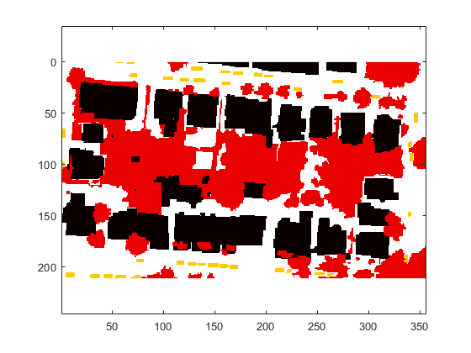

Figure 7 - Ground Truth

The images comprised of 4 different classes on interest.

1. Building - Black
2. Vegetation - Red
3. Car - Orange
4. Ground – White

The goal of the exercise was to select pixel references from the different images and create training data to predict the correct classification of each pixel from each image. Thereby automatically classifying each object in each image a either a building, vegetation, cars or the ground.

# Process Overview

MATLAB was chosen as the tool to perform this exercise. The code used is also attached to the coursework submission.

First, each of the 6 reference images were loaded into Matrix form. This allowed each pixel to correspond to the reference Ground Truth Matrix that was also provided. Each cell in the matrix represented a value between 0 & 255 for the 8-bit grey scale colour depth of each pixel.

Next, 20 samples of each class were manually selected as training points from each image. The samples were not selected randomly. Instead, the samples were chosen from different areas of the image and it was ensured that each pixel had some variance. For example, the buildings have some very light areas as well as some very dark areas. The reference points selected represented both the lighter and darker pixels of the classes.

Next, each training pixel was grouped to into a vector that represented a single pixel for each image – a 1 X 6 vector size.

When all 20 training points of a class were selected, the vectors were combined into a matrix for that class, therefore creating a matrix of size 20 x 6.

Combining these points into matrices in this way, provides an easy way to calculate the means across images as well as creating a covariance matrix. These components are required to create a Gaussian Model for training and applying a maximum likelihood of testing pixels to fall into one of these 4 classes.

This therefore, created 4 vectors of size 1 x 6, that represented the means for each class across each image, and a covariance matrix of size 6 x 6.

To illustrate this, the means from the MATLAB test are shown below, in Table 1.

Table 1 - Classification Means

|  |  |  |  |  |  |  |
| --- | --- | --- | --- | --- | --- | --- |
| Class | Image 1 mean | Image 2 Mean | Image 3 Mean | Image 4 Mean | Image 5 Mean | Image 6 Mean |
| Buildings | 155.0667 | 144.2333 | 178.3667 | 174.7667 | 151.9667 | 176.8 |
| Cars | 160.3 | 80.85 | 153.4 | 75.55 | 143.65 | 144.15 |
| Ground | 130.5667 | 47.1 | 137.2 | 46.36667 | 105.5333 | 127.1667 |
| Vegetation | 67.95 | 147.5 | 96.15 | 82.6 | 140.55 | 86.75 |

Once the means and covariance for each class were calculated, they were then fed into a function, along with each pixel from each image, that calculated the probability, based on a Gaussian model, that each pixel belonged to a given class.

To do this, a method was created, that looped through each pixel of each image and then fed the 8-bit representation of that pixel into the function. This was then repeated for each class mean and variance. This would result in 6 probability values that a pixel belonged to each class. These were then compared, and a maximum likelihood was applied, so that the class with the highest probability was the selected class for that pixel. This resulted in a new matrix that could graphically represent the classification results.

# Classification & Analysis of Results Results

After the initial run, the output produced the following results, where Figure 8 is the original Ground Truth and Figure 9 is the results of the first test.

|  |  |
| --- | --- |
| Figure 8 - Ground Truth | Figure 9 - 1st pass Classification Results |

Just looking at the results of the 1st pass, it can be seen that there is an over-classification of cars with especially with respect to the ground.

This can also be illustrated in the confusion matrix in Figure 10. It can also be seen that Vegetation (2) was the most accurately classified.

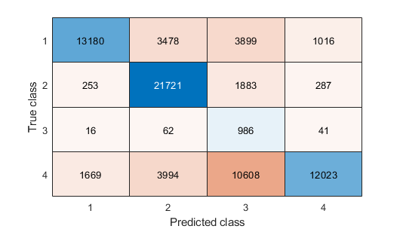

Figure 10 - 1st Pass Confusion Matrix

The next step was to address the issue of the over classification of cars with respect the ground. This was approached by increasing the training size for both classes, therefore taking the total training references for the cars and the ground to 30 each. The classification results and comparison are shown in figures 11 & 12 below.

|  |  |
| --- | --- |
| Figure 11 - Ground Truth | Figure 12 – 2nd pass Classification Results |

It can now be seen that the over classification problem for cars, with respect to the ground has been improved considerably, again also represented in the 2nd confusion matrix in figure 13 below.

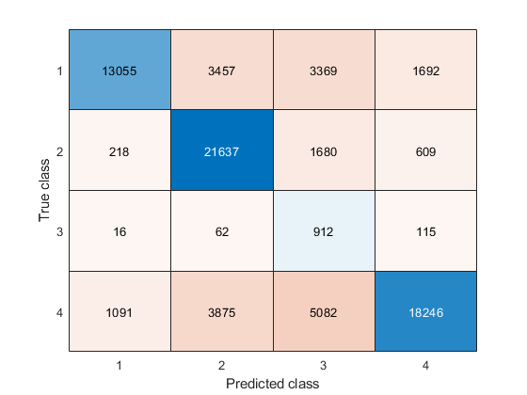

Figure 13 - 2nd Confusion Matrix

Here you can see that there is a considerable improvement for Ground Classification, and the car over classification has also been reduced. However, there remains an under-classification problem for some buildings too, especially with respect to vegetation..

The 2nd least confidence class was building. The next step was to increase the size of the buildings samples to 30 too to see if that also had a more positive affect in getting a higher classification accuracy. This meant that, buildings, cars and the ground had 30 classification training samples from each image and vegetation remained at 20.

The figure below illustrates the difference in tests 2 & 3.

|  |  |
| --- | --- |
| Figure 13 - 2nd Pass Classification Results | Figure 11 - - 3rd Pass Classification Results |

You can see here that there has been a small decrease in the level of noise in around the buildings but not as much of a change when compared to the difference between tests 1 & 2. The 3rd test confusion matrix is shown below in Figure 15. This also reduced the classification accuracy of vegetation, although this now had the smallest sample size.

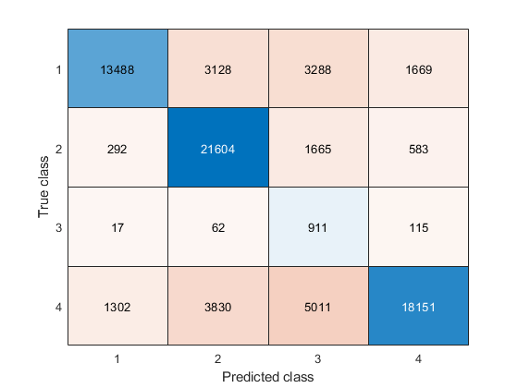

Figure 12 - 3rd Test Confusion Matrix

# Conclusion

After the final 3 tests, an overall classification rate of 72% was achieved. With each class accuracy as follows

|  |  |  |
| --- | --- | --- |
| Class | % Accuracy | Total Pixel Count |
| Building | 66% | 21,573 |
| Vegetation | 89% | 24,144 |
| Cars | 82% | 1,105 |
| Ground | 64% | 28,294 |

Here you can see that the % accuracy for cars is higher that buildings and the ground, although the confidence is lower in the confusion matrix. It could be concluded that the larger the training size, the greater the accuracy overall, as seen between tests 2 & 3. A good way to view the overall results is to combine the graphical classification along with the confusion matrix and overall classification results to see how accurate the tests have been, as one of these methods alone can be too subjective.

Overall, the methods used in the exercise were reasonably successful after a relatively small sample size. If clustering were used in conjunction with this method, it would provide a relatively accurate way of classifying objects.