IBM UrbanCode Deploy Integration with Cloud Foundry
Overview

This Cloud Foundry plug-in enables you to do the following:
- manage various kinds of applications which Cloud Foundry support
- manage various kinds of services which Cloud Foundry support
Furthermore we can connect this process into whole continuous delivery pipeline and DevOps cycle.

The UrbanCode Deploy plug-in for Cloud Foundry v1.0 works with Cloud Foundry cf versions 6.0.0.x through later.

The plug-in provides steps that enables you to manage applications and services
- Push/Delete/Start/Stop/Restart Application
- Create/Bind/UnBind Service
- Create/Delete Domain
- Create/Delete/Map/Unmap Route

The following steps provide and overview of the process you follow
- Create resources. For the deployment of an application package to a Cloud Foundry server like BlueMix, you have to populate resources manually. You can view the resources you create in the Resources view. Each resource corresponds to the machine on which Cloud Foundry cf cli runs .
- Define components, applications, and environments to automate deployment.
- Deploy.

Usage

This section elaborates on the procedure to be followed to use this plug-in.
Before you begin
- Installed and started your UrbanCode Deploy Server, you can refer to
http://coltrane-new.rtp.raleigh.ibm.com/ucdeploy/index.jsp
- Installed Started the UrbanCode Deploy Agent which connects to the UrbanCode Deploy Server
- Load the Cloud Foundry plug-in into the UrbanCode Deploy Server

Push your application with a manifest file

- For the pushing application onto a Cloud Foundry server like BlueMix, create a Resource Group

- Add the agent (installed on the system that will run Cloud Foundry cf cli to this resource group.
  - Hover over the row for the resource group, click Actions, and select Add agent, you will get picture like this:
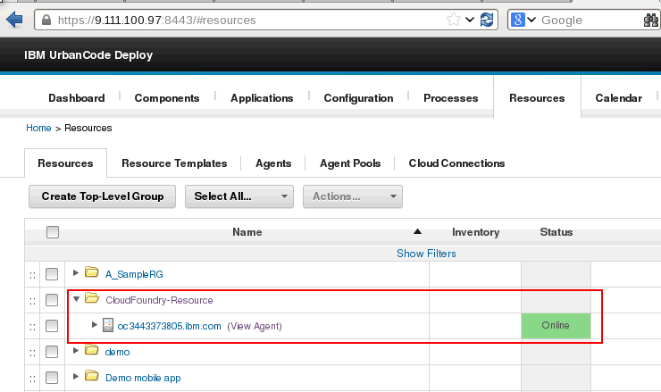

  - Add some shared properties as below to be used in each Cloud Foundry plug-in steps.

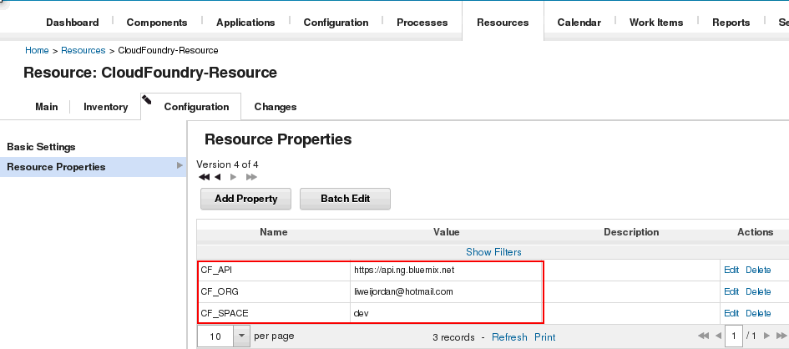

- Create components for the resources. You need one component for each resource to deploy like below.

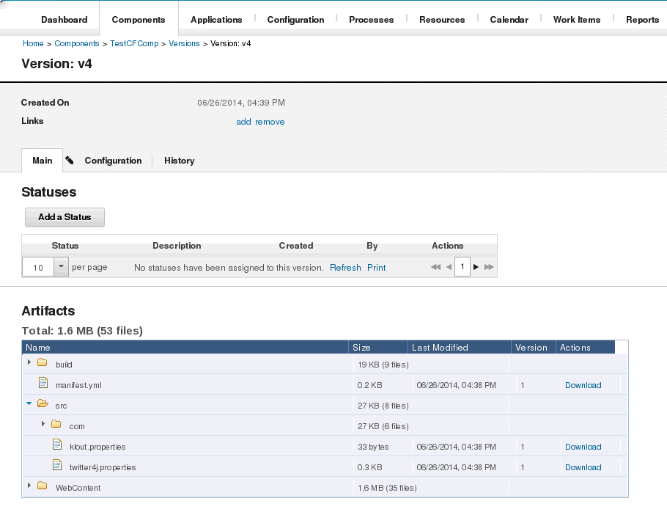

- The manifest.yml file contains the configuration of your Cloud Foundry application like below:
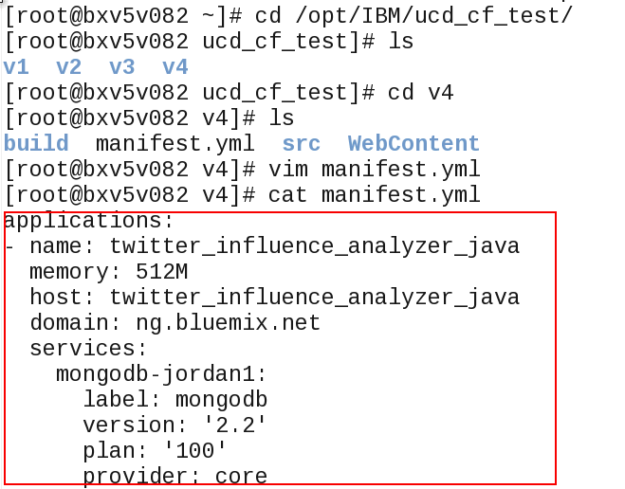
4. Create the component process of type Deployment, Drag-and-drop steps like Push Application into deployment process, and input some parameters like Cloud Foundry User, Password, Application Name, Manifest File etc. like the picture shows below in which:
-Cloud Foundry User
The user name of the account that will interact with Cloud Foundry system
-Application Name
The name of the application to use when deployed. Required if not using a manifest.
-Manifest File
Path to the manifest file. Default is to look in the working directory.
-Domain
Set a custom domain to be used when deploying the application.
-Sub-domain
Define a sub-domain for your application. This is useful to ensure that the URL route for the
application is unique within the domain.
-Number of Instances
The number of instances of the application that will be created.
-Custom buildpack
Custom buildpack by name (e.g. my-buildpack) or GIT URL (e.g. https://github.com/heroku/heroku-
buildpack-play.git).
-Application Path
Path of app directory or zip file.
-No start
Does not start the application if selected.
-No route
Does not create a URL route for the application if selected. Manually create and map a route later.
-No manifest
Ignore the manifest file if one exists.
-No hostname
Map the root domain to this application.
And also you can input similar properties to Delete/Start/Stop/Restart your application.

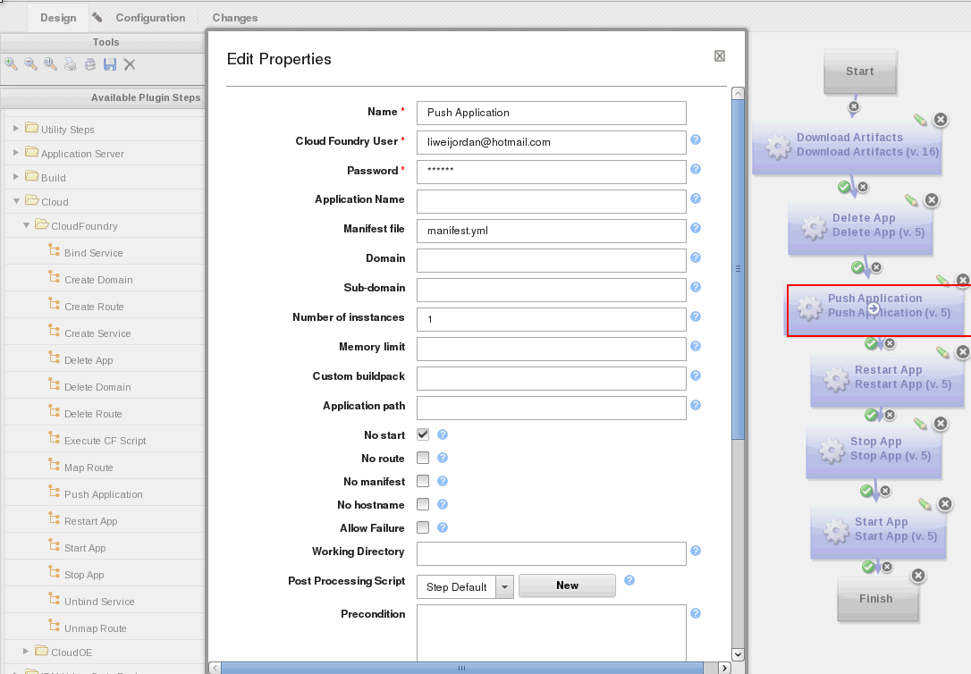

5. Add the components to the resources.
- Go to the resource.
- Choose Actions > Add Component
- Select the component to use, you will get result like this:
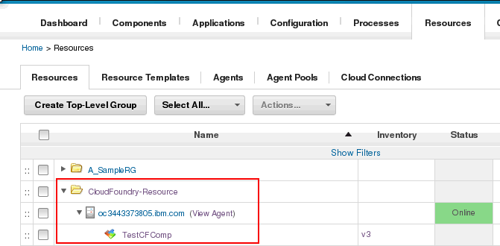

6. Create the application.
- Go to Applications.
- Click Create New Application (if one does not exist). You can also use an existing application that is attached to the cell to manage.
- Enter an application name, then click Save.
- Click the Components tab, then add the component that was created in step 3 above.

7. Create an application environment.
- In the Environments tab, click Create New Environment.
- Enter an environment name, then click Save.
- Go to the environment editing page.
- Click on the environment name, then click Add Base Resource. Choose the group for your Process Center environment.

8. Create an application process of type Deployment
- Click the Processes tab.
- Add a deploy step.
- Drag and drop the Install Component step onto the process editor.
1. Select the component to use. You created this component for the resource. For example, you created a component to contain the process application to be deployed.
2. Choose the process for the component.
- Click Save.
- Save the process.

9. Then you can run this deployment process and check the corresponding status and log information like below.
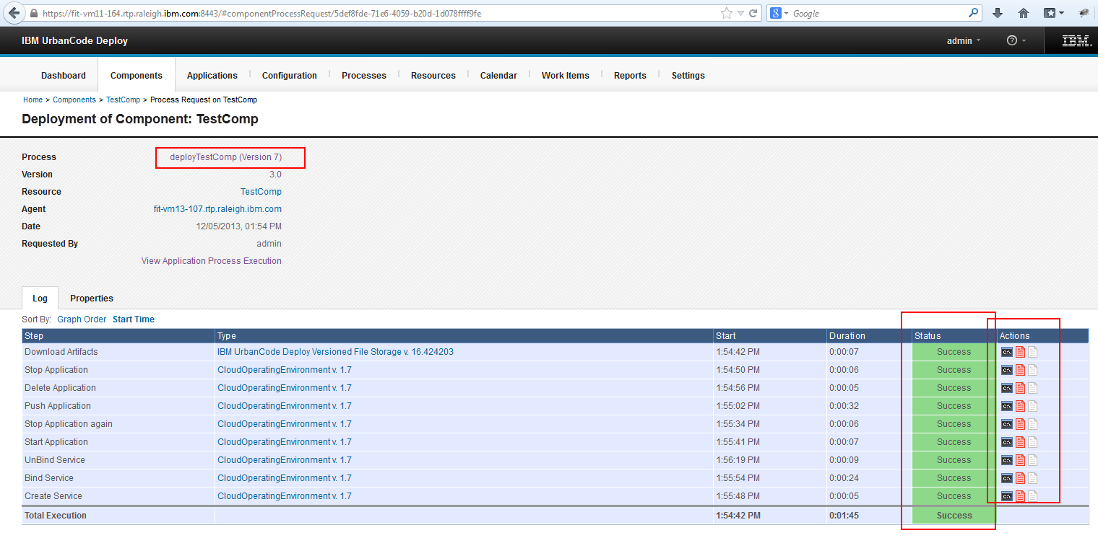

10. Finally you will find that your application is running in Cloud Foundry environment like below.

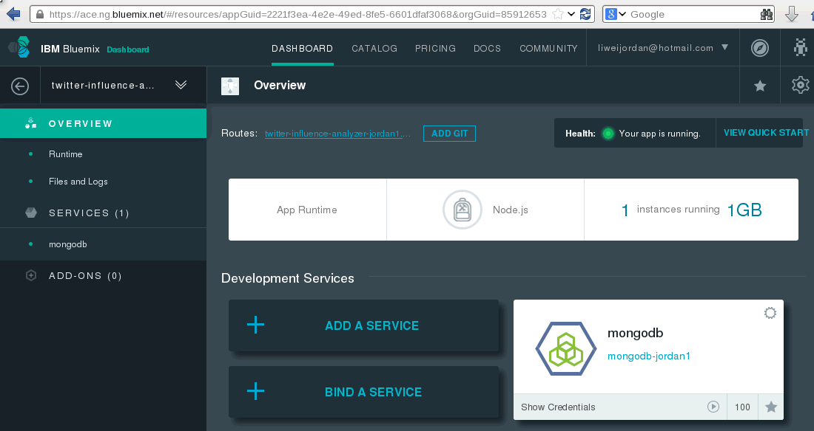

Create a service and bind to your application

Steps 1, 2, 3 are similar with corresponding steps above.

4. Create the component process of type Deployment, Drag-and-drop steps like Create Service into deployment process, and input some parameters like Cloud Foundry User, Password, Service Name, Service Type, Service Plan etc. like the picture shows below:

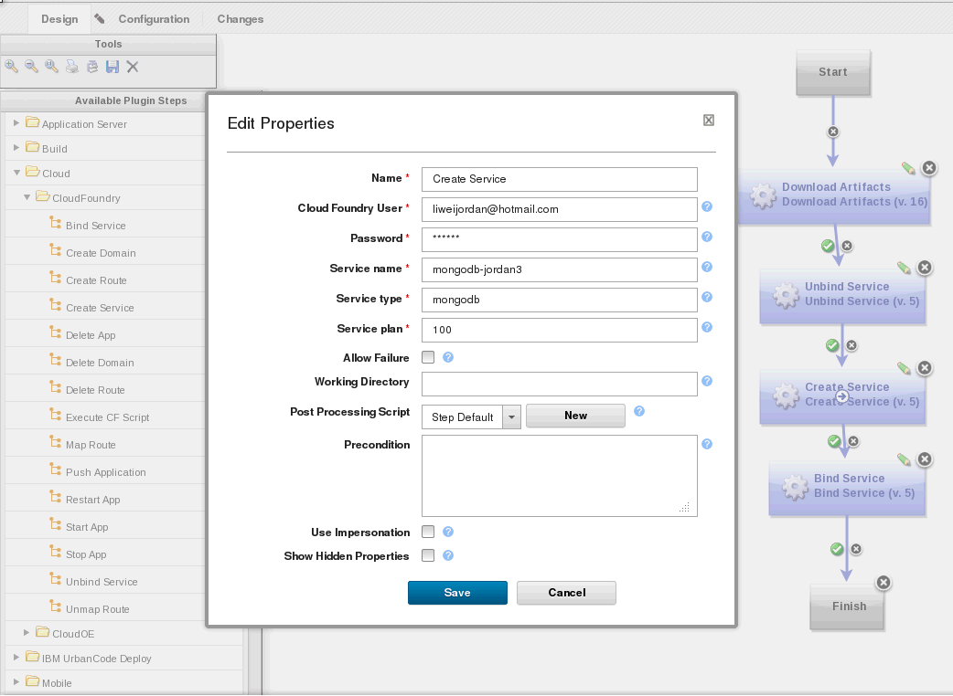

Steps 5, 6, 7, 8 are similar with corresponding steps above.

9. Then you can run this deployment process and check the corresponding status and log information like below.
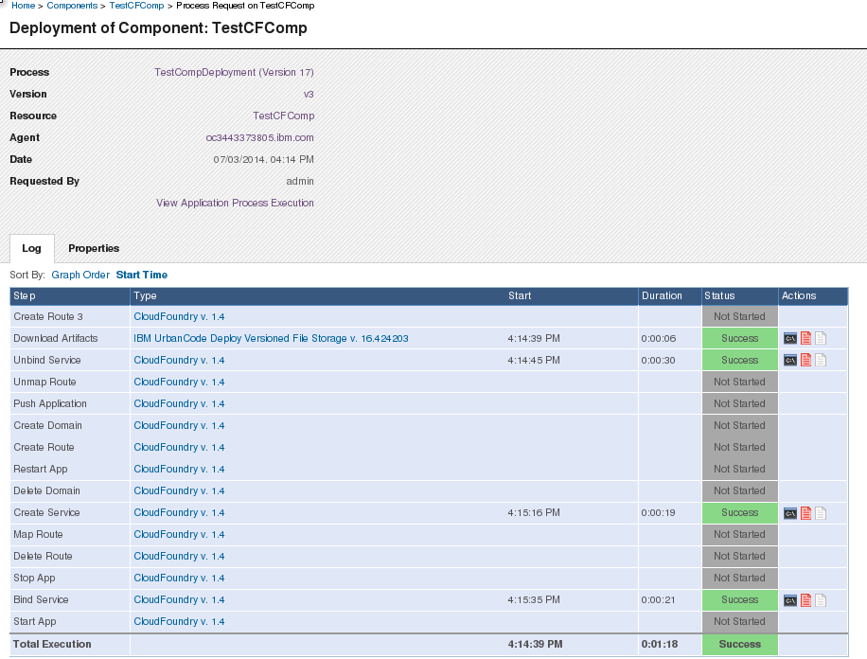

10. Finally you will find that your service is bound to one application in BlueMix UI or from cf cli like below.

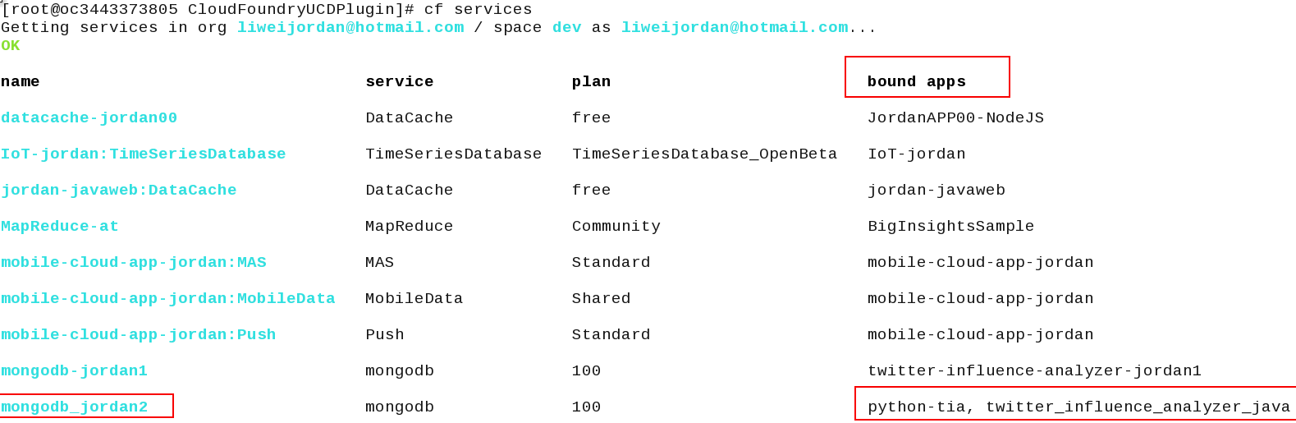

Create/Delete a Domain

Steps 1, 2, 3 are similar with corresponding steps above.

4. Create the component process of type Deployment, Drag-and-drop steps like Create Domain into deployment process, and input some parameters like the picture shows below:
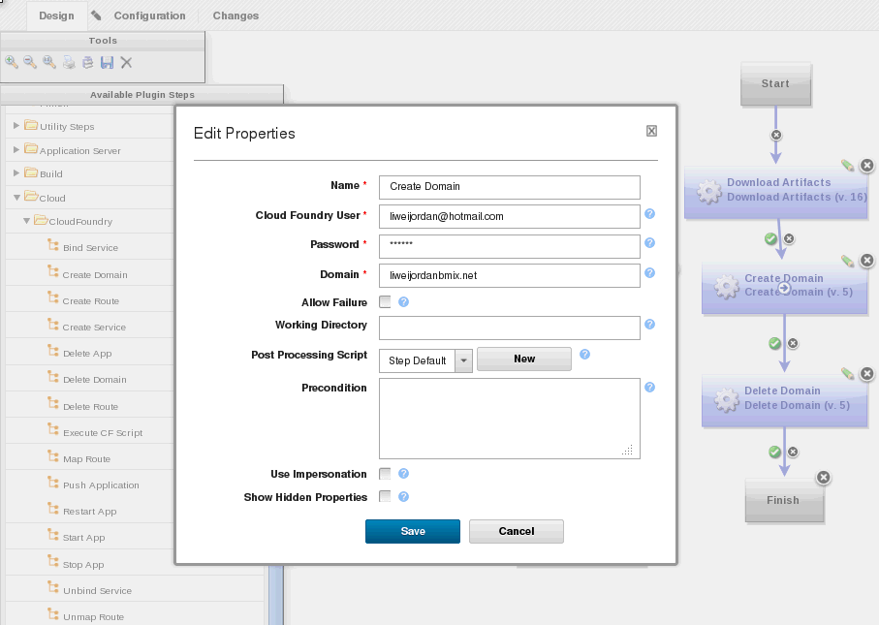

Steps 5, 6, 7, 8 are similar with corresponding steps above.

9. Then you can run this deployment process and check the corresponding status and log information like below.

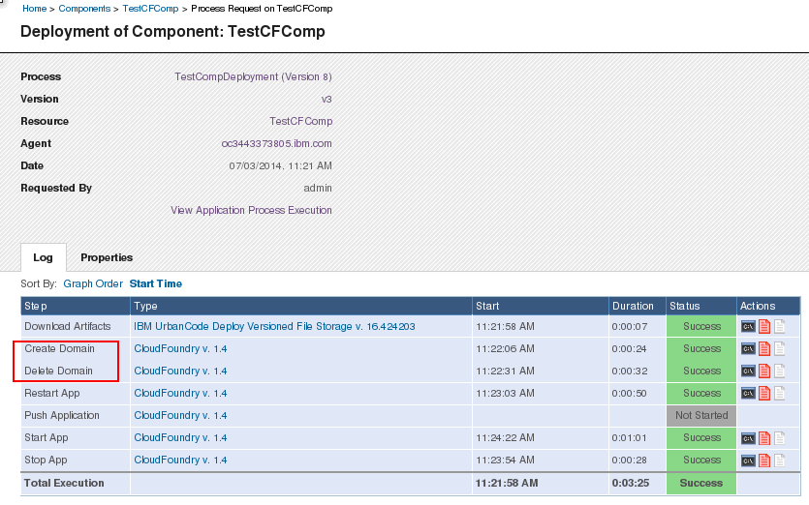

10. Finally you will find that your Domain is created in BlueMix UI or from cf cli like below.
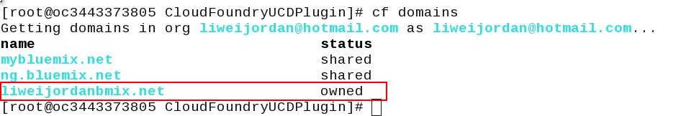

Create/Delete a Route for your application

Steps 1, 2, 3 are similar with corresponding steps above.

4. Create the component process of type Deployment, Drag-and-drop steps like Create Route into deployment process, and input some parameters like the picture shows below:
-Domain
Domain to be used when deploying the application later.
-Host Name
The hostname within the domain for the url route.
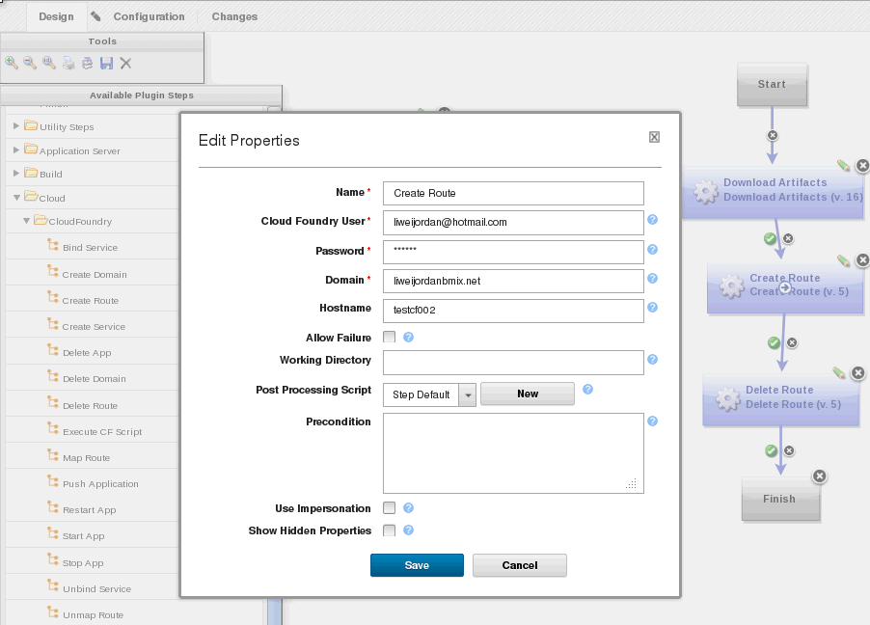

Steps 5, 6, 7, 8 are similar with corresponding steps above.

9. Then you can run this deployment process and check the corresponding status and log information like below.

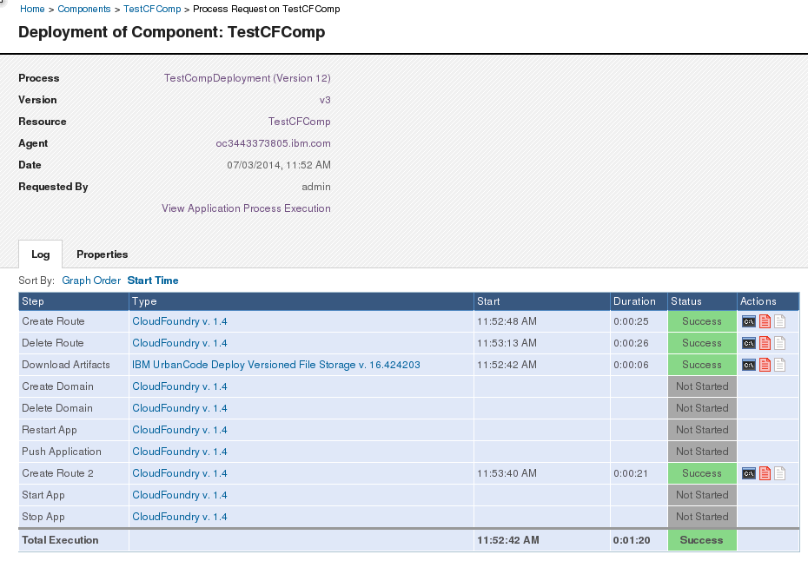

10. Finally you will find that your Domain is created in BlueMix UI or from cf cli like below.

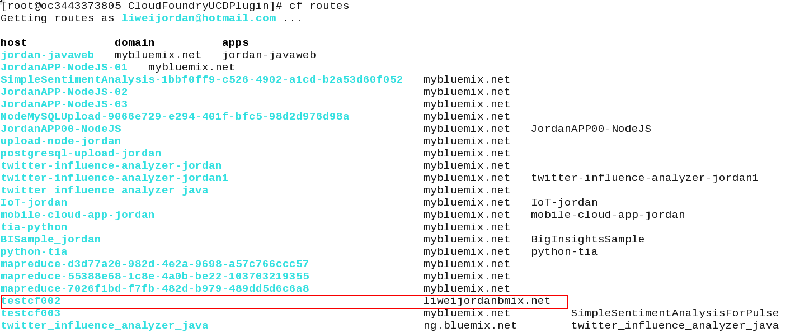

Map/Unmap a Route for your application

Steps 1, 2, 3 are similar with corresponding steps above.

4. Create the component process of type Deployment, Drag-and-drop steps like Map Route into deployment process, and input some parameters like the picture shows below:

-Application Name
The name of the application to map url route to.
-Domain
Domain to be used when deploying the application later.
-Host Name
The hostname within the domain for the url route.
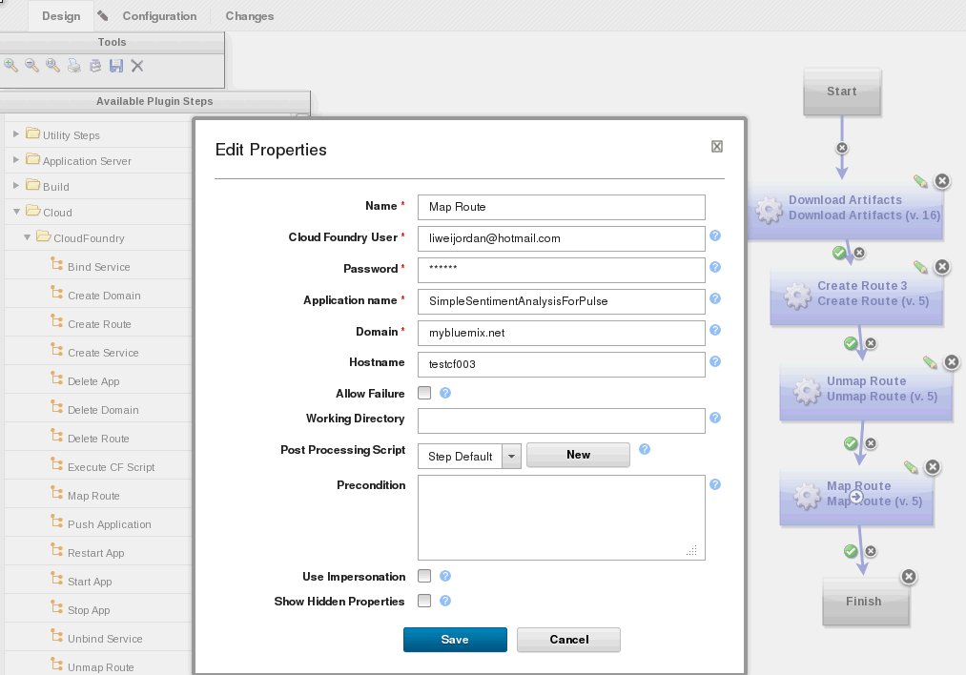

Steps 5, 6, 7, 8 are similar with corresponding steps above.

9. Then you can run this deployment process and check the corresponding status and log information like below.

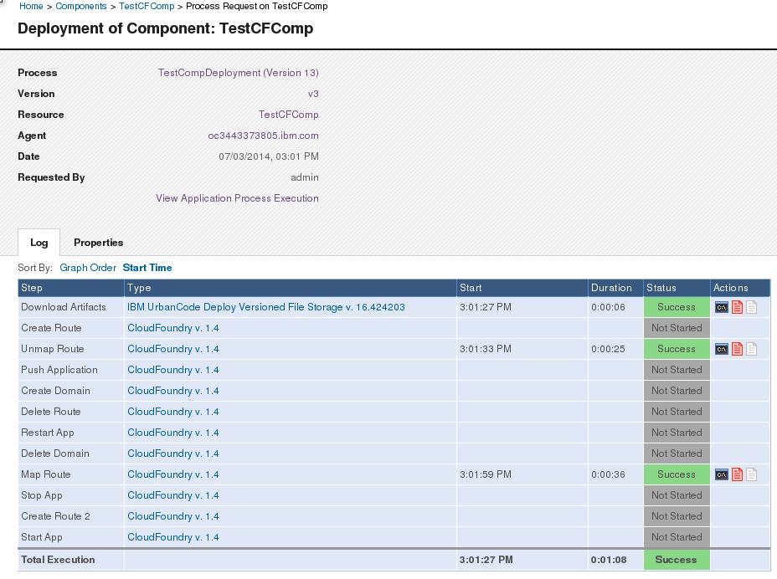

10. Finally you will find that your Domain is created in BlueMix UI or from cf cli like below.

