Instructions For Fraction Collection Unit

Introduction

This document provides instructions for converting the Creality Ender 5 S1 3D Printer to a fraction collection unit.

Contents

Building the Creality Ender 5 S1 3D Printer | P2
Printing The Components | P3
Making a Potential Divider | P4
Modifying the 3D printer | P5
Installing The Software | P6
Using The Fraction Collection Unit | P7

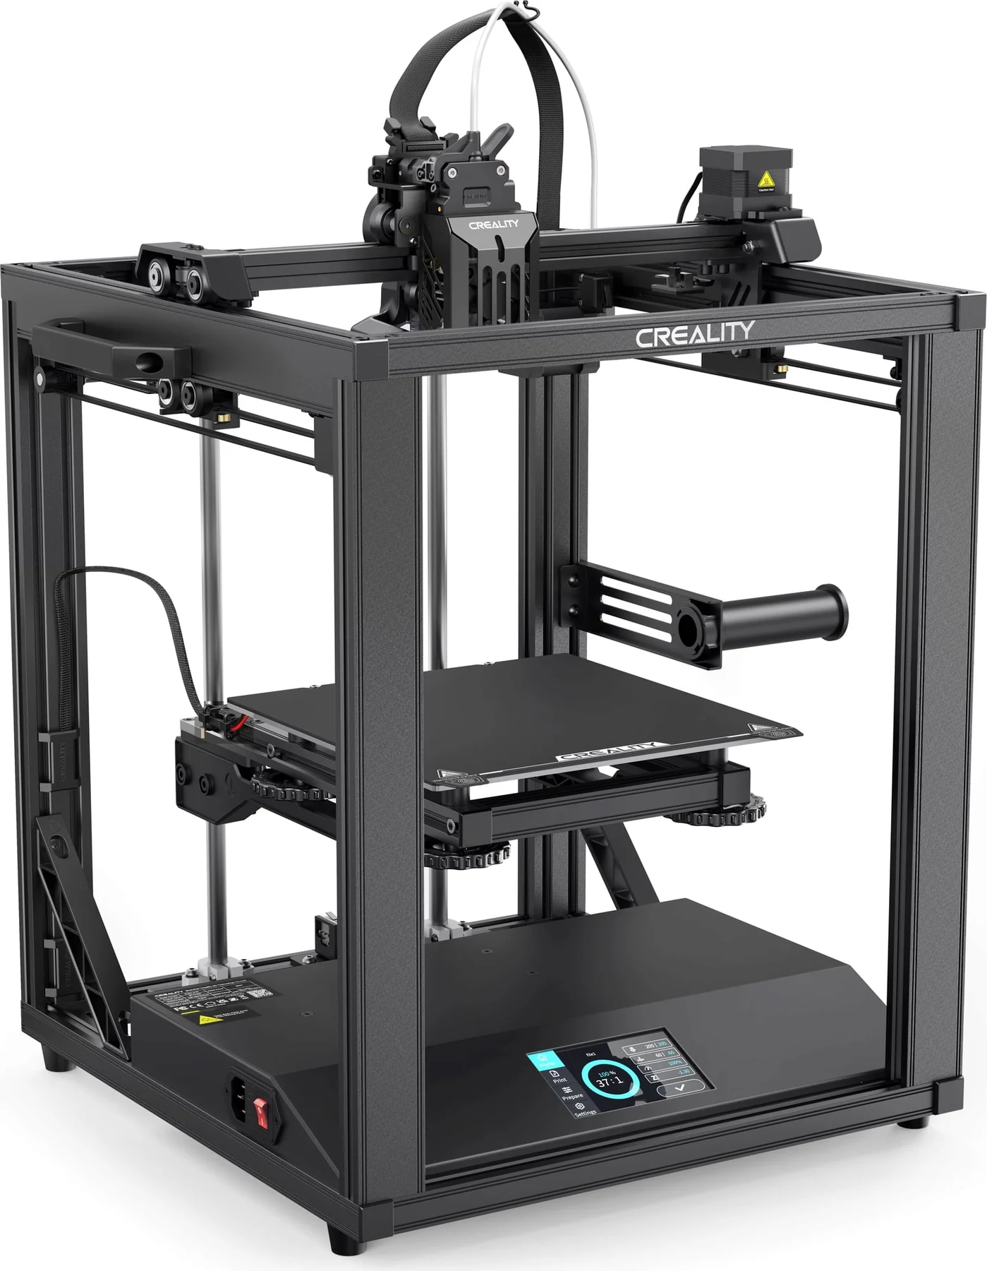
Building the Creality Ender 5 S1 3D Printer

A complete set of instructions is provide with the printer so the procedure won’t be duplicated here.

Printing The Components

Now that you have built the 3D printer you can print the necessary components for the project.

Slicing software is required to print a 3D object from the STL files. The recommended software for this Cura and can be found here: https://ultimaker.com/software/ultimaker-cura/

The software provides a configuration for the Creality Ender-5 which works very well.

