

What is evolutionGPT?n
evolutionGPT is a tiny little LLM (33M something parameters) trained through evolution*, aka the genetic algorithm
What is an LLM? What is nanochat?
An LLM (large language model) is the underlying model powering all modern chatbots (I.e chatgpt, claude, grok, etc). Nanochat is a from-scratch training pipeline of an LLM, which I used as the base of my project, shout out Andrej Karparthy.
What is the genetic algorithm?
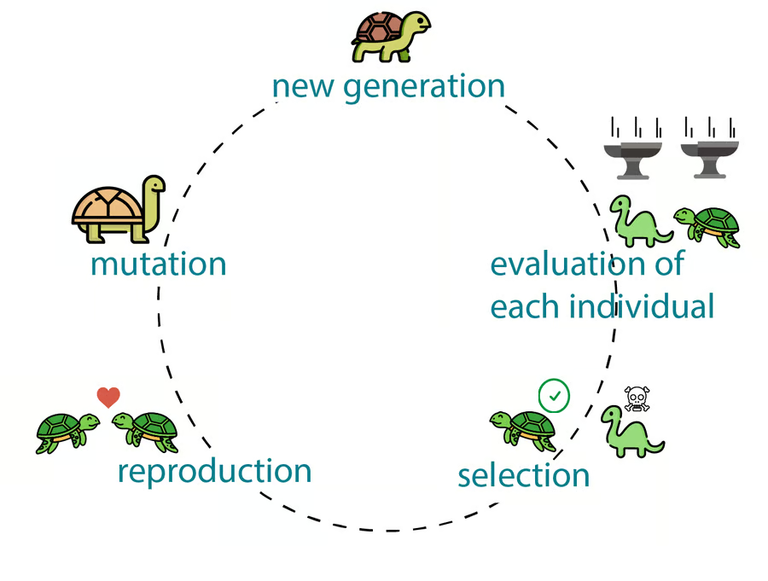
The genetic algorithm is a machine learning training process mimicking evolution™ from biology, the same stuff that brought you dinosaurs, humans, and crabs. The process consists of four stages. The first stage is competition, where N (such as 25) candidates are evaluated through a fitness function. The second stage is natural selection, the top M (such as top 5) candidates with the highest results from the fitness function get to advance to the next generation, and the other N-M (20) candidates are *eliminated*. The third stage is reproduction, where the competitors reproduce with each other to create N-M (20) new candidates, which also compete in the next generation. The fourth stage is mutation, where the parameters of all candidates have a small random chance to be tweaked, creating new genes. This process repeats to create high fitness candidates.
Does the genetic algorithm work for training LLMs?
Ehhhhhh not really. LLMs are notoriously hard to train towards a good solution (which we call convergence), and the random nature of genetic algorithms further prevents convergence. This leads to a veeeery stupid and low performance model.
Ok so what did I do about this?
I combined it with backpropogation, the traditional way of training LLMs. For the purposes of this piece of paper in your hand, backpropogation allows an LLM to adjust its parameters by directly interacting with error (the opposite of fitness) to finetune its own parameters to reduce error in the future. In the competition stage of the genetic algorithm, backpropogation is applied to all candidates, making them more attuned to have higher fitness, then fitness is calculated, we have natural selection, reproduction, and mutation. The result of this is training that actually gets a somewhat good LLM through a combination of evolution and backpropogation.
What data are you training on?

The first dataset is ClimbMix, a dataset of 400B tokens of lots of random things, made by nvidia, mainly for their nemotron models. The second dataset is smol-smoltalk, from huggingface, giving the model somewhat of a chatting capability
Are you training from scratch?
Yeah. However the codebase isnt from scratch, being built upon nanochat by andrej karparthy. This has allowed me to focus on implementing the genetic algorithm part of training, rather than needing to painstakingly implement a GPT model from scratch.
This model lowkey sucks
yeah, its only 33M parameters and trained from scratch in a weekend through an experimental genetic+backpropogation training algorithm, its gonna suck BAD
Please vote for me (evolutionGPT) on categories “People’s choice”, “Interdisciplinary” (because biology), “Presentation”, alongside “Best Overall”.
Pretty please pretty please

