FORM DESIGN

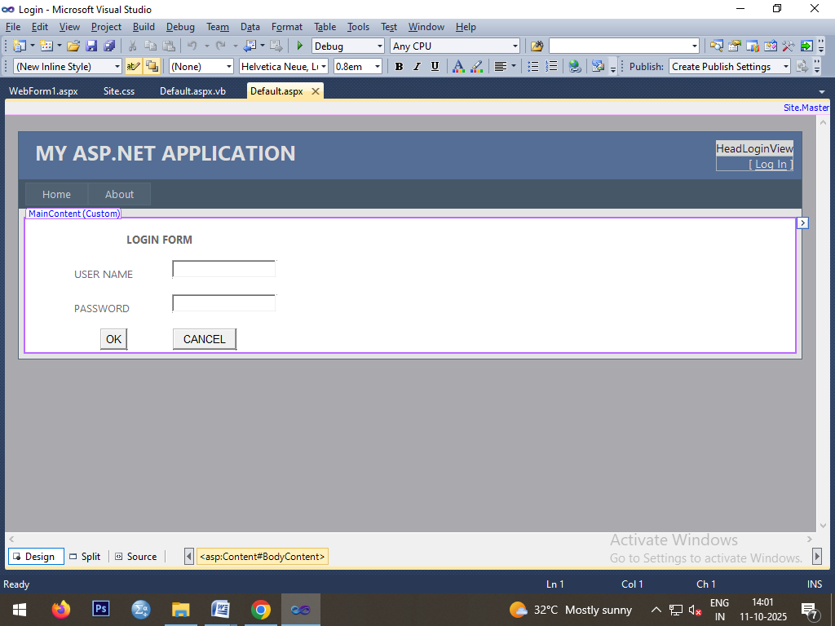

CODING

Public Class _Default

Inherits System.Web.UI.Page

Protected Sub Button1_Click(ByVal sender As Object, ByVal e As EventArgs) Handles Button1.Click

If TextBox1.Text = "ADMIN" And TextBox2.Text = "12345" Then

Response.Redirect("WebForm1.aspx")

Else

Response.Write("Invalid username or password")

End If

End Sub

End Class

OUTPUT

