**3. CALCULATOR**

**FORM DESIGN**

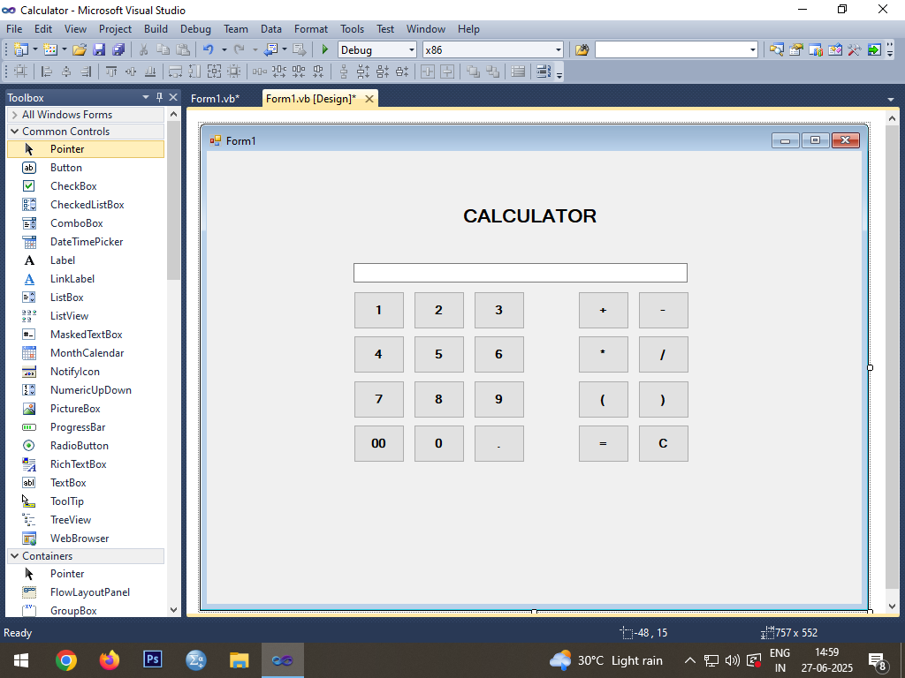

**CODING**

Public Class Form1

Dim result As Double = 0

Private Sub Button1_Click(ByVal sender As System.Object, ByVal e As System.EventArgs) Handles Button1.Click

TextBox1.Text += Button1.Text

End Sub

Private Sub Button2_Click(ByVal sender As Object, ByVal e As System.EventArgs) Handles Button2.Click

TextBox1.Text += Button2.Text

End Sub

Private Sub Button3_Click(ByVal sender As Object, ByVal e As System.EventArgs) Handles Button3.Click

TextBox1.Text += Button3.Text

End Sub

Private Sub Button4_Click(ByVal sender As Object, ByVal e As System.EventArgs) Handles Button4.Click

TextBox1.Text += Button4.Text

End Sub

Private Sub Button5_Click(ByVal sender As Object, ByVal e As System.EventArgs) Handles Button5.Click

TextBox1.Text += Button5.Text

End Sub

Private Sub Button6_Click(ByVal sender As Object, ByVal e As System.EventArgs) Handles Button6.Click

TextBox1.Text += Button6.Text

End Sub

Private Sub Button7_Click(ByVal sender As Object, ByVal e As System.EventArgs) Handles Button7.Click

TextBox1.Text += Button7.Text

End Sub

Private Sub Button8_Click(ByVal sender As Object, ByVal e As System.EventArgs) Handles Button8.Click

TextBox1.Text += Button8.Text

End Sub

Private Sub Button9_Click(ByVal sender As Object, ByVal e As System.EventArgs) Handles Button9.Click

TextBox1.Text += Button9.Text

End Sub

Private Sub Button10_Click(ByVal sender As Object, ByVal e As System.EventArgs) Handles Button10.Click

TextBox1.Text += Button10.Text

End Sub

Private Sub Button11_Click(ByVal sender As Object, ByVal e As System.EventArgs) Handles Button11.Click

TextBox1.Text += Button11.Text

End Sub

Private Sub Button12_Click(ByVal sender As System.Object, ByVal e As System.EventArgs) Handles Button12.Click

TextBox1.Text += Button12.Text

End Sub

Private Sub Button13_Click(ByVal sender As System.Object, ByVal e As System.EventArgs) Handles Button13.Click

TextBox1.Text += Button13.Text

End Sub

Private Sub Button14_Click(ByVal sender As Object, ByVal e As System.EventArgs) Handles Button14.Click

TextBox1.Text += Button14.Text

End Sub

Private Sub Button15_Click(ByVal sender As System.Object, ByVal e As System.EventArgs) Handles Button15.Click

TextBox1.Text += Button15.Text

End Sub

Private Sub Button16_Click(ByVal sender As Object, ByVal e As System.EventArgs) Handles Button16.Click

TextBox1.Text += Button16.Text

End Sub

Private Sub Button17_Click(ByVal sender As Object, ByVal e As System.EventArgs) Handles Button17.Click

TextBox1.Text += Button17.Text

End Sub

Private Sub Button18_Click(ByVal sender As Object, ByVal e As System.EventArgs) Handles Button18.Click

TextBox1.Text += Button18.Text

End Sub

Private Sub Button19_Click(ByVal sender As System.Object, ByVal e As System.EventArgs) Handles Button19.Click

Dim temp, oper As String

temp = TextBox1.Text

Dim len As Double

len = temp.Length - 1

oper = temp.Chars(len)

If oper = "+" Or oper = "-" Or oper = "*" Or oper = "/" Or oper = "(" Then

MsgBox("Syntax Error")

Else

result = New DataTable().Compute(temp, Nothing)

TextBox1.Text = result

End If

End Sub

Private Sub Button20_Click(ByVal sender As System.Object, ByVal e As System.EventArgs) Handles Button20.Click

TextBox1.Text = ""

End Sub

End Class

**OUTPUT**

