**NOTEPAD**

**FORM DESIGN**

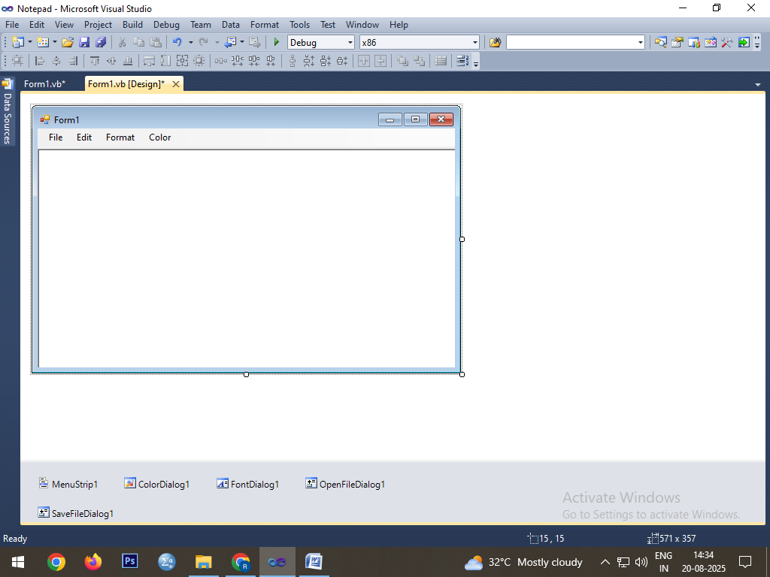

**CODING**

Public Class Form1

Dim str As String

Private Sub NewToolStripMenuItem_Click(ByVal sender As System.Object, ByVal e As System.EventArgs) Handles NewToolStripMenuItem.Click

RichTextBox1.Clear()

RichTextBox1.BackColor = Color.White

RichTextBox1.ForeColor = Color.Black

End Sub

Private Sub OpenToolStripMenuItem_Click(ByVal sender As System.Object, ByVal e As System.EventArgs) Handles OpenToolStripMenuItem.Click

OpenFileDialog1.ShowDialog()

RichTextBox1.LoadFile(OpenFileDialog1.FileName, RichTextBoxStreamType.PlainText)

End Sub

Private Sub SaveToolStripMenuItem_Click(ByVal sender As Object, ByVal e As System.EventArgs) Handles SaveToolStripMenuItem.Click

SaveFileDialog1.ShowDialog()

RichTextBox1.SaveFile(SaveFileDialog1.FileName, RichTextBoxStreamType.PlainText)

End Sub

Private Sub ExitToolStripMenuItem_Click(ByVal sender As System.Object, ByVal e As System.EventArgs) Handles ExitToolStripMenuItem.Click

End

End Sub

Private Sub CutToolStripMenuItem_Click(ByVal sender As System.Object, ByVal e As System.EventArgs) Handles CutToolStripMenuItem.Click

str = RichTextBox1.SelectedText

RichTextBox1.SelectedText = ""

RichTextBox1.Cut()

End Sub

Private Sub CopyToolStripMenuItem_Click(ByVal sender As Object, ByVal e As System.EventArgs) Handles CopyToolStripMenuItem.Click

str = RichTextBox1.SelectedText

End Sub

Private Sub PasteToolStripMenuItem_Click(ByVal sender As Object, ByVal e As System.EventArgs) Handles PasteToolStripMenuItem.Click

RichTextBox1.Text += str

End Sub

Private Sub UndoToolStripMenuItem_Click(ByVal sender As System.Object, ByVal e As System.EventArgs) Handles UndoToolStripMenuItem.Click

RichTextBox1.Undo()

End Sub

Private Sub RedoToolStripMenuItem_Click(ByVal sender As System.Object, ByVal e As System.EventArgs) Handles RedoToolStripMenuItem.Click

RichTextBox1.Redo()

End Sub

Private Sub SelectAllToolStripMenuItem_Click(ByVal sender As System.Object, ByVal e As System.EventArgs) Handles SelectAllToolStripMenuItem.Click

RichTextBox1.SelectAll()

End Sub

Private Sub FindToolStripMenuItem_Click(ByVal sender As System.Object, ByVal e As System.EventArgs) Handles FindToolStripMenuItem.Click

Dim fs As String

str = InputBox("Enter the string to search:")

fs = RichTextBox1.Find(str, 0, Len(RichTextBox1.Text), 1)

If fs >= 0 Then

MsgBox("String is Found")

Else

MsgBox("String is not Found")

End If

End Sub

Private Sub ReplaceToolStripMenuItem_Click(ByVal sender As System.Object, ByVal e As System.EventArgs) Handles ReplaceToolStripMenuItem.Click

str = InputBox("Enter the replace string:")

RichTextBox1.SelectedText = str

End Sub

Private Sub DeleteToolStripMenuItem_Click(ByVal sender As System.Object, ByVal e As System.EventArgs) Handles DeleteToolStripMenuItem.Click

RichTextBox1.Clear()

End Sub

Private Sub FontToolStripMenuItem1_Click(ByVal sender As System.Object, ByVal e As System.EventArgs) Handles FontToolStripMenuItem1.Click

FontDialog1.ShowDialog()

RichTextBox1.Font = FontDialog1.Font

End Sub

Private Sub BackcolorToolStripMenuItem_Click(ByVal sender As System.Object, ByVal e As System.EventArgs) Handles BackcolorToolStripMenuItem.Click

ColorDialog1.ShowDialog()

RichTextBox1.BackColor = ColorDialog1.Color

End Sub

Private Sub ForecolorToolStripMenuItem_Click(ByVal sender As System.Object, ByVal e As System.EventArgs) Handles ForecolorToolStripMenuItem.Click

ColorDialog1.ShowDialog()

RichTextBox1.ForeColor = ColorDialog1.Color

End Sub

End Class

**OUTPUT**

