A Project Report on
CHURN MODELLING
carried out as part of the course CS1701 Submitted by
By
Priya Garg
169108106
Priyanka Batra
169105135
7th Semester, Computer Science
in partial fulfillment for the award of the degree of
BACHELOR OF TECHNOLOGY
In
Computer Science & Engineering


Under the guidance of Mr. Yogesh Gupta
Department of Computer & Communication Engineering, School of Computing and IT,
Manipal University Jaipur, October, 2019

CERTIFICATE

This is to certify that the project entitled “Churn Modelling” is a bonafide work carried out as part of the course CS1701 Big Data and Analytics, under my guidance by Priyanka Batra and Priya Garg, students of B.Tech, VIIth Semester at the Department of Computer Science & Engineering , Manipal University Jaipur, during the academic semester VIIth , in partial fulfillment of the requirements for the award of the degree of Bachelor of Technology in Computer Science & Engineering, at MUJ, Jaipur.

Place: Manipal University Jaipur

Date: 14th October 2019 Signature of the Instructor (s)

DECLARATION

I hereby declare that the project entitled “CHURN MODELLING” submitted as part of the partial course requirements for the course CS 1701 Big Data and Analytics, for the award of the degree of Bachelor of Technology in Computer Science & Engineering at Manipal University Jaipur during the B.Tech, VIIth semester, has been carried out by us. We declare that the project has not formed the basis for the award of any degree, associate ship, fellowship or any other similar titles elsewhere.

Further, we declare that we will not share, re-submit or publish the code, idea, framework and/or any publication that may arise out of this work for academic or profit purposes without obtaining the prior written consent of the Course Faculty Mentor and Course Instructor.

Signature of the Students:

Place: Manipal University Jaipur

Date: 14th October, 2019

ABSTRACT

New companies providing various schemes and services to abstract various customers to get switch from competitor’s service to their service because may be customers are not happy with old schemes and services. Therefore, the main goal of those companies is to retain their existing customers. Hence it is necessary for those companies to know in advance which customer may switch from their service to their competitor’s service. So the goal of our project is to analyze and predict which customers are might be going churn or not by using dataset of customers. This will help companies to know in advance which customer may switch from their service to their competitor’s service. This will avoid the companies to face big loss.

TABLE OF CONTENTS

- Introduction 6
- Problem Statement 7
- Methodology and Framework 8
  - Dataset Description 8
  - Algorithms and Techniques Implemented 9
    - Classification Models 9
- Work Done 12
  - Data Collection 12
  - Data Preprocessing 12
    - Handling Null Values 12
    - Standardization 12
  - Data Preparation 12
  - Implementation 12
  - Results and Discussion 15
- Conclusion and Future Scope 16
- References 17

INTRODUCTION

It is no secret that customer retention is a top priority for many companies; acquiring new customers can be several times more expensive than retaining existing ones. Furthermore, gaining an understanding of the reasons customers churn and estimating the risk associated with individual customers are both powerful components of designing a data-driven retention strategy. A churn model can be the tool that brings these elements together and provides insights and outputs that drive decision making across an organization.
In an Online business, with multiple competitors in the same business it’s really important to re-engage existing customers and keep them from churning. This project is an attempt to make a sample model for a Tele-company to predict customer’s behavior and prevent them from abandoning their product.
For a business in a stipulated period of time, customers can come under 3 major categories-

a) Newly Acquired Customers
b) Existing Customers
c) Churned Customers

Churned Customers are those who have decided to end their relationship with their existing company. It can happen because of variety of reasons like-

a) Bad customer Service
b) Bad Onboarding
c) Lack of Ongoing Customer Success

Churned Customers means a direct loss of Marketing Acquisition Cost and possible revenue which could be capitalized post sale. Hence, predicting possible customers who can churn beforehand can help us save this loss.

PROBLEM STATEMENT

After going through various articles and the problems faced by many commercial organizations, we decided to frame the Problem Statement as:

“PREDICTING THE CHURN OF CUSTOMERS”

In an Online business, with multiple competitors in the same business it’s really important to re-engage existing customers and keep them from churning. This project is an attempt to make a sample model for a Tele-company to predict customer’s behavior and prevent them from abandoning their product.

METHODOLOGY AND FRAMEWORK

3.1 Dataset Description

Name: Bank Customer Churn Modelling
Link: https://www.kaggle.com/barelydedicated/bank-customer-churn-modeling
The data set includes information about:
- Customers who left within the last month — the column is called Churn
- Services that each customer has signed up for — phone, multiple lines, internet, online security, online backup, device protection, tech support, and streaming TV and movies
- Customer account information — how long they’ve been a customer, contract, payment method, paperless billing, monthly charges, and total charges
- Demographic info about customers — gender, age range, and if they have partners and dependent

3.2 Algorithms and Techniques Implemented
We implemented Deep Learning models to predict churned customers and further suggest how we can employ different methods to prevent such churning in the future. The algorithms implemented in this project are Deep Learning’s Artificial Neural Networks as well as Machine Learning’s Logistic Regression.

3.2.1 Classification Models

o Logistic Regression

The appropriate regression analysis to conduct when the dependent variable is dichotomous (binary), in our case churned and not churned. Like all regression analyses, the logistic regression is a predictive analysis. Logistic regression is used to describe data and to explain the relationship between one dependent binary variable and one or more nominal, ordinal, interval or ratio-level independent variables.
Binary logistic regression major assumptions:
The dependent variable should be dichotomous in nature (e.g., presence vs. absent).
There should be no outliers in the data, which can be assessed by converting the continuous predictors to standardized scores, and removing values below -3.29 or greater than 3.29.
There should be no high correlations (multicollinearity) among the predictors. This can be assessed by a correlation matrix among the predictors. Tabachnick and Fidell (2013) suggest that as long correlation coefficients among independent variables are less than 0.90 the assumption is met.
At the center of the logistic regression analysis is the task estimating the log odds of an event. Mathematically, logistic regression estimates a multiple linear regression function defined as:
logit(p) 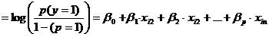
for i = 1…n.

Overfitting. When selecting the model for the logistic regression analysis, another important consideration is the model fit. Adding independent variables to a logistic regression model will always increase the amount of variance explained in the log odds (typically expressed as R²). However, adding more and more variables to the model can result in overfitting, which reduces the generalizability of the model beyond the data on which the model is fit.

o Artificial Neural Networks (ANN)

ANNs are composed of multiple nodes, which imitate biological neurons of human brain. The neurons are connected by links and they interact with each other. The nodes can take input data and perform simple operations on the data. The result of these operations is passed to other neurons. The output at each node is called its activation or node value.

Each link is associated with weight. ANNs are capable of learning, which takes place by altering weight values.

Types of Artificial Neural Networks :

There are two Artificial Neural Network topologies − Feedforward and Feedback.

FeedForward ANN

In this ANN, the information flow is unidirectional. A unit sends information to other unit from which it does not receive any information. There are no feedback loops. They are used in pattern generation/recognition/classification. They have fixed inputs and outputs.

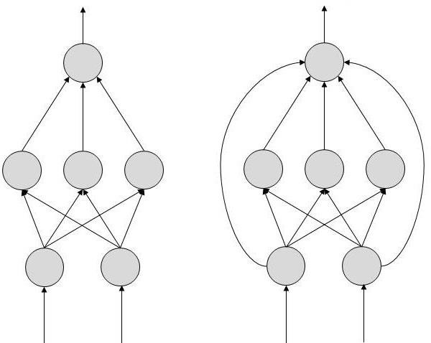
Fig 4: Feedforward ANN

FeedBack ANN

Here, feedback loops are allowed. They are used in content addressable memories.

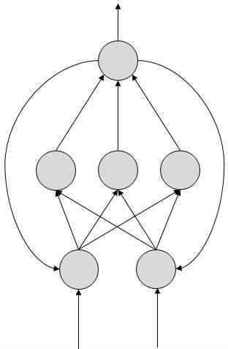
Fig 5: Feedback ANN

WORK DONE

Data Collection
There was a readily available dataset on Kaggle which we used for our project. But due to confidentiality issues, not much information was available about the features of the dataset. Feature were obtained after Pearson correlation.

Data Pre-processing
Data pre-processing is an integral step in Deep Learning as the quality of data and the useful information that can be derived from it directly affects the ability of our model to learn; therefore, it is extremely important that we pre-process our data before feeding it into our model.

4.2.1 Handling Null Values
When we first obtained the data, there were no missing values to be handled.

4.2.2. Standardization
We had to apply Standard Scaling on our dataset to bring all the values within a specified range and to remove the outliers if any.

Data Preparation
Data Preparation is an important step before proceeding with any DL model. In this project, we had multiple categorical values and thus made use of Label Encoder to first convert those values into unique numeric forms and thence proceed further.

Implementation

PHASE I
- The dataset was fed to our model on which the concept of Artificial Neural Networks as well as Logistic Regression was applied. In this phase we applied the model to all the features in the dataset. Following is the accuracy report of the same for ANN and Logistic Regression respectively.
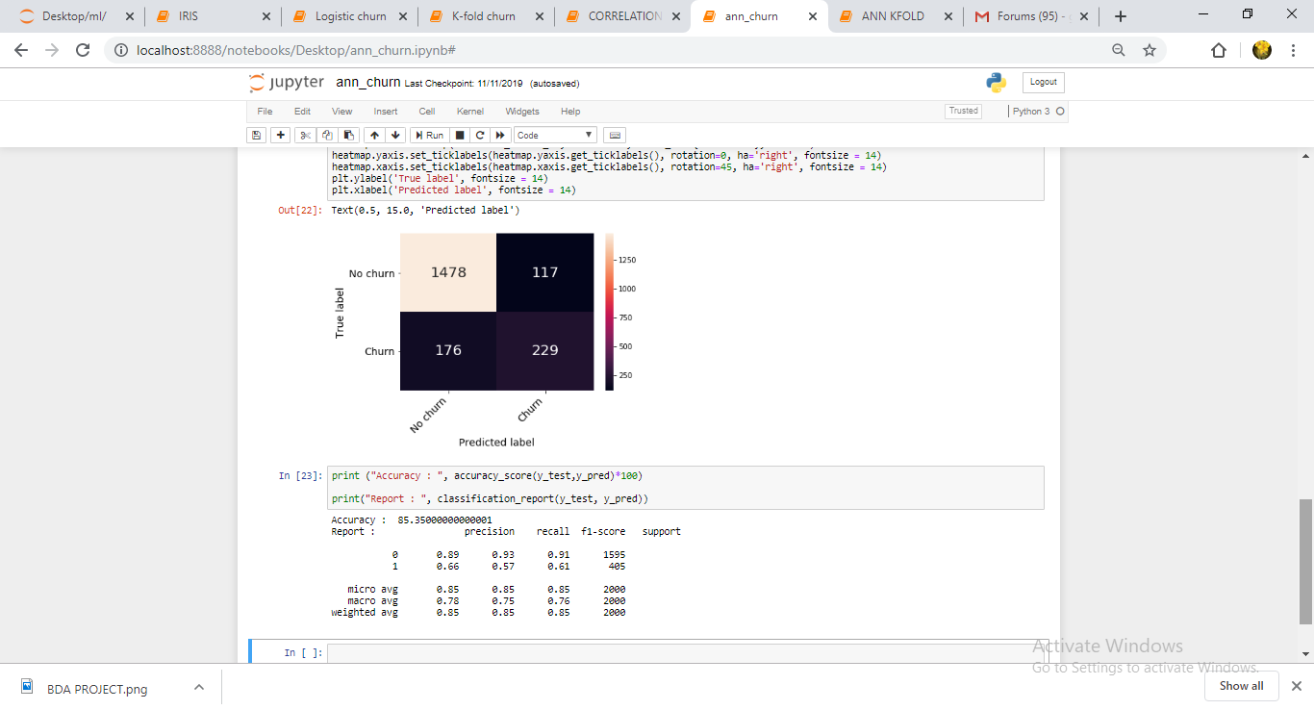
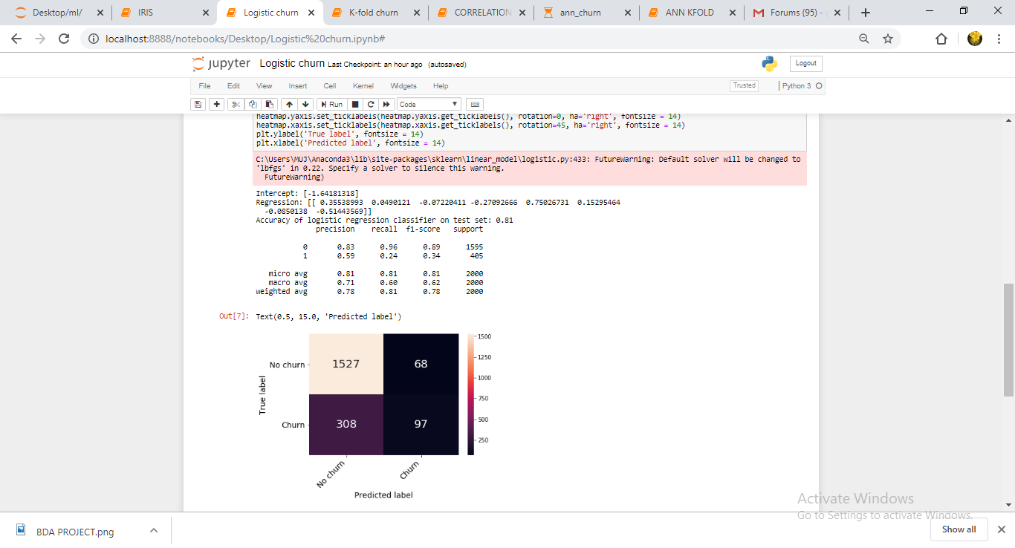

PHASE II
- Applied Pearson correlation with threshold value set at 0.02. Thus only the features that best contributed to classification have been taken into consideration in this phase.
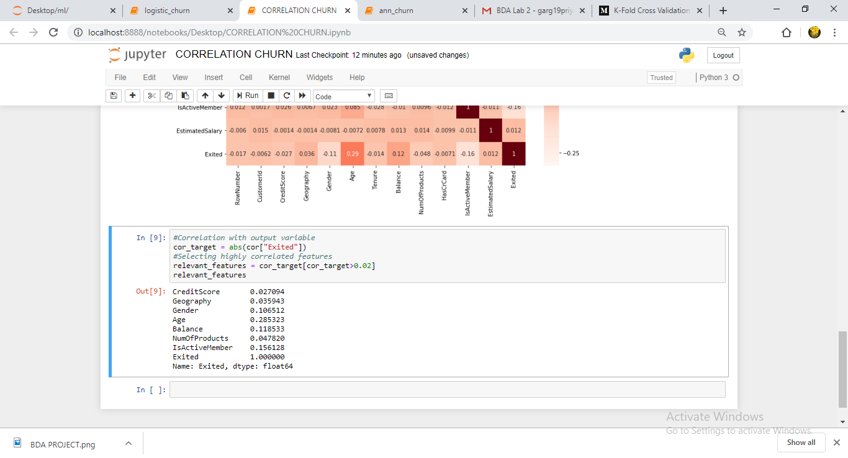
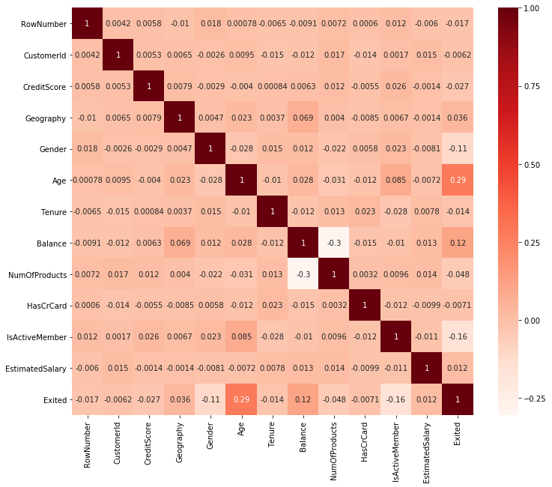
- K-Fold Cross Validation has been applied here for better efficiency and thus accuracy of the model.

Results and Discussion
PHASE I
- ANN Accuracy: 85.36%
- Logistic Accuracy: 81.26%
PHASE II
- ANN Accuracy: 81.86%
- Logistic Accuracy: 50.25%

FUTURE WORK

Suggesting actions to be taken in order to prevent churning would define the scope of future work in this project. Some of those are listed below:

1. Offer Incentives
2. Pay Attention to Complaints
3. Offer long term benefits
4. Prioritize certain services according to your best customers.

CONCLUSION AND FUTURE SCOPE

Customer churn analysis allows to minimize acquisition costs and increase marketing efficiency, preparing a solid base for future marketing analysis and campaigns. Customer churn analysis opens new opportunities for cross-selling and upselling and serves as one of the starting points for customer-driven product development, keeping customers engaged and loyal over time.

The following can be considered to improve the proposed customer loyalty assessment model and actionable knowledge discovery system.

• The proposed models can be further enhanced, if the processes can be parallelizing. This is feasible, by identifying operations that are independent to each other and propose a parallel architecture to improve the performance.

• Amount of memory used loyalty assessment and action discovery is another area which can be analyzed in future.

• Classification process can be improved by using advanced techniques like ensemble clustering or ensemble classification.

REFERENCES
- https://ieeexplore.ieee.org
- https://www.researchgate.net
- https://www.kaggle.com
- https://indatalabs.com/blog/customer-churn-analysis-prediction

