#---------------------------------READ ME----------------------------#

Step 1:

We take the user's input for the URL and pincode. Since we are working on the TATAMG1 website, which determines prices and delivery dates based on the city (not the pincode), we first need to fetch the city from the provided pincode. The technology used here is an API; I used the PostalCode API for this purpose.

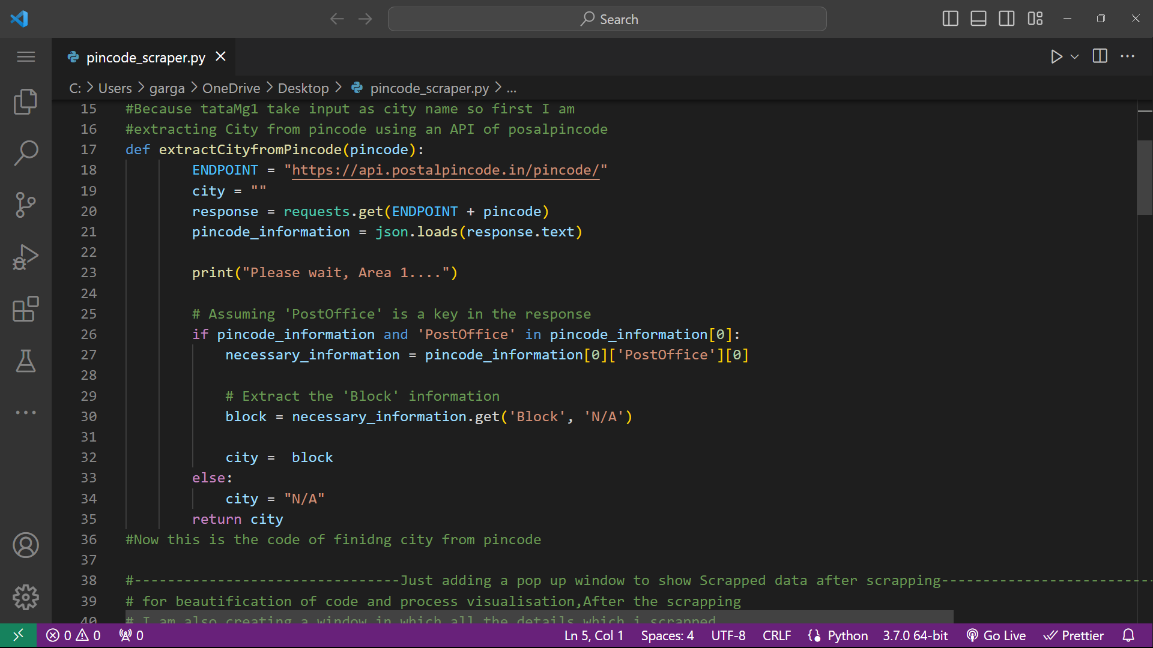

**Step 1 Figure**

Step 2:

Now that I have obtained the city, I will input it into the search bar on the website. However, before doing that, I need to navigate to the website.

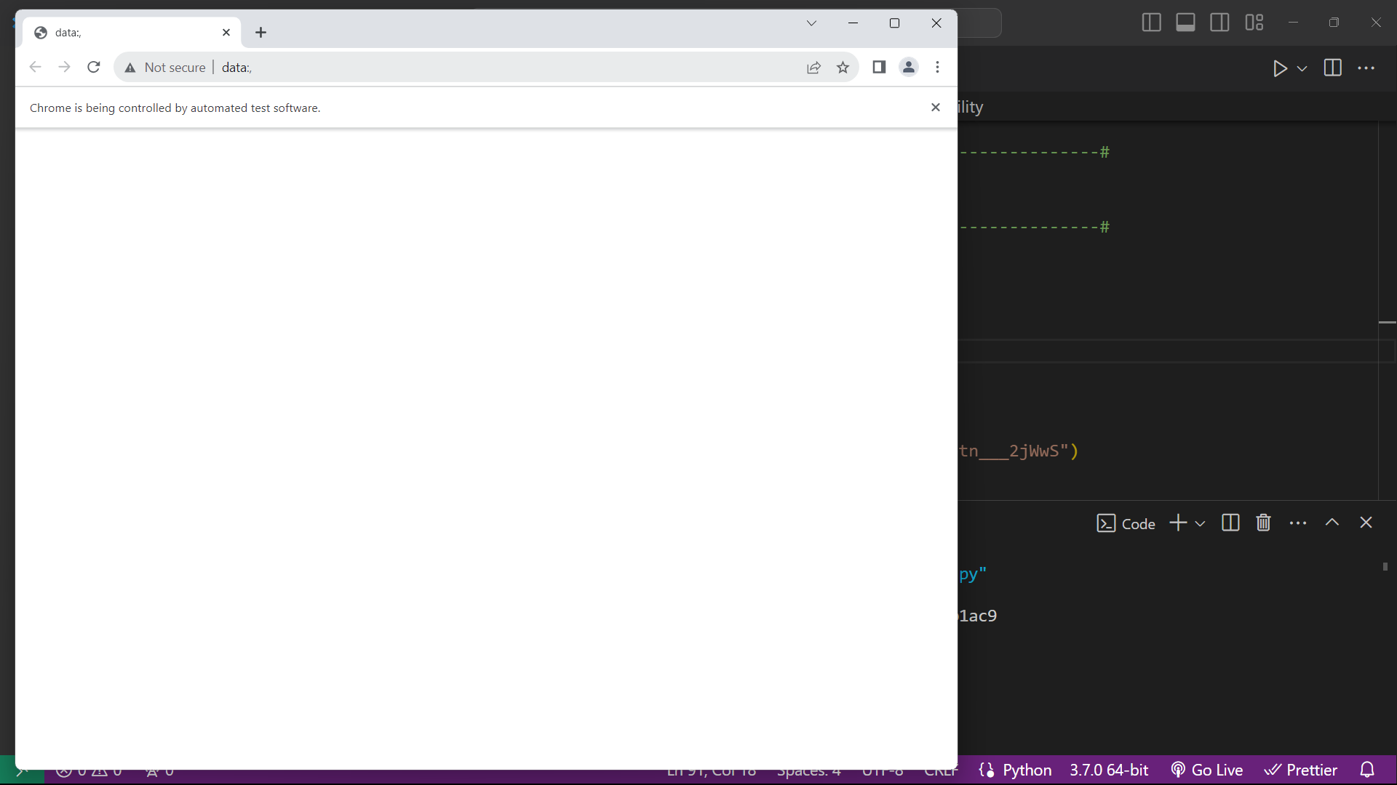

Step 3:

I have written a function to navigate to the website using Selenium. I utilised Selenium and the Chrome driver to open Chrome, and after opening, the URL is typed into the search bar.

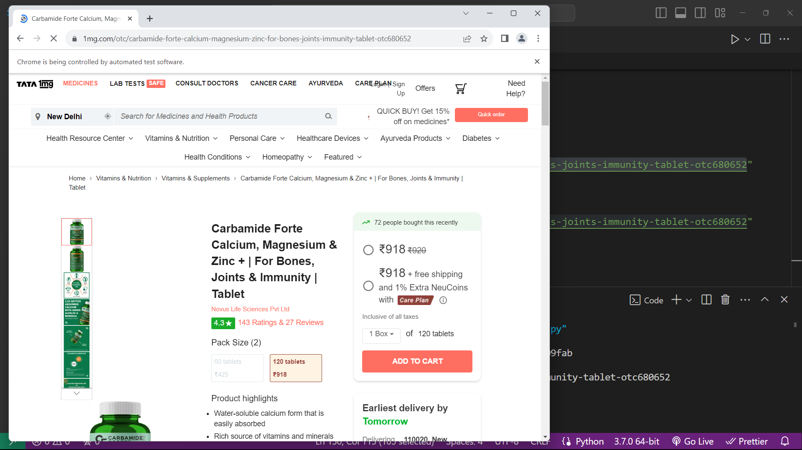

Step 4:

After the website is opened, a pop-up appears that needs to be removed automatically by clicking on cancel. I accomplished this using the findElement by class method and clicking on cancel in the code.

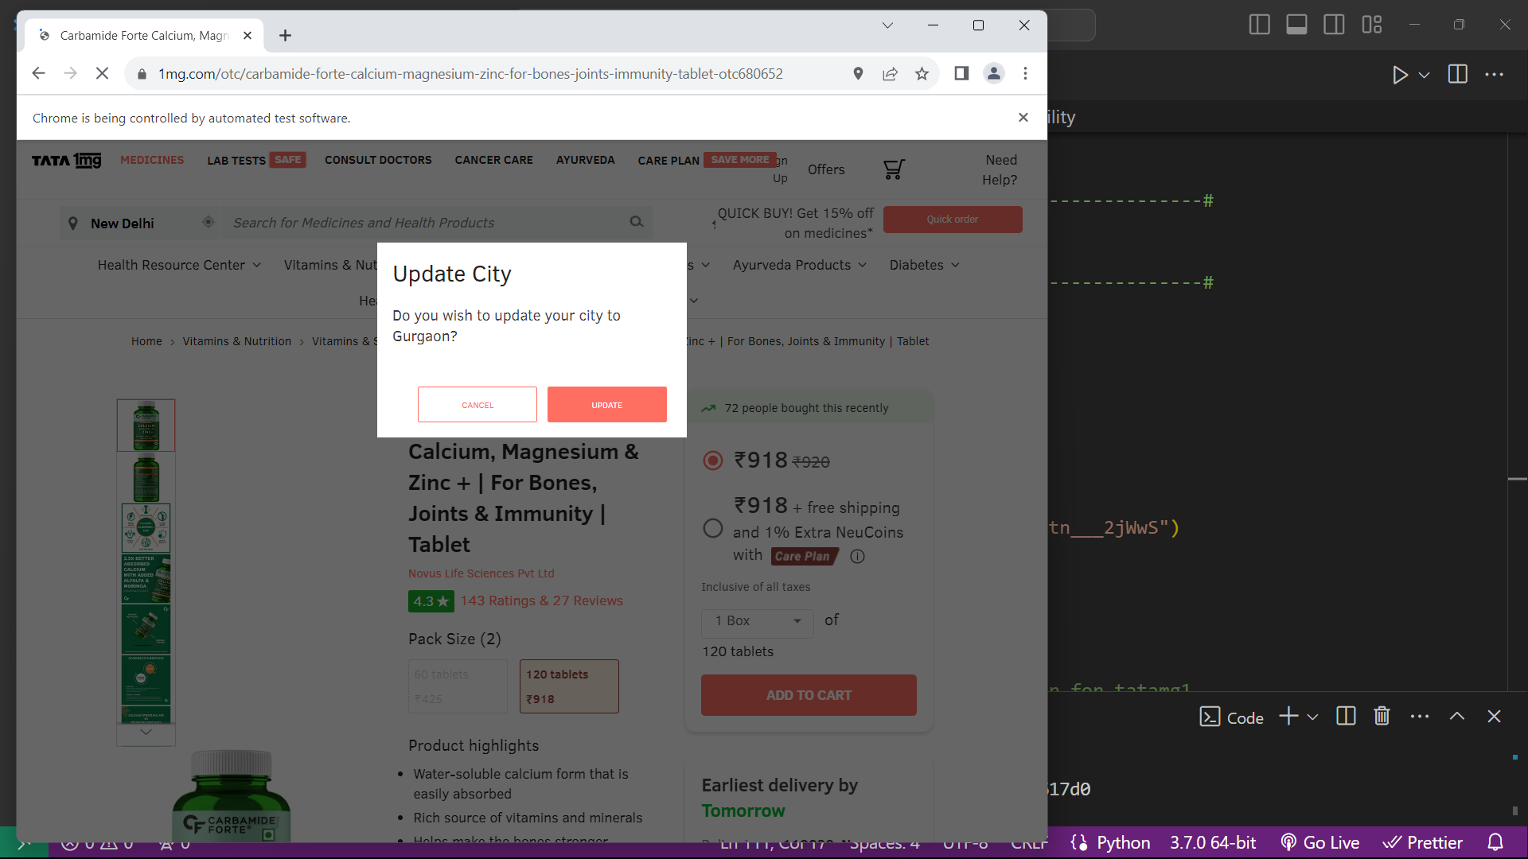

Step 5:

Next, there is a search bar on the screen where we need to enter our city. My code will input the city name obtained in step 1, and then it will click on the city dropdown (pressing Enter doesn't work in this search engine).

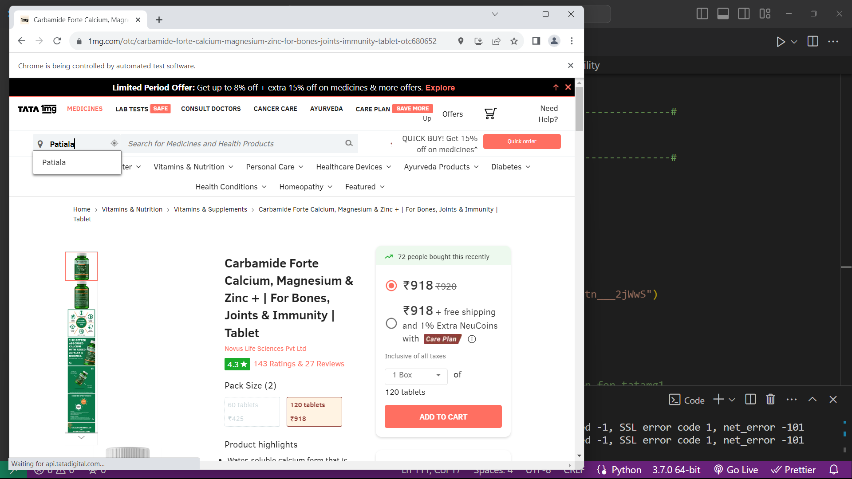

Step 6:

Once the details are displayed on the screen, I will scrape the relevant information from there.

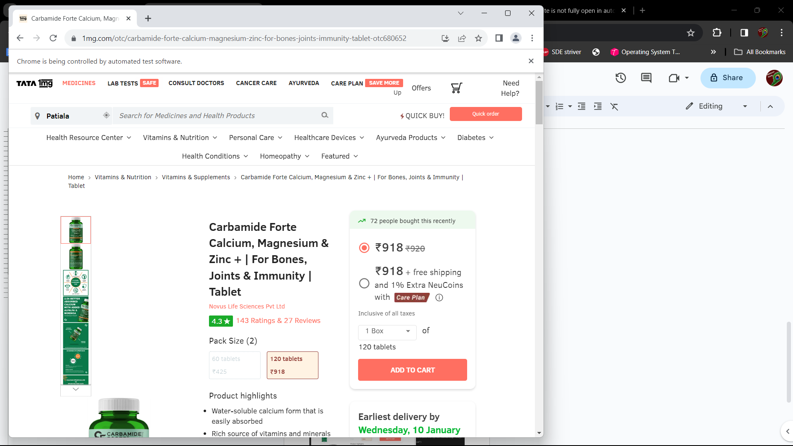

Step 7:

After scraping the details, for better visualization, I am creating a new window to display all the scraped details, in addition to printing them.

