Start working on AWS cloud in less than 10 minutes — At Zero Cost!



AWS EC2 — Free Tier Setup in 12 very simple steps.

In this article I will be covering: How to set-up Elastic Cloud Compute (EC2) machine instance on Amazon Web Services (AWS)

Step 1. Go to: <https://aws.amazon.com/> and log into the AWS Console. Create new account if you don’t have one or use the existing account. Note: for new signup you need to enter credit card details. But if you select all Free Tier services, which I will be covering in this article, you will NOT be charged a penny.

Caution! Do not turn on any service which is not mentioned as Free Tier Eligible. Free Tier account provides lot of privileges refer: [link](https://aws.amazon.com/free/?trk=ps_a134p000003yBfvAAE&trkCampaign=acq_paid_search_brand&sc_channel=ps&sc_campaign=acquisition_US&sc_publisher=google&sc_category=core&sc_country=US&sc_geo=NAMER&sc_outcome=acq&sc_detail=%2Baws%20%2Bfree&sc_content=Cost_bmm&sc_segment=438195701039&sc_medium=ACQ-P|PS-GO|Brand|Desktop|SU|AWS|Core|US|EN|Text&s_kwcid=AL!4422!3!438195701039!b!!g!!%2Baws%20%2Bfree&ef_id=CjwKCAiAzNj9BRBDEiwAPsL0d1J3z7OUK2XkuCmM9PBk_nnhFwEgefmPrXoudrSiVNlFjbWBCwCDvhoCucIQAvD_BwE:G:s&s_kwcid=AL!4422!3!438195701039!b!!g!!%2Baws%20%2Bfree&all-free-tier.sort-by=item.additionalFields.SortRank&all-free-tier.sort-order=asc)

Step 2: Click on Services and select EC2:

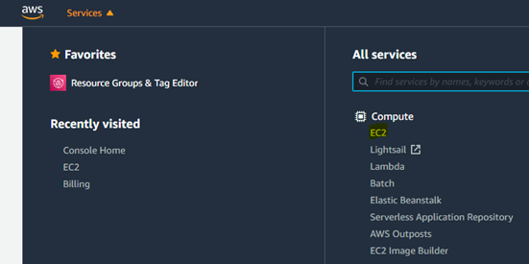AWS Screen post login to select services

Step 3: Click on Launch Instance.

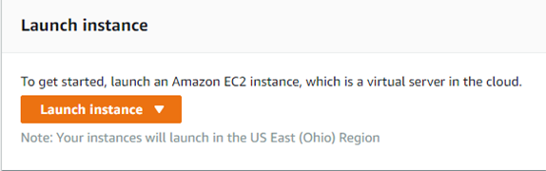AWS: Screenshot to launch instance

Step 4: 1. Select AMI Linux ‘Free tier eligible’. Stick to default selection. Note: You may select another free tier machine. But for simplicity of selection, ease of computation and maintenance I prefer AMI Linux.

AWS: Selection of Amazon Linux ‘Free Tier Eligible’ machine

Step 5: 1. Select t2 micro (highlighted in blue in the screenshot below).

AWS: Selection of machine instance type

Step 6: We will keep all the options as default. Click on ‘Review and Launch’. Highlighted in blue below.

AWS: Instance with default options

Step 7: Click on Launch. Highlighted in blue.

AWS: Launch instance with default options

Step 8: Select ‘Create a new key pair’ from dropdown. This is very important step. You will need this later to connect with the machine.

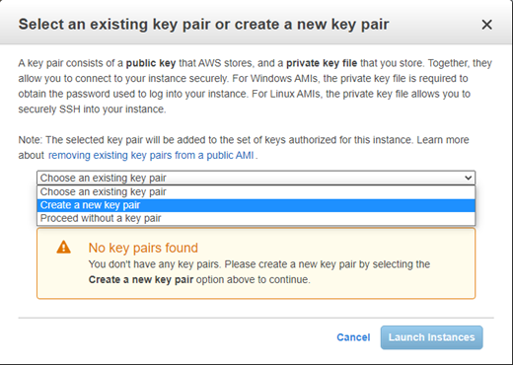AWS: Step to create key-pair required to connect with the instance created

Step 9: Name the key pair as per your choice. I named it Ai4Markets.

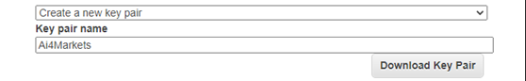AWs: Naming the new key-pair as per your choice

Step 10: Click on ‘Download Key Pair’ grey box. This will generate .pem file. Save this file on your machine. Note: Very important! Please remember the location where you saving this file as we will be using this file later.

Step 11: Click on Launch Instances. You will get below message. This will take few minutes to launch the instance

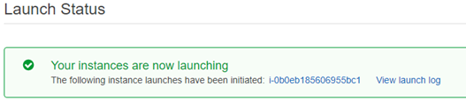AWS: Machine Instance that I created following above steps

Step 12: Click on View Instances to check the status of the launch. Once your machine is launched you will get the ‘Instance state’ as running:

AWS: Running instance that we created following above steps

**CONGRATULATIONS!!! You have successfully launched EC2 instance on AWS.**

Note: In case you don’t need this machine or you want to reboot it, you can Stop or Terminate or Reboot the instance by selecting the instance and from the drop down ‘Instance state’ select the action as required (refer to screenshot below):

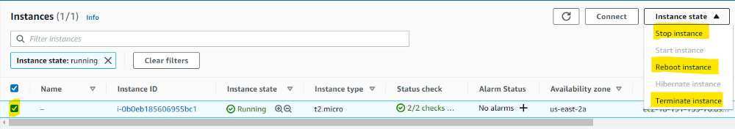AWs: Steps to Terminate / Stop / Reboot instance created

In next article I will be covering how to connect with this instance using Putty.

Thank You.

Happy Learning!

Ankush Garg