Connect and copy data to and from AWS EC2 instance – WinSCP

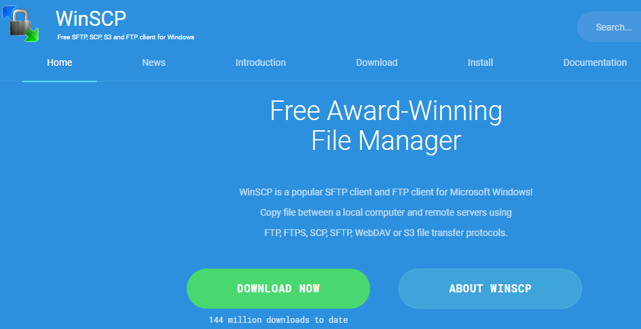Source: WinSCP



Do not have an EC2 instance? No worries! Setup new EC2 instance for FREE in 10 minutes. Article Link: [LinkedIn](https://www.linkedin.com/posts/ankushgarg19_ec2-instance-setup-steps-ugcPost-6736310776782487552-kXWi) and [Medium](https://medium.com/ai4markets/start-working-on-aws-cloud-in-less-than-10-minutes-at-zero-cost-b5e87aec7a5e)

Step 1: Download and install WinSCP: [Link](https://winscp.net/eng/download.php)



Step 2: Install. Go with all the default options

Step 3: Start WinSCP

Step 4: Click on new Site. Following window will open:

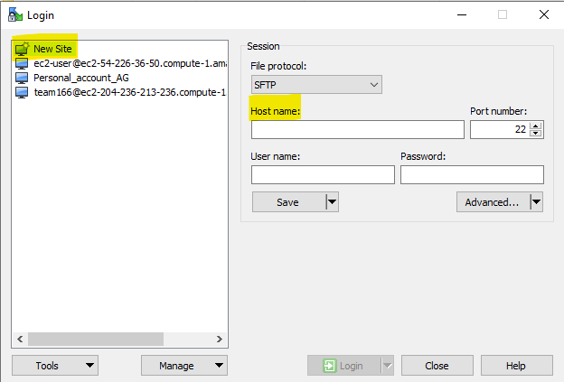

Ignore other names below New Site. I created other configurations earlier.

Step 5: To connect to our EC2 instance we need it’s Host Name. You can find this on the instances page on AWS. Login to AWS and go to running instances. To set-up instance refer to another article link: [LinkedIn](https://www.linkedin.com/posts/ankushgarg19_ec2-instance-setup-steps-ugcPost-6736310776782487552-kXWi) or [Medium](https://medium.com/ai4markets/start-working-on-aws-cloud-in-less-than-10-minutes-at-zero-cost-b5e87aec7a5e)

Screenshot below highlights Host Name in blue. Add this to Host name box highlighted in above screenshot.

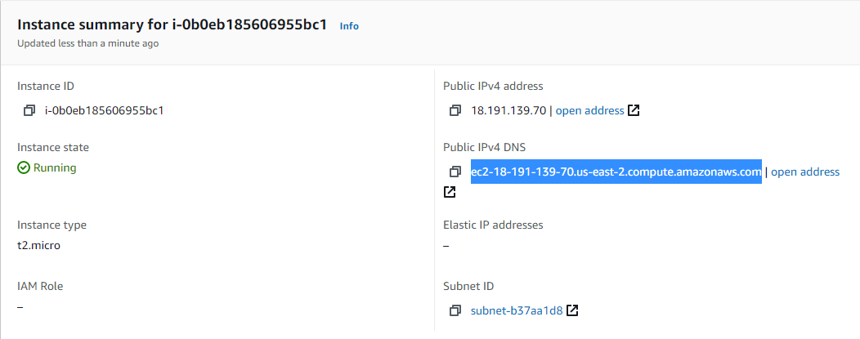

Step 6: In the Username add ‘ec2-user’. This is default for AMI Linux. Refer to screenshot below:

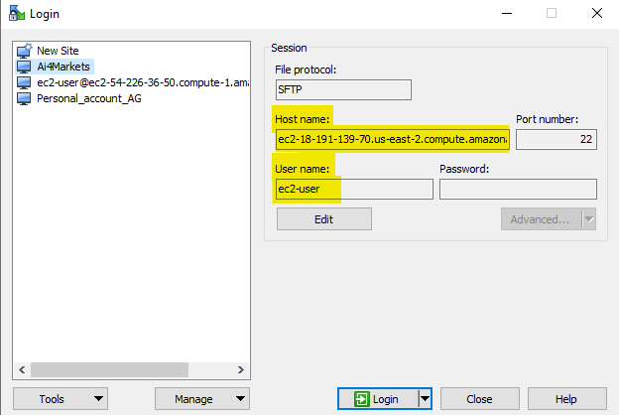

Step 7: Click Advanced button. Under Advanced select SSH and Authentication. We need to enter .ppk file here.

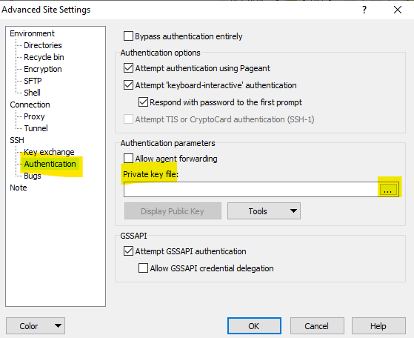

Step 8: Select the private key file. Created when EC2 was launched. Refer to article link: [LinkedIn](https://www.linkedin.com/posts/ankushgarg19_ec2-instance-setup-steps-ugcPost-6736310776782487552-kXWi) or [Medium](https://medium.com/ai4markets/start-working-on-aws-cloud-in-less-than-10-minutes-at-zero-cost-b5e87aec7a5e)

Step 9: Save the session so that we do not want to repeat above steps to connect with EC2 instance. To save: click on save. Add Site Name as per your choice. I have added Ai4Markets

Step 10: Click on Login

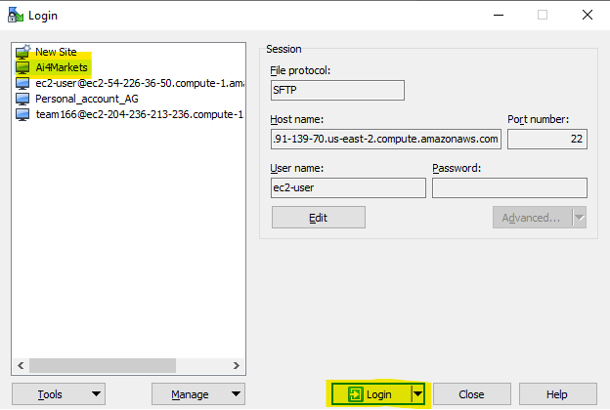

Step 11: You will get warning. Click yes

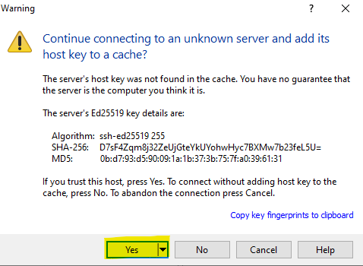

Step 12: You will be logged in and see following screen. Wherein left pane is folder on your machine and right pane is EC2 instance created.

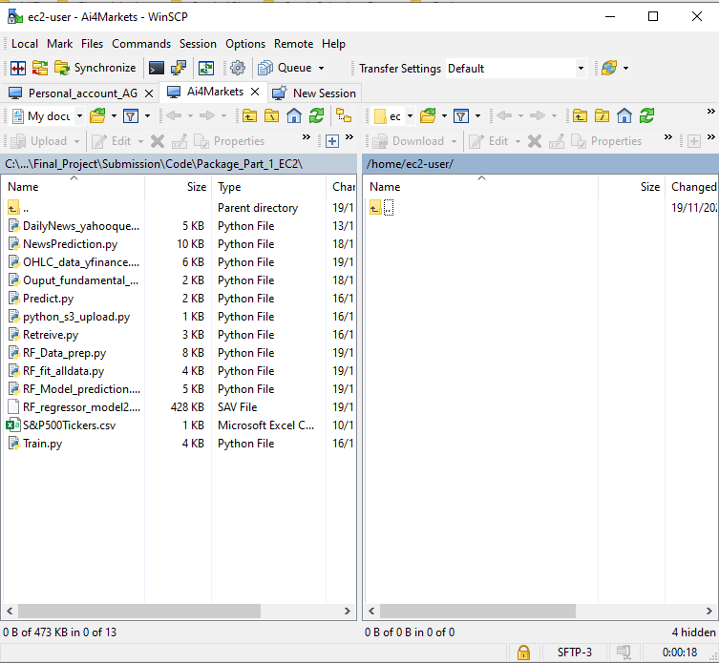

CONGRATULATIONS!!! You have connected to EC2 instance with WinSCP and can drag and drop data between your local machine and EC2 instance.

Happy Cloud Learning

Thank You.

Ankush Garg

Email: [Anks.garg@gmail.com](mailto:Anks.garg@gmail.com)

LinkedIn: [linkedin.com/in/ankushgarg19](https://www.linkedin.com/in/ankushgarg19)

Medium: <https://gargankush.medium.com/>