Connect with AWS EC2 instance - Putty



Very simple steps to connect with EC2 instance from your Laptop / Desktop



Do not have an EC2 instance? No worries! Setup new EC2 instance for FREE in 10 minutes. Article Link: [LinkedIn](https://www.linkedin.com/posts/ankushgarg19_ec2-instance-setup-steps-ugcPost-6736310776782487552-kXWi) and [Medium](https://medium.com/ai4markets/start-working-on-aws-cloud-in-less-than-10-minutes-at-zero-cost-b5e87aec7a5e)

Step 1: Download and Install Putty: Link: <https://www.chiark.greenend.org.uk/~sgtatham/putty/latest.html>. Download and install based on your local machine operating system (Windows or Unix). I am on windows 64 bit.

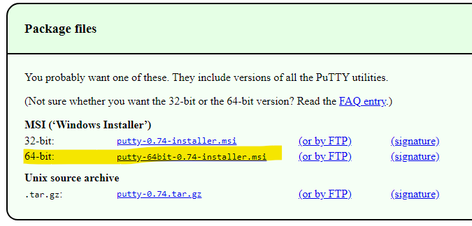

We need putty to convert the key pair in the “*.pem*” file to a “*.ppk*” file so that Putty can understand it and to connect with EC2 instance created.

Step 2: Install Putty. Follow the instruction on the screen for installation. Please go with default options for installation

Step 3: Once installation is complete ‘Open Puttygen’. For ease search for Puttygen in search bar as shown in screenshot

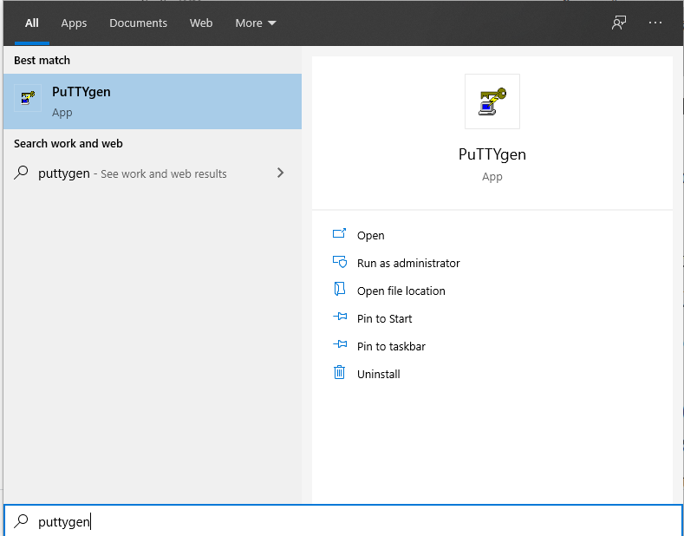

Step 4: Click on puttygen.

Step 5: Click on load and select the .pem file that we saved in the EC2 launch step (Refer to EC2 instance setup instructions here: [LinkedIn](https://www.linkedin.com/posts/ankushgarg19_ec2-instance-setup-steps-ugcPost-6736310776782487552-kXWi) and [Medium](https://medium.com/ai4markets/start-working-on-aws-cloud-in-less-than-10-minutes-at-zero-cost-b5e87aec7a5e)

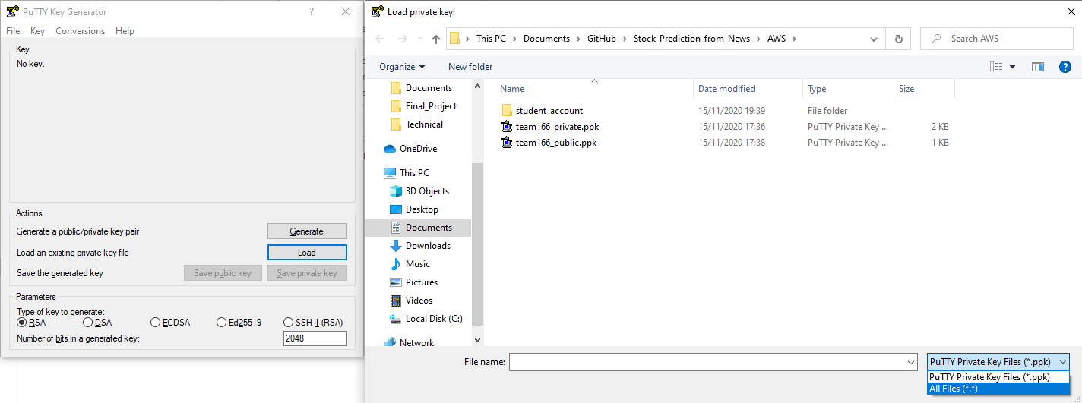

Step 6: Select .pem file. In my case it was ‘Ai4Markets.pem’ and click open

Step 7: You will get message ‘Successfully imported foreign key’. Click Ok

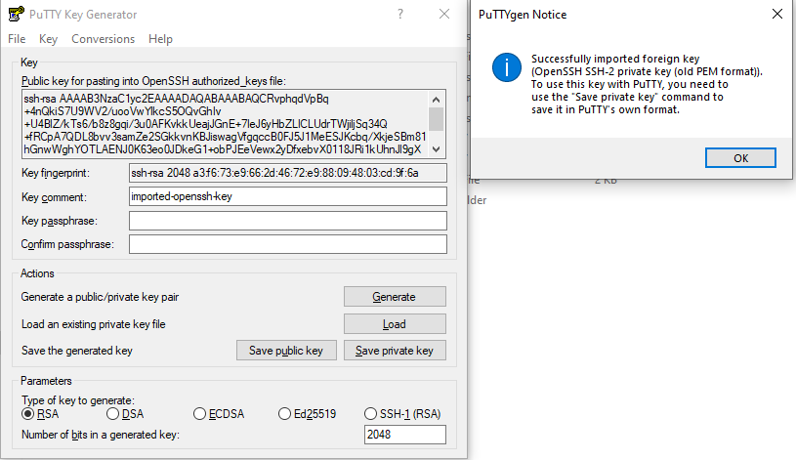

Step 8: Save the private key by clicking ‘Save Private key’

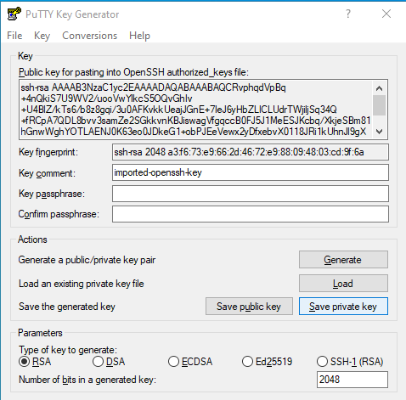

Step 9: Name the private key as per your choice. I named it as Ai4Markets. This will save private key as Ai4Markets.ppk

Step 10: Now, Open Putty. To connect to our EC2 instance we need it’s Host Name. Please log in to your AWS account and click on instances.You can find this on the Instances page on AWS. Refer to screenshot below. I have highlighted Host Name in blue. To setup EC2 instance please refer to steps here: [LinkedIn](https://www.linkedin.com/posts/ankushgarg19_ec2-instance-setup-steps-ugcPost-6736310776782487552-kXWi) and [Medium](https://medium.com/ai4markets/start-working-on-aws-cloud-in-less-than-10-minutes-at-zero-cost-b5e87aec7a5e)

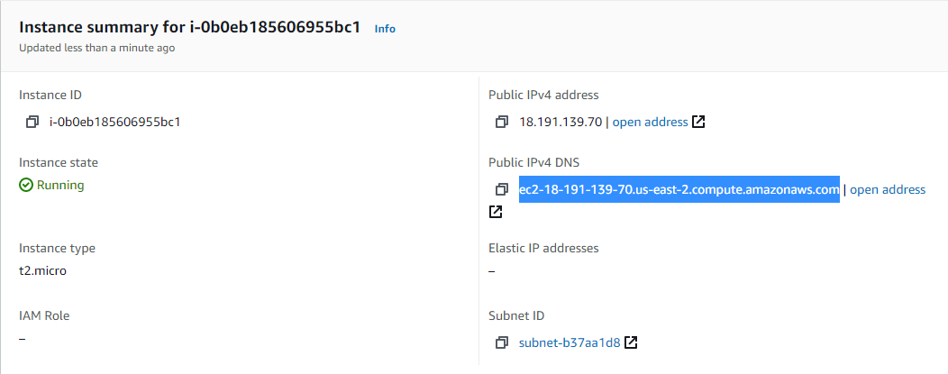

Step 11: Prefix the host name with ‘ec2-user@’ as this is user name for Amazon Linux AMI. So, the full host name becomes: [ec2-user@ec2-18-191-139-70.us-east-2.compute.amazonaws.com](mailto:ec2-user@ec2-18-191-139-70.us-east-2.compute.amazonaws.com). Note: there should be no space between ec2-user@ and public domain

Step 12: Add the full host name created to putty as shown in screenshot below: Don’t change the port. Leave it as default 22

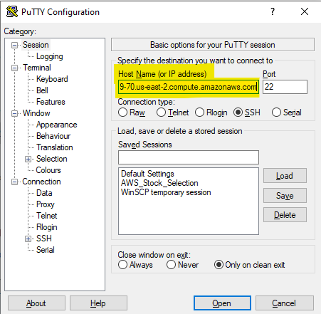

Step 13: Next, under the “Category” pane on the left hand side, expand “SSH” and then select “Auth”. Under “Authentication Parameters”, Browse for the “.ppk” file we created above (Ai4Markets.ppk) and select it. Now go back to “Session” in the “Category” pane on the left.

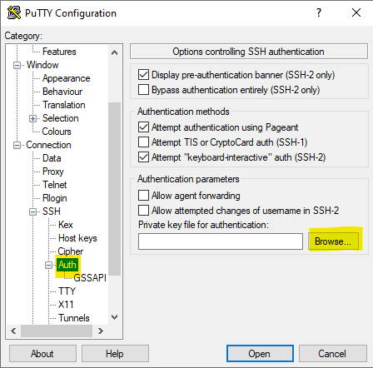

Step 14: Save this session configuration so that we don’t have to type in everything again the next time we connect. So, type in a name under “Saved Sessions” and then click “Save”. Next time we want to launch it, just select the session and click on “Load”, it should also load the “.ppk” file automatically for authentication. I have named as Ai4Markets

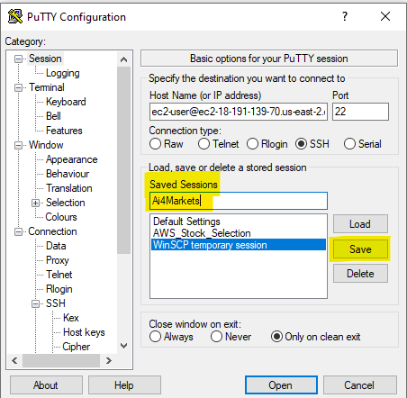

Step 15: Click Open. The Putty terminal should open up and you will also get a Security Warning, just click “Yes”.

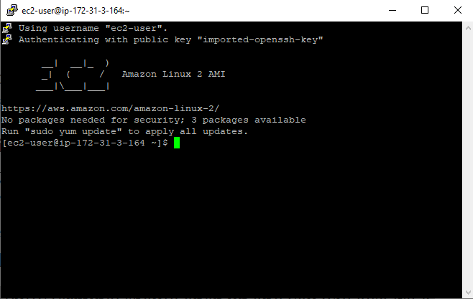

# Congratulations!!! You are connected to EC2 instance.

Happy Cloud Learning

Thank You.

Ankush Garg

Email: [Anks.garg@gmail.com](mailto:Anks.garg@gmail.com)

LinkedIn: [linkedin.com/in/ankushgarg19](https://www.linkedin.com/in/ankushgarg19)

Medium: <https://gargankush.medium.com/>