SS Nesten Solution Pvt. Ltd.



A project documentation

On

“NodeJS and JavaScript”

**Submitted by:-**

Bhushan Kumar

**Submitted to:-**

Mr. Seernu.

**Content**

|  |  |  |
| --- | --- | --- |
| SR.NO | Chapter Name | Page no. |
| 01. | INTRODUCTION | 02 |
| 02. | DEVELOPMENT TOOLS | 02 |
| 03. | SYSTEM REQUIREMENTS | 02 |
| 04. | FEATURE | 02 |
| 05. | SNAPSHOTS | 02-05 |
| 06. | SOURCE CODE | 05-08 |

***Introduction***

The objective of this mini project is to design an dynamic game and on online frameworks which is full fledged logic and environment using new trending technologies in market with functionalities, efficienecy maximum optional speed on web and one key feature it must be more information.

JavaScript is a cross-platform, object-oriented scripting language used to make webpages interactive (e.g., having complex animations, clickable buttons, popup menus, etc.). There are also more advanced server side versions of JavaScript such as Node.

**Development tools**:-

1. Language Css ,Javascript and HTML.
2. I have used Sublime Text as my editior.
3. Web-browser: mozila firefox/Google chrome/opera mini.
4. Framework and Libraries: Bootstrap , Math and JQuery.

**System Requirements:**

* Operation System(Window)
* Web Server
* Google API Fonts

**Features :-**

* Userfriendly.
* Informative.
* Chain scope.

**Snapshot :-**

* First Page when game starts. Which display the Game format.

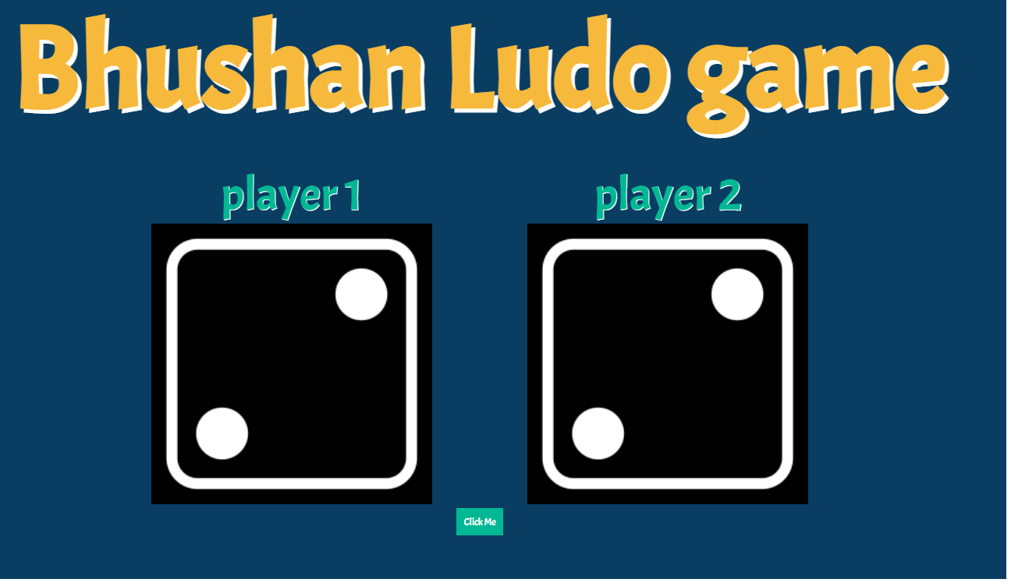

* Second snapshot when button is clicked. In these event is trigger and show which playerwon the game.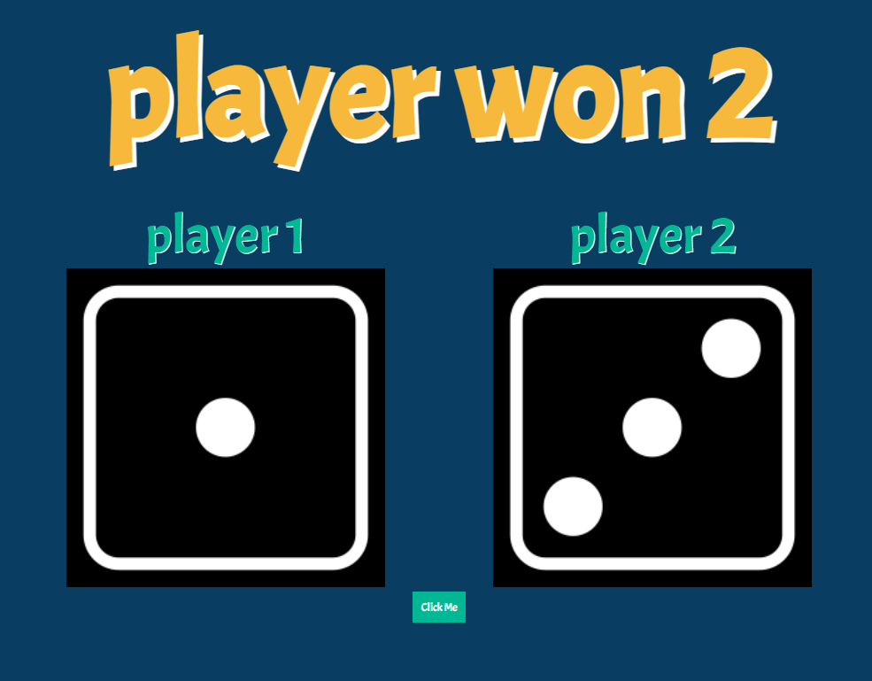
* Third snapshot, when both the dice having some value.

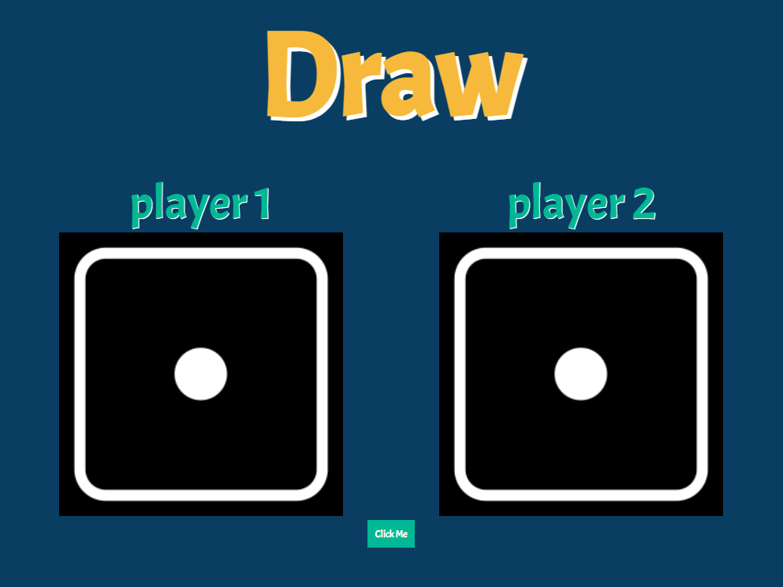

**Source code in HTML with Javascript.**

<html>

<head>

<title></title>

<link rel="stylesheet" type="text/css" href="style.css">

<link href="https://fonts.googleapis.com/css2?family=Acme" rel="stylesheet">

</head>

<body>

<div class = "container">

<h1>Bhushan Ludo game</h1>

<div class = "dice">

<p>player 1</p>

<img src = 'diceimage/dice 2.png' id ='checkimg'>

</div>

<div class = "dice">

<p>player 2</p>

<img src = 'diceimage/dice 2.png' id = 'checkimg2'>

</div>

<div>

<button onclick="ludogame()"> Click Me</button>

</div>

</div>

<script type="text/javascript">

function ludogame(){

const play1 = Math.floor(Math.random()*6)+1;

const play1dice = `diceimage/dice ${play1}.png`;

document.getElementById('checkimg').setAttribute("src",play1dice);

const play2 = Math.floor(Math.random()*6)+1;

const play1dice2 = `diceimage/dice ${play2}.png`;

document.getElementById('checkimg2').setAttribute("src",play1dice2);

if(play1>play2){

document.querySelector('h1').innerHTML = "player won 1";

}else if(play1<play2){

document.querySelector('h1').innerHTML = "player won 2";

}else{

document.querySelector('h1').innerHTML = "Draw";;

}

}

</script>

</body>

</html>

***Source code in css.***

*{

margin:0 ;padding: 0;

font-family: 'Acme', sans-serif;

}

body{

background-color: #0a3d62;

}

.container{

width: 70%; margin: auto; text-align: center;

}

.dice{

text-align: center;display: inline-block;

}

h1{

margin: 30px;

text-shadow: 5px 5px white;

font-size: 10rem;

color: #f6b93b;

}

p{

font-size: 4rem;

color: #00b894;

text-shadow: 1px 1px white ;

}

button{

padding: 10px;

background-color:#00b894; color: white;

border: none;

}

img{

width: 75%;

}