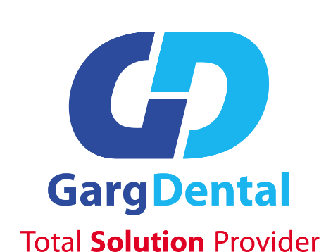

{{ proposal.title }}
Authorized Distributor for below listed companies for the territory of Nepal

Submitted to:
{{ customer.designation }}
{{ customer.company_name }}
{{ customer.address }}
Nepal

Submitted by:

Garg Dental Pvt Ltd
127, Gairidhara, Kathmandu
Bagmati, Nepal
Tel: + 977-1-4436544
Emai: info@gargdental.com

Ref No: {{ customer.reference_number }}
Date: {{ proposal.quotation_date }}

To
{{ customer.designation }}
{{ customer.company_name }}
{{ customer.address }}
Nepal
Subject: {{ proposal.subject }}
Dear Sir,
We thank you for your enquiry for RVG Sensor & Portable X-ray. We derive extreme pleasure in informing you that we are the authorized distributor for below listed companies for the territory of Nepal. Please find our offer as below.{{ (' Notes: ' + customer.notes) if customer.notes else '' }}

S N | DESCRIPTION | RATE (NRS)
{%tr for item in items %}
{{ loop.index }}. | {{ item.product_name }}  MODEL : {{ item.model }}  BRAND: {{ item.brand }}  ORIGIN: {{ item.origin }}  {% if item.image %}{{ item.image }}{% endif %}  Key Features :  - {%p for f in item.features %}  - {{ f }}  - {%p endfor %}  - {{ ('Warranty: ' + item.warranty) if item.warranty else '' }}  - {{ 'Technical Specifications :' if item.specifications else '' }}  - {%p for s in item.specifications %}  - {{ s }}  - {%p endfor %}  - {{ 'Accessories :' if item.accessories else '' }}  - {%p for a in item.accessories %}  - {{ a }}  - {%p endfor %}  - {{ ('Installation Notes: ' + item.installation_notes) if item.installation_notes else '' }}  - {{ ('Additional Notes: ' + item.additional_notes) if item.additional_notes else '' }} | {{ item.rate_formatted }}
{%tr endfor %}
 | Subtotal | {{ totals.subtotal_formatted }}
 | Discount | {{ totals.discount_formatted }}
 | VAT | {{ totals.vat_formatted }}
 | Grand Total | {{ totals.grand_total_formatted }}

TERMS & CONDITION

{%p for term in company.terms %}
{{ term.0 }}: {{ term.1 }}
{%p endfor %}
Warranty is invalid under the following condition:
- Damages due to power fluctuations, stable power supply and protection must be ensured.
- Damages due to fire, natural calamity, flood, earthquake etc. (within scope of insurance)
- Lack of moisture control, humidity, dust.
- Use of fake or low quality spares, tempering by untrained technicians/engineers
- Manhandling, physical damage etc. irrespective of any conditions.
We should be glad to be favored with your order and are always at your disposal for further information.

For & on behalf of

………………………………………
Garg Dental Pvt. Ltd
Gairidhara, Kathmandu

