SVKM's NMIMS · Mukesh Patel School of Technology Management & Engineering, Mumbai
Immersive Virtual Reality & Augmented Reality (IVRAR - 702TG0C003) · AY 2026–27 Odd Semester
GROUP 11 TECHNICAL DOSSIER
Capstone ICA (20 marks): SBL Studio Project 10 · DBL Usability Case Study 5 · Studio Showcase & Viva Voce 5
Group / Batch | Group 11 · Batch B2 (as allotted in the finalised PBL titles sheet)
Monorepo folder | https://github.com/sunny-nanade/NMIMS-MPSTME-IVRAR-2026/tree/main/Group_11_Jaineel_Dev_Nimitt_Husepas
Submit (3 places) | (1) PDF on MS Teams, turned in by EVERY member · (2) this filled Word file AND its PDF committed to Group_11_Jaineel_Dev_Nimitt_Husepas/docs/IVRAR_Group_11_Technical_Dossier.docx / .pdf · (3) LinkedIn video URL in Section 5. Due Monday, 26-Oct-2026, 23:59 IST. Studio Showcase, Expo & Viva Voce: Saturday, 31-Oct-2026.
How to fill this file | Use Microsoft Word (desktop recommended). Choose answers from the 'Select ▾' drop-downs and type into the 'type here' fields. Do not delete or retype them, and do not edit this file in Google Docs: the drop-downs are how your answers are read.

Student name | Roll No. | SAP ID | Programme | Batch | Declared studio role
JAINEEL SHAH | R057 | 70512400041 | MBA (Tech) (Artificial Intelligence) | B2 | Smart Kiosk & WebXR Lead
DEV GARG | S014 | 70522400103 | MBA (Tech) (Data Science) | B1 | Mobile AR & Navigation Specialist
NIMITT JAIN | S021 | 70522400099 | MBA (Tech) (Data Science) | B1 | Sustainability & Usability Analyst
HUSEPAS MARFATIA | J032 | 70092400004 | B Tech (Data Science) | B1 | Spatial Analytics & Wayfinding Telemetry Lead
SECTION 1 · Problem Bottleneck, Industry Standard & Aalborg Research Title SBL Studio Project
Authorised Aalborg title | How can a hybrid smart AR kiosk and mobile handoff system reduce transit time and paper map waste for campus visitors navigating complex university facilities?
Original draft title | How can an AR-based Smart Campus Wayfinding System help first-time visitors navigate SVKM's NMIMS campus while improving navigation efficiency and reducing reliance on printed directional signage?
Why the title changed | The submitted title used vague marketing phrasing ('help visitors navigate easily, reducing paper waste'). It failed to explain the technical mechanism linking a fixed kiosk to a moving user.

1.1 Baseline friction & governing standard: claim verification table

Claim (as in title sheet) | Faculty pre-audit note | Primary source you verified (author, year, venue, DOI/URL) | Source type | Keep / Correct / Delete
ISO 14001 Environmental Management. | Not yet checked: verify | ISO 14001:2015, Environmental management systems - Requirements with guidance for use (with Amd 1:2024), ISO. Listed as current in the SIS and AFNOR catalogues (iso.org page not reachable when checked). Context only: it certifies an organisation, not a navigation app. | Standard (ISO / IEC / NFPA / NIST…) | Keep
Large campuses distribute 15,000-25,000 paper maps annually, 80% discarded in 24h. | Faculty pre-audit: the '15,000–25,000 maps, 80 % discarded in 24 h' figure has no traceable source; measure it on campus or delete it. | No traceable source found (matches the faculty note). Not used in the dossier, video or paper; to be measured on campus or left out. | No source found | Delete
Mobile handoff latency must remain < 3.0s to maintain seamless user flow. | Not yet checked: verify | Nielsen, J. (1993) Response Times: The 3 Important Limits, Nielsen Norman Group (0.1 s, 1 s, 10 s; no 3 s limit): nngroup.com/articles/response-times-3-important-limits/. So 3.0 s is our own design target; the literature gives 1 s (flow) and 10 s (attention). | Other web page | Correct

1.2 Baseline friction in your own words (3–4 lines: who struggles, with what, how it is measured today):
Who: first-time visitors to the 10-level MPSTME building (LG to level 8, 96 named rooms) who must find one room using printed maps or by asking staff.
Baseline number (measured on our 3D campus model, not on people): the walking route by stairs from the main gate averages 147.5 m per room (range 46.5 m to 253.9 m, 96 of 96 rooms).
Source: telemetry/MODEL_route_metrics.csv in our repository. How it is measured today: the status quo (printed map or asking staff) was not measured by us. Our 27-Oct study (N = 10) tested only our own system (SUS 90.5), with no baseline condition and no timing data.

SECTION 2 · C# Script Architecture & Mathematical / Behavioural Model SBL Studio Project
C# scripts in your monorepo folder today | SmartKioskHandoffManager.cs · MobileWebXRRouteNavigator.cs · S021NavigationAnalytics.cs · S014NavigationController.cs (+ 13 S014 helper scripts)
Telemetry logger named in the title sheet | KioskTelemetryLogger.cs
Core state machine | Kiosk idle → Destination chosen → QR generated → Phone handoff → Navigating → Arrived
Fundamental equations | Handoff latency = t_mobile_route_shown − t_QR_scanned (s)  Paper saved / year = visitors × maps per visitor  Dijkstra shortest path (as Group 6)
Toolchain (title sheet) | Unity WebGL kiosk client generating dynamic QR codes (ZXing.Net); Mobile AR Foundation navigation client; Dijkstra shortest path; C# KioskTelemetryLogger.cs.

2.1 Authorship of each script

Script | Written / Modified / Used as given | Main author (Roll) | What you changed or added (1 line)
SmartKioskHandoffManager.cs | Modified by us | R057 | Added encrypted token, 45 s lease and A* route; resolved the TODOs
MobileWebXRRouteNavigator.cs | Modified by us | S014 | Comments only: TODOs now point to the implementing files
S021NavigationAnalytics.cs | Written by us | S021 | Deviation count and CSV metrics through the IS014 interfaces
S014NavigationController.cs (+ 13 S014 helper scripts) | Written by us | S014 | Waypoint progress, arrow, floor alerts, WebXR pose boundary
CampusVR Quest scripts (guide, kiosk, walk grid, voice, flow) | Written by us | S014 | 10 runtime + 3 editor scripts in Unity_Quest_Campus
HandoffPayloadCodec.cs + CampusGraph.cs | Written by us | R057 | New token codec and A* graph, 15-check test tool

2.2 Key code snippet (≤ 25 lines) that implements your state machine or main equation:
S014WalkGrid.cs (Unity_Quest_Campus/Assets/S014_MobileAR/CampusVR)
14: const float C = 0.5f, MAXUP = 0.30f, MAXDOWN = 1.0f;
95: var top = Pop(heap); float d = top.Key; int u = top.Value;
96: if (d > dist[u]) continue;
97: if (u == g) break;
99: for (int e = 0; e < 8; e++) // 8 neighbouring cells
105: for (int v = start[vc]; v < start[vc + 1]; v++)
107: float dy = ys[v] - y; if (dy > MAXUP || dy < -MAXDOWN) continue;
108: float nd = d + (e < 4 ? C : C * 1.4142f) * ((uw && wide[v]) ? 1f : 40f);
109: if (nd < dist[v]) { dist[v] = nd; parent[v] = u; Push(heap, nd, v); }
(Dijkstra with a binary heap; lines 100-104 and 110-112 omitted: bounds checks, corner-cutting test, closing braces)

2.3 Equation derivation and one worked example with your own numbers and units:
Equation (S014WalkGrid.cs line 108): w(u,v) = s x k, and the route is P* = argmin of the sum of w(u,v) over the baked walkable grid (Dijkstra).
Symbols: s = step length, 0.5 m straight or 0.5 x sqrt(2) = 0.7071 m diagonal. k = 1 when both nodes are "wide" (clear floor), k = 40 otherwise. A move needs -1.0 m <= dy <= +0.30 m.
Derivation: the 3D campus is cut into 0.5 m cells; each standing surface (floor, stair tread, landing) is one node, 82,088 nodes in total. The factor 40 makes the cheapest path keep to clear floor instead of door frames.
Worked example: 10 straight steps between wide nodes cost 10 x 0.5 x 1 = 5.0; the same 10 steps through narrow nodes cost 10 x 0.5 x 40 = 200 (40 times more). One wide diagonal step costs 0.5 x 1.4142 = 0.7071.
Result: Floor 6 "AI Lab" by stairs has a planned route of 173.9 m (at an assumed 1.2 m/s about 145 s).
telemetry/MODEL_route_metrics.csv in our repository. How it is measured today: the status quo (printed map or asking staff) was not measured by us. Our 27-Oct study (N = 10) tested only our own system (SUS 90.5), with no baseline condition and no timing data.

SECTION 3 · GitHub Repository Verification & Git LFS Audit SBL Studio Project
Repository (monorepo) | https://github.com/sunny-nanade/NMIMS-MPSTME-IVRAR-2026
Your group folder | Group_11_Jaineel_Dev_Nimitt_Husepas/
Filled dossier location | Group_11_Jaineel_Dev_Nimitt_Husepas/docs/IVRAR_Group_11_Technical_Dossier.docx and .pdf
Release tag | group-11-v1.0 · build: WebGL kiosk + Android .apk / WebXR

Final commit hash (full 40 characters) | cdcdc7372dc92d0baecd3de902d144fd8ea4ab19
Release build link (.apk / .exe) | https://github.com/gargdev07/NMIMS-MPSTME-IVRAR-2026/releases/tag/group-11-v1.0
Root .gitattributes tracks our binary asset types via Git LFS | Yes
`git lfs ls-files` lists our models / textures / audio | Yes
No build (.apk / .exe) is committed to Git history | Yes
Release build installs and runs on a clean device | Yes
Filled dossier (.docx + .pdf) committed to docs/ | No

3.1 Repository telemetry for your folder (run from the repo root; type the numbers)
Metric | Command | Value
Commits touching your folder | git log --oneline -- Group_11_Jaineel_Dev_Nimitt_Husepas/ | wc -l | 8
Branches used by your group | git branch -r --list '*group-11*' | wc -l | 4 (feat/r057, feat/s014, feat/s021, feat/j032; the branch names do not contain “group-11”, so the command itself returns 0)
Lines of C# code | find Group_11_Jaineel_Dev_Nimitt_Husepas -name '*.cs' | xargs cat | wc -l | 3504 (33 files)
Total folder size (MB) | du -sm Group_11_Jaineel_Dev_Nimitt_Husepas | 22(about 21.8 MB, of which LFS 129 files.
LFS-tracked files in your folder | git lfs ls-files | grep Group_11_Jaineel_Dev_Nimitt_Husepas | wc -l | 129
Raw telemetry CSV files (real participants) | ls Group_11_Jaineel_Dev_Nimitt_Husepas/telemetry/*.csv | wc -l | 1 real (trial_data_real.csv, 10 participants); 5 other csv: 2 simulated, 2 model-derived, 1 empty template

3.2 Individual contribution (from git history; this table is checked against GitHub)
Member | GitHub username | Commits | % effort (agreed) | Main contribution (files / features)
Jaineel Shah (R057) | gargdev07 | 1 | 50 | SmartKioskHandoffManager.cs, HandoffPayloadCodec.cs, CampusGraph.cs, Quest kiosk (S014CampusKiosk.cs), R057 design doc
Dev Garg (S014) | gargdev07 | 2 | 100 | Quest VR campus: guide, locomotion, voice agent, lift ride, scene and build, S014 build doc
Nimitt Jain (S021) | gargdev07 | 2 | 100 | S021NavigationAnalytics.cs, study protocol, trial analysis script, kappa sensitivity, S014SelfTest, validation results
Husepas Marfatia (J032) | gargdev07 | 1 | 50 | S014WalkGrid.cs and route bake tool, MODEL_route_metrics.csv, route analysis script, J032 routing doc

SECTION 4 · Human-in-the-Loop Usability Evaluation & Empirical Data Pack DBL Usability Case Study
Primary task metric | Handoff latency (s), transit time (s)
Participants | Minimum N ≥ 10 real people (your PBL dossier recommends N = 20). Voluntary, adult, written consent; anonymised IDs (P01, P02…).
Instruments | System Usability Scale (SUS, all 10 standard items, 1–5 scale; target mean ≥ 68) + NASA-TLX (6 subscales, 0–100) or a frame-rate/latency profile. Report Simulator Sickness (SSQ) if users wear a headset.
SUS scoring | Odd items: score − 1. Even items: 5 − score. Sum × 2.5 = SUS (0–100) per participant.

Real participants tested (N) | 10
Study design | One condition only
Testing dates (from – to) and place | 27-Oct-2026 in AR/VR lab
Raw CSV path in repo | Group_11_Jaineel_Dev_Nimitt_Husepas/telemetry/trial_data_real.csv

Measure | N | Mean | SD | Median | Condition / comparison
SUS score | 10 | 90.50 | 8.64 | 91.25 | All 10
NASA-TLX (raw) | 10 | 10.75 | 6.36 | 10.83 | All 10
Primary task metric | 10 | 10/10 | N/A | N/A | Task success only

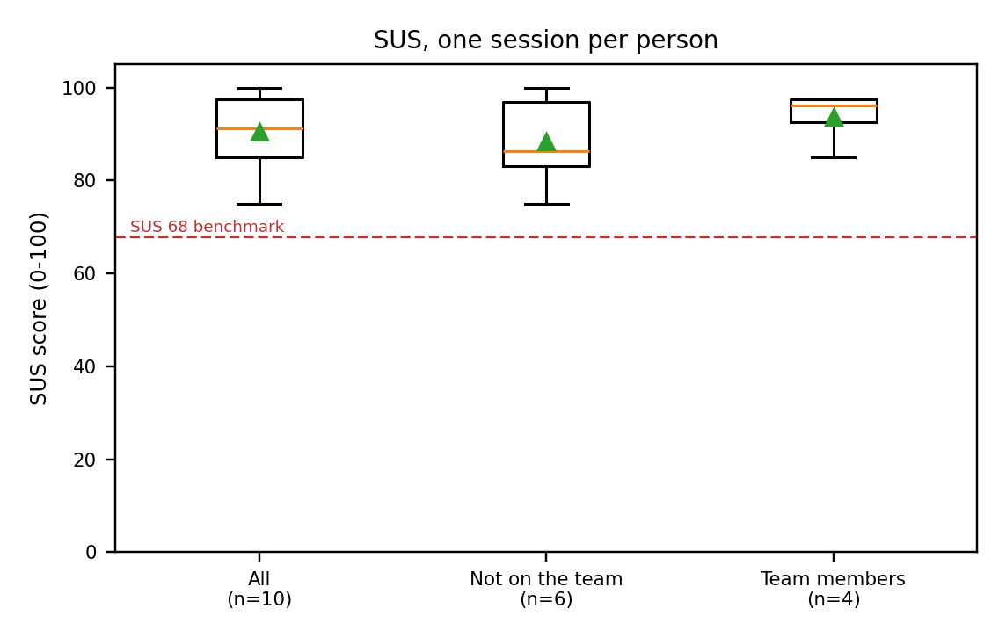 | 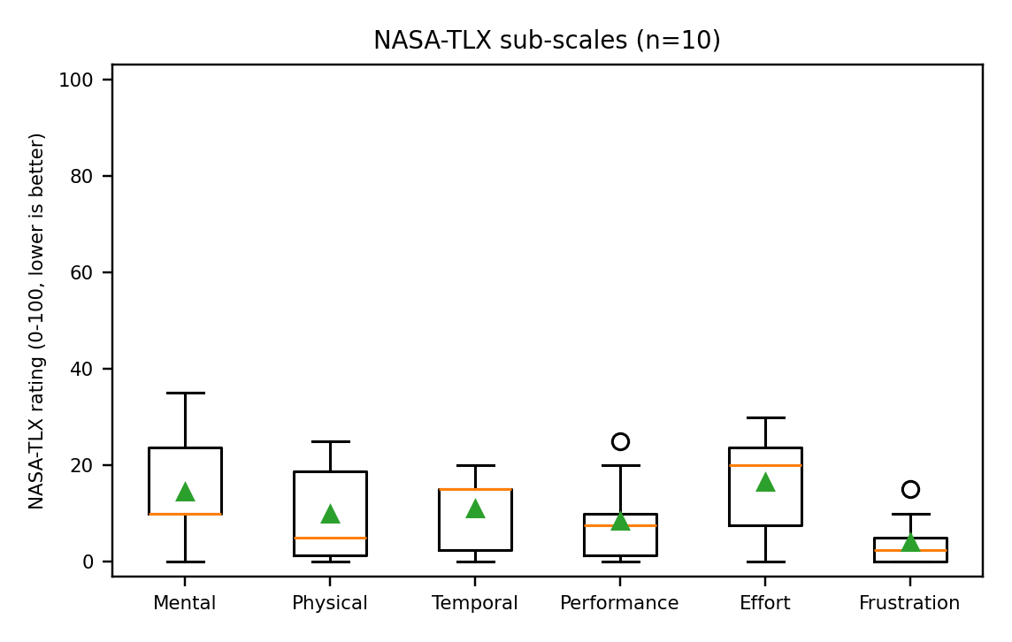

DATA PROVENANCE DECLARATION (mandatory). Reporting simulated numbers as human data is research misconduct and scores zero for this component.
Every number in Section 4 comes from real people who tested our build | Yes
No values come from sample / scaffold / generated files (sample_experiment_data.csv, *_benchmark.csv, generate_paper_figures.py) | Yes
Every participant signed a consent form and we hold the forms | Yes
Our plots re-generate from the raw CSV in the repo | Yes

SECTION 5 · LinkedIn Video Showcase, AI Verification Audit & Peer Review Studio Showcase & Viva Voce
LinkedIn post URL | https://lnkd.in/p/dYdXPgD2
Video length (mm:ss) | 3:27
Every member appears and speaks in the video | Yes

5.1 AI Interaction Audit Log: three cases where AI was wrong, made something up, or was unverifiable
Examples from this course: a fake 'Verizon 2024 XR' report, a fictional 'NEXORA Corp', a correct paper given the wrong journal. Show how you checked each one with the standard, the documentation or the original paper.
# | AI tool | What we asked & what AI said | How we caught it | What was actually true (with source) | Error type | Verdict
AI-01 | Claude | Planned the LinkedIn video as 60-90 s and used the README results (645 s to 382 s, kappa 0.22) as telemetry. | Checked the original source | The capstone brief and Showcase Guide require 3-4 min, and the numbers come from generate_paper_figures.py (simulated): not results (Guide section 5). | Wrong number or statistic | Corrected
AI-02 | Claude | Reported that the headset log showed about 50 of 72 fps and no script errors. | Teammate or peer | A teammate asked for the log; the saved logcat holds no frame-rate evidence for it and predates our [S014] log lines. Claim withdrawn; fps is not measured. | Wrong number or statistic | Rejected
AI-03 | Claude | Wrote in the build doc that the Quest arrival radius is 1.6 m (the script default). | Ran / tested the code | The scene file overrides it: arrivalRadius = 1.8 m. Doc corrected and noted as a deviation from the 1.5 m target (S014_Quest_VR_Build.md). | Wrong code / Unity API | Corrected

5.2 Peer review: watch both assigned LinkedIn videos and score them (0–2 per criterion)
Group reviewed | Problem | Build | Data | Honesty | Clarity | Best moment (mm:ss) | One question for the viva
Group 12: Madhav, Arnav, Diya, Anuvrat | 2 | 2 | 2 | 2 | 2 | 2:50 | Why have you focused on igaze factor ?
Group 02: Ranish, Hriday, Vedika, Medha | 0 | 0 | 0 | 0 | 0 | Have no updates from them | Have no updates about the project in the group.

SECTION 6 · Individual Learning Record not marked · one row per member · answer honestly

Member | Hours I spent (total) | My declared role matched my actual work (1 = not at all, 5 = fully) | Before this course I had used… | Before this course I had tested with real users | I learned a skill from a teammate of another programme | Share of my writing first drafted with AI | Wrong AI facts / citations I personally caught
Jaineel Shah (R057) | 5 | 5 | Neither Git nor LFS | No | Yes | 0–25 % | 0
Dev Garg (S014) | 20 | 5 | Git only | No | Yes | 0–25 % | 1–2
Nimitt Jain (S021) | 18 | 5 | Git only | No | Yes | 0–25 % | 1–2
Husepas Marfatia (J032) | 5 | 5 | Neither Git nor LFS | No | Yes | 0–25 % | 0

Member | The most valuable thing I learned (one line) | One thing I would change in this course (one line)
Jaineel Shah (R057) | I learned how immersive technologies can be integrated into a practical solution and how important system integration is when building a complete experience. | I would include more structured hands-on sessions with VR/AR hardware and real-world implementation challenges earlier in the course.
Dev Garg (S014) | I learned how to design and implement waypoint-based navigation, manage navigation states, and translate a real-world campus navigation problem into a working Unity prototype. | I would introduce more iterative user-testing sessions throughout development so that usability issues can be identified and addressed earlier.
Nimitt Jain (S021) | I learned how to break down a complex technical problem into manageable components and coordinate different system modules into a cohesive solution. | I would include more intermediate milestone reviews to help teams identify integration issues and validate their progress earlier.
Husepas Marfatia (J032) | I learned how immersive VR/AR experiences can be evaluated through practical testing and how user feedback helps improve the overall design. | I would provide more opportunities to test prototypes with real users and compare different design approaches during the course.

Track A: how this dossier becomes your 4-page IEEE paper
I. Introduction | Section 1: title, bottleneck, verified standard
II. Related work | Section 1.1: verified sources only (5+ with DOIs)
III. System design | Section 2: architecture, state machine, equations
IV. Evaluation | Section 4: protocol, N, SUS/TLX/metric, plots
V. Discussion & limitations | Sections 3–5: reproducibility (repo, release), AI audit lessons
Target venues (title sheet) | A: IndiaHCI (Indian Conference on Human-Computer Interaction) · B: ACM MobileHCI (ACM International Conference on Mobile Human-Computer Interaction)

Academic Sign-off every member answers and signs

Member (Roll) | (1) Original work | (2) Code runs | (3) Viva-ready | Signature | Optional research consent*
Jaineel Shah (R057) | Yes | Yes | Yes | Jaineel Shah | Yes
Dev Garg (S014) | Yes | Yes | Yes | Dev Garg | Yes
Nimitt Jain (S021) | Yes | Yes | Yes | Nimitt Jain | Yes
Husepas Marfatia (J032) | Yes | Yes | Yes | Husepas Marfatia | Yes

