Forecasting UPI Growth in India (2016–2026): Model Reliability Across Changing Growth Patterns

Course: Python for Data Science
Programme: M.Sc. Economics – Data Analytics
Project type: time-series analysis and forecast-reliability evaluation.

Gargi Dey – 25060242046
KL Manish – 25060242060



Abstract
This study looks at 123 months of official NPCI data from April 2016 to June 2026 to see how UPI digital payments growth has changed and how well simple time-series forecasting models can predict the volume. Growth slowed in every period after the launch phase: the average monthly growth of UPI transactions fell from 33.42% (July 2016 to July 2018) to 3.36% (April 2021 to June 2026). Chow tests were large at candidate dates in August 2018 and March 2020. The curved trend and errors that repeat over time mean the tests show a changing growth pattern and do not prove a structural break. In 14 different rolling-origin evaluation windows Holts linear-trend model had the error (RMSE 566.96 million transactions, MAPE 3.54%) while ARIMA, recursive lag regression and the benchmark models performed worse and their errors grew as the forecast horizon increased. From June 2021 to June 2026 the number of transactions grew faster than the value so the average value, per transaction fell. This analysis only shows associations. Does not identify causes of structural change.
Keywords: UPI; digital payments; time-series forecasting; rolling-origin evaluation; structural change.

Problem Statement
India's Unified Payments Interface (UPI) has grown a lot since 2016. The number of transactions each month has not gone up the same way every time. The time when it first started a change in how things were reported in August 2018 and later changes in the economy and technology make it hard to predict what will happen in the future. This project does more than just talk about growth. It looks at how wrong predictions get when they try to see into the future. It also checks if simple models for trends still work when tested again and again. It also studies how the number of transactions has changed compared to the value of the transactions. Using 123 reports from NPCI the study compares different ways of making predictions. These include models, smoothing methods, ARIMA models and regression models that use past data. The study is both, about describing what has happened and predicting what might happen next. It does not say that any one event caused the changes that were seen.
Background. Forecast evaluation guidance recommends judging models on data that were not fitted to models and where over repeated forecast origins rather than a single split (Tashman, 2000). The properties of common accuracy measures are reviewed by Hyndman and Koehler (2006). Exponentially weighted trend methods (Holt, 2004) and ARIMA models are tools for series of this kind (Hyndman & Athanasopoulos 2021). The Chow test (Chow, 1960) and its extension to a break date (Andrews, 1993) are standard tools for examining whether a relationship changes over time.

UPI has become a component of India's digital payment ecosystem. The National Payments Corporation of India (NPCI, n.d.) publishes transaction volume and value statistics while the Reserve Bank of India (RBI, 2025) tracks the broader expansion of digital payments, through its Digital Payments Index.
Existing research has looked at the factors that influence UPIs growth. Gopika et al. (2026) Look at the factors that influence UPI growth. Say that earlier research was mainly about predicting. This project asks a question: how accurate are monthly UPI predictions from different sources for different time frames and with different data periods and how does the growth in volume compare with the growth in value.

Research gap. Even though previous research helps explain the factors that influence UPI growth this project focuses on a real-world question: how accurate can monthly UPI transaction volume be predicted as the series grows and the patterns change? The project uses rolling-origin evaluation to compare forecasting models looks at how prediction errors change for different time frames and compares the growth in transaction volume with the growth in transaction value and the growth in average transaction value. It therefore gives a look, at how reliable the predictions are instead of just looking at the factors that influenced past growth.

2. Project Objectives
- To describe monthly UPI transaction volume and value from April 2016 to June 2026, while distinguishing the early launch phase from more recent growth.
- To examine candidate changes in the growth pattern around August 2018 and March 2020 without treating statistical association as proof of causation.
- To forecast monthly UPI transaction volume using benchmark, exponential-smoothing, ARIMA and lag-based regression models.
- To assess forecast reliability through a chronological hold-out test, rolling-origin evaluation and error comparisons across forecast horizons.
- To compare the growth of transaction volume with the growth of total transaction value over the most recent five years.

3. Research Questions
- How does forecast accuracy change as the forecast horizon extends from one month to twelve months?
- Has recent UPI expansion been associated more with the number of transactions (volume) or with the total value of transactions?
- How consistently do forecasting models perform across repeated rolling-origin windows, and which model is most reliable among those tested?
- Do the data indicate candidate changes in the growth pattern near August 2018 or March 2020? These dates are investigated as candidates, not assumed causes or definitive breaks.
The analysis is associational. It describes patterns and forecast performance in aggregate monthly data and does not identify causes or individual payment behaviour.

4. Dataset Description and Source
The data are NPCI's official monthly UPI statistics, downloaded one financial year at a time (11 files, FY2016-17 to FY2026-27) and stacked into one series.
Table 1. Dataset description and source.
Item | Detail
Dataset | UPI Product Statistics (monthly)
Producer | National Payments Corporation of India (NPCI)
Source | npci.org.in/product/upi/product-statistics
Data accessed | 28 July 2026
Period | April 2016 to June 2026
Coverage | India, national aggregate
Unit of observation | One calendar month
Observations | 123
Original variables | 4: Month, banks live on UPI, volume (million transactions), value (₹ crore)
Key limitation | NPCI excludes same-account debit/credit transactions from August 2018, so earlier and later figures are not fully comparable
Other limitations | Volume and value are 0.0 for April–June 2016; national totals only, with no state, app or user detail

5. Tools and Technologies Used
Table 2. Tools and technologies used.
Tool | Used for
Python 3 on Google Colab | Notebook environment; Google Drive for file storage
pandas, NumPy | Loading, cleaning, transformation, lag features
Matplotlib | Charts
statsmodels | ADF test, exponential smoothing (SES, Holt), ARIMA, OLS regression, CUSUM test
scikit-learn | Linear regression, error metrics (MAE, RMSE)
SciPy | F-distribution p-values for the Chow test
Microsoft Excel files (.xlsx) | Format of the NPCI downloads, read through pandas
Libraries: pandas (McKinney, 2010), statsmodels (Seabold & Perktold, 2010), scikit-learn (Pedregosa et al., 2011), Matplotlib (Hunter, 2007) and SciPy (Virtanen et al., 2020). Methods: the ADF unit-root test (Dickey & Fuller, 1979), Holt's linear trend (Holt, 2004), ARIMA modelling (Hyndman & Athanasopoulos, 2021), the Chow test (Chow, 1960) with a sup-F scan (Andrews, 1993), the error measures MAE, RMSE and MAPE (Hyndman & Koehler, 2006) and rolling-origin evaluation (Tashman, 2000).

Data Cleaning and Preprocessing
I examined the series and found that the original series contains 123 monthly rows and there are no missing values or duplicate months in the original series. In the series numeric values that were stored with comma separators were converted to numeric types; dates were parsed and sorted chronologically. The original series kept the three zero‑volume months in April–June 2016. The original series excluded those months from the percentage‑growth calculations because growth, from a zero base is undefined.
Table 3. Data-quality audit.
Data issue | Variable | Records | Treatment | Justification
Numbers stored as text with comma separators | volume_mn, value_cr | 123 each | Commas removed, converted to float | Needed for statistics, plots and models
Dates stored as text | Month | 123 | Converted to datetime, sorted chronologically | Needed for time-series analysis
Unclear column names | 3 columns | 3 | Renamed banks_live, volume_mn, value_cr | Readable, safe in code
Zero volume and value | volume_mn, value_cr | 3 (Apr–Jun 2016) | Kept, excluded from growth statistics | Recorded values, but growth from zero is undefined
Undefined growth (infinity) | volume_growth_pct | 1 (Jul 2016) | Converted to NaN | An infinite value would distort means and plots
Missing values | all | 0 | None needed | None found
Duplicate rows or months | all | 0 | None needed | None found
High recent volumes | volume_mn | n/a | Kept | Genuine growth; the 1.5×IQR rule flagged no outliers in volume or value
Categorical standardisation | n/a | n/a | Not applicable | No categorical variables
Derived variables include year, calendar month, month-on-month growth, log volume and lagged volume features. Derived variables help to capture seasonality and trend. The raw data have 123 rows and 4 columns; the cleaned data have 123 rows and 7 columns because no observation needed removal. Raw data are unchanged while cleaned data add three columns for Derived variables. The modelling frame has 111 rows and 13 columns and starts in April 2017 because the 12-month lag has no value for the first 12 months. Modelling frame is the core of the analysis. It is split chronologically into 99 training months (April 2017 to June 2025). 12 Test months (July 2025 to June 2026). Training months are used to fit the model while test months evaluate its performance.
Features: include volume lags of 1, 2 3 6 and 12 months, plus month number. Volume lags capture history. Volume is log-transformed (log of 1. Volume) for ARIMA to turn exponential growth into roughly additive growth. Log-transformed volume makes the data more normal. The single hold-out test covers July 2025 to June 2026. Hold-out test provides a check. In addition rolling-origin evaluation uses 14 forecast origins, each generating a 12-month forecast. Rolling-origin evaluation offers a view. These overlapping windows provide a descriptive assessment, than one split but their errors are not independent statistical tests.

7. Exploratory Data Analysis
Monthly UPI volume grew from zero to about 23,200 million transactions, and the early years behave very differently from the later ones.
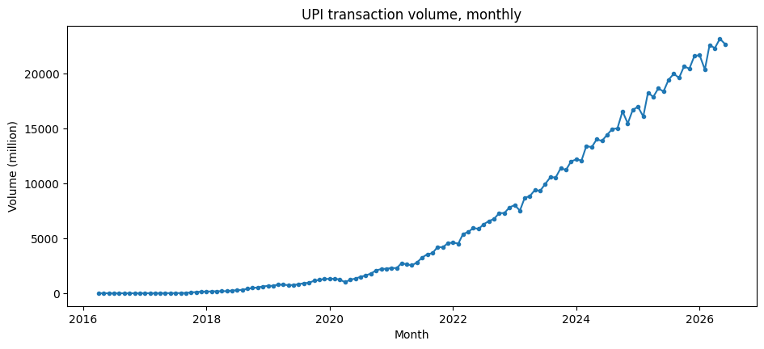
Figure 1. Monthly UPI transaction volume, April 2016 to June 2026.
Table 4. Summary statistics of banks live, volume and value (April 2016 to June 2026).
 | mean | median | min | max | std
banks_live | 307.2 | 224.0 | 21.0 | 731.0 | 231.9
volume_mn | 6485.9 | 2731.7 | 0.0 | 23201.9 | 7279.6
value_cr | 941692.9 | 504886.4 | 0.0 | 2990424.2 | 968076.4
Skewness of volume_mn: 0.92

Observations
- Volume rises across the whole period with no sustained decline. Individual months do fall (the smallest month-on-month change is about −20%), but only as brief dips.
- The distribution is right-skewed (skewness 0.92). The mean volume (6,486 million) is well above the median (2,732 million), and 59 of 123 months fall in the lowest of ten histogram bins (up to about 2,320 million), because UPI spent its early years at small volumes.
- The 1.5×IQR rule flags no outliers in volume or value. The high recent values are genuine growth, so none were removed.
- Banks live, volume and value are highly correlated (banks–volume 0.980, volume–value 0.994, banks–value 0.991). All three trend upward together, so these correlations mostly reflect a shared trend and do not show that more banks cause more transactions.
- Percentage growth is very high and volatile in the first months and settles at a much lower level later, which Section 8 quantifies.

Key Results and Visualisations
The main takeaway is not about picking a model. About how reliable it is. Holt’s linear-trend method produced the overall rolling-origin error compared to the other models tested. At the time forecast errors tended to grow as the prediction horizon got longer. There has also been a rise in the number of transactions but the total value of those transactions has not kept up. This means the average value, per transaction has gone down.

Stationarity (ADF test, training data)
Table 5. Augmented Dickey-Fuller tests on volume and log volume (training data).
 | Series | Test setting | ADF stat | p-value | Lags | Conclusion
0 | Volume (level) | constant | -0.515 | 0.8892 | 12 | non-stationary
1 | Log volume (level) | constant | -1.754 | 0.4037 | 12 | non-stationary
2 | Volume, 1st difference | constant | -0.296 | 0.9261 | 11 | non-stationary
3 | Log volume, 1st difference | constant | -3.847 | 0.0025 | 12 | stationary
4 | Volume (level) | constant + trend | -1.114 | 0.9267 | 12 | non-stationary
5 | Log volume (level) | constant + trend | -1.340 | 0.8776 | 12 | non-stationary

The ADF results indicate that log volume in levels is non-stationary, while the first difference of log volume is stationary (ADF = −3.847, p = 0.0025, with a constant). This supports investigating an ARIMA specification with one difference; it does not by itself determine the AR and MA orders.
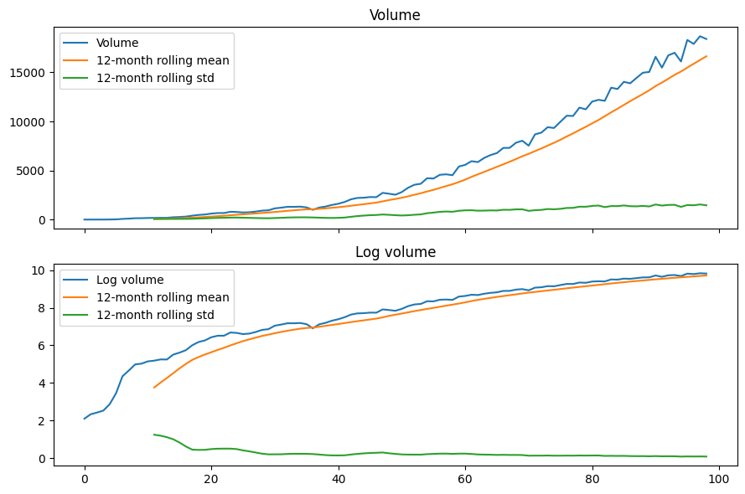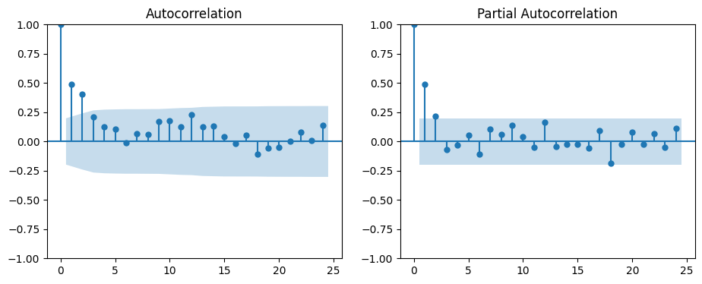
Figure 2. Volume and log volume with 12-month rolling mean and standard deviation, and ACF and PACF of differenced log volume (training data).

Forecast comparison
Test window: July 2025 to June 2026. Rolling-origin evaluation: 14 forecast origins from April 2022 to July 2025, each forecasting the next 12 months (1,344 forecasts). MAE and RMSE are in million transactions.
Table 6. Forecast accuracy by model: single hold-out test (July 2025 to June 2026) and rolling-origin evaluation (14 origins, 12-month horizon).
 | Single split MAE | Single split RMSE | Single split MAPE | Rolling MAE | Rolling RMSE | Rolling MAPE | RMSE vs Naive (%) | Windows won | Total windows
model
Holt | 468.49 | 559.27 | 2.22 | 452.93 | 566.96 | 3.54 | 78.7 | 13 | 14
Holt damped | 484.99 | 577.75 | 2.29 | 494.30 | 612.93 | 3.85 | 77.0 | 1 | 14
Linear Reg. (recursive) | 1529.98 | 1892.80 | 7.01 | 1221.11 | 1507.36 | 9.08 | 43.4 | 0 | 14
ARIMA (last 36m, reselected) | 1726.23 | 2162.59 | 7.89 | 1768.52 | 2238.27 | 12.52 | 16.0 | 0 | 14
Naive | 2847.97 | 3105.90 | 13.11 | 2304.76 | 2663.65 | 17.10 | 0.0 | 0 | 14
SES | 2823.54 | 3083.51 | 13.00 | 2325.33 | 2682.53 | 17.20 | -0.7 | 0 | 14
ARIMA (last 48m, reselected) | 1127.76 | 1510.55 | 5.18 | 2315.78 | 2926.79 | 16.73 | -9.9 | 0 | 14
ARIMA (reselected) | 6744.68 | 8834.51 | 30.55 | 6791.75 | 8850.90 | 48.05 | -232.3 | 0 | 14

•Holt’s linear-trend method worked best in the rolling-origin comparison: MAE 452.93 million transactions RMSE 566.96 million and MAPE 3.54%. It had the RMSE in 13 out of 14 origins. Holt’s damped-trend version came in second with RMSE 612.93 million and MAPE 3.85%. Naive and simple exponential smoothing forecasts do not perform well for a series that keeps rising. These methods assume a path and fail to capture the continuing upward trend.

•The recursive lag-regression forecast feeds each predicted month back into the month’s lag features. This means errors can build up over a 12-month forecast path. A one-step-ahead regression uses observed lags at every step so it is not comparable to recursive multi-step forecasts. That is why it is not included in Table 6.

•ARIMA performance was highly sensitive to the training window. A model trained on the history was shaped by the fast growth during the launch phase and struggled when trying to extrapolate that trend. Shorter rolling windows helped improve ARIMA’s performance. Even then ARIMA variants still had higher total errors than Holt in this test. This shows that both model choice and training window are important for this dataset. It does not prove that Holt will always be the best in the future. For the reselected ARIMA models the ARIMA order was chosen using AIC based on the data in each training window at the forecast origin. The single holdout split gave ARIMA trained on the 48 months a lower RMSE (1,510.55) than the rolling-origin evaluation (2,926.79) suggesting ARIMA performed better in a single test period than, across multiple forecast origins.
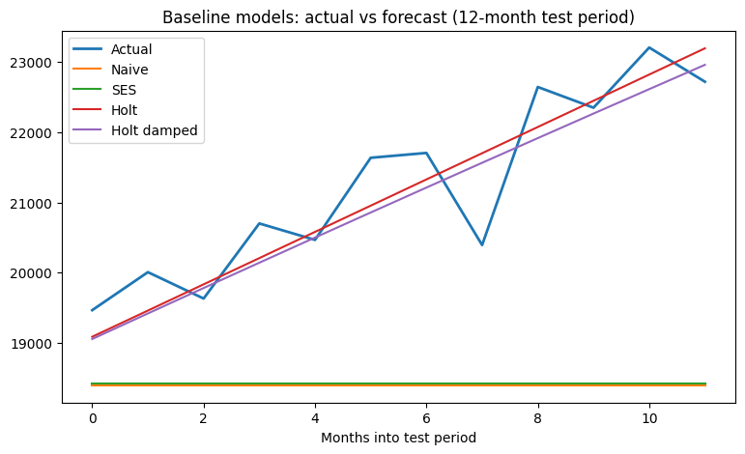
Figure 3. Naive, SES, Holt and Holt damped forecasts against actual volume, July 2025 to June 2026. The regression and ARIMA results are in Table 6.
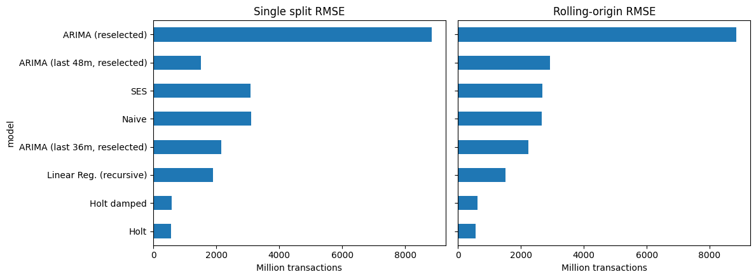

Figure 4. Single-split and rolling-origin RMSE by model.

Structural-break tests (full history, July 2016 to June 2026)
Table 7. Chow tests at candidate break dates, linear and quadratic trends (full history, July 2016 to June 2026).
 | Break date | Obs before | Obs after | F (linear trend) | p (linear) | F (quadratic trend) | p (quadratic)
0 | Aug 2018 (methodology change) | 25 | 95 | 667.2 | 0.0 | 442.6 | 0.0
1 | Mar 2020 (COVID onset) | 44 | 76 | 174.3 | 0.0 | 298.7 | 0.0

Log volume is curved than well represented by a single straight trend. R² rises from 0.768 under a trend to 0.918 under a quadratic trend. Chow statistics are large at both candidate dates, August 2018 and March 2020 under both specifications. A scan over candidate dates places the statistic in 2018 – March 2018 under the linear trend September 2018 under the quadratic trend – not at the COVID onset. A CUSUM test, with statistic 2.506 also points to instability in the linear‑trend model. However standard Chow‑test assumptions are questionable for a trending time series, with correlated errors and the maximum of a scan needs Andrews (1993) critical values. These statistics are therefore indicative only. Statistics do not establish a break or show that either date caused the change.
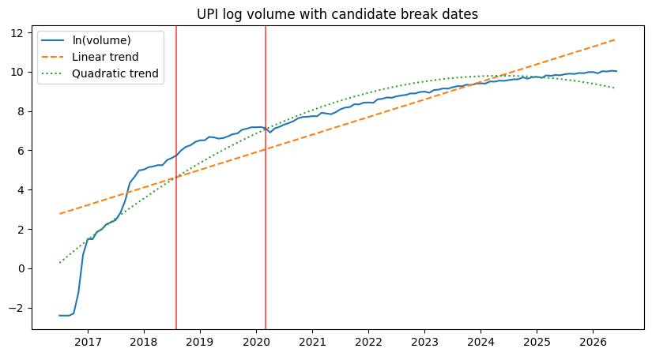
Figure 5. Log volume with linear and quadratic trends and candidate break dates (August 2018, March 2020).

Growth by sub-period
Table 8. Monthly volume growth by sub-period.
 | Months | Start_vol | End_vol | Mean_MoM | Median_MoM | SD_MoM | CMGR (%) | Annualised (%)
period
Jul16-Jul18 | 25 | 0.09 | 273.75 | 33.42 | 12.19 | 45.29 | 39.68 | 5415.13
Aug18-Feb20 | 19 | 312.02 | 1325.69 | 8.30 | 8.14 | 8.34 | 8.37 | 162.33
Mar20-Mar21 | 13 | 1246.84 | 2731.68 | 5.56 | 7.80 | 11.15 | 6.75 | 119.09
Apr21-Jun26 | 63 | 2641.06 | 22716.07 | 3.36 | 3.01 | 5.54 | 3.53 | 51.66
Mean monthly log-growth declined across the displayed periods: from 33.42% during the early launch phase to 8.30% from August 2018 to February 2020, 5.56% from March 2020 to March 2021, and 3.36% from April 2021 to June 2026. These are average log-differences expressed as approximate percentages. The COVID-period mean was below the preceding period, so the results do not support a claim that monthly percentage growth accelerated during COVID.
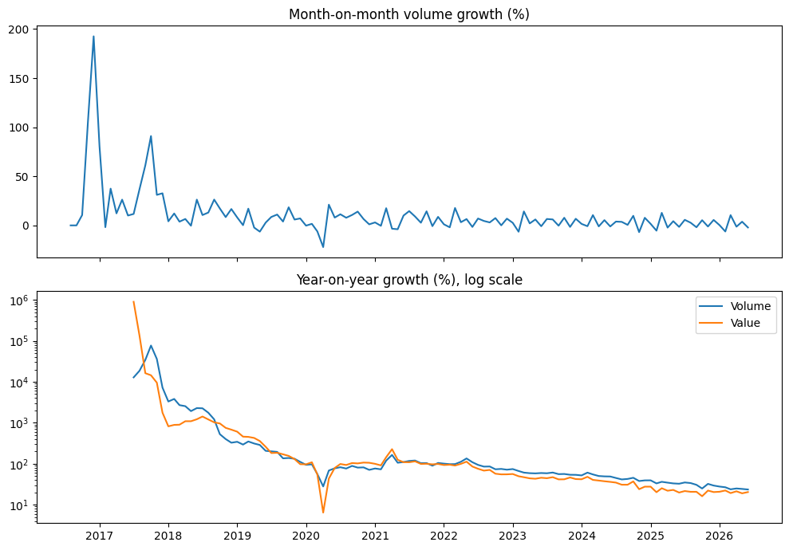
Figure 6. Month-on-month and year-on-year volume growth (%).

Average transaction size
Average transaction value is calculated as total value divided by transaction volume, with the units converted to rupees per transaction. It is an aggregate ratio, not the observed size of a typical individual payment. In June 2026, total value was ₹2,892,138.67 crore and volume was 22,716.07 million transactions, giving an average of approximately ₹1,273 per transaction.
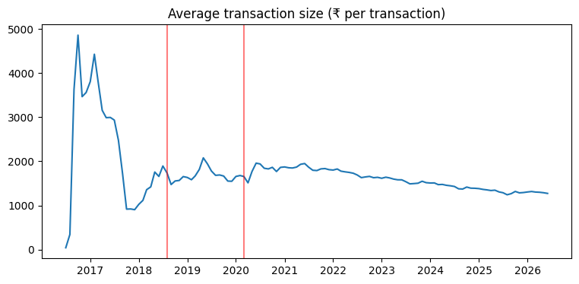Figure 7. Average transaction value (₹ per transaction).

Recent five-year comparison (June 2021–June 2026)
Table 9. Five-year change in volume, total value and average transaction value (June 2021 to June 2026).
 | Period | Start month | End month | Volume growth (%) | Total value growth (%) | Average transaction value growth (%) | Volume CAGR (%) | Value CAGR (%) | Average transaction value CAGR (%)
0 | Recent five years | Jun 2021 | Jun 2026 | 709.12 | 428.37 | -34.7 | 51.92 | 39.51 | -8.17

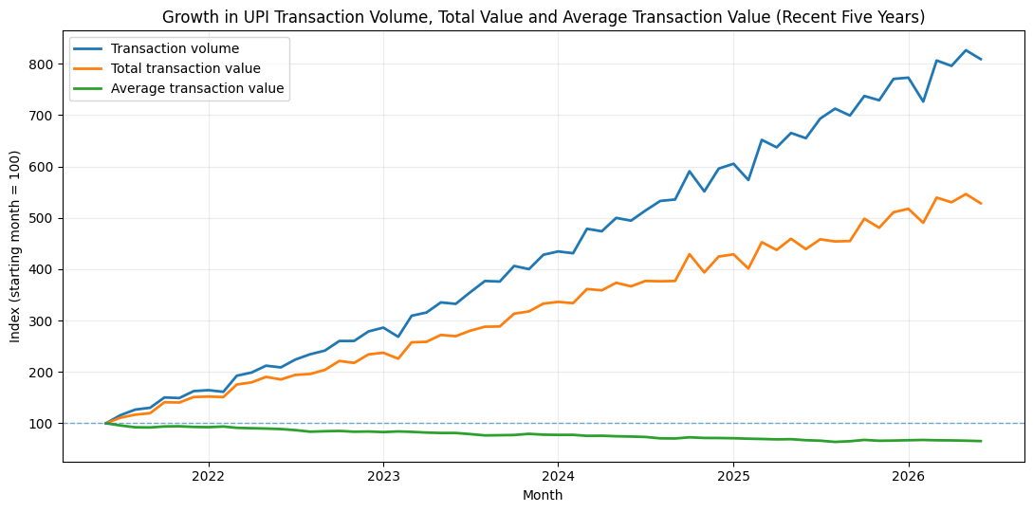
Figure 8. Index of transaction volume, total value and average transaction value (June 2021 = 100).
Interpretation: over this recent five-year period, transaction volume increased faster than total value. This supports a descriptive “volume versus value” comparison; it does not establish why the ratio changed or describe any individual payment. A full-sample comparison is not reported, because the series starts from a near-zero base. The comparison uses single-month endpoints, and June 2026 volume (22,716 million) is below the May 2026 peak (23,202 million), so the percentages depend on the endpoint chosen. Values are in nominal rupees, so the fall in average transaction value is not adjusted for inflation.

Forecast reliability by horizon
Table 10. Mean absolute error by forecast-horizon group, rolling-origin windows (million transactions).
horizon_band | Months 1-3 | Months 4-6 | Months 7-9 | Months 10-12
model
ARIMA (last 36m, reselected) | 467.71 | 1139.78 | 2108.34 | 3358.26
ARIMA (last 48m, reselected) | 648.70 | 1505.39 | 2753.83 | 4355.21
ARIMA (reselected) | 1208.81 | 3864.56 | 8064.81 | 14028.84
Holt | 303.80 | 396.19 | 488.11 | 623.62
Holt damped | 308.67 | 409.68 | 542.73 | 716.12
Linear Reg. (recursive) | 346.47 | 773.84 | 1472.27 | 2291.86
Naive | 736.73 | 1748.07 | 2821.64 | 3912.60
SES | 743.91 | 1773.10 | 2846.67 | 3937.63

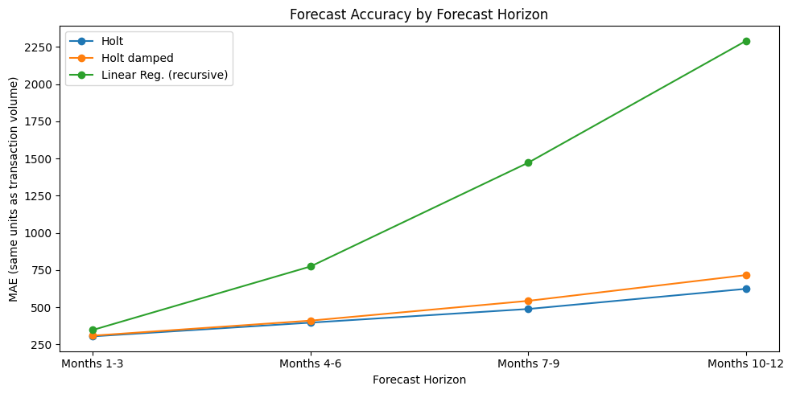
Figure 9. Forecast MAE by horizon group for Holt, Holt damped and recursive linear regression (the three most accurate models; Table 10 reports all eight).
MAE values are in million transactions. For every listed model, error is higher in the months 10–12 group than in the months 1–3 group. This supports the conclusion that longer-horizon forecasts are less reliable in these rolling windows; it does not show which specific historical period was hardest to forecast.

9. Major Findings
- Rapid expansion. Monthly volume increased from zero at launch to over 22,700 million transactions in June 2026. The early zero months were retained in the level series but excluded from growth-rate calculations.
- Growth slowed after the launch phase. Mean monthly growth fell from 33.42% in the early launch period to 8.30%, 5.56% and 3.36% in the subsequent periods. The COVID-period mean was lower than the preceding period.
- Changing pattern, not proven causation. Candidate-break statistics are large near August 2018 and March 2020, but the curved trend, serial dependence and reporting-methodology change limit the interpretation. The analysis does not establish a causal COVID effect or a definitive break at either date.
- Holt was the most reliable of the tested models in rolling-origin evaluation. Its RMSE was 566.96 million transactions and MAPE was 3.54%, with the lowest RMSE in 13 of 14 origins. This is a result for the evaluation windows studied, not a guarantee of future performance.
- Complexity did not guarantee better forecasts. The recursive lag regression and the tested ARIMA variants had higher rolling-origin errors than Holt. ARIMA fitted to the full history was especially sensitive to the unusually steep early growth phase.
- Volume grew faster than total transaction value in the most recent five-year comparison, and the average value-per-transaction ratio declined. This is consistent with growth being associated more with a larger number of transactions than with a higher average transaction value, but aggregate data cannot establish changes in individual behaviour.
- Practical implication. For near-term planning, the tested Holt trend model is a useful benchmark, but forecasts should be treated as less certain farther into the future. Model performance should be monitored as new monthly data arrive, rather than assuming that early growth rates will continue.
Economic interpretation and policy relevance. Very high percentage growth from a small base is typical of a newly launched payment network. As the network matures, further growth needs more users, more banks and wider use, so percentage growth falls even while the monthly increase in transactions stays large. The fall in average value per transaction is consistent with UPI being used increasingly for smaller payments, although aggregate data contain no information on who is paying, for what, or in what amounts. For regulators, banks and payment providers, the results suggest planning capacity on recent trends rather than launch-period growth rates, tracking forecast errors as new months arrive, and treating the August 2018 reporting change as a comparability issue when judging earlier periods.

10. Limitations
- Data scope: one national aggregate series of 123 monthly observations, with no state-, demographic-, merchant- or app-level detail.
- Launch regime: the 2016–2018 growth phase differs sharply from later years and strongly affects models fitted to the full history.
- Methodology change: NPCI reporting excludes same-account transactions from August 2018, so values before and after that change may not be fully comparable.
- Break tests: standard Chow-test assumptions are questionable for a trending series with serially correlated errors. The log trend is curved, and a scan for an unknown change point requires appropriate critical values; reported statistics are therefore indicative, not definitive evidence of a structural break.
- Period comparisons are descriptive. The earliest “before” period includes the launch phase, so comparisons across candidate dates mix launch-to-maturity changes with any other contemporaneous changes.
- Evaluation: one 12-month hold-out test and 14 overlapping rolling windows were used. Window-level errors overlap, so differences are descriptive rather than formal significance tests. Horizon-level error increases show that longer forecasts are harder in this dataset; they do not identify which historical episode was intrinsically hardest to forecast.
- Model scope: the forecasting models rely mainly on historical volume and, for regression, calendar month. Policy changes, fees, incentives, outages, internet access and other external drivers are not modelled.
- Derived measure: average transaction value is the ratio of aggregate total value to aggregate volume, not a transaction-level average from individual payment records. The three zero-volume months were excluded from growth statistics.
- Association only: the analysis does not identify causes, and past forecast accuracy does not guarantee future accuracy.

11. Conclusion
UPI’s monthly transaction volume expanded dramatically between 2016 and 2026, but the growth rate slowed after the launch phase. The most useful contribution of this analysis is its focus on forecast reliability: across 14 rolling-origin windows, Holt’s linear-trend model produced the lowest aggregate errors among the models tested, while errors generally rose as the forecast horizon lengthened. In the most recent five years, transaction volume grew faster than total transaction value and the aggregate average value per transaction fell. Candidate changes around August 2018 and March 2020 deserve contextual attention, but the available tests do not prove that either event caused a structural break. Future work could test more formal change-point methods, include external explanatory variables and evaluate the forecasts as new observations arrive.

12. References
- Andrews, D. W. K. (1993). Tests for parameter instability and structural change with unknown change point. Econometrica, 61(4), 821–856. https://doi.org/10.2307/2951764
- Chow, G. C. (1960). Tests of equality between sets of coefficients in two linear regressions. Econometrica, 28(3), 591–605. https://doi.org/10.2307/1910133
- Dickey, D. A., & Fuller, W. A. (1979). Distribution of the estimators for autoregressive time series with a unit root. Journal of the American Statistical Association, 74(366), 427–431. https://doi.org/10.1080/01621459.1979.10482531
- Gopika, C. G., Biju, A. V., Sasidharan, A., & Sarpong-Kumankoma, E. (2026). Government-led design and growth of India’s UPI ecosystem: A time series analysis of associated factors. Journal of Science and Technology Policy Management. Advance online publication. https://doi.org/10.1108/JSTPM-07-2024-0284
- Holt, C. C. (2004). Forecasting seasonals and trends by exponentially weighted moving averages. International Journal of Forecasting, 20(1), 5–10. https://doi.org/10.1016/j.ijforecast.2003.09.015
- Hunter, J. D. (2007). Matplotlib: A 2D graphics environment. Computing in Science & Engineering, 9(3), 90–95. https://doi.org/10.1109/MCSE.2007.55
- Hyndman, R. J., & Athanasopoulos, G. (2021). Forecasting: Principles and practice (3rd ed.). OTexts. https://otexts.com/fpp3/
- Hyndman, R. J., & Koehler, A. B. (2006). Another look at measures of forecast accuracy. International Journal of Forecasting, 22(4), 679–688. https://doi.org/10.1016/j.ijforecast.2006.03.001
- McKinney, W. (2010). Data structures for statistical computing in Python. Proceedings of the 9th Python in Science Conference, 56–61. https://doi.org/10.25080/Majora-92bf1922-00a
- National Payments Corporation of India. (n.d.). UPI product statistics [Data set]. Retrieved July 28, 2026, from https://www.npci.org.in/product/upi/product-statistics
- Pedregosa, F., Varoquaux, G., Gramfort, A., Michel, V., Thirion, B., Grisel, O., Blondel, M., Prettenhofer, P., Weiss, R., Dubourg, V., Vanderplas, J., Passos, A., Cournapeau, D., Brucher, M., Perrot, M., & Duchesnay, É. (2011). Scikit-learn: Machine learning in Python. Journal of Machine Learning Research, 12, 2825–2830. https://jmlr.org/papers/v12/pedregosa11a.html
- Reserve Bank of India. (2025, January 29). RBI – Digital Payments Index for September 2024 [Press release]. https://www.rbi.org.in/Scripts/BS_PressReleaseDisplay.aspx?prid=59632
- Seabold, S., & Perktold, J. (2010). statsmodels: Econometric and statistical modeling with Python. Proceedings of the 9th Python in Science Conference. https://doi.org/10.25080/Majora-92bf1922-011
- Tashman, L. J. (2000). Out-of-sample tests of forecasting accuracy: An analysis and review. International Journal of Forecasting, 16(4), 437–450. https://doi.org/10.1016/S0169-2070(00)00065-0
- Virtanen, P., Gommers, R., Oliphant, T. E., Haberland, M., Reddy, T., Cournapeau, D., Burovski, E., Peterson, P., Weckesser, W., Bright, J., van der Walt, S. J., Brett, M., Wilson, J., Millman, K. J., Mayorov, N., Nelson, A. R. J., Jones, E., Kern, R., Larson, E., . . . SciPy 1.0 Contributors. (2020). SciPy 1.0: Fundamental algorithms for scientific computing in Python. Nature Methods, 17, 261–272. https://doi.org/10.1038/s41592-019-0686-2

13. Individual Contribution
Member | Tasks personally completed
Gargi Dey – 25060242046 | • Literature background and research gap  • Data validation and preparation for analysis  • Transaction value, average ticket size and growth analysis  • ACF/PACF analysis and structural-change discussion  • Damped Holt, regression and ARIMA models  • Rolling-origin evaluation and horizon-wise error analysis  • Compare model performance and discuss limitations  • Draft findings, conclusion and presentation slides
KL Manish – 25060242060 | • Problem statement and research objectives  • Data collection and cleaning  • Transaction volume trends and visualization  • Stationarity tests and ADF interpretation  • Naive, SES and Holt models  • Holdout testing and forecast metrics  • Interpret transaction growth patterns  • Draft methodology and data analysis sections

