# PL/SQL Control Structures – Banking Scenarios

Initial tables:

Customers:

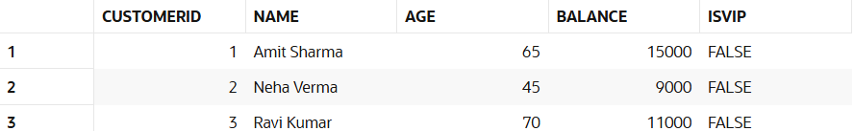

Loans:

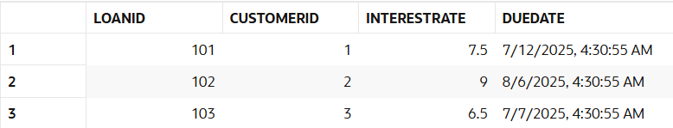

## Scenario 1: Interest Rate Discount for Senior Citizens

Requirement: Apply a 1% discount to the current loan interest rates for customers above 60 years old.

BEGIN  
 FOR rec IN (  
 SELECT l.LoanID  
 FROM CUSTOMERS c  
 JOIN LOANS l ON c.CustomerID = l.CustomerID  
 WHERE c.Age > 60  
 )  
 LOOP  
 UPDATE LOANS  
 SET InterestRate = InterestRate - 1  
 WHERE LoanID = rec.LoanID;  
 END LOOP;  
  
 COMMIT;  
END;

Output:

Loans:

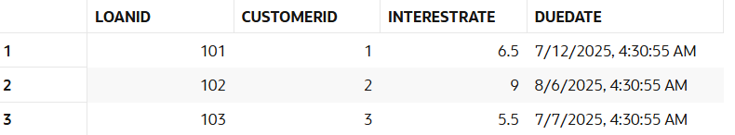

## Scenario 2: VIP Status Based on Balance

Requirement: Set IsVIP = TRUE for customers with a balance over $10,000.

BEGIN  
 FOR rec IN (  
 SELECT CustomerID  
 FROM CUSTOMERS  
 WHERE Balance > 10000  
 )  
 LOOP  
 UPDATE CUSTOMERS  
 SET IsVIP = 'TRUE'  
 WHERE CustomerID = rec.CustomerID;  
 END LOOP;  
  
 COMMIT;  
END;

Output:

Customers:

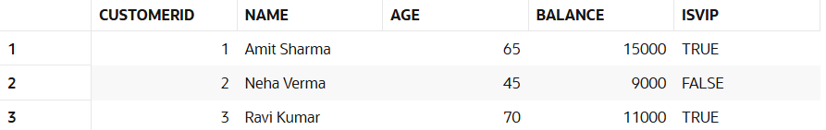

## Scenario 3: Loan Due Reminder Messages

Requirement: Print reminder messages for customers whose loans are due within the next 30 days.

BEGIN  
 FOR rec IN (  
 SELECT l.LoanID, c.Name, l.DueDate  
 FROM LOANS l  
 JOIN CUSTOMERS c ON l.CustomerID = c.CustomerID  
 WHERE l.DueDate BETWEEN SYSDATE AND SYSDATE + 30  
 )  
 LOOP  
 DBMS_OUTPUT.PUT_LINE(  
 'Reminder: Dear ' || rec.Name ||  
 ', your loan (ID: ' || rec.LoanID ||  
 ') is due on ' || TO_CHAR(rec.DueDate, 'DD-MON-YYYY') || '.'  
 );  
 END LOOP;  
END;

Output:

