# PL/SQL Stored Procedures – Banking Scenarios

Initial tables:

Accounts:

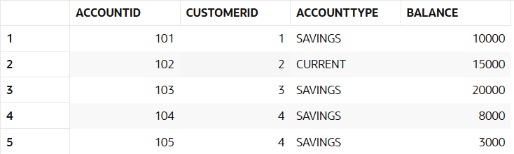

Employees:

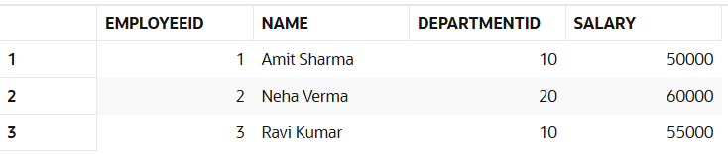

## Scenario 1: Process Monthly Interest for Savings Accounts

Stored Procedure: ProcessMonthlyInterest  
Description: Calculates and updates the balance of all savings accounts by applying a 1% interest rate.

CREATE OR REPLACE PROCEDURE ProcessMonthlyInterest IS  
BEGIN  
 FOR rec IN (  
 SELECT AccountID, Balance  
 FROM ACCOUNTS  
 WHERE AccountType = 'SAVINGS'  
 )  
 LOOP  
 UPDATE ACCOUNTS  
 SET Balance = Balance + (Balance * 0.01)  
 WHERE AccountID = rec.AccountID;  
 END LOOP;  
  
 COMMIT;  
END;

Running:

BEGIN

ProcessMonthlyInterest;

END;

Output:

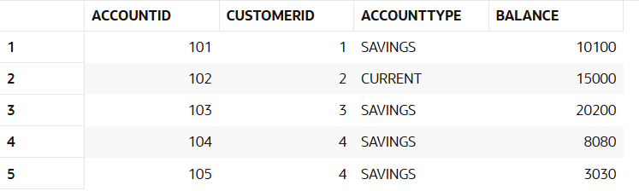

## Scenario 2: Update Employee Bonus by Department

Stored Procedure: UpdateEmployeeBonus  
Description: Updates employee salaries in a given department by adding a bonus percentage passed as a parameter.

CREATE OR REPLACE PROCEDURE UpdateEmployeeBonus (  
 dept_id IN NUMBER,  
 bonus_percent IN NUMBER  
) IS  
BEGIN  
 UPDATE EMPLOYEES  
 SET Salary = Salary + (Salary * bonus_percent / 100)  
 WHERE DepartmentID = dept_id;  
  
 COMMIT;  
END;

Running:

BEGIN

UpdateEmployeeBonus(10, 10); -- 10% bonus to dept 10

END;

Output:

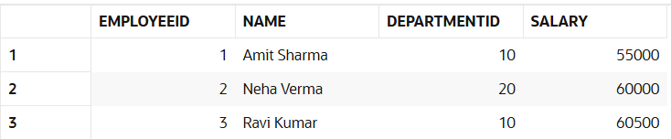

## Scenario 3: Transfer Funds Between Accounts

Stored Procedure: TransferFunds  
Description: Transfers a specified amount from one account to another, ensuring sufficient balance in the source account.

CREATE OR REPLACE PROCEDURE TransferFunds (  
 from_account IN NUMBER,  
 to_account IN NUMBER,  
 amount IN NUMBER  
) IS  
 from_balance NUMBER;  
BEGIN  
 SELECT Balance INTO from_balance FROM ACCOUNTS WHERE AccountID = from_account FOR UPDATE;  
  
 IF from_balance < amount THEN  
 RAISE_APPLICATION_ERROR(-20001, 'Insufficient funds in source account');  
 END IF;  
  
 UPDATE ACCOUNTS  
 SET Balance = Balance - amount  
 WHERE AccountID = from_account;  
  
 UPDATE ACCOUNTS  
 SET Balance = Balance + amount  
 WHERE AccountID = to_account;  
  
 COMMIT;  
END;

Running:

BEGIN

TransferFunds(104, 105, 2000); -- Transfer 2000 from 104 to 105

END;

Output:

