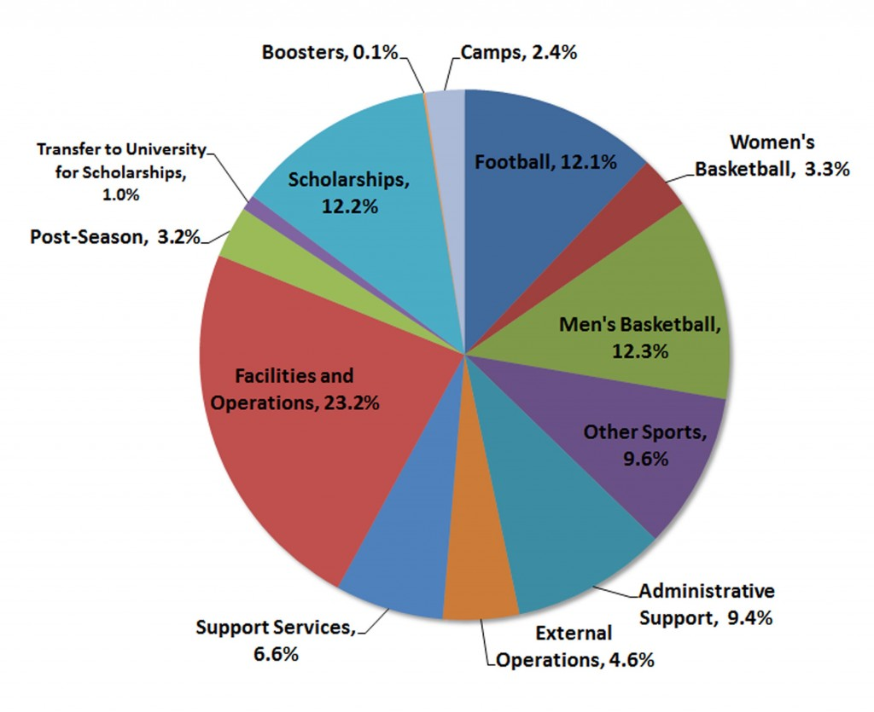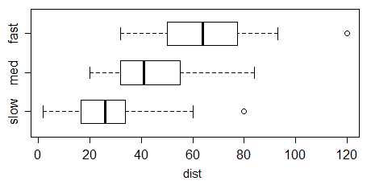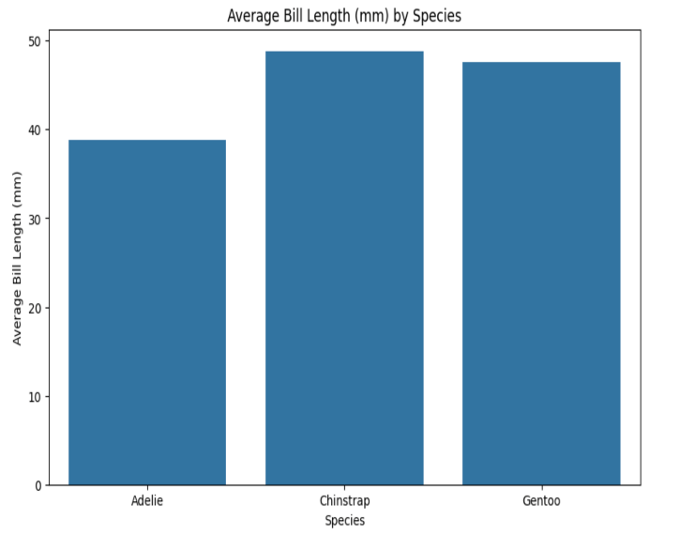

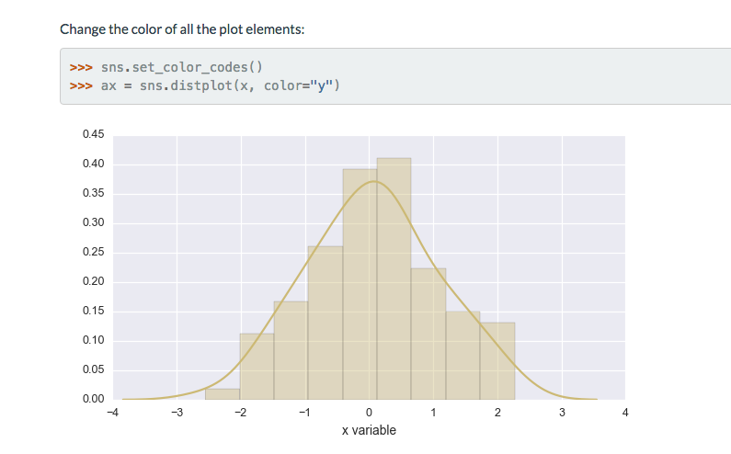

[This Photo](http://stackoverflow.com/questions/43565892/python-seaborn-distplot-y-value-corresponding-to-a-given-x-value) by Unknown Author is licensed under [CC BY-SA](https://creativecommons.org/licenses/by-sa/3.0/)

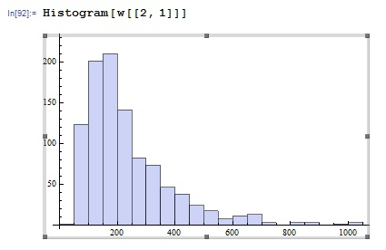

[This Photo](http://mathematica.stackexchange.com/questions/44695/what-is-the-best-distribution-for-my-histogram) by Unknown Author is licensed under [CC BY-SA](https://creativecommons.org/licenses/by-sa/3.0/)

