**Go-Back-N ARQ**

**Following are the file and RTT specifications:**

Transfer file: lotr.txt

Size of transfer file: 1.03MB

Round trip time obtained from traceroute ≈ 108 ms

**Task 1: Effect of Window Size N**

Following graph shows the effect of varying window size while keeping the MSS and loss probability constant. 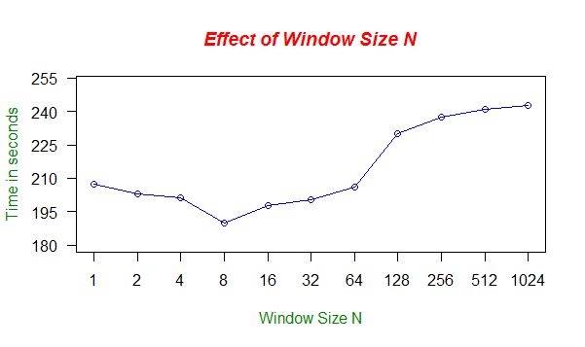

|  |  |
| --- | --- |
| **Window Size N** | **Average delay (in seconds)** |
| 1 | 207.1932 |
| 2 | 203.0475 |
| 4 | 201.3175 |
| 8 | 189.8520 |
| 16 | 197.8575 |
| 32 | 200.2120 |
| 64 | 205.9635 |
| 128 | 229.8050 |
| 256 | 237.3833 |
| 512 | 241.0240 |
| 1024 | 242.6837 |

From the above graph and table it is seen that large window sizes cause more delays. Delay is minimum for medium window sizes like 4, 8, 16 and 32. For very small window sizes like 1 and 2 the delay is less than large window sizes but greater than medium window sizes. For large window sizes, for every packet loss, we need to re-transmit a large number of packets which increases the file transfer time. For very small window sizes, we are sending very few segments at a time which slows down the transfer.

**Task 2: Effect of MSS**

Following graph shows the effect of varying MSS while keeping the window size and loss probability constant. 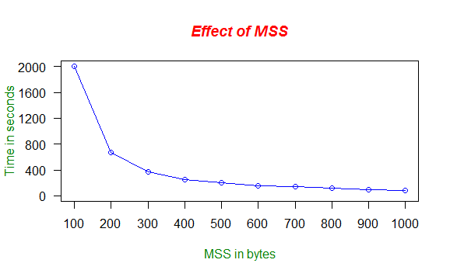

|  |  |
| --- | --- |
| **MSS in bytes** | **Average delay (in seconds)** |
| 100 | 2003.4550 |
| 200 | 675.0900 |
| 300 | 376.6825 |
| 400 | 256.7030 |
| 500 | 198.7737 |
| 600 | 150.7505 |
| 700 | 137.7210 |
| 800 | 115.1055 |
| 900 | 96.1915 |
| 1000 | 78.4855 |

From the above graph and table it is seen that small MSS values cause more delays. As the value of MSS increases linearly, the transfer time decreases exponentially. This is the expected result. When the MSS is small, there are more number of packets to send, hence, packet loss is high which results in more re-transmissions. As a result the transfer time increases.

**Task 3: Effect of Loss Probability p**

Following graph shows the effect of varying loss probability while keeping the window size and MSS constant. 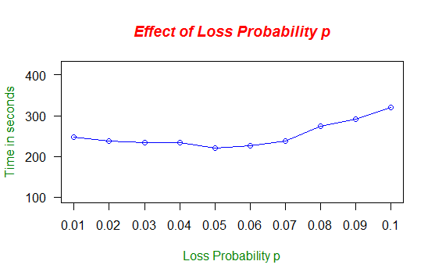

|  |  |
| --- | --- |
| **Loss Probability** | **Average delay (in seconds)** |
| 0.01 | 248.1803 |
| 0.02 | 238.1345 |
| 0.03 | 233.3655 |
| 0.04 | 234.5305 |
| 0.05 | 219.6640 |
| 0.06 | 226.6590 |
| 0.07 | 238.3340 |
| 0.08 | 274.0495 |
| 0.09 | 291.4245 |
| 0.1 | 320.1210 |

From the above graph and table it is seen that the transfer time is nearly constant for p between 0.01 and 0.07. For higher p, i.e. 0.8, 0.9 and 0.1, the delay increases along with increase in p.

**Following are the messages used in the project and their interpretations:**

* **Packet Discarded, Checksum not matching :** Displayed at server side when checksum does not match for the incoming packet.
* **Ack retransmitted** : Displayed at server side when the sequence number of incoming packet at server is less than the expected sequence number.
* **Packet loss, sequence number <Number>** : This is displayed at server side in two cases:

**Case 1**: When the sequence number of incoming packet at server is greater than the expected sequence number.

**Case 2**: When the randomly generated probability is less than the specified loss probability.

* **Timeout, sequence** **number <Number>** : This is displayed at client side when timeout occurs for a packet.

We have taken the observations of the three tasks on three different days.