**Selective Repeat ARQ**

**Following are the file and RTT specifications:**

Transfer file: lotr.txt

Size of transfer file: 1.03MB

Round trip time obtained from traceroute ≈ 108 ms

**Task 1: Effect of Window Size N**

Following graph shows the effect of varying window size while keeping the MSS and loss probability constant. 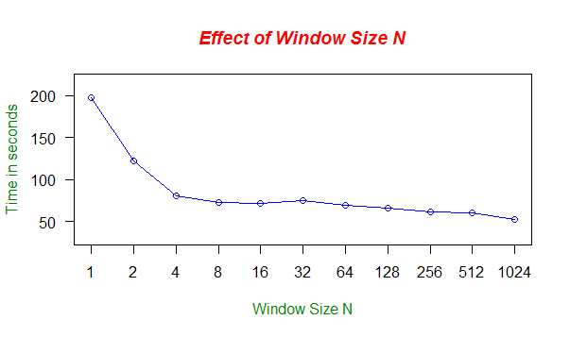

|  |  |
| --- | --- |
| **Window Size N** | **Average delay (in seconds)** |
| 1 | 197.5860 |
| 2 | 122.0780 |
| 4 | 80.2820 |
| 8 | 72.4090 |
| 16 | 71.1320 |
| 32 | 75.2120 |
| 64 | 69.2580 |
| 128 | 65.8065 |
| 256 | 61.4475 |
| 512 | 60.1755 |
| 1024 | 51.9355 |

From the above graph and table it is seen that as the window size decreases, delay increases in selective arq. This is because as the window size decreases, less number of packets are sent at a time. Also packet loss does not occur when the incoming packet has a sequence number greater than the expected sequence number.

**Task 2: Effect of MSS**

Following graph shows the effect of varying MSS while keeping the window size and loss probability constant. 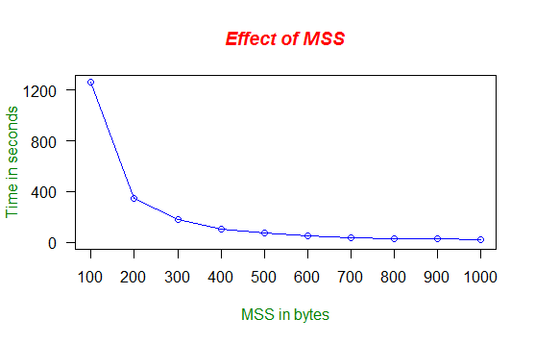

|  |  |
| --- | --- |
| **MSS in bytes** | **Average delay (in seconds)** |
| 100 | 1262.027 |
| 200 | 350.049 |
| 300 | 179.003 |
| 400 | 107.027 |
| 500 | 71.221 |
| 600 | 52.965 |
| 700 | 39.310 |
| 800 | 32.116 |
| 900 | 30.489 |
| 1000 | 21.483 |

From the above graph and table it is seen that small MSS values cause more delays. As the value of MSS increases linearly, the transfer time decreases exponentially. This is the expected result. When the MSS is small, there are more number of packets to send, hence, packet loss is high which results in more re-transmissions. As a result the transfer time increases.

**Task 3: Effect of Loss Probability p**

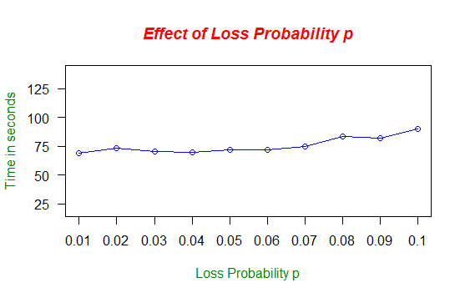

Following graph shows the effect of varying loss probability while keeping the window size and MSS constant.

|  |  |
| --- | --- |
| **Loss Probability** | **Average delay (in seconds)** |
| 0.01 | 68.960 |
| 0.02 | 73.140 |
| 0.03 | 70.123 |
| 0.04 | 69.477 |
| 0.05 | 71.559 |
| 0.06 | 72.129 |
| 0.07 | 74.686 |
| 0.08 | 83.652 |
| 0.09 | 82.245 |
| 0.1 | 89.997 |

From the above graph and table it is seen that the transfer time is nearly constant when we vary p from 0.01 to 0.1 in increments of 0.01. The highest time recorded is for p = 0.1 which is slightly higher than the times recorded for the other values of p.

**Following are the messages used in the project and their interpretations:**

* **Packet Discarded, Checksum not matching :** Displayed at server side when checksum does not match for the incoming packet.
* **Ack retransmitted** : Displayed at server side when the sequence number of incoming packet at server is less than the expected sequence number.
* **Packet loss, sequence number <Number>** : This is displayed at server side when the randomly generated probability is less than the specified loss probability.
* **Timeout, sequence** **number <Number>** : This is displayed at client side when timeout occurs for a packet.

We have taken the observations of the three tasks on three different days.