Munshi Premchand

July 31, 1880.

**Godan** (1936)

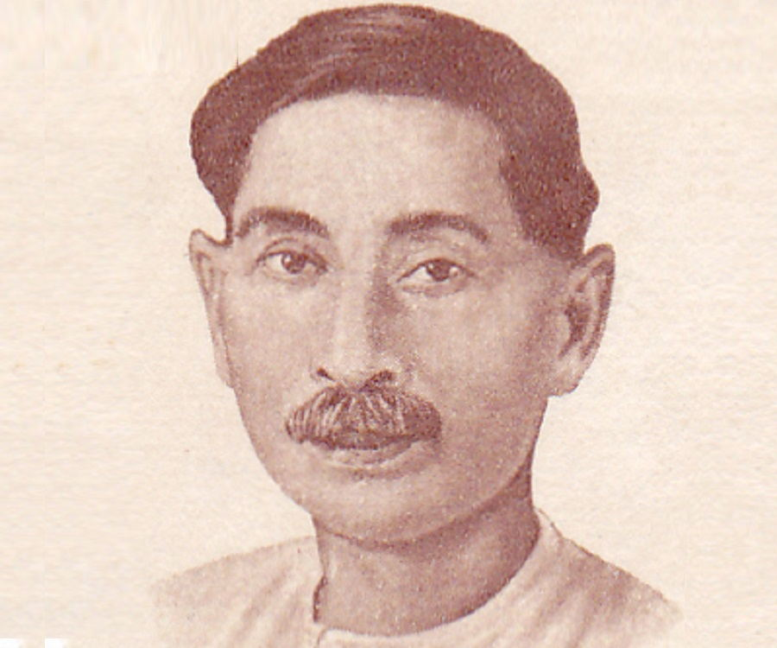

1. William Shakespeare

April 26, 1564

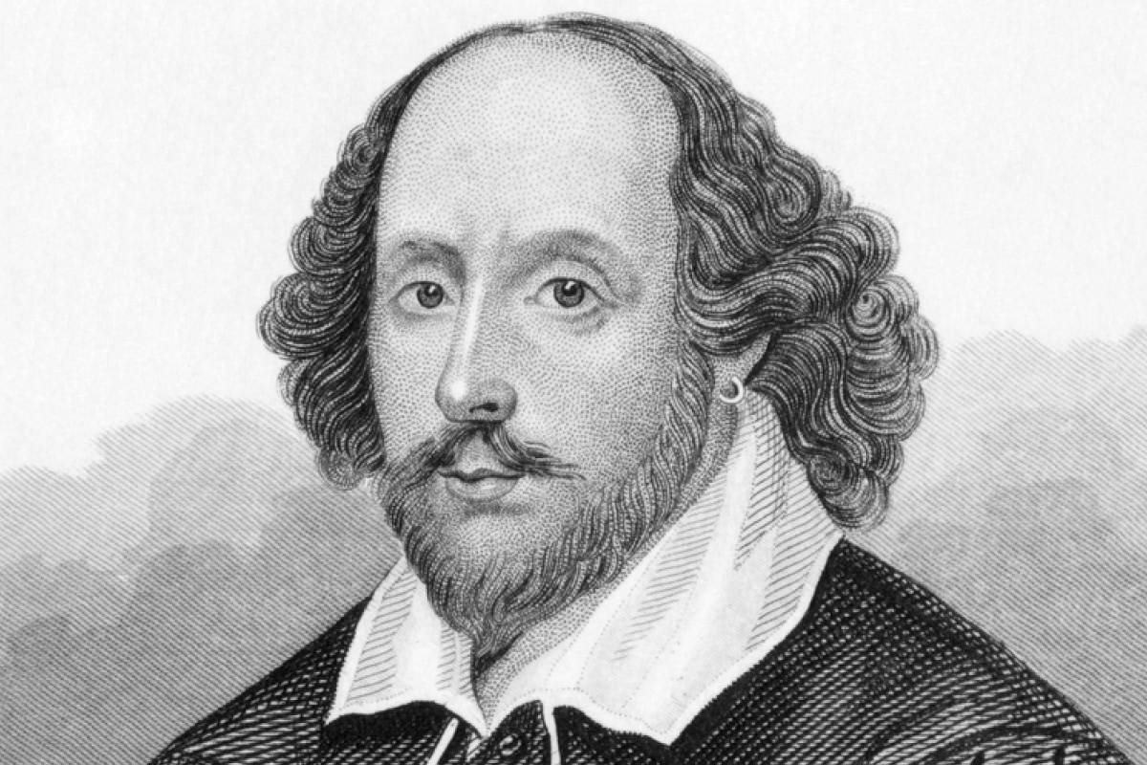Venus and Adonis (1593)

People involved in historical events

1. B.R. Ambedkar - Key architect of the Indian Constitution, social reformer, and leader of the Dalit movement..

a. Bhimrao Ramji Ambedkar,

b. April 14, 1891.

c. **Architect of the Indian Constitution**:

d. 26th January, 1950

2 Subhas Chandra Bose - Indian nationalist leader who led the Indian National Army against British rule during World War II.

a. dob: January 23, 1897.

b. **Azad Hind Fauj (Indian National Army) (1942-1945)**:

3. Leonardo da Vinci - Italian polymath who made contributions to various fields including art, science, engineering, and anatomy.

a. **Artistic Masterpieces (Late 15th to early 16th centuries)**:

b. Dob: April 15, 1452.

4. Martin Luther - German monk, theologian, and key figure in the Protestant Reformation.

a. **Translation of the Bible into German (1522-1534)**:

b. November 10, 1483.

5. Bhagat Singh - Revolutionary socialist who played a significant role in the Indian independence movement, known for his involvement in the Lahore conspiracy case and the Hindustan Socialist Republican Association.

a. **Central Legislative Assembly Bombing (1929)**

**b.** September 28, 1907.

6. Sardar Vallabhbhai Patel - Senior leader of the Indian National Congress, known as the "Iron Man of India" for his role in the integration of princely states into the Indian Union.

a. **Leadership in the Bardoli Satyagraha (1928)**

**b.** October 31, 1875.

**Mathematician**

1. Euclid - Often referred to as the "Father of Geometry," known for his work "Elements" which is one of the most influential works in the history of mathematics.

a. **"Elements" (circa 300 BCE)**:

b. birth around 300 BCE,

2. Pythagoras - Famous for the Pythagorean theorem and for founding the Pythagorean school of mathematics.

a. Pythogorous theorem around the 6th century BCE

b. DOB: around 570 BCE

3. Archimedes - Made significant contributions to geometry, calculus, and mechanics, including the invention of the method of exhaustion.

a. **Archimedes' Principle (circa 250 BCE)**:

b. DOB: around 287 BCE

4. Aryabhata - Ancient Indian mathematician and astronomer, known for his work on the approximation of pi and the concept of zero.

a. **Aryabhata's Model of the Solar System (circa 499 CE)**

**b.** around 476 CE in the ancient kingdom of Magadha, which is present-day Bihar, India.

5. Brahmagupta - Indian mathematician and astronomer who made important contributions to algebra and arithmetic, including the rules of operations with zero.

a. **Brahmagupta's Formula for Quadrilaterals (circa 7th century CE)**

**b.** rom around 598 CE to 668 CE.

6. Leonardo Fibonacci - Italian mathematician who introduced Hindu-Arabic numerals to Europe and is known for the Fibonacci sequence.

a. **Popularization of the Fibonacci Sequence (circa 1202 CE)**

**b.** around 1170 CE

**Scientist**

1. Isaac Newton - English mathematician, physicist, and astronomer, known for his laws of motion and universal gravitation.

a. **Newton's Laws of Motion (late 17th century)**:

**b**. DOB: December 25, 1642,

1. Albert Einstein - German-born theoretical physicist, known for his theory of relativity (both special and general) and the equation E=mc^2.

a. **Special Theory of Relativity (1905)**:

**b**. March 14, 1879.

1. Charles Darwin - English naturalist and biologist, known for his theory of evolution by natural selection.

a. **Theory of Evolution by Natural Selection (1859)**:’

**b**. February 12, 1809.

1. Marie Curie - Polish-born physicist and chemist, known for her pioneering research on radioactivity and for being the first woman to win a Nobel Prize.

a. **Discovery of Polonium and Radium (1898)**:

b. November 7, 1867.

1. Galileo Galilei - Italian astronomer, physicist, and engineer, known as the "father of observational astronomy" and the "father of modern physics."

a. **Concept of Inertia (late 16th to early 17th century)**:

b. DOB: February 15, 1564.

1. Nikola Tesla - Serbian-American inventor, electrical engineer, and physicist, known for his contributions to the development of alternating current (AC) electrical systems.

a. **Alternating Current (AC) Induction Motor (late 19th century)**:

**b**. July 10, 1856.

**Software Developer**

Bill Gates - Co-founder of Microsoft, known for developing the Windows operating system and MS-DOS.

a. Microsoft Corporation was founded by Bill Gates and Paul Allen on April 4, 1975.

b. dob: October 28, 1955.

Steve Jobs - Co-founder of Apple Inc., known for developing the Macintosh computer, iPhone, iPad, and iPod.

a. Apple Inc. was founded on April 1, 1976, by Steve Jobs,’

b. dob: February 24, 1955.

Linus Torvalds - Creator of the Linux kernel, the core component of the Linux operating system.

a. The Linux kernel was first released on September 17, 1991, by Linus Torvalds, who developed it as an open-source operating system kernel.’

b. December 28, 1969.

Tim Berners-Lee - Inventor of the World Wide Web, developed the first web browser and web server.

a. the World Wide Web, occurred in December 1990.’’

b. June 8, 1955.

Larry Page and Sergey Brin - Co-founders of Google, developed the Google search engine and various other Google products.

a. Google was founded on September 4, 1998,

b. Larry Page was born on March 26, 1973, and Sergey Brin was born on August 21, 1973.

Mark Zuckerberg - Co-founder of Facebook, developed the social networking platform.

a. Facebook was founded on February 4, 2004, by Mark Zuckerberg,

b. May 14, 1984.