Name: Gargi P. Revandkar
Roll No: 149
Div: C
Subject Name:
Slip Number:

Q1 A.) Initialize a new Git repository in a folder and create a file named as your rollnumber_firstname. Add some content and commit the changes.
Create a .html file in the repository
Code:
Output:
- Initialize a new Git repository in a folder and create a file named as your rollnumber_firstname. Add some content and commit the changes.
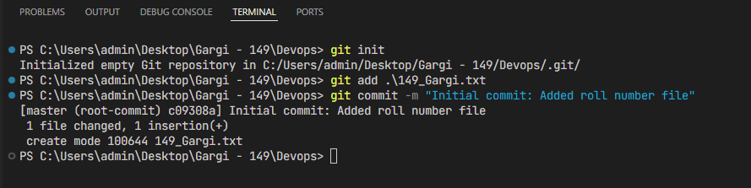

Q1 B.) Create a new branch in GitHub, make changes to a file, and push the changes to the remote repository.
Code:
Output:

4. Push the HTML File to GitHub
Instead of the terminal, you can use the Source Control icon (the third one down on the left sidebar that looks like a branch):
- Click the + next to index.html to stage the change.
- Type "Added index.html" in the message box at the top.
- Click Commit.
- Click Sync Changes (or the cloud icon) to push it to GitHu

