Analysis of Student Mental Health using Data Visualization
And Data Science Techniques

INTRODUCTION
Problem Statement
Student Mental Health- It is a rising concern among the students due to increasing academic pressure, Social expectations and lifestyle changes. It is important to address this issue and analyze the various factors which are affecting the student mental health. The main objective of this project is to analyze the student data in order to identify the factors which are affecting student’s performance. The dataset contains various factors such as: CGPA, academic stress, financial, stress, depression , medical issues ,etc. The goal is to analyze these factors and build an predictive model.
Business Objective
The goal is to help students, parents and educational institution to identify the factors which are affecting student success and improve the decision making for better performance in academics.

CRISP_DM Process
CRISP-DM approach is used in this project:
- Business Understanding
- Data Understanding
- Data Preparation
- Modeling
- Evaluation
- Deployment

DATA UNDERSTANDING
Dataset Description
The dataset Student Depression dataset contains various student related information such as:

- Gender
- Student Age
- Academic stress
- CGPA
- Study hours
- Sleep Duration
- Financial stress
- Depression
- Medical history
- Dietary habits
- Depression(Target Variable)
Data Types
- Numerical Data: CGPA , study Hours
- Categorical Data: Diet, Sleep Duration
- Binary: Depression(0=No, 1=Yes)

Data Quality Assessment
Data quality assessment was conducted to check whether the data is reliable, consistent ,and suitable for analysis and modeling.
- The dataset was examined for null values across all attributes present.
- No significant missing values were found in key columns such as Depression, Academic pressure, CGPA and sleep duration.
- The dataset was checked for duplicate entries using unique identifiers and row comparisons.

- No significant duplicate records were found.

- Categorical variables such as Gender, Dietary Habits and sleep duration were checked for inconsistent labels.

- Standardization was applied where necessary to maintain uniformity.

- Each column was verified to ensure correct data types.

- The target variable Depression was analyzed:

Approximately 58.5%=Depressed
Approximately 41.5%=Not Depressed

DATA CLEANING
- Removed duplicate records to ensure data uniqueness.
- Investigated missing values but none found:
- Standardized categorical values.
- Ensure consistency in data format and labels.
- Removed irrelevant columns.
- Applied encoding techniques for categorical variables.
- Standardized numerical features.
- Normalize the data using min-max scaling.

CODE:
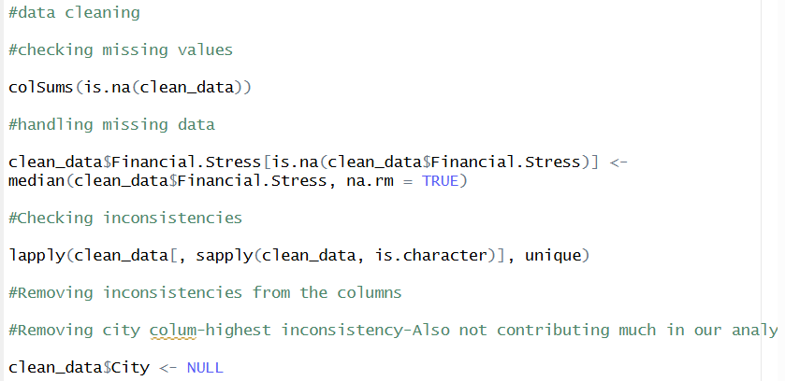
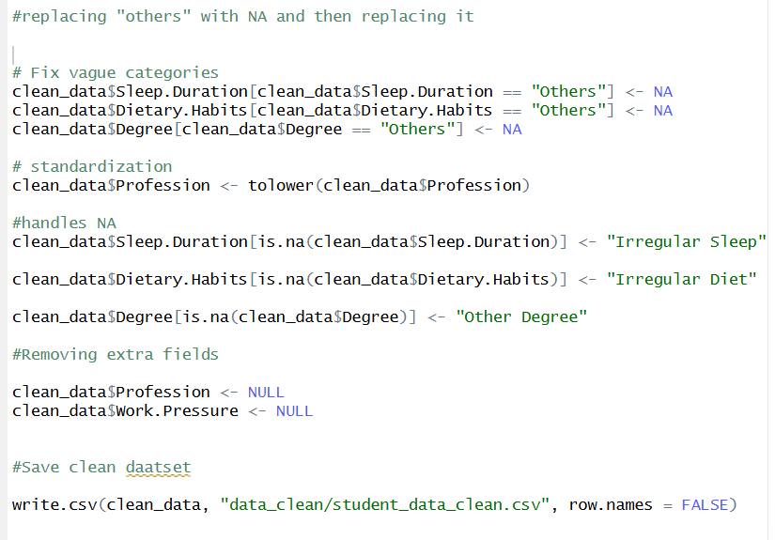

EXPLORATORY DATA ANALYSIS
Student Depression Distribution
The graph shows the distribution of depression among students, 0 represents student with no depression and 1 shows student with depression .The graph clearly shows that a larger number of students fall under the depressed category. This suggests that it is a Major issue among the students.

CODE:
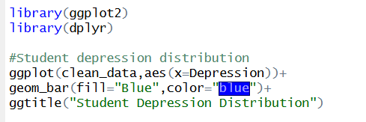

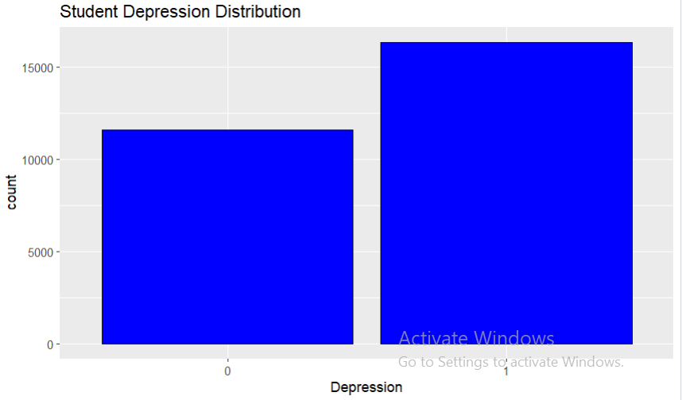

Student Age Distribution
The dataset’s age distribution is displayed in this histogram. The majority of the students fall into the lower to medium range, with the largest frequency occurring between 0.2 and 0.3. There are very less students in the upper range as indicated by the small right skew. Overall, the graph indicates that students from a more limited and comparable age range predominate in the sample
CODE:
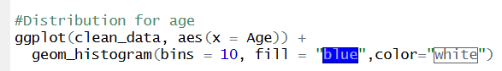
.

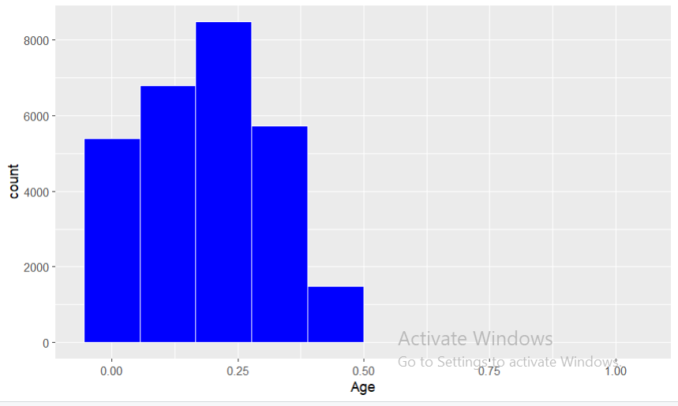

CGPA Distribution
The histogram shows the CGPA distribution of the dataset. Many students had comparatively good academic achievement, as seen by the majority of observations being centered in the higher CGPA range. Overall, the graph indicates that a percentage of students with higher academic achievement are included in the dataset.
CODE:
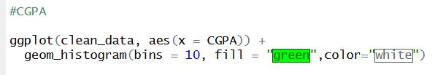

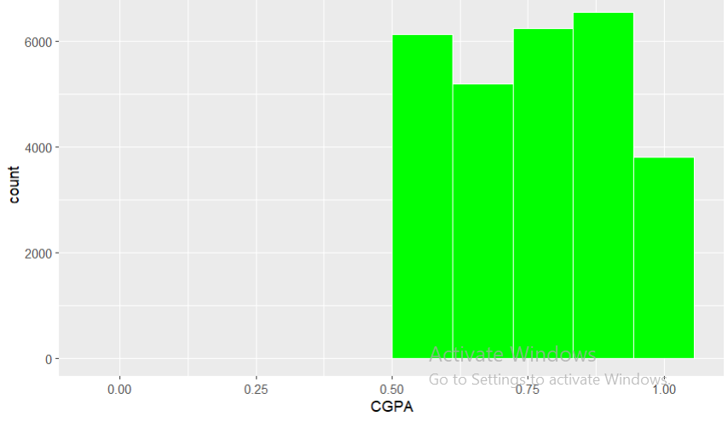

Financial Stress
The financial stress is displayed in this graph. Although the frequencies are well spread between the categories, the count rises with increasing levels of financial stress, peaking at the maximum stress group. This implies that a greater percentage of students in the sample deal with moderate to severe financial stress, which might have a significant impact on student’s mental health.
CODE:
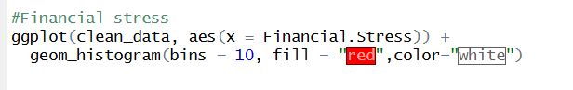

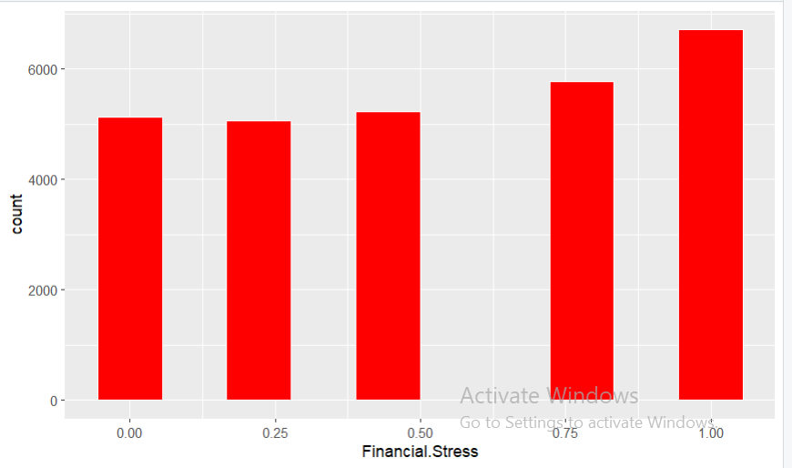

Categorical Variable Analysis
Gender Vs Depression
The graph shows the correlation between gender and depression. There are more students who are classed as depressed(1) than a not depressed(0) for both males and females. The number of male students with depression is somewhat greater tan that of female students, indicating that depression seems to be more common among male students in this sample. Overall, the graph suggests that gender and depression may be related.

CODE:
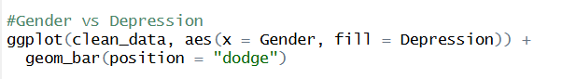

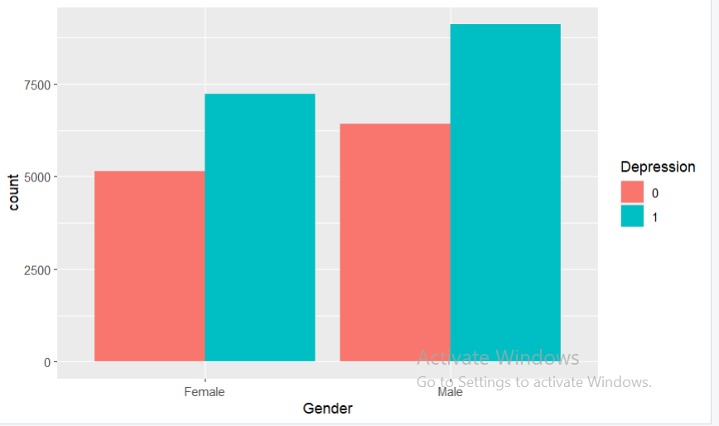

Sleep duration Vs Depression
Students who sleep for fewer than five hour shad the highest incidence of depression diagnoses, according to this graph, suggesting a potential link between inadequate sleep and worse mental health. Students who get more than eight hours of sleep seem to have lower levels of depression.

CODE:
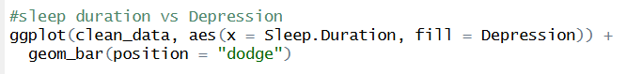

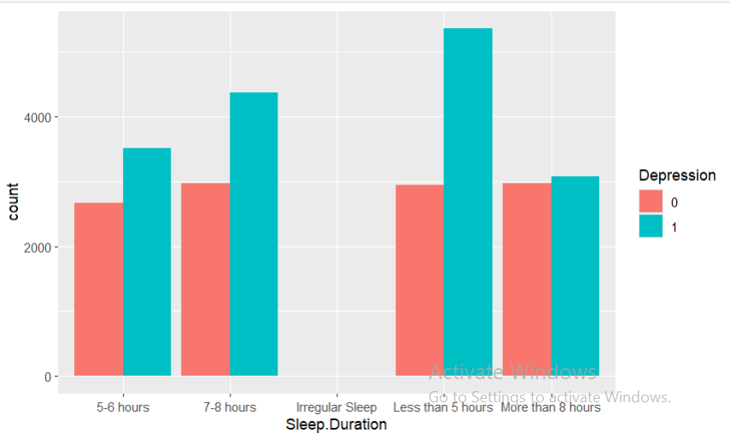

Dietary habits Vs Depression
The graph clearly shows a connection between depression levels and eating habits. Healthy eating may be linked to improved mental health, as evidenced by the reduced number of depression cases among students who follow a healthy diet compared to those who do not. Depression cases are more common than non-depression patients in the moderate diet group, suggesting a potential risk increase. Students with bad eating habits exhibit the sharpest trend, with a much larger proportion of sad students than non-depressed pupils. Overall, the graph indicates that a higher incidence of depression among students may be linked to poorer eating habits.
CODE:
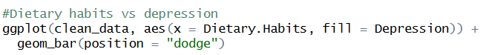

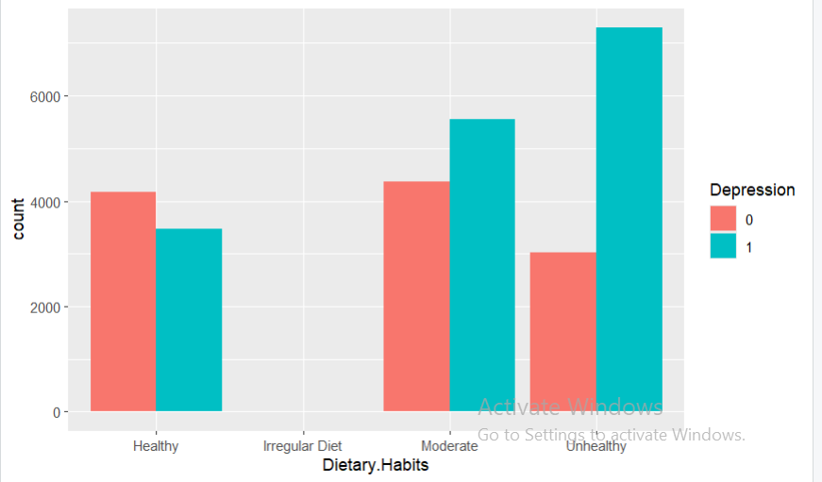

Family history Vs depression
The graph indicates a correlation between depression among pupils and a family history of mental illness. The number of depression cases among students with a family history of mental illness is much greater than that of students without such a history. Depression cases are still more common among students without a family history, but the difference is greater for those who do. This pattern suggests that a higher risk of depression may be associated with a family history of mental disease.

CODE:
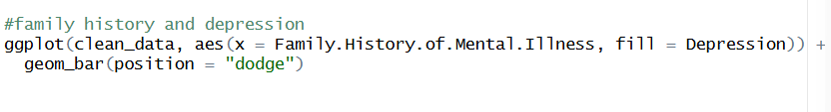

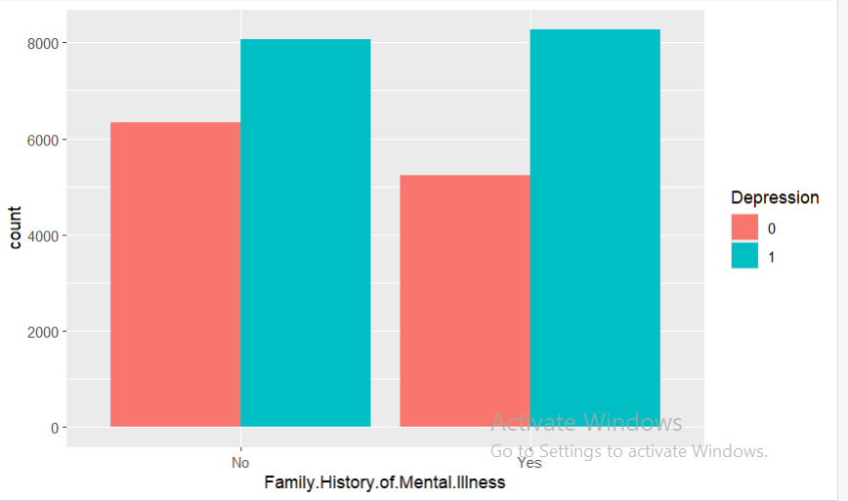

Relationship analysis:
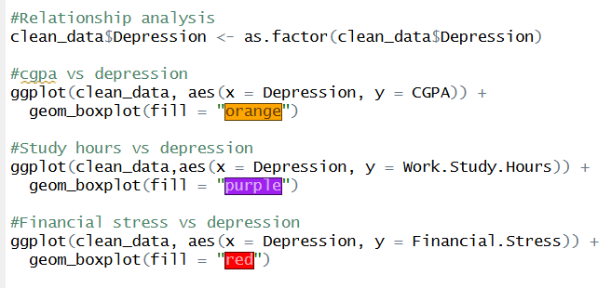

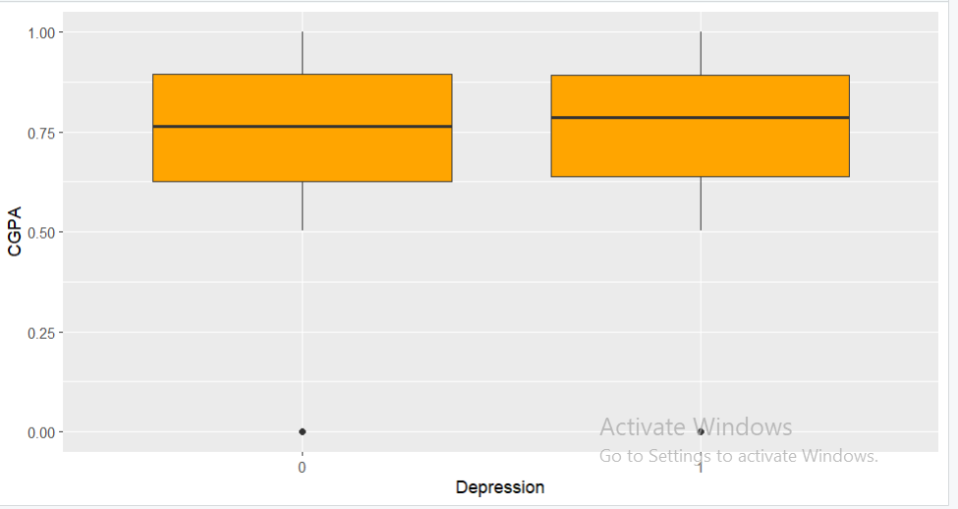

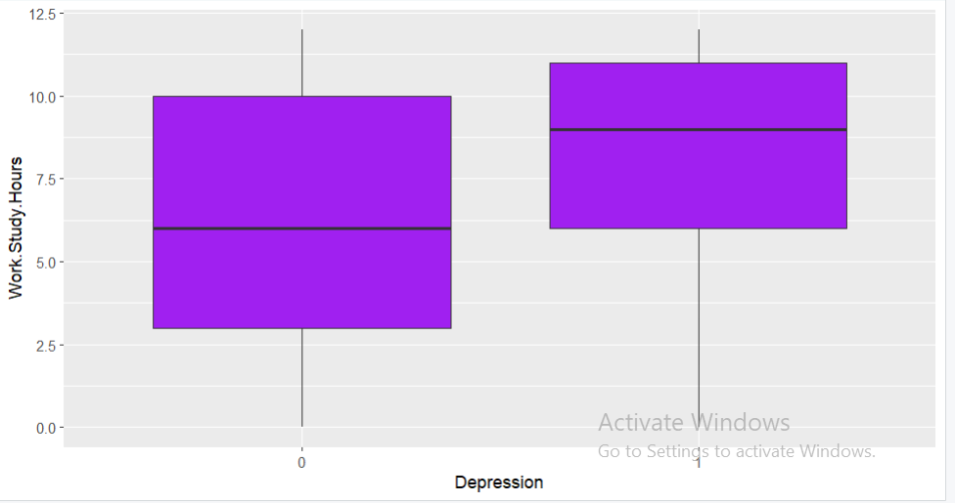

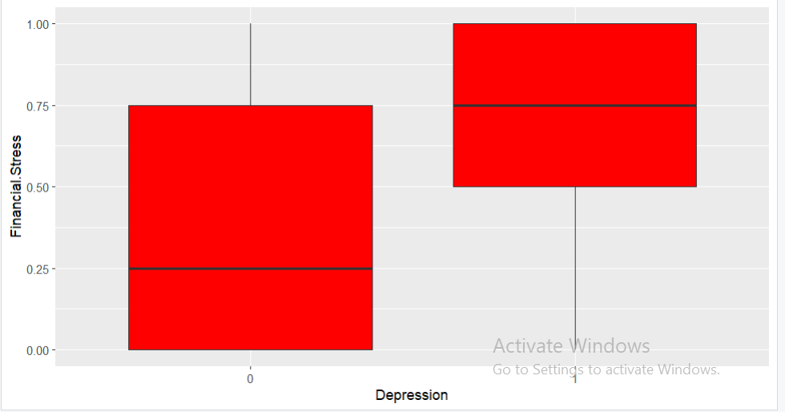

Absence of multicollinearity
Logistic regression assumes that predictors are not highly correlated with each other. This condition is known as absence of multicollinearity.
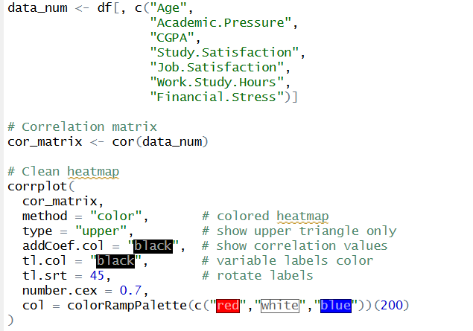

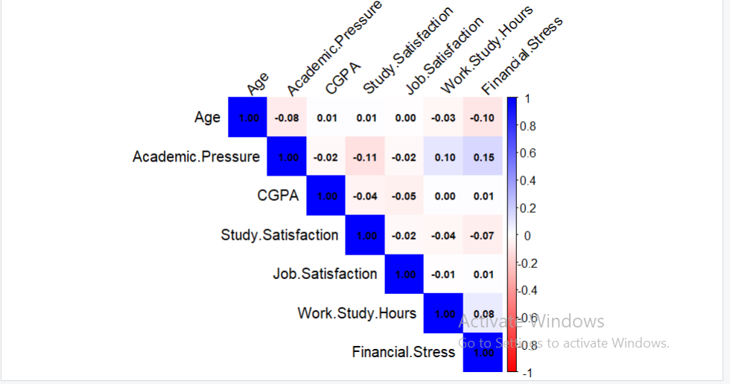

Probability and Statistical Analysis
Performed:
- Mean
- Variance
- Standard deviation
Mean Values:
- Average Age= 25.82 years
- Average CGPA= 7.65
- Academic Pressure=3.14
- Financial Stress=3.13
- Depression probability=0.585
Variance and Standard Deviation:
- Age shows moderate variation (SD=4.90)
- Work study hours show high variation(SD=3.70)
- CGPA is relatively stable(SD=1.47)

Interpretation:
- Student experience moderate academic pressure.
- Majority of students show signs of depression.
- Student differs significantly in workload.
- Academic performance is relatively consistent.

CODE:
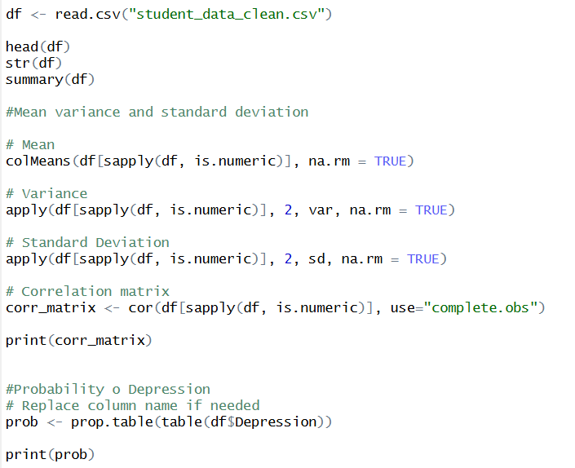

CORRELATION ANALYSIS
Key correlation with Depression:
- Academic Pressure =0.47
- Financial Stress=0.36
- Work study Hours=0.20
- Age=-0.22
- Study Satisfaction=-0.16

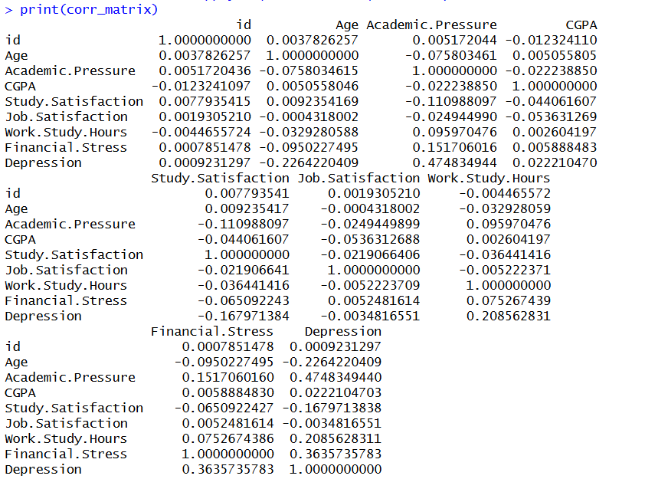

Interpretation:
- Higher academic pressure increase depression.
- Financial stress is a major contributing factor.
- Higher satisfaction reduces depression.
- Older students are slightly less depressed.

Probability Analysis
Probability of Depression:
- P(Depression=1)=0.585
- P(Depression=0)=0.414

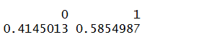

Interpretation:
- More than half of the students are experiencing depression.

Hypothesis Testing
Test performed:
Comparison of CGPA based on work study Hours(High vs Low)
Hypothesis:
H0: Study hours do not affect CGPA
H1: Study hours affect CGPA
Results:
p-value:0.3713
it is greater than he value of alpha 0.3713> 0.05
Conclusion:
Fail to reject H0
Interpretation:
Study hours do not significantly affect CGPA.
CODE:
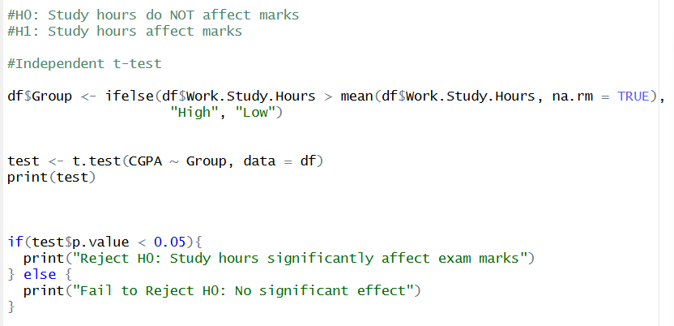

One-Sample T-Test on CGPA:
- Mean CGPA =7.65
- P-value < 2.2e-16

Interpretation:
The average CGPA is significantly different from 0, confirming valid data distribution.

CODE:
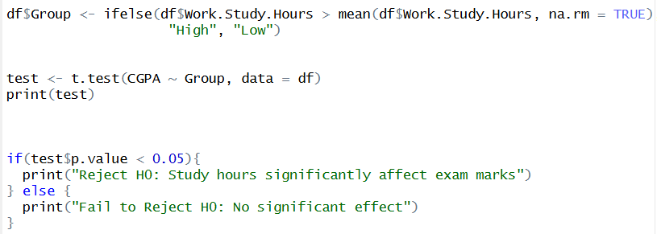

Feature Engineering
Feature Selection:
Removed irrelevant columns and retained important predictors.
Feature Transformation:
- Converted Depression into factor variable.
- Encoded categorical variables
CODE:
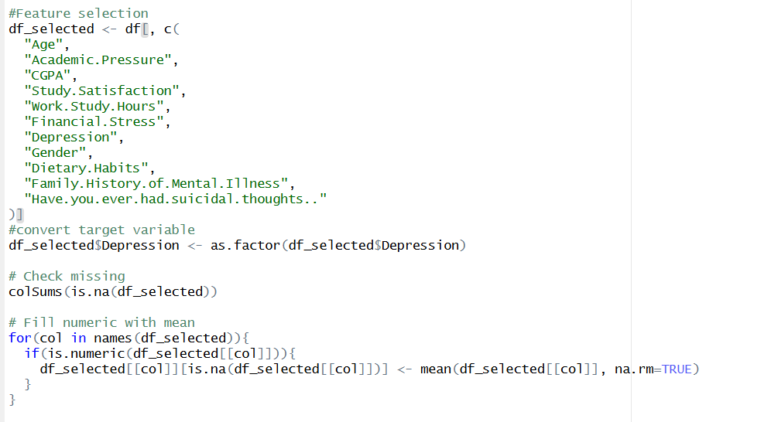

Feature Scaling:
- Normalized numeric features to improve model performance.

CODE:
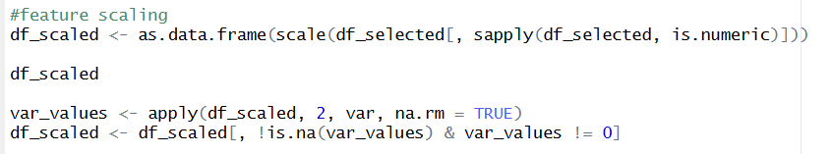

PCA:
- Applied dimensionality reduction.
- Removed redundant features.
CODE:
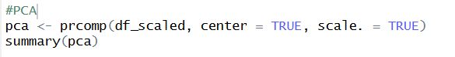

Machine learning model
Train-test split:
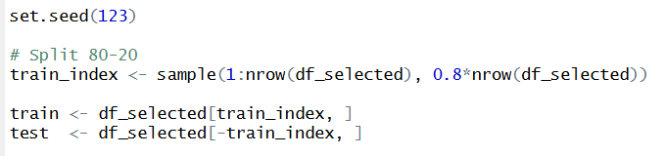

Supervised Learning:
Linear Regression
To understand how many factors are affecting student’s academic performance ,which is measured using CGPA , a linear regression model is used. The factors which are considered in the model are:
- Age
- Academic Pressure
- Study satisfaction
- Financial stress
- Gender
- Mental health indictors
The results shows that few variables have a statistically significant effect on CGPA. Specifically, academic pressure and study satisfaction have discernible negative relation with CGPA.Ths shows that student’s academic performance may get affected by increasing academic pressure and decreased study satisfaction.

Model Performance
The R-squared value of this model is very (approx. 0.0056) , which implied that chosen factors account for just 0.56% of the variation in CGPA.
This indicates that:
- The model’s fit to the data is poor.
- The dataset probably excludes additional significant variables that have an impact on CGPA.
Conclusion:
Overall, the linear regression model shows that while some elements, such as study satisfaction and academic pressure can affect academic success, the model’s overall predictive ability is limited. Therefore , linear model alone may not be sufficient to accurately predict CGPA and more sophisticated models or variables are needed for improved results.
CODE:
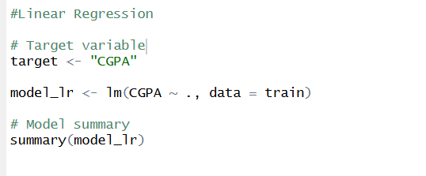

Decision Tree
Students were categorized according to their depression state using a Decision tree , which took into account both personal and academic circumstances. According to the model, the most significant variables are financial stress, academic pressure, and suicidal thoughts.
The model achieved 82.17% training accuracy and 81.99% test accuracy, the model shows strong prediction performance and reliable outcomes on unknown data. The model does not exhibit significant overfitting and appears to generalize effectively based on the slight discrepancy between test and training accuracy.

Conclusion:
The Decision Tree model demonstrated a substantial correlation between mental health and suicidal thoughts, financial stress, and academic pressure, and it performed well in predicting student sadness.
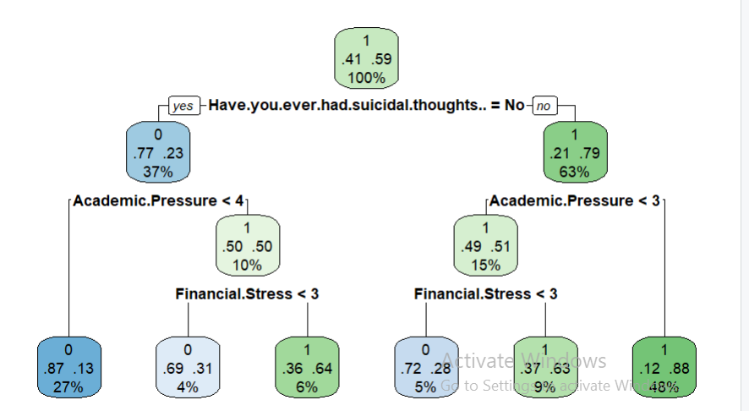

CODE:
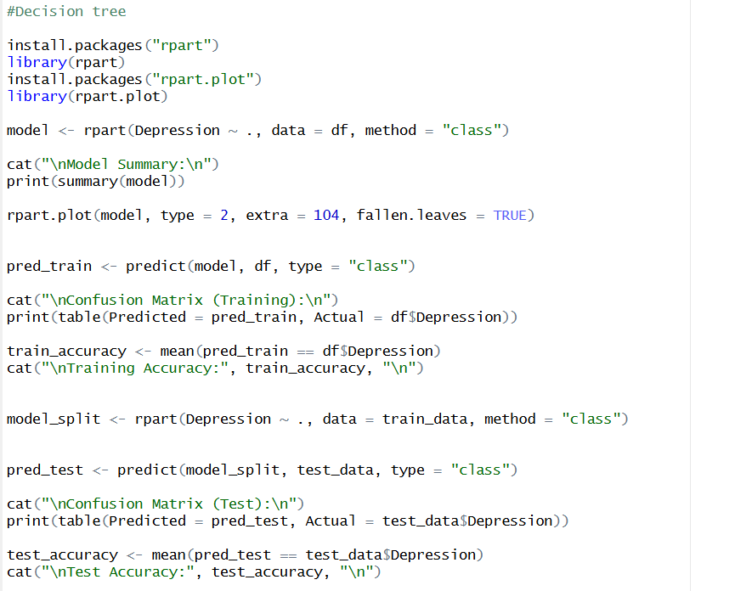

KNN
Using the chosen predictor variables, a KNN model was employed to categorize pupils according to their depression level. The model was assessed using test data after being trained with k=5. The model’s predictive ability in identifying depressed pupils was moderate, with an accuracy of 75.56%. Although some examples were incorrectly classified, the confusion matrix shows that the model was able to accurately categorize a significant percentage of cases.
Conclusion
The Decision Tree model outperformed KNN model for this dataset, as evidenced by the latter’s higher accuracy in predicting student sadness.
CODE:
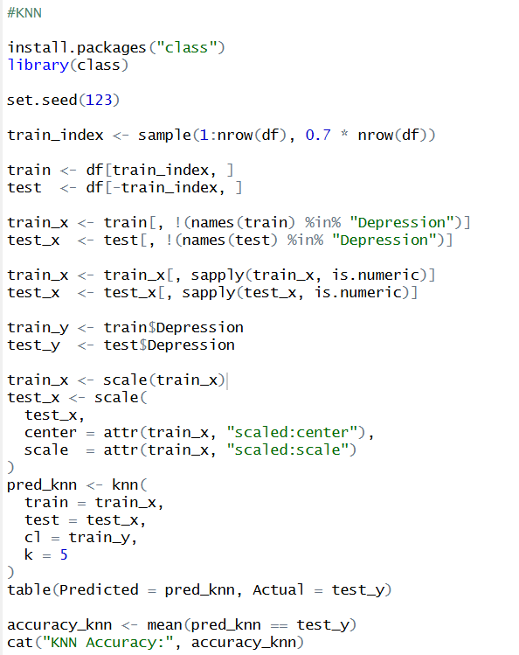

Logistic Regression
Students were categorized according to their depression level using academic, financial, and personal aspects using a logistic regression model. The findings indicate that a family history of mental illness, work-study hours, financial stress, suicidal thoughts, food habits, and academic pressure all have a substantial impact on depression.
The model had an excellent prediction performance with an accuracy of 84.73%. Suicidal thoughts had the most impact out of all the factors, followed by financial hardship and academic pressure.
Conclusion:
The Logistic Regression model shows that academic stress, financial stress, and suicidal thoughts have a significant impact on mental health and performed well in predicting student depression. Additionally, it outperformed KNN and Decision Tree on this dataset.
CODE:
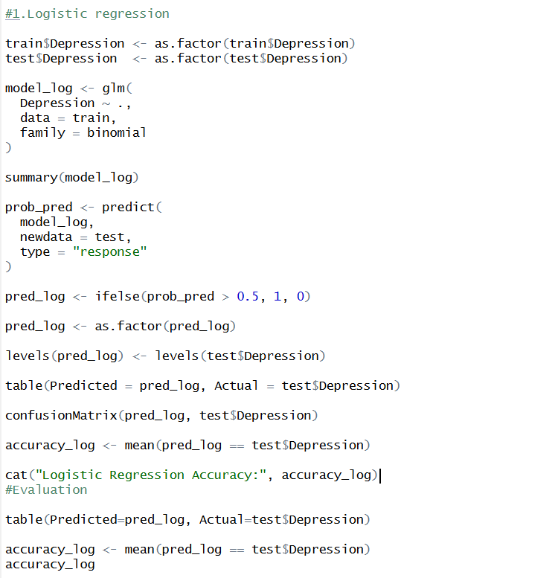

Unsupervised Learning:
K means Clustering
Students were divided into three groups according to similarity in academic and mental health-related characteristics using K-means clustering. Different student groupings in the dataset were revealed by the study, which created clusters of sizes 9025, 11108, and 7768.
The clustering results point to variations in pupils patterns of stress and mental health. Higher degrees of academic pressure, financial stress, and depression are linked to one cluster, whereas students with lower levels of stress and generally greater well-being are represented by another cluster.
The significant divergence between the groups is indicated by the inter-cluster variance(24.4%), demonstrating that K-Means was successful in indentifying unique student profiles.
Conclusion:
In conclusion, K-means clustering helped divide students into several risk categories according to stress and depression-related variables and uncovered hidden patterns in student mental health.

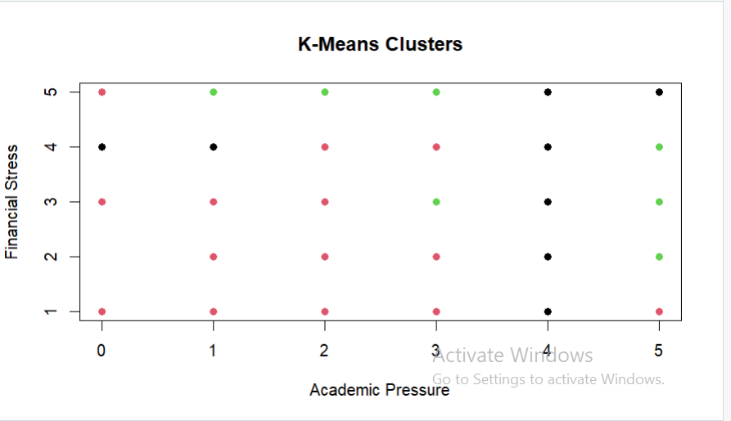

CODE:
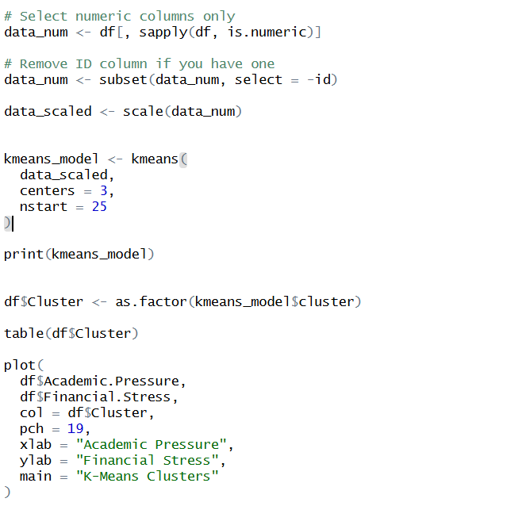

Hierarchical Clustering
Students were naturally grouped according to academic and mental health-related variables using hierarchical clustering. Utilizing the ward. Three clusters with sizes of 16,333, 11,560, and 8 observations were shown in dendrogram using the D2 technique.
The clustering results show the existence of discrete student groups with various stress and mental health- related issues. The dataset’s primary student groupings are represented by the first two clusters, whereas the third cluster, which is quite small, could reflect outliers or a very separate subgroup.
Conclusion:
Hierarchical clustering validated the existence of distinct student profiles and uncovered hidden patterns in data, which may aid in identifying groups with differing degrees of mental health risk.

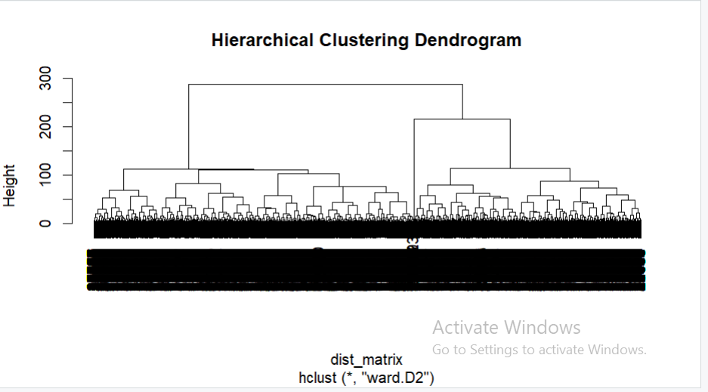

CODE:
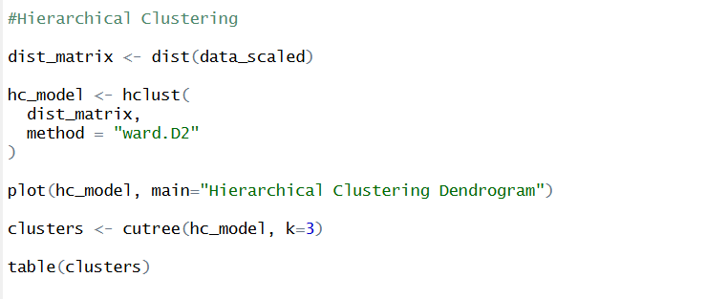

Model Evaluation
Classification Models Evaluation
Linear Regression
CODE:
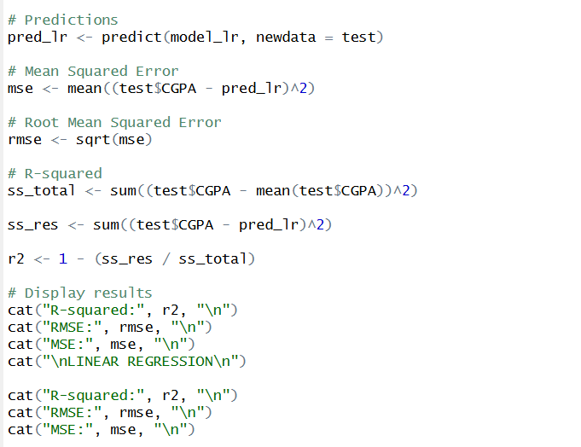
OUTPUT:
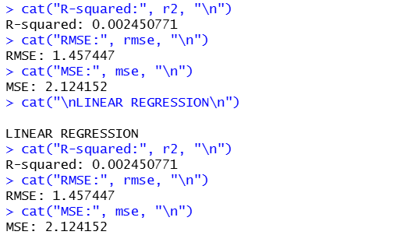

Classification Models
CODE:
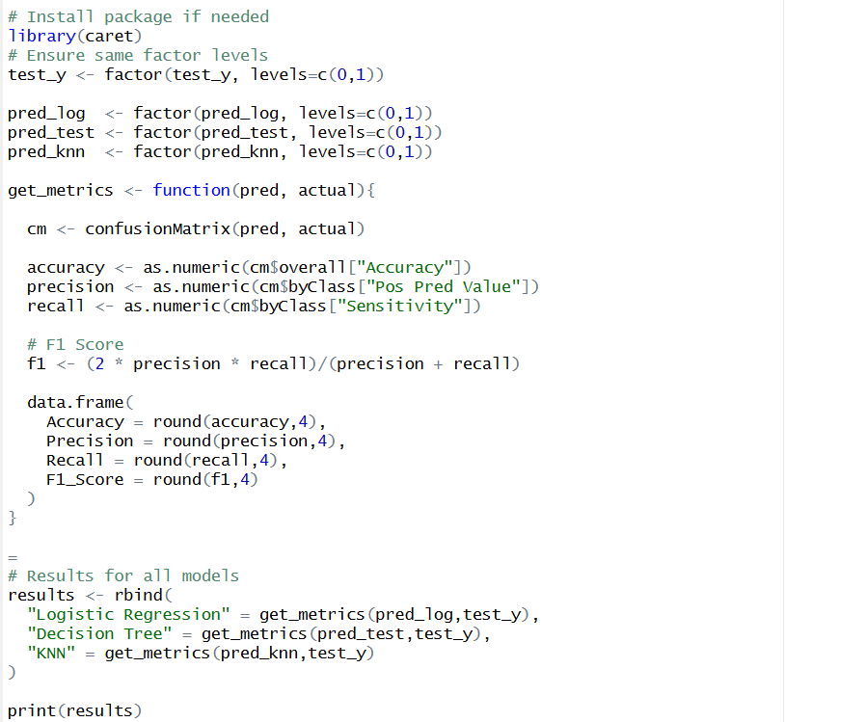
OUTPUT:
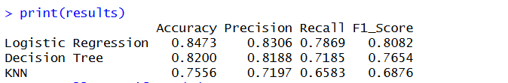

Clustering Models Evaluation
K-means clustering
CODE:
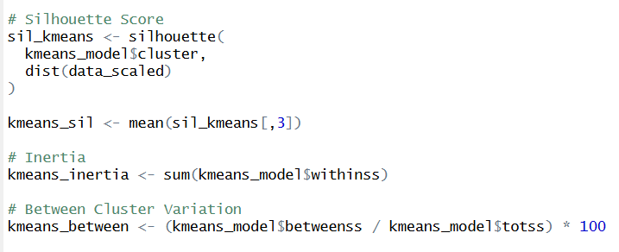

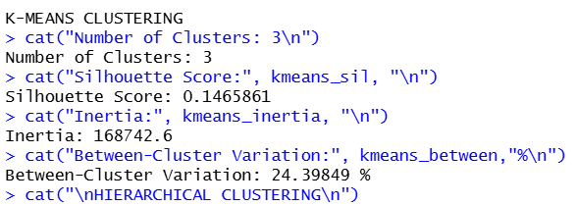

Hierarchical clustering
CODE:
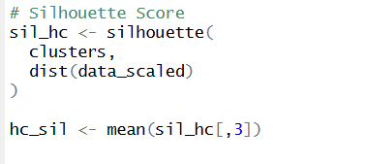

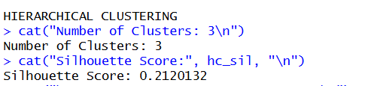

Interpretation:
The performance of the above 4 models are evaluated using confusion matrix, accuracy,precision,Recall and F1 score:
- Linear Regression: It gives the negative R^2 value which indicate poor fit and unsuitability for this dataset.
- Logistic Regression: It achieved the highest accuracy of 84.73%, Precision(83.06%), Recall(78.69%), and F1-Score(80.82%) .This suggests that i it is the best classification model for this dataset.
- Decision Tree: It achieved an accuracy of 81.99% ,F1-score of 76.54%, which is slightly lower than Logistic Regression ,so it performed the Second best.
- KNN: It achieved the lowest frequency among all the models, which shows that its comparatively weaker performance.

Conclusion:
Logistic regression is the best performing model among all the classification models.

K-Means Clustering:
The students were successfully split into three groups using K-Means. The degree of separation and significance of the clusters is indicated by the silhouette score and between-cluster variance. Based on the academic stress, financial stress and satisfaction and other associated features students may be divides into different mental health patterns.

Hierarchical Clustering:
This also create three clusters and the quality of cluster creation is indicated by its silhouette score. Also this technique shows more evidence that the dataset had natural groups.

Conclusion:
Both the clustering techniques found significant student grouping, while K-Means offered a more transparent cluster structure for segmentation analysis.

Results and Insights
The analysis of student mental health revealed several important patterns related to factors influencing depression among students. Exploratory analysis showed that variables such as academic pressure, financial stress, sleep duration, dietary habits, and family history of mental illness have a notable relationship with student depression. Students experiencing higher academic pressure and financial stress showed a greater likelihood of depression. Similarly, students with poor sleep patterns, unhealthy dietary habits, and a family history of mental illness were observed to have higher depression prevalence.
Correlation analysis indicated generally weak correlations among predictor variables, suggesting low multicollinearity and supporting the suitability of the dataset for predictive modeling. The heatmap showed some relationships, such as a slight positive association between academic pressure and financial stress, and a weak negative relationship between academic pressure and study satisfaction.
In supervised learning, multiple models were applied and evaluated. Logistic Regression emerged as the best-performing model, achieving the highest accuracy (84.73%) along with the strongest precision, recall, and F1-score. Decision Tree also showed good performance, while KNN performed comparatively lower. Linear Regression showed poor predictive performance, indicating it was not suitable for this problem. These results suggest that student depression can be effectively predicted using classification models, particularly Logistic Regression.
In unsupervised learning, K-Means and Hierarchical Clustering successfully identified distinct student groups based on mental health-related characteristics. The clustering results suggest that students can be segmented into meaningful groups with different stress, satisfaction, and depression patterns, which can help in targeted mental health interventions.
Key Insights
- Academic pressure and financial stress emerged as major factors associated with depression.
- Sleep duration and dietary habits showed significant influence on student mental well-being.
- Family history of mental illness appears linked to higher depression prevalence.
- Logistic Regression was the most effective predictive model for identifying depression risk.
- Clustering revealed meaningful student segments, supporting the presence of different mental health profiles among students.
- Machine learning techniques can be effectively used to support early identification of at-risk students and aid in data-driven mental health interventions.
Overall, the project demonstrates that both predictive modeling and clustering provide valuable insights into student mental health and can support better understanding, monitoring, and intervention strategies.

