LOVELY PROFESSIONAL UNIVERSITY



Cap 202: C++ Laboratory

Ca 3: project report

|  |  |
| --- | --- |
| SUBMITTED BY:  NAME: GARGI SHARMA  REG. NO: 12403355  ROLL NO: RD2411A24  NAME: SAHIB CHOUHAN  REG. NO: 12411026  ROLL NO: RD2411A03  SECTION: D2411[G1] | SUBMITTED TO:  Mrs. YAMINI BHARDWAJ  UID:30979 |



TITLE:

Courier Tracking System – Track packages and update delivery status

CHANGES MADE:

**1. Class Structure & Inheritance**

* **CA-2**:
  + Uses a simple Courier class without inheritance.
* **CA-3**:
  + Introduces a **base class**Person (for shared attributes like name).
  + Courier **inherits** from Person (reusing name for sender).
* **2. Features & Enhancements**

| **Feature** | **CA-2** | **CA-3** |
| --- | --- | --- |
| **Priority Levels** | ❌ No | ✅ Yes (Normal/Express) |
| **Rating System** | ❌ No | ✅ Yes (1-5 stars) |
| **Express Filtering** | ❌ No | ✅ showExpressCouriers() |
| **Destructor** | ❌ No | ✅ Prints deletion message |

**3. Fee Calculation**

**CA-2**:

fee = (weight * 10) + (distance * 5);

**CA-3**:  
Adds **priority-based pricing** (Express costs 1.5× more):

fee = (weight * 10) + (distance * 5);

if (priority == "Express") fee *= 1.5;

**4. Input Validation**

* **CA-3** adds:
  + Rating validation (1-5 only).
  + Checks if a courier is **delivered** before allowing ratings.

**5. Menu System**

| **CA-2 Menu** | **CA-3 Menu** |
| --- | --- |
| 1. Add Courier | 1. Add Courier |
| 2. Track Courier | 2. Track Courier |
| 3. Update Status | 3. Update Status |
| 4. Display All | 4. Show Express Couriers |
| 5. Exit | 5. Display All |
|  | 6. Rate Courier |
|  | 7. Exit |

**5. User Interface (UI)**

* **CA 2**:
  + Plain text output.
* **CA 3**:
  + Uses **ANSI color codes** (e.g., \033[1;32m for green).
  + More **visually appealing** (e.g., colored statuses, ratings).

**Comparison with CA-2**

| **Feature** | **CA-2 (No Inheritance)** | **CA-3 (With Inheritance)** |
| --- | --- | --- |
| **Constructor** | Simple, no base class init | Must call Person(s) Previous |
| **Default Args** | No default values | Supports defaults (weight=1.0, etc.) |
| **Destructor** | Not defined | Defined (prints deletion message) |
| **Initialization Order** | N/A | Person → Courier |



CODE:

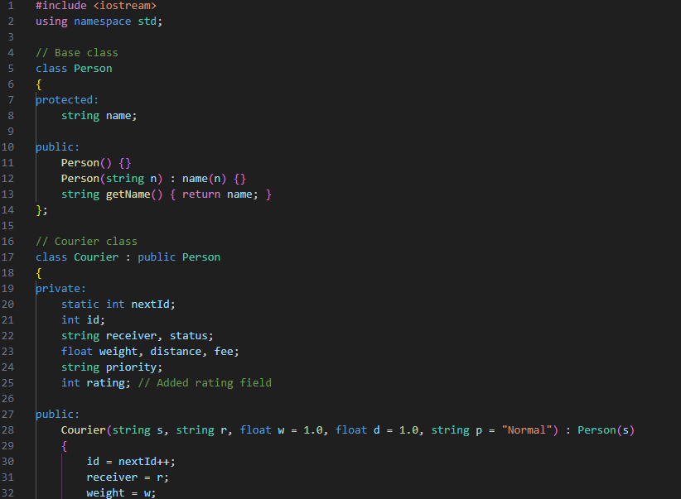

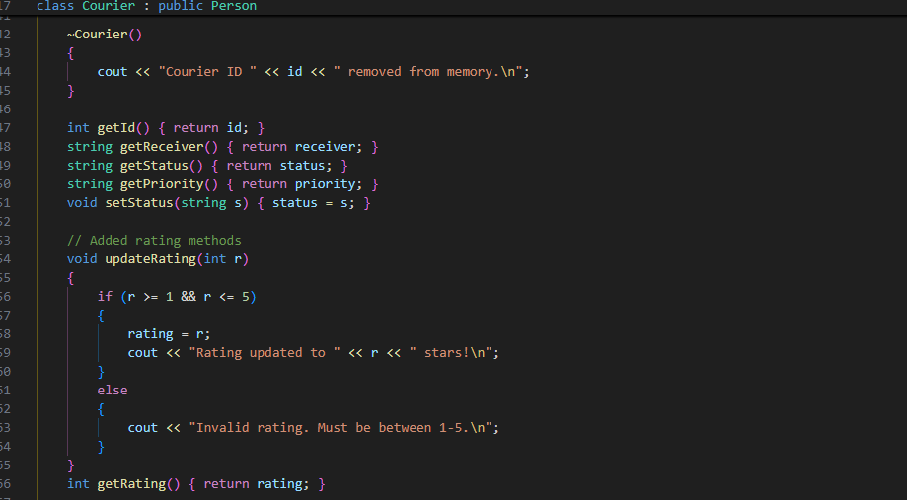

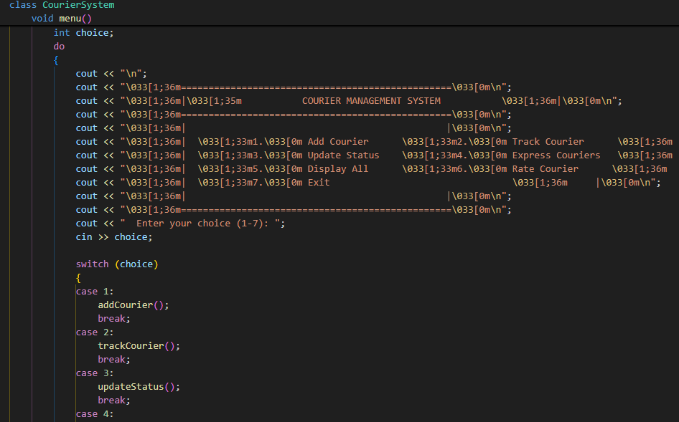

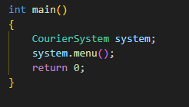

OUTPUT:

