**Assessment 20 – Ansible1**

**Trainee Name : Gargi Sharma**

**Mentor Name : Mr. Akansh Gupta**

**College Name : UPES**

**1. Run Ansible Ad-hoc commands:**

1.1 To execute command in bash and see the result

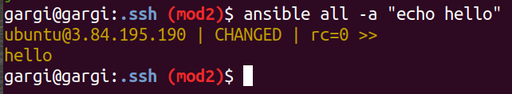

1.2 To check all running processes.

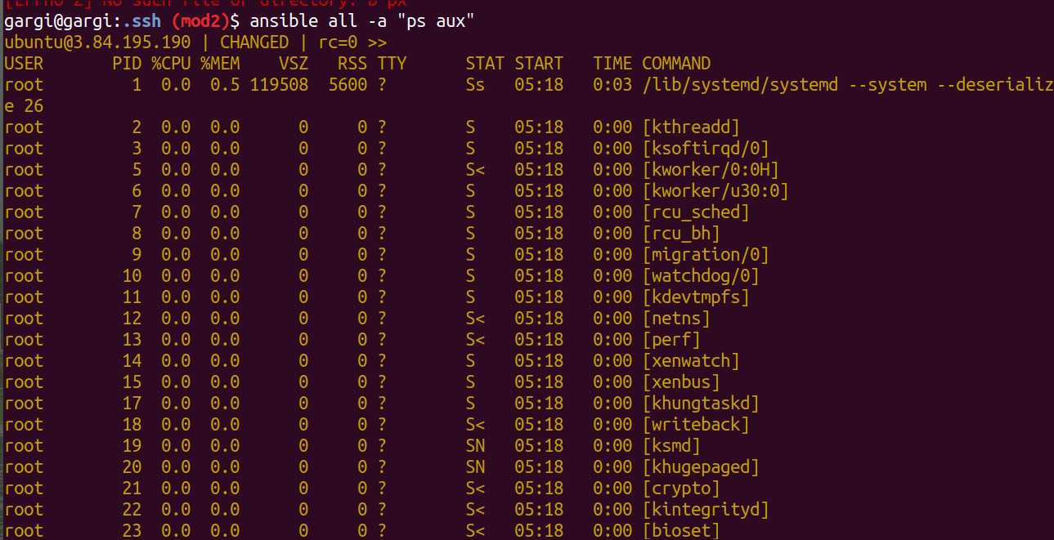

1.3 To copying files to multiple nodes concurrently

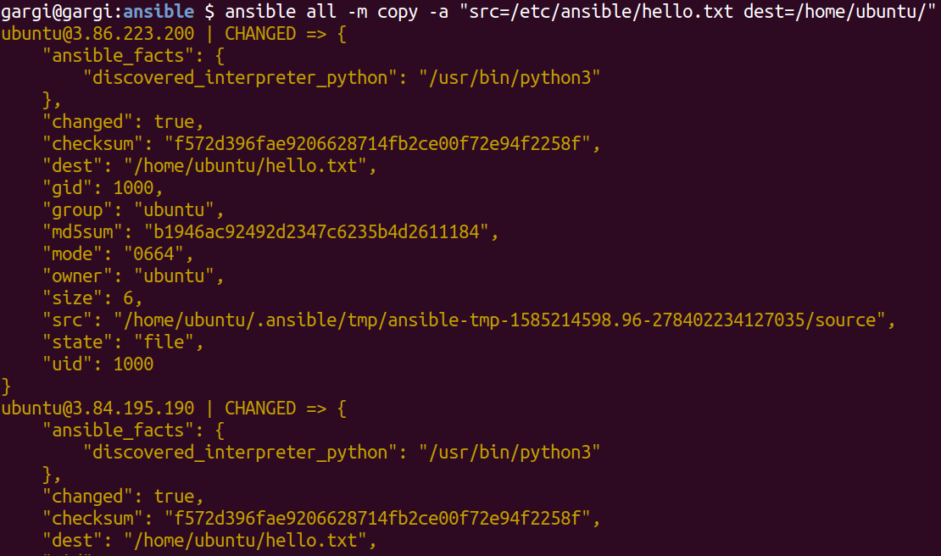

1.4 To add and delete user

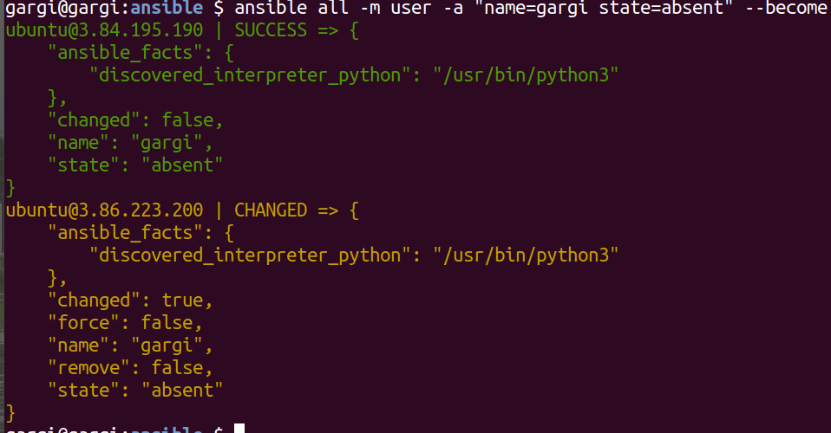

2. **Create nginx ansible playbook and run the node. Also check if nginx service and defualt page is running or not.**

Create an ansible playbook.

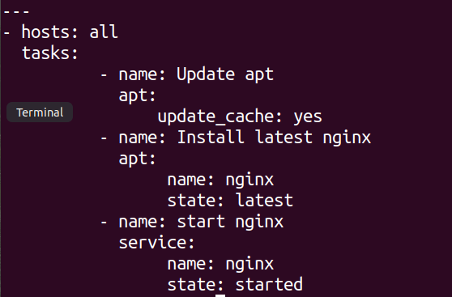

Dry run to check for errors in yml file.

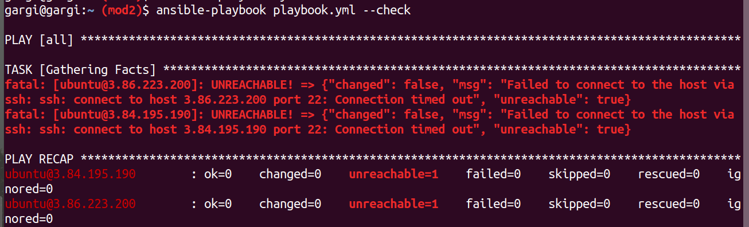

Run the playbook.

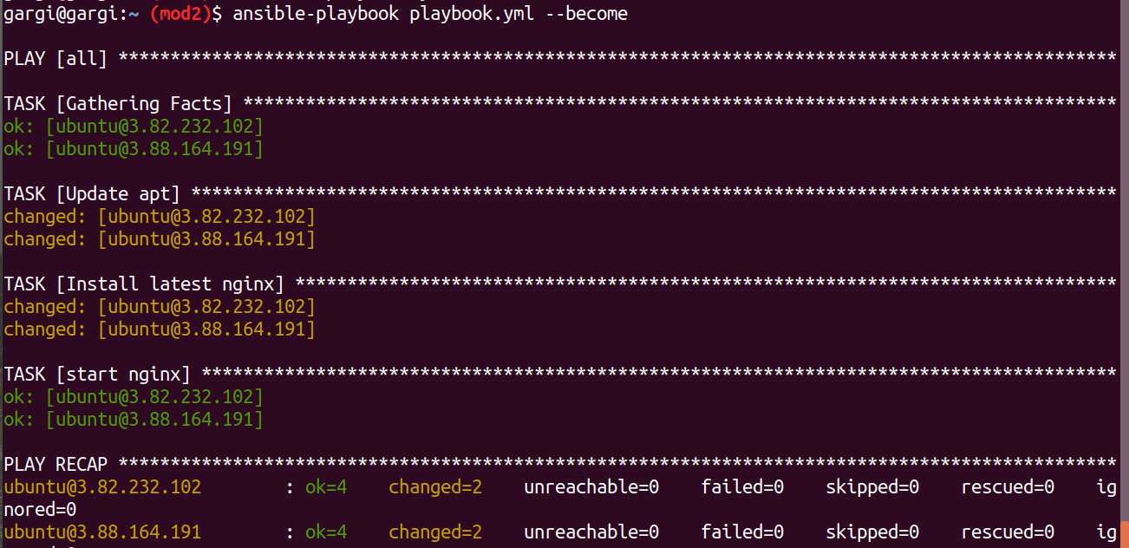

Check if the default page is displaying

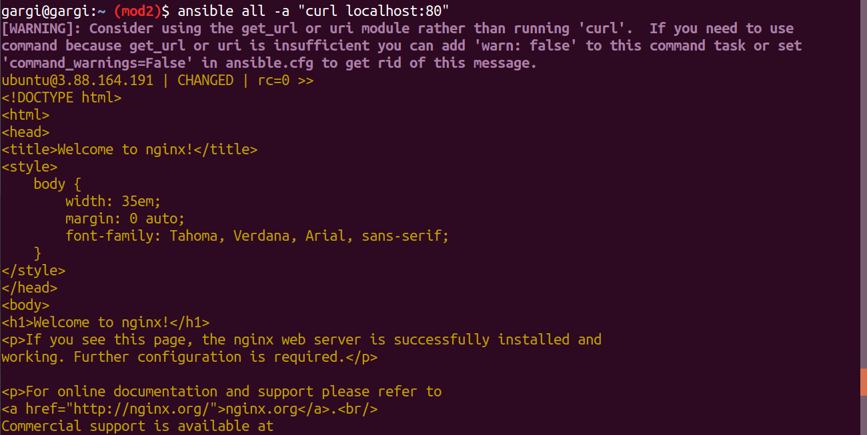

Check if the service is running.

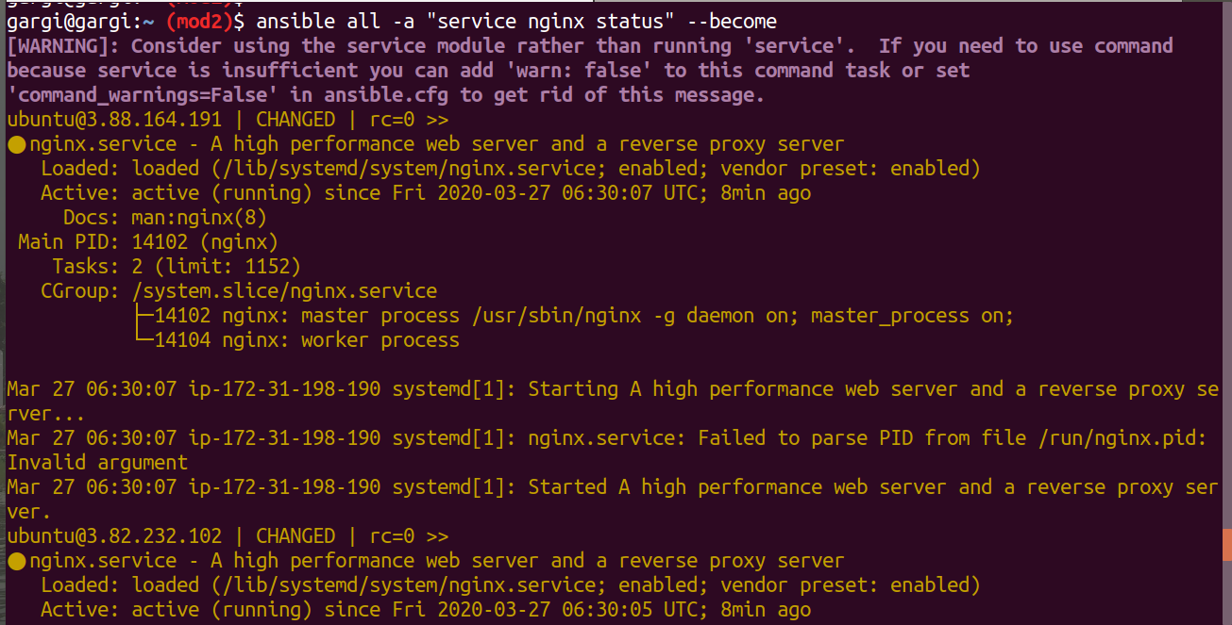

3. **Create role for the same playbook and create custom conf file and index.html**

**Create ansible role directory structure.**

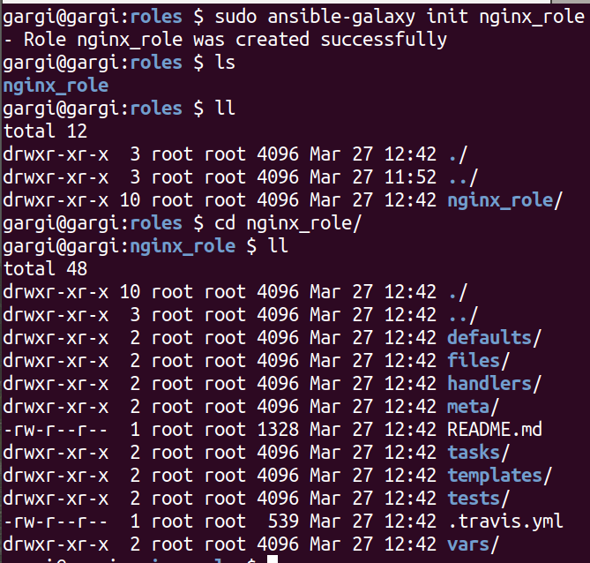

Go to tasks and edit main.yml

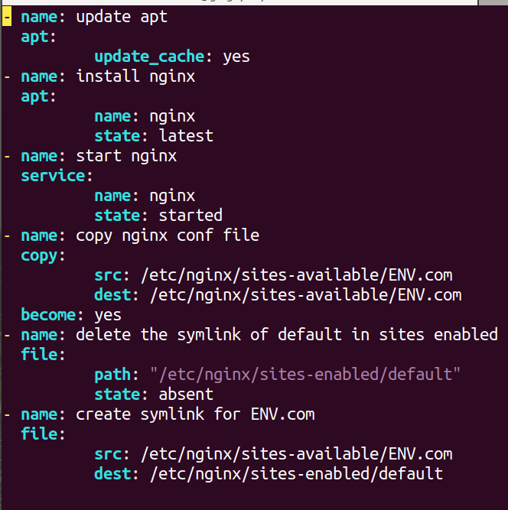

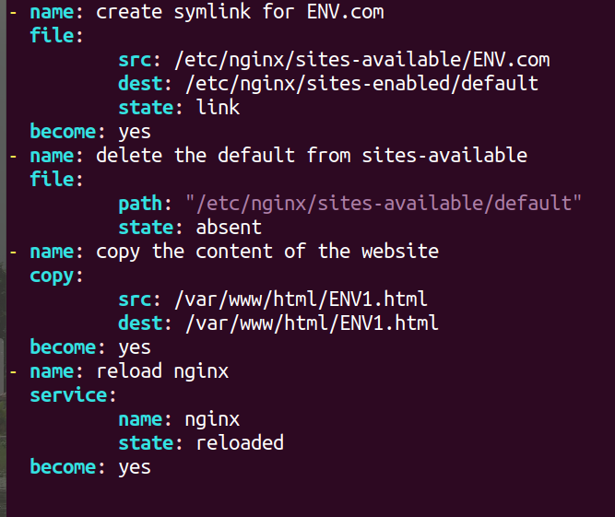

Create a playbook

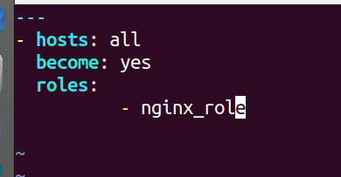

Run the playbook

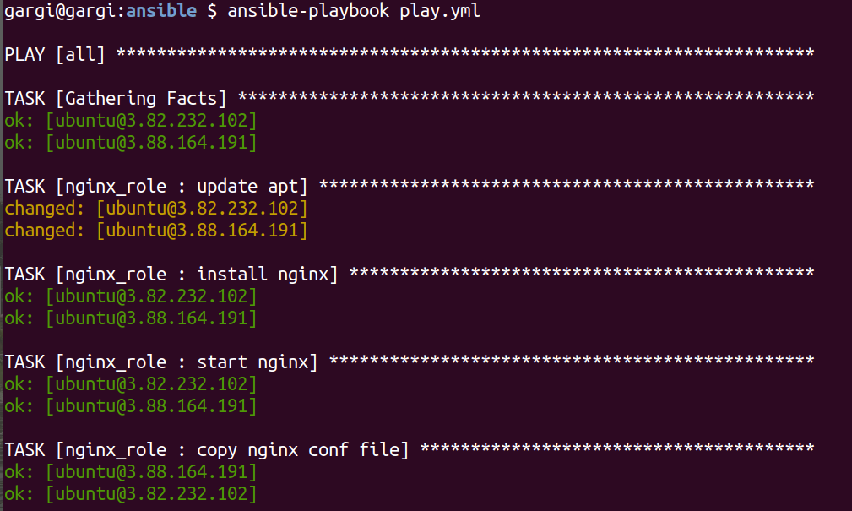

Go to the remote server and check for a custom website.

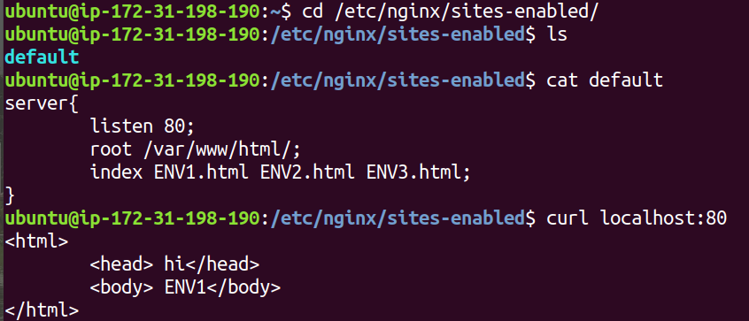

4. **Using loops copy multiple files from ansible machine to the remote machine.**

**Ansible Playbook**

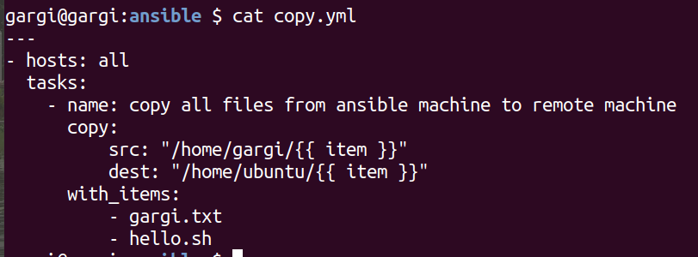

Run ansible playbook

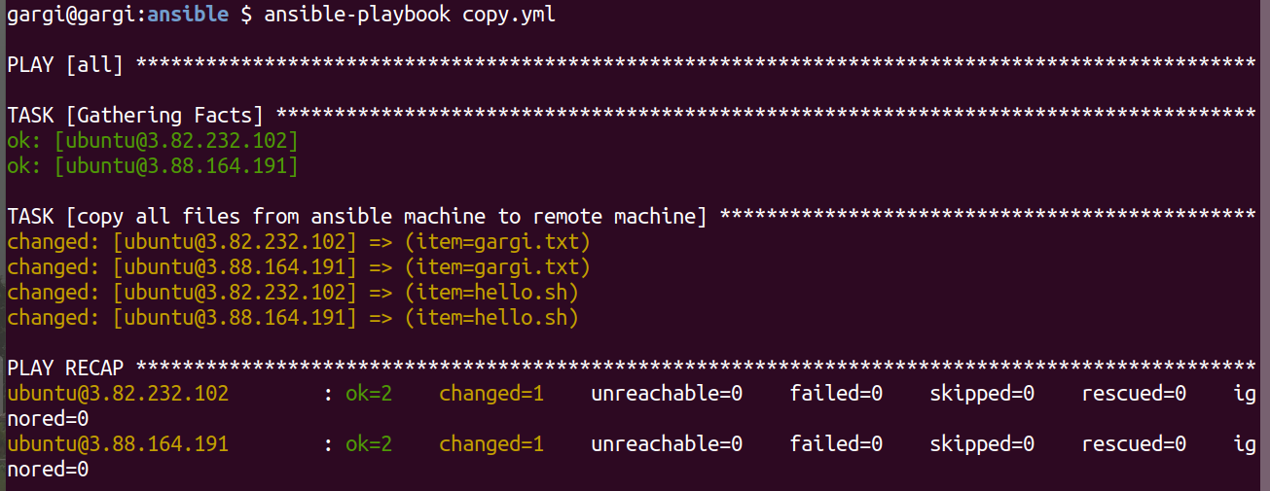

Remote Machine:



5. **Write a playbook to demonstrate the precedence of default and var file, override them from CLI.**

Create a role



Go to the defaults folder and define the variable of var.

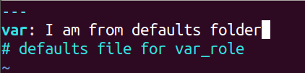

Go to the vars folder and define the value of vars.

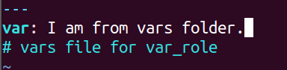

Task folder.

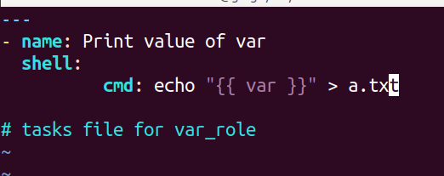

Playbook:

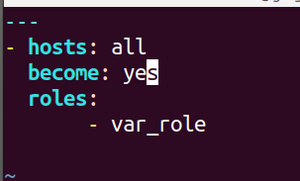

Output when we mention variable value in the vars folder. It overrides value in the default folder.

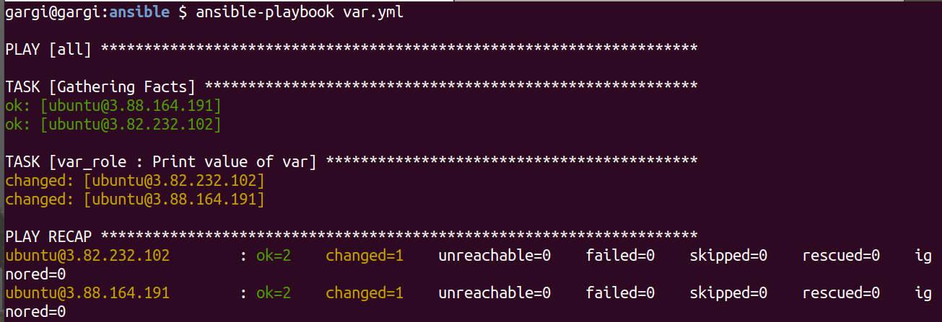

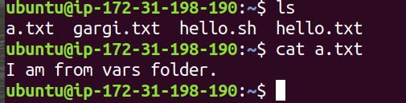

Output when we don’t mention variable value in vars. The value of the variable in defaults gets printed.

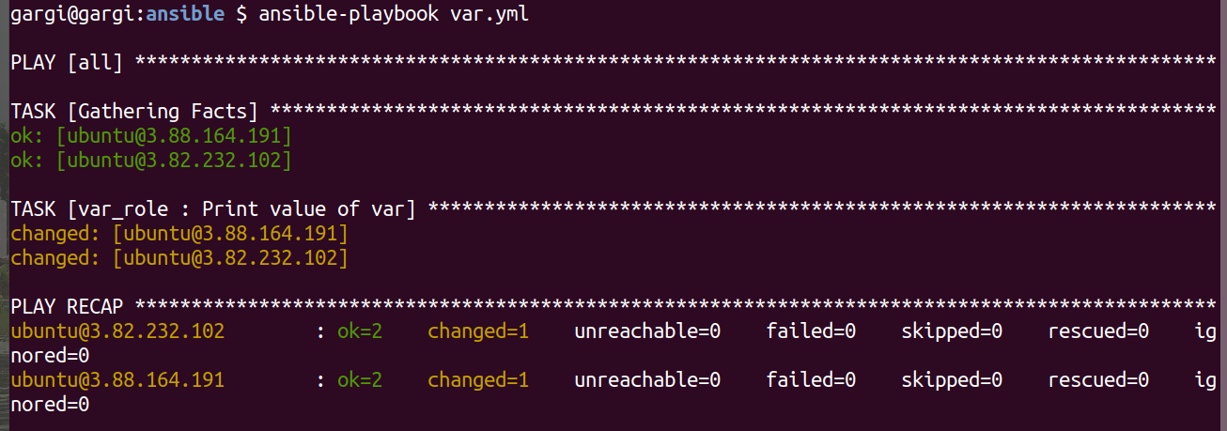

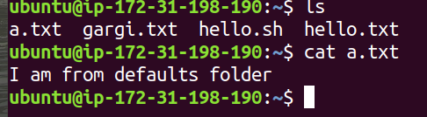

Output when we pass external arguments or values for variables. It will override all the values and will get printed no matter what.

