**Assessment 28- Cloudformation**

**Trainee Name : Gargi Sharma**

**Mentor Name : Mr. Akansh Gupta**

**College Name : UPES**

1. **Start an EC2 Instance with Parameter KEY NAME, VPC, Subnet using Cloudformation Template.**

Create a cloudformation template:  
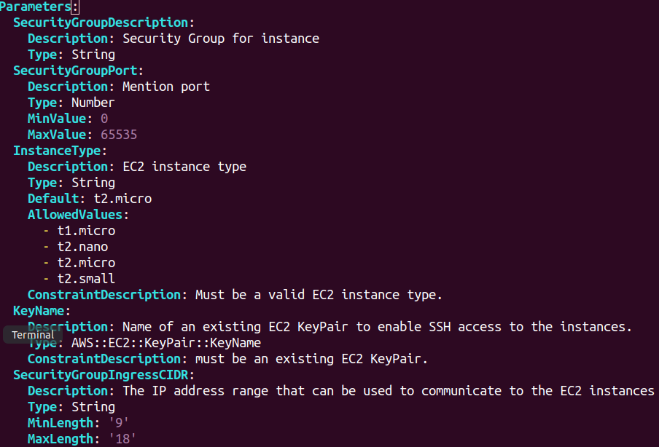

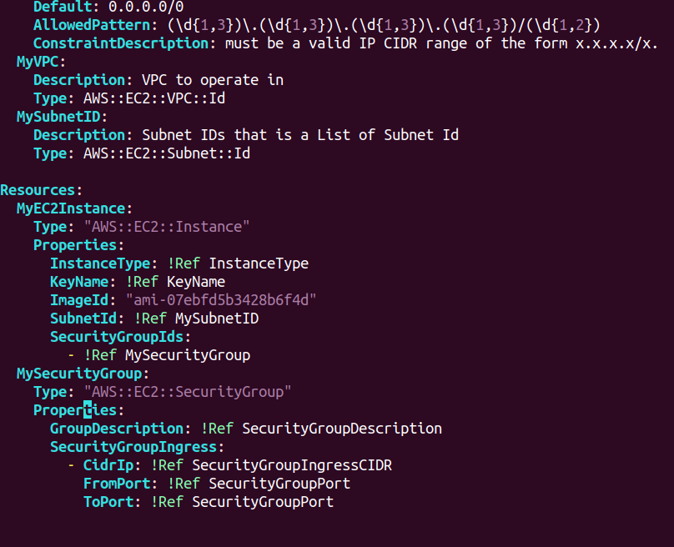

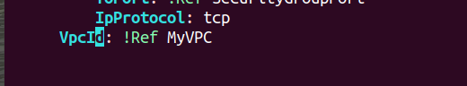

Now go to aws console->cloudformation-> Create Stack

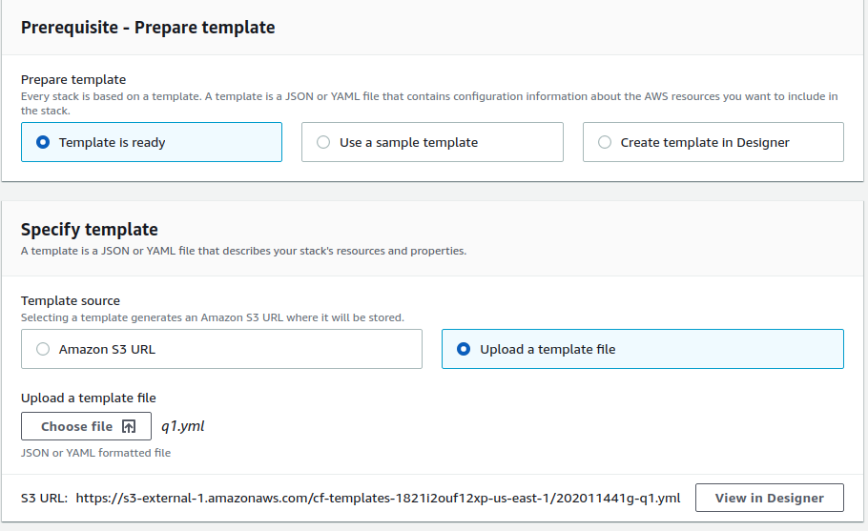

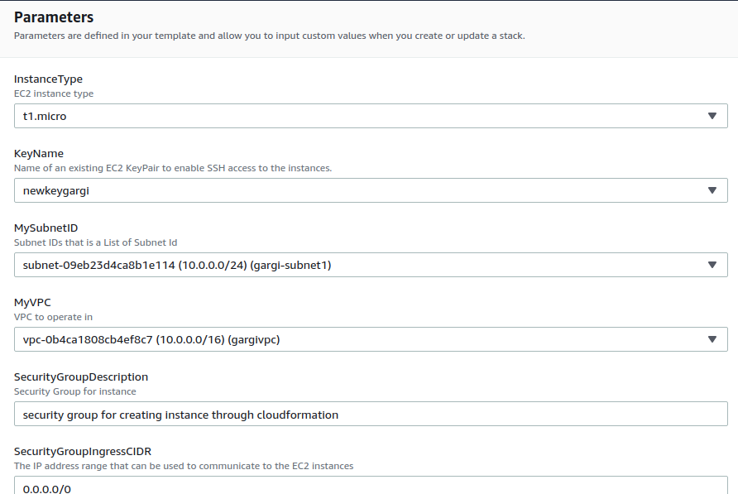

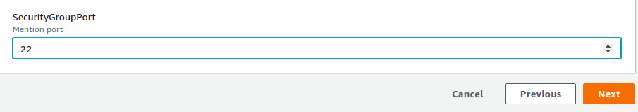

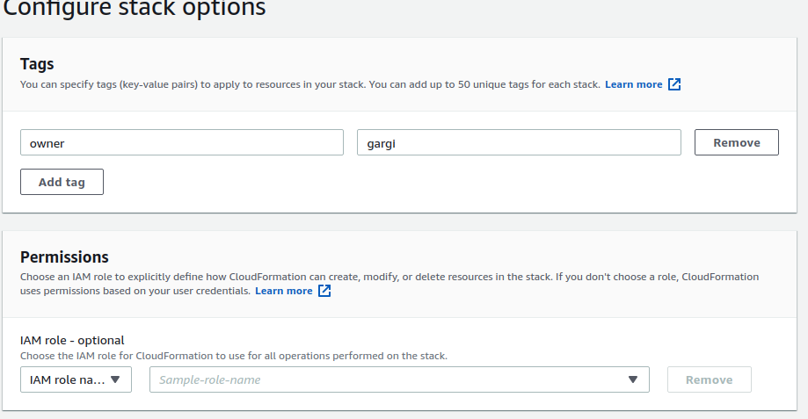

Now check for the events on the Cloudformation dashboard:

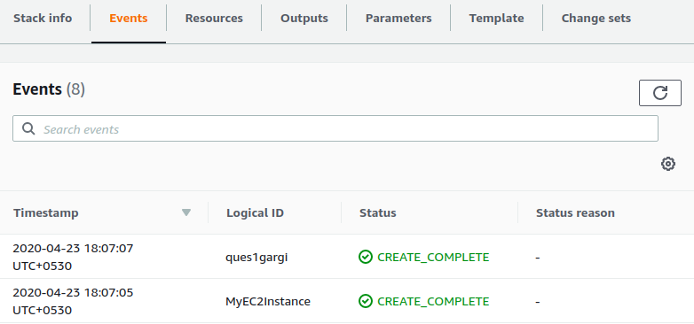

Resources:

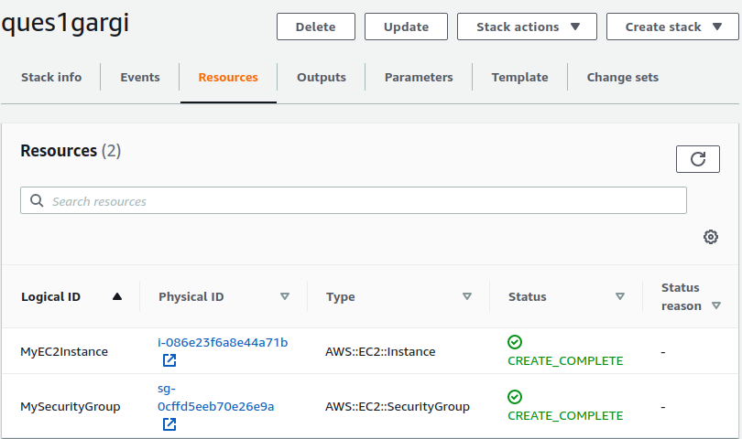

Check for instance on ec2 dashboard:

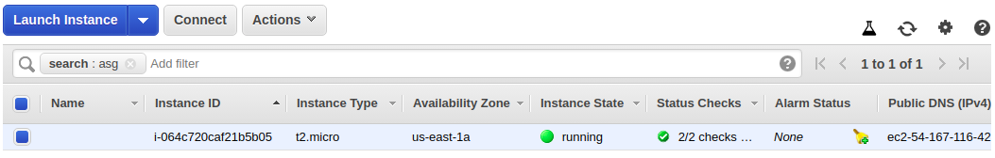

Check for the security group attached with the instance:

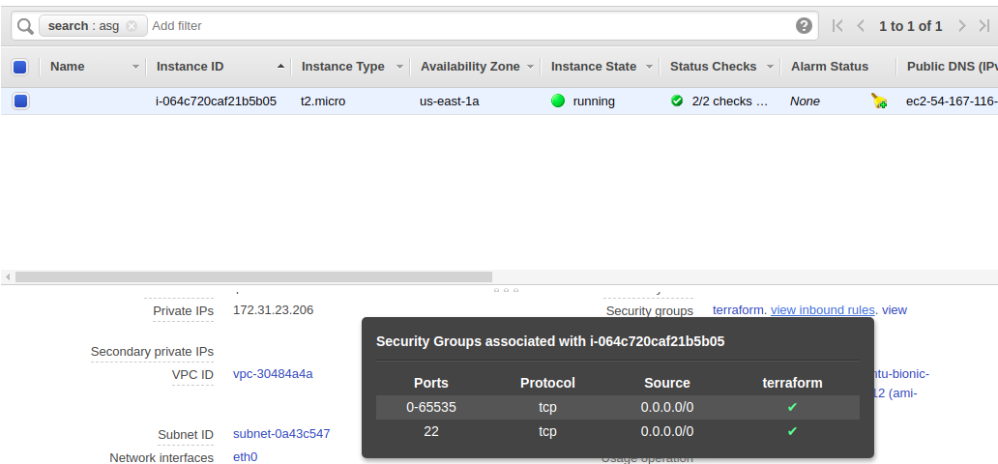

Ec2 instance with specified vpc and security group is set up successfully using Cloudformation.

2. **Install Nginx in EC2 and put it in an ASG.**

**i) First by Userdata**

**ii) By Metadata**

**i .) By Userdata:**

Create a cloudformation template

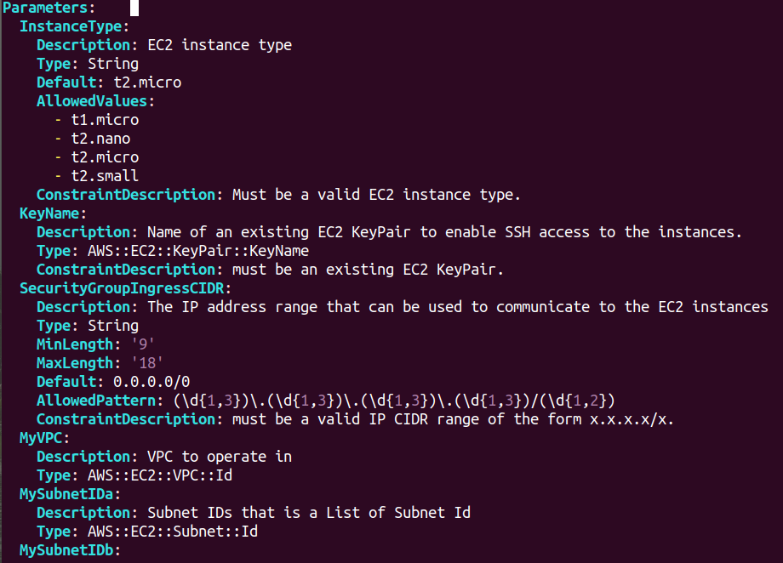

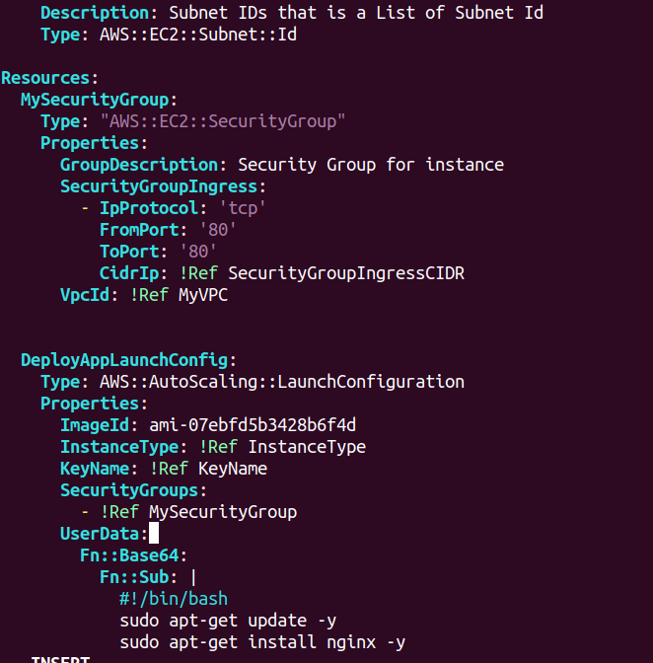

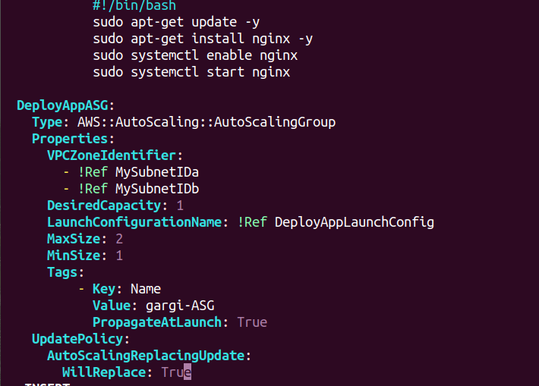

Now go to cloudformation-> Create Stack -> Upload a template

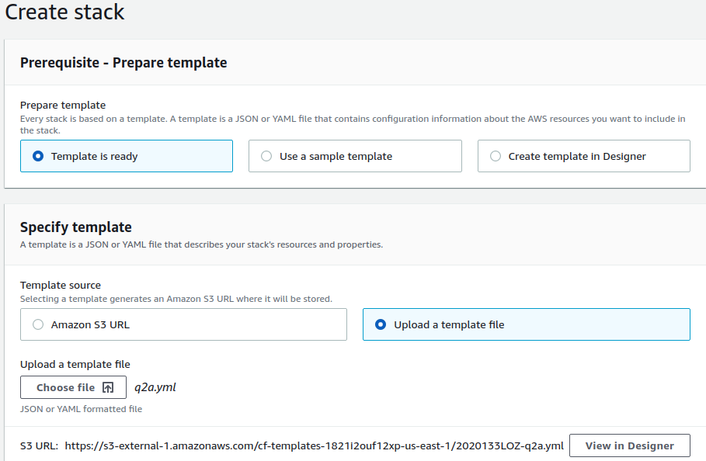

Specify the name of the stack and give parameters.

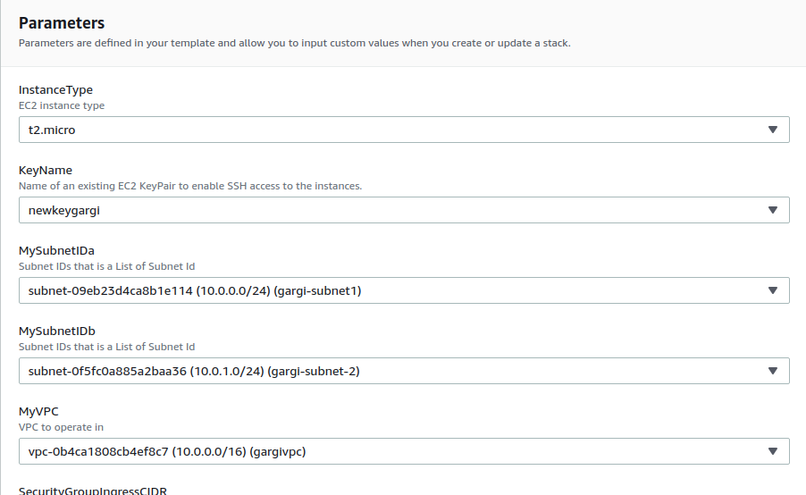

Configure stack options

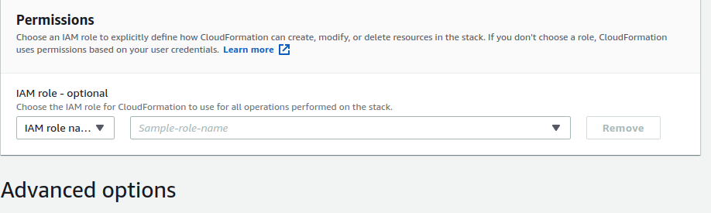

Review stack:

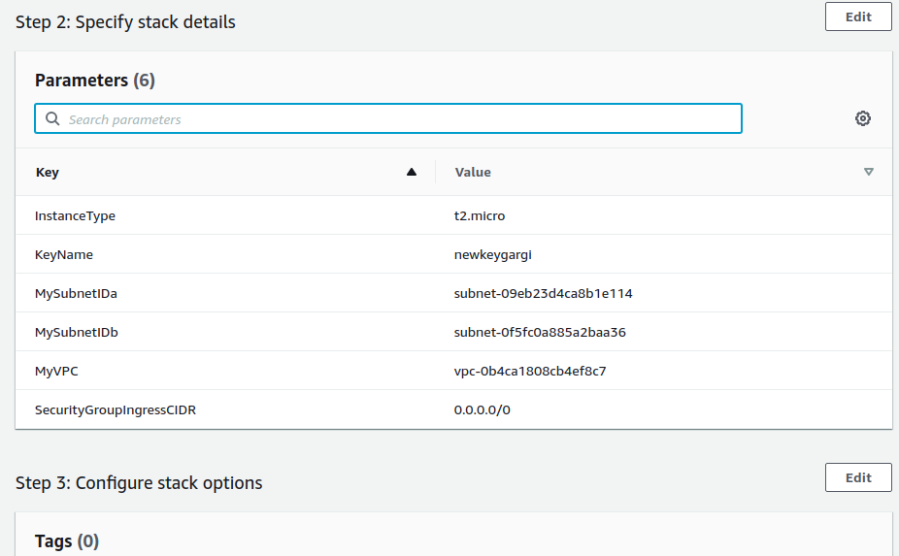

Check for events

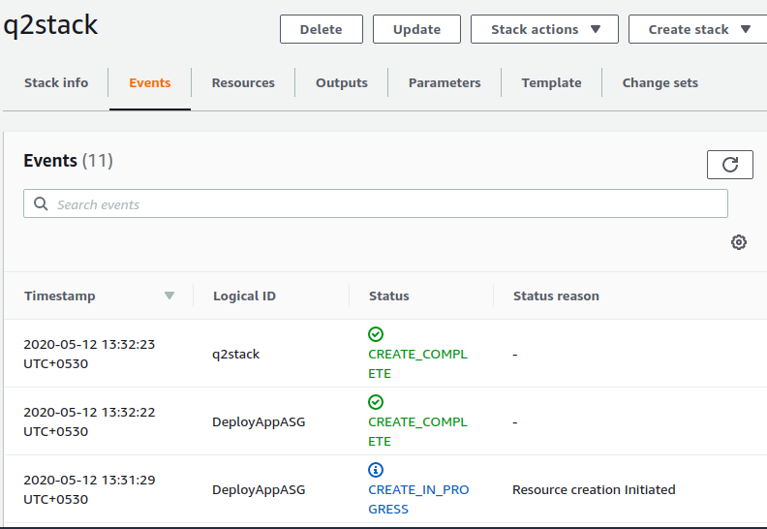

Check resources created

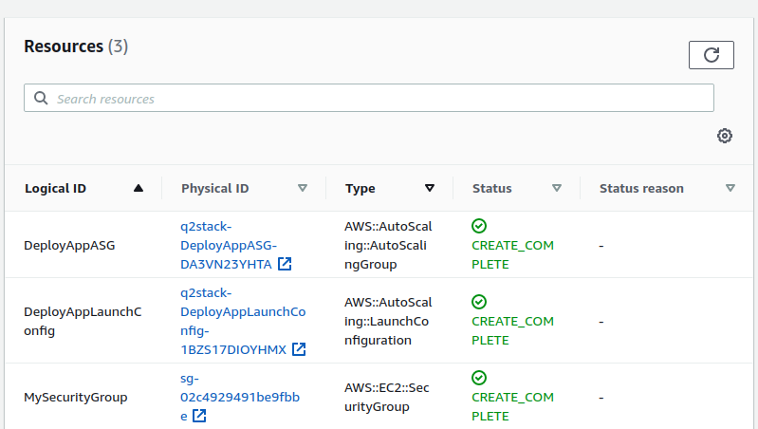

Go to ASG and look for the newly created instances

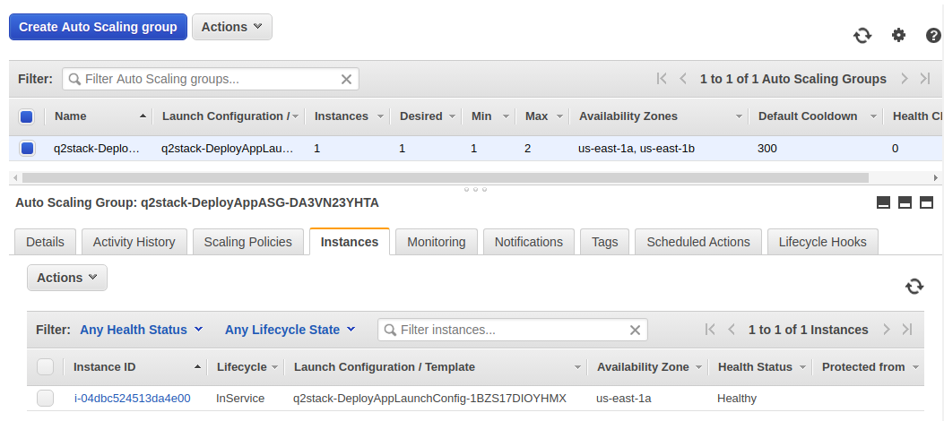

Copy the instance IP and hit it on a browser

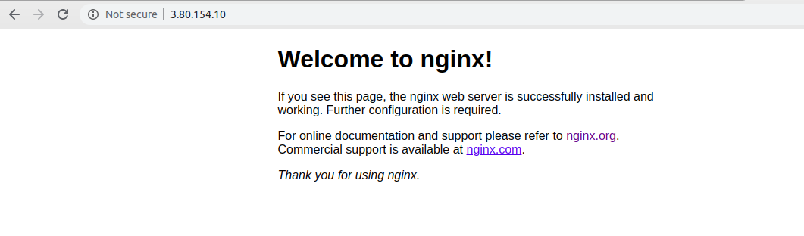

**ii.) With Metadata**

Write cloudformation template

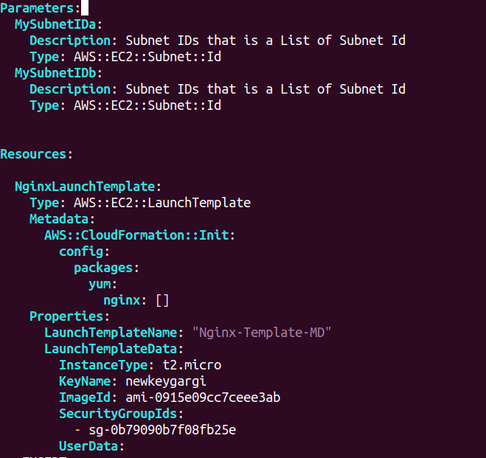

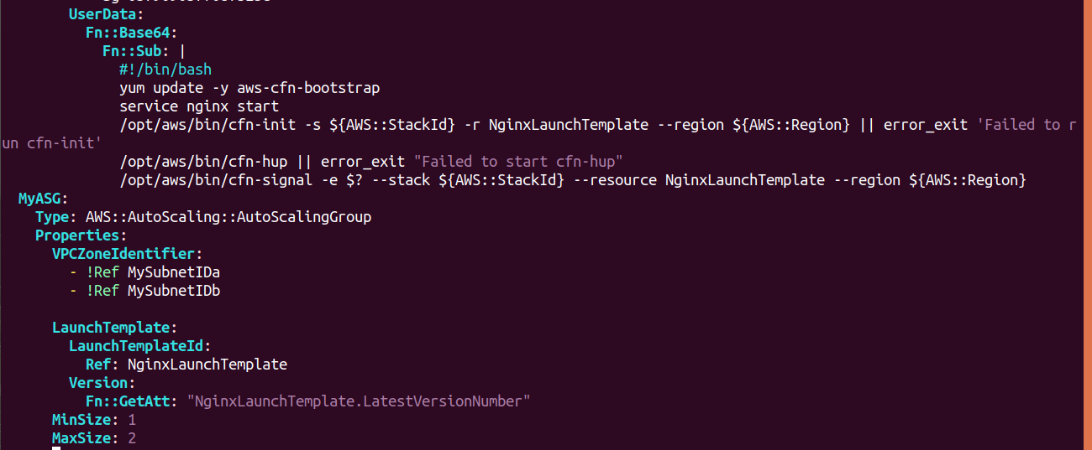

Create stack

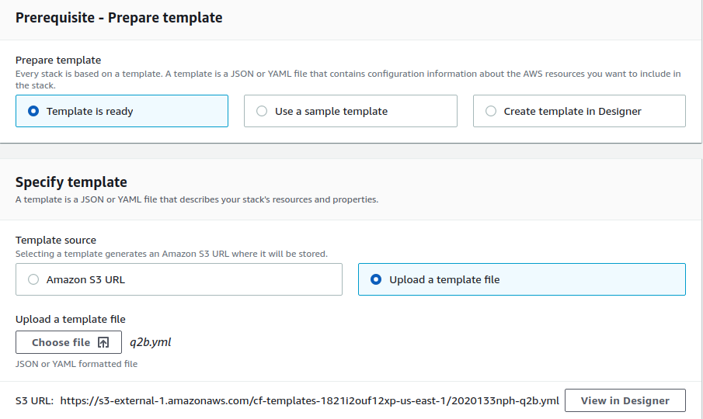

Specify parameters

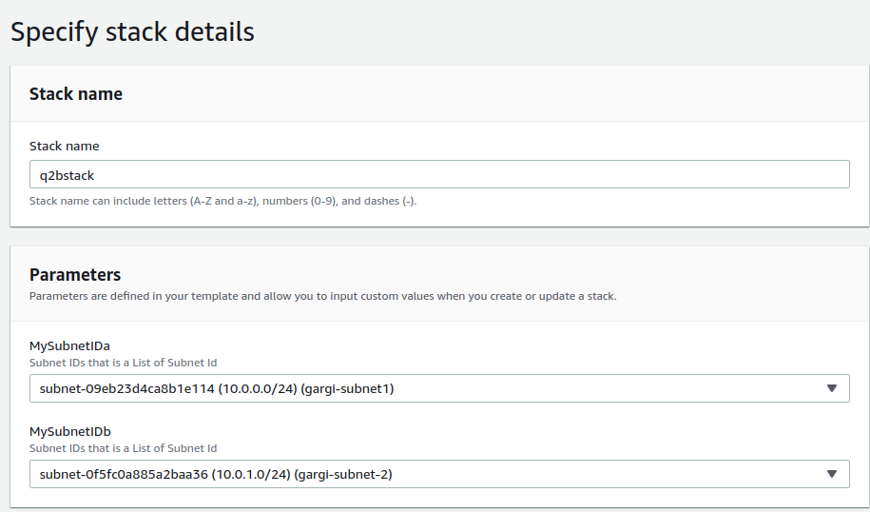

Configure stack options

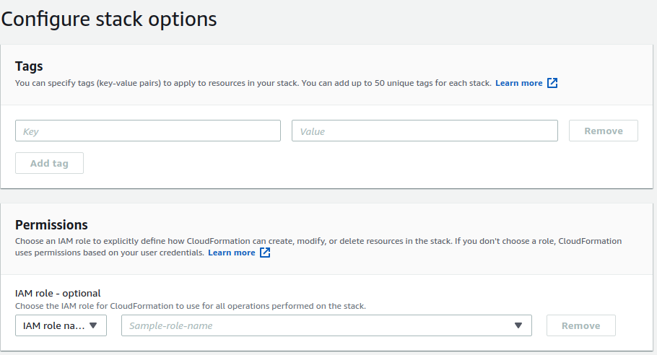

Review stack

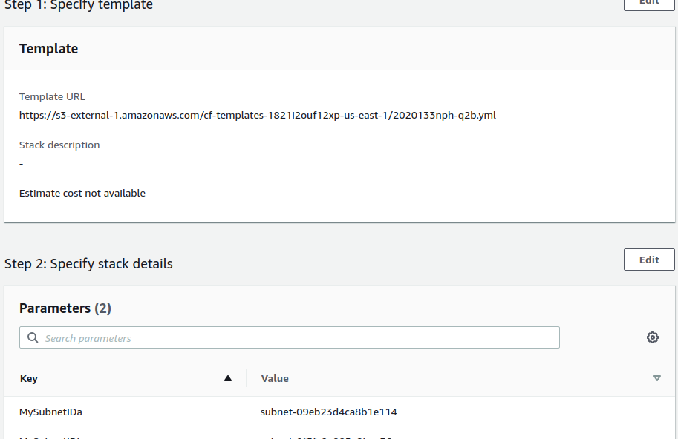

Check Events

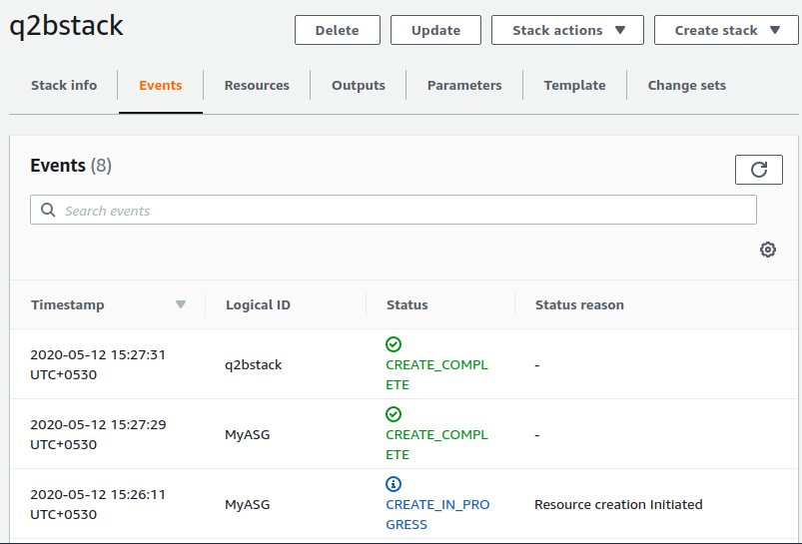

Check Resources

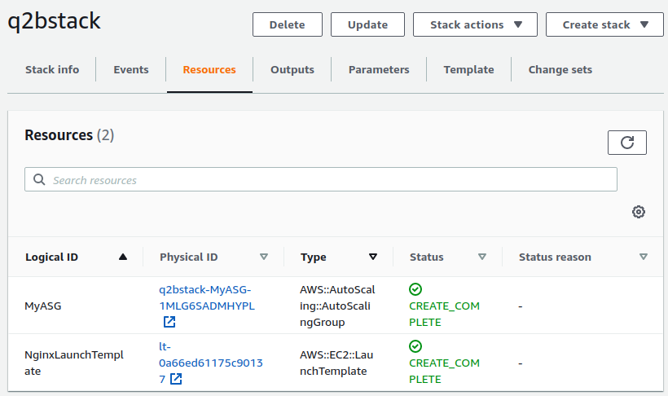

Find the instance under ASG

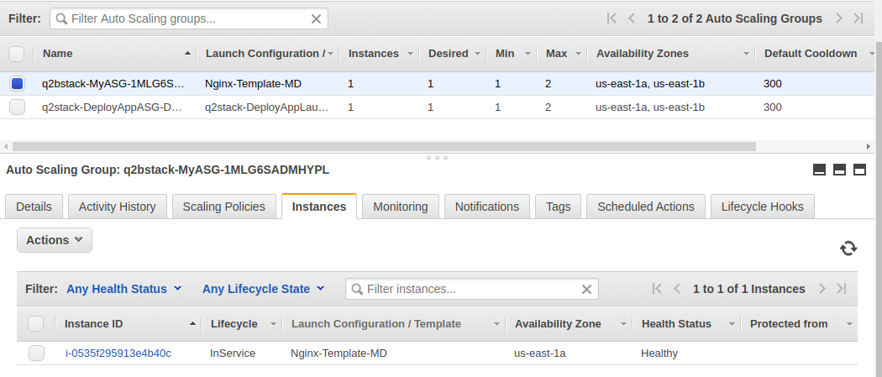

SSH into the instance and start nginx. Copy the public ip of the instance and hit it on port 80

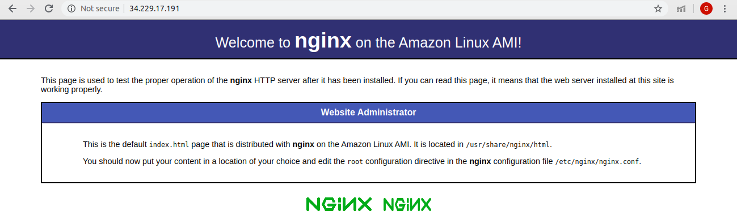

**3. Create a Sample Index file and copy this file using MetaData into EC2 Instance.**

Create a cloudformation template

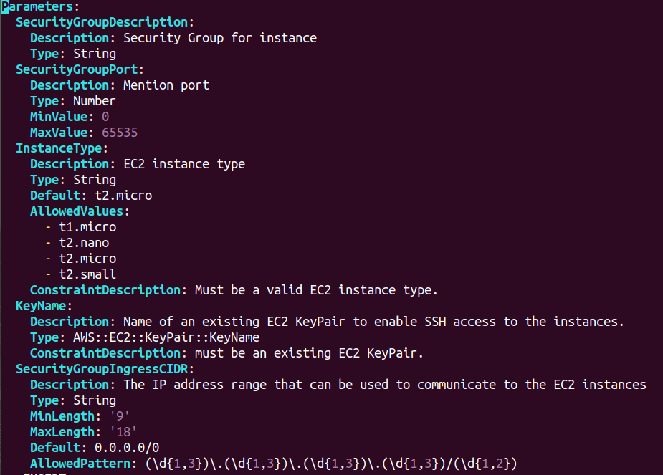

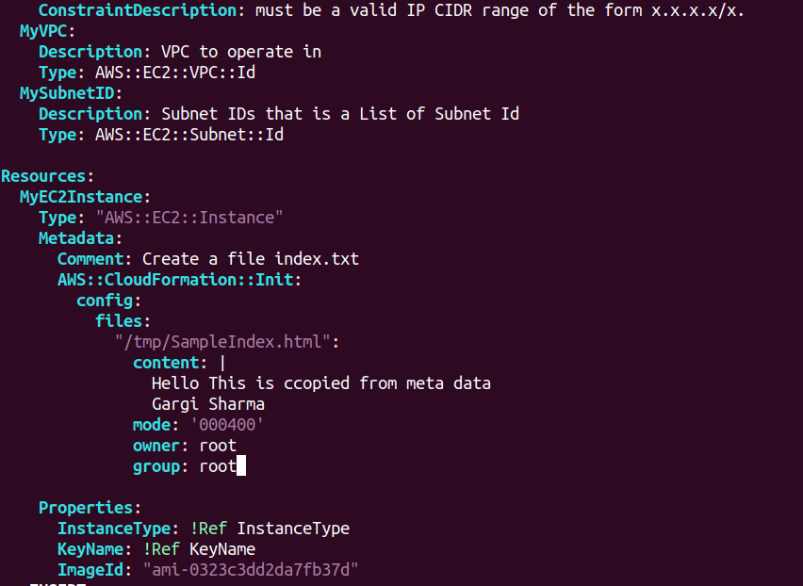

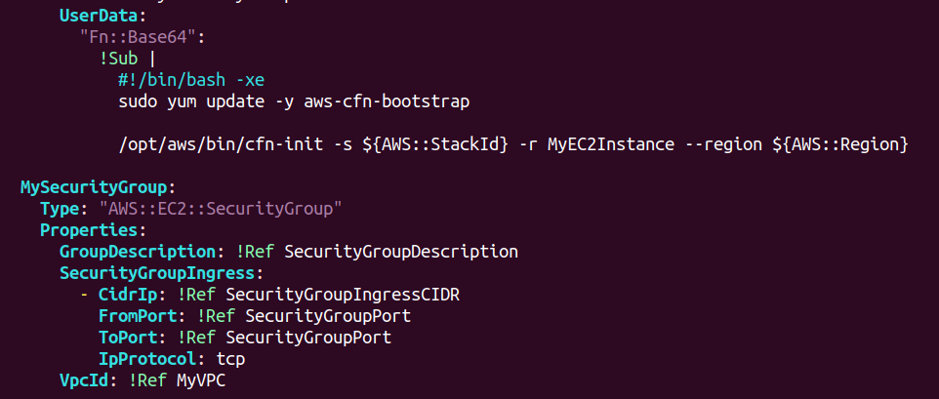

Go to cloudformation and create stack

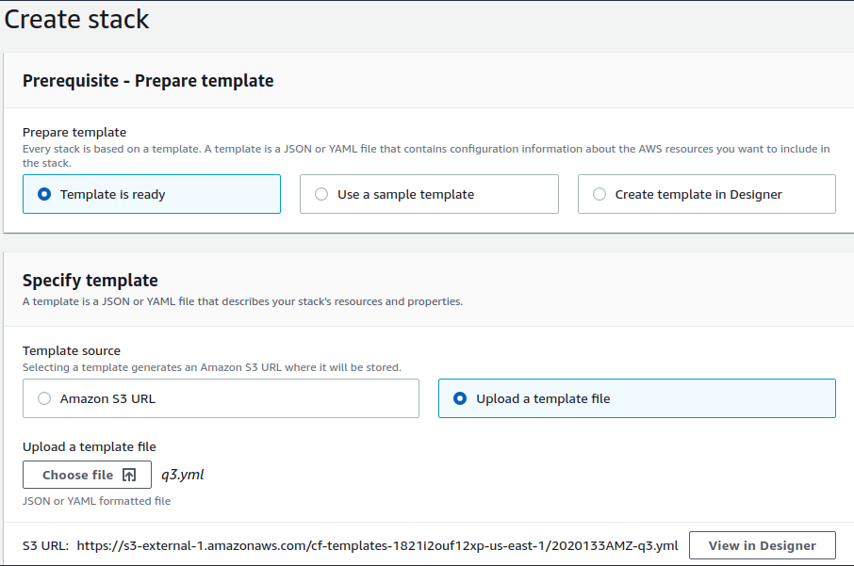

Specify parameters

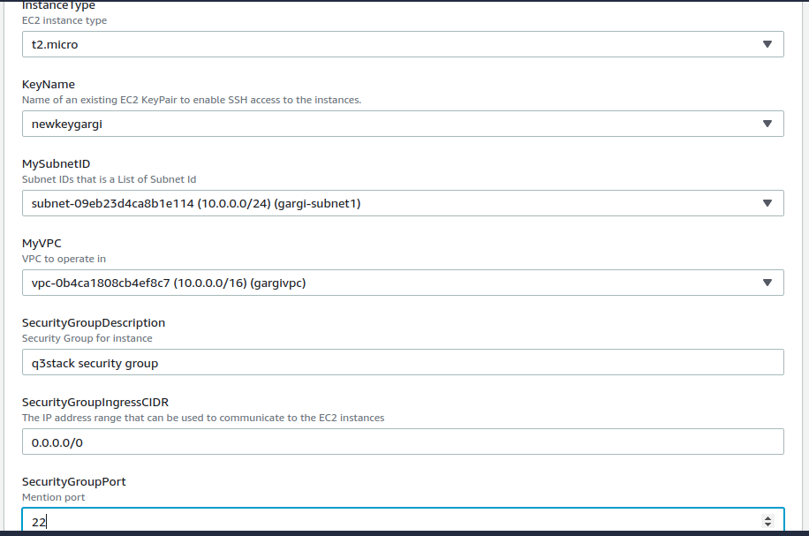

Configure stack options

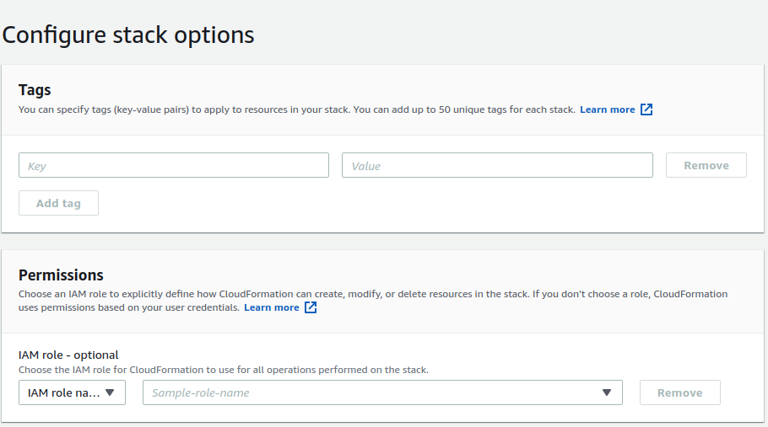

Review stack

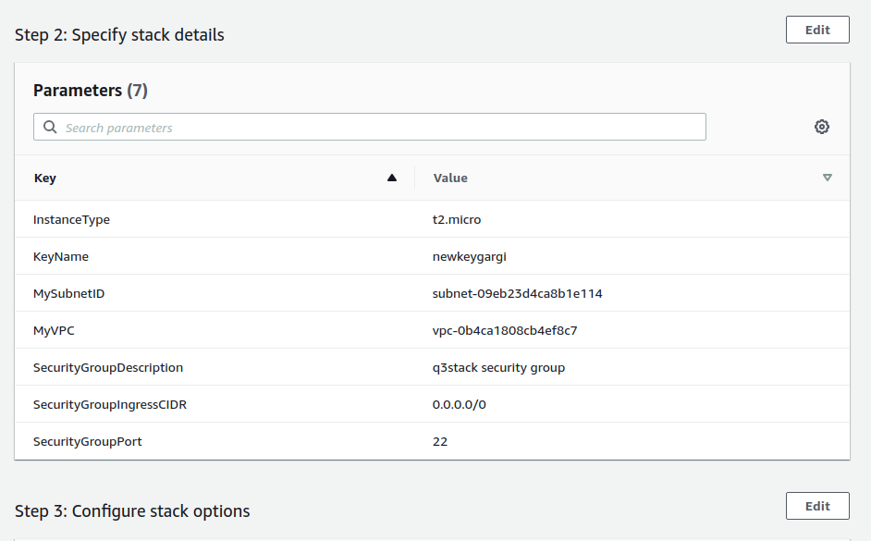

Check for events in stack

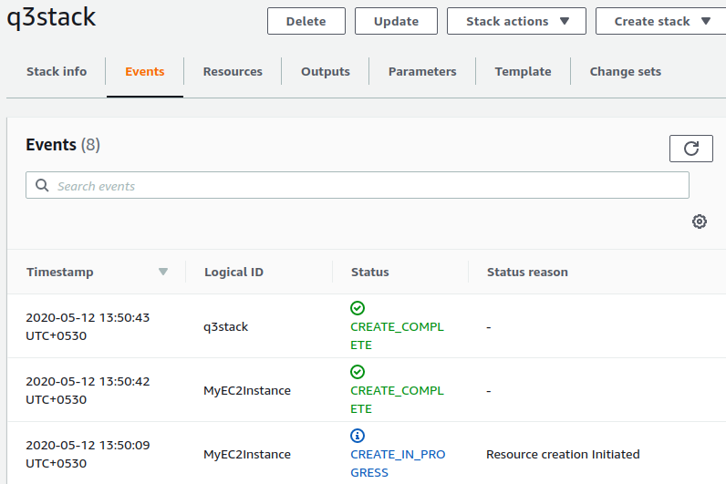

Check resources

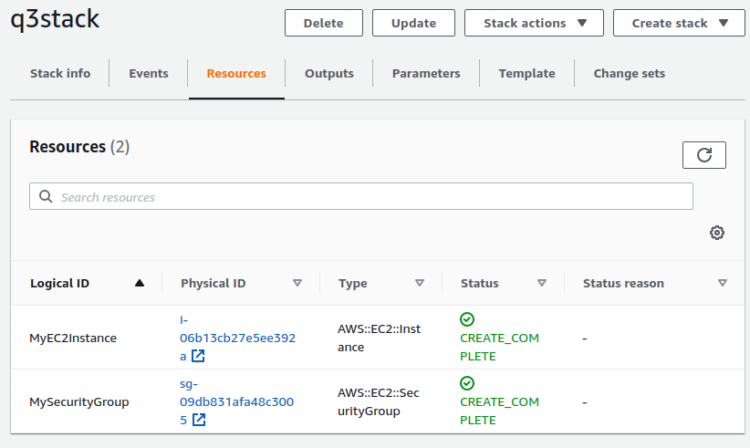

Now ssh into the instance and find the copied file in /tmp directory

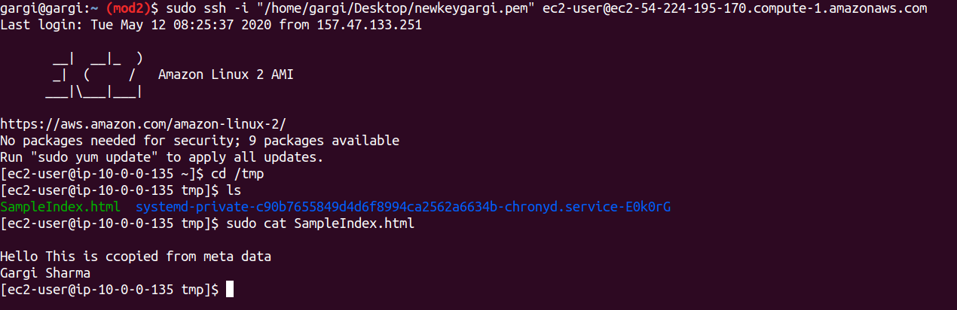

**4. Changing the content of Index should reload the nginx config automatically in EC2 Instance.**

**5. Perform ASG Rolling Update with the change in UserData in above Cloudformation Template.**

**Both the questions are solved using this script**

Write a cloudformation template

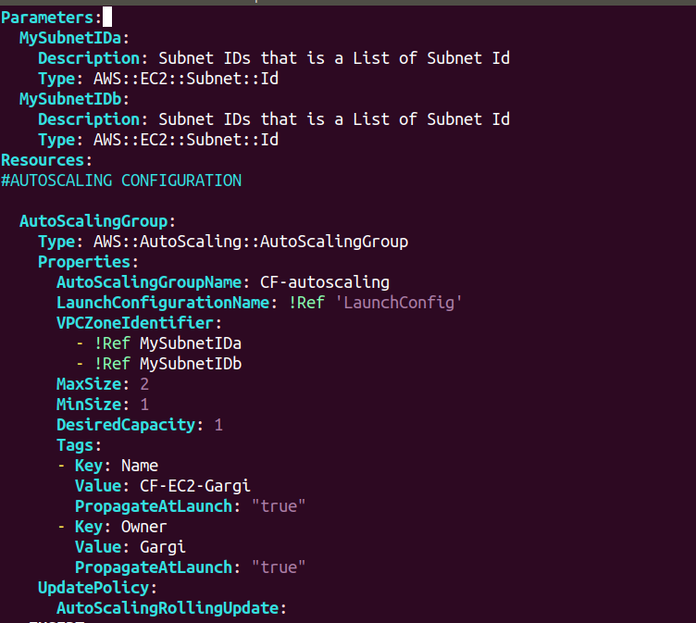

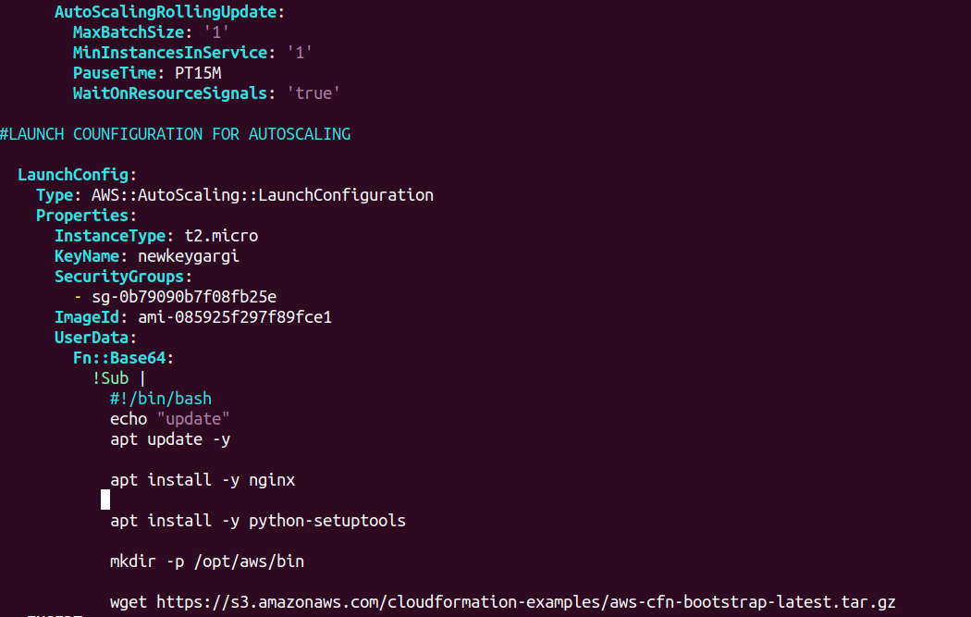

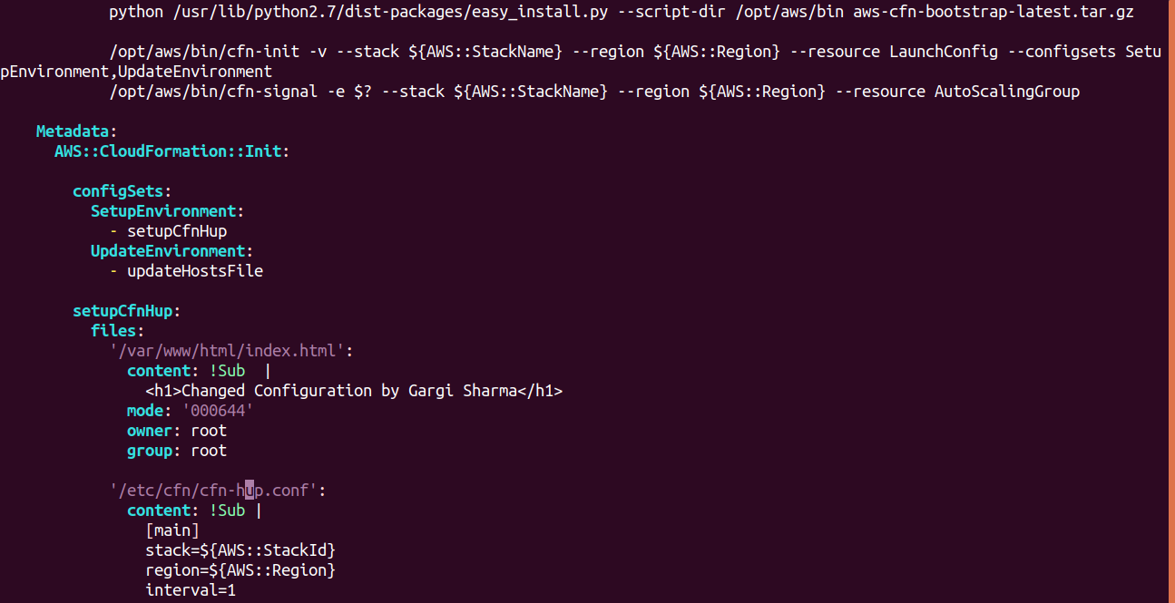

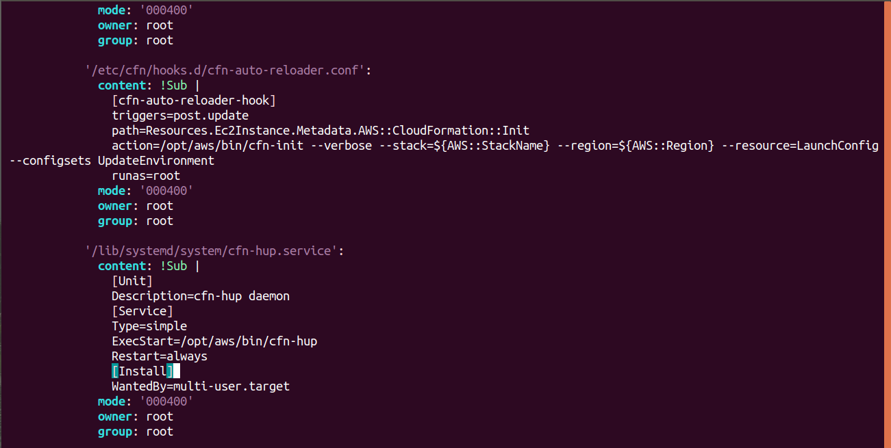

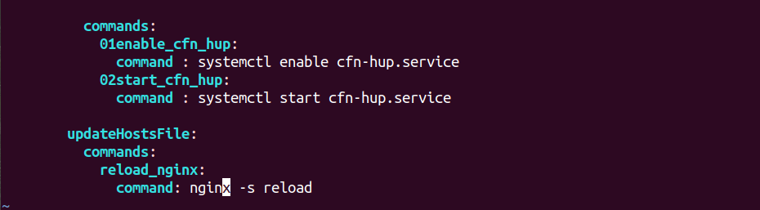

Create Stack

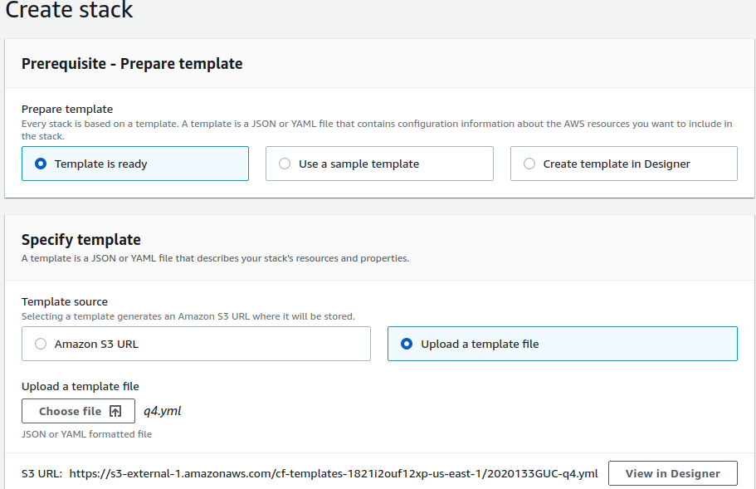

Specify stack parameters

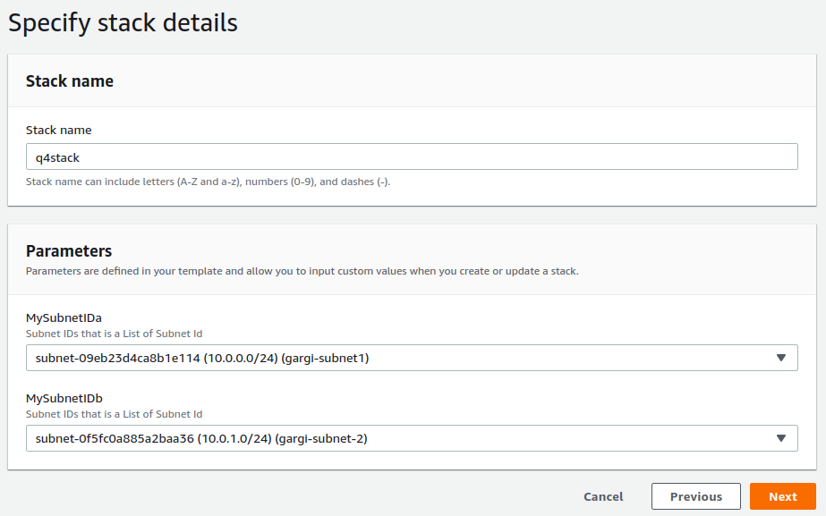

Configure stack options

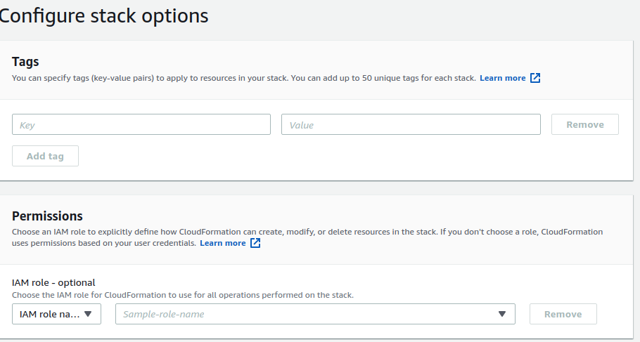

Check Events

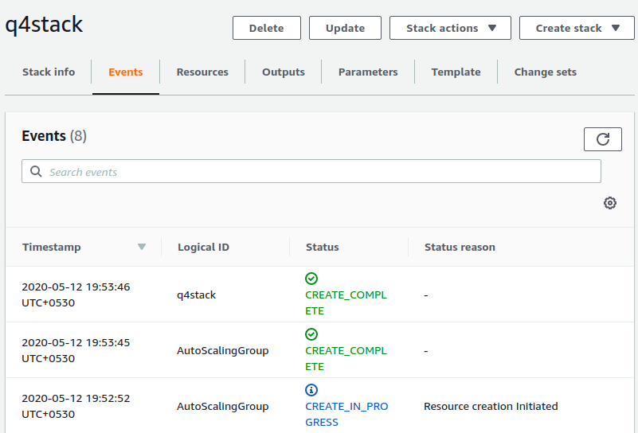

Check Resources

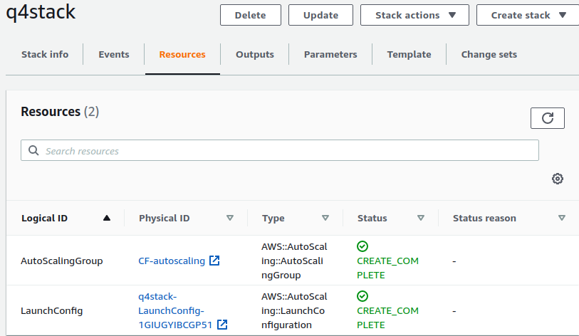

Copy the instance IP in the ASG and hit on port 80

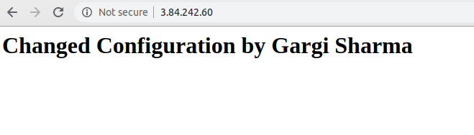

Now update the template to perform rolling update. The name of the new template should be different.

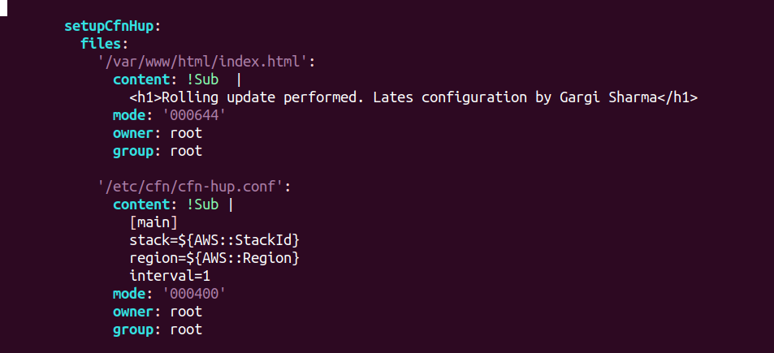

Go to Cloudformation-> Create stack-> Update stack

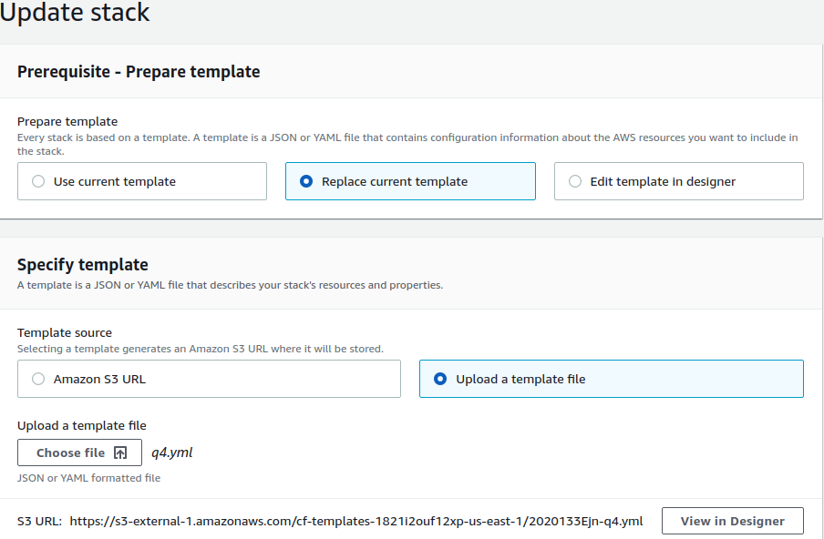

Specify stack details

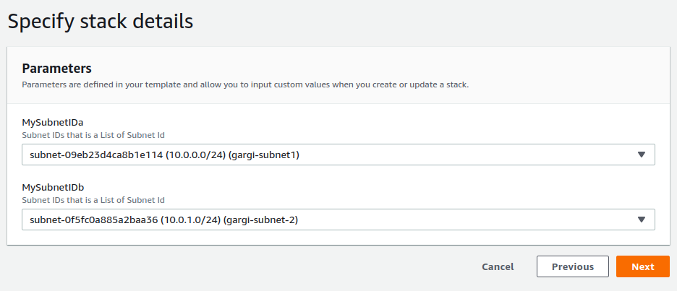

Configure stack options

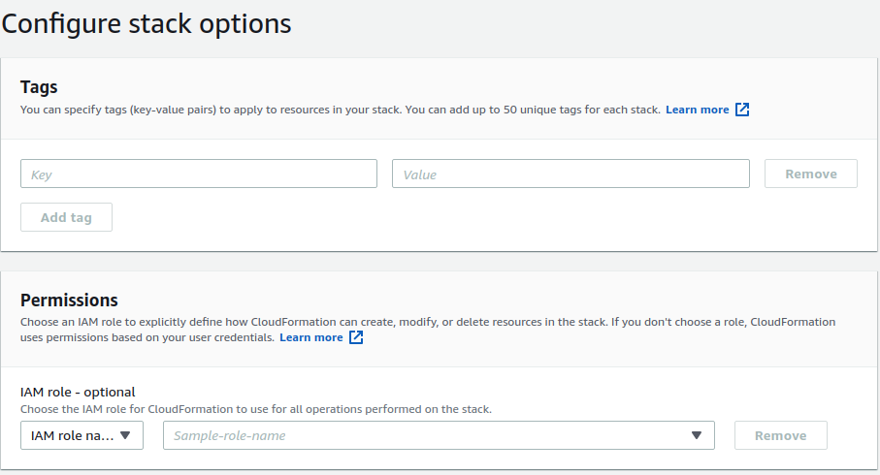

Review the changed configuration

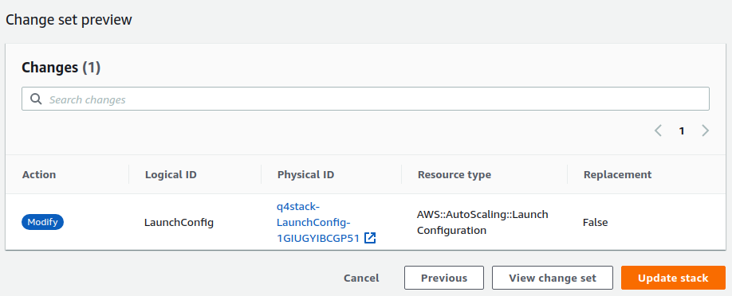

Check events.

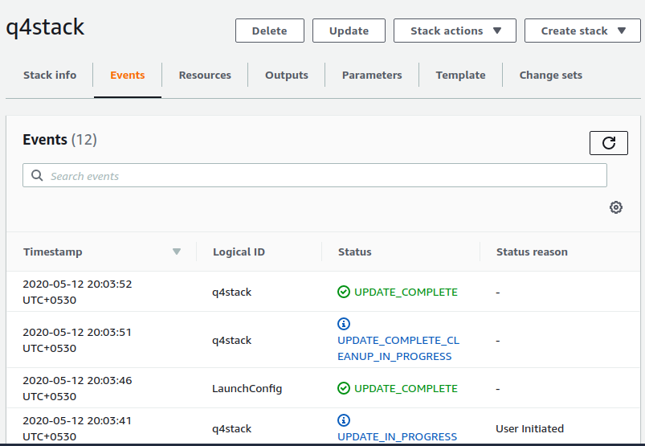

Now hit the instance ip at port 80. It should show new configuration.

