**Assessment 14– Cloudwatch, SNS,SES**

**Trainee Name : Gargi Sharma**

**Mentor Name : Mr. Akansh Gupta**

**College Name : UPES**

1. **Monitor Your Estimated Charges Using CloudWatch**

**Step 1: Enable Billing Alerts**

**Step 2: Create a Billing Alarm**

**Step 3: Check the Alarm Status**

**Step 4: Create & Subscribe to SNS Topic**

**Step 5: Send a notification to all the stakeholder, if AWS resource pricing reaches the threshold value.**

Billing metric is not available so we will demonstrate using EC2.

Step 1: Goto CloudWatch -> Alarms->Create Alarm->select metric->EC2->Per-Intsnace Metric->CPU Utilisation(any instance)

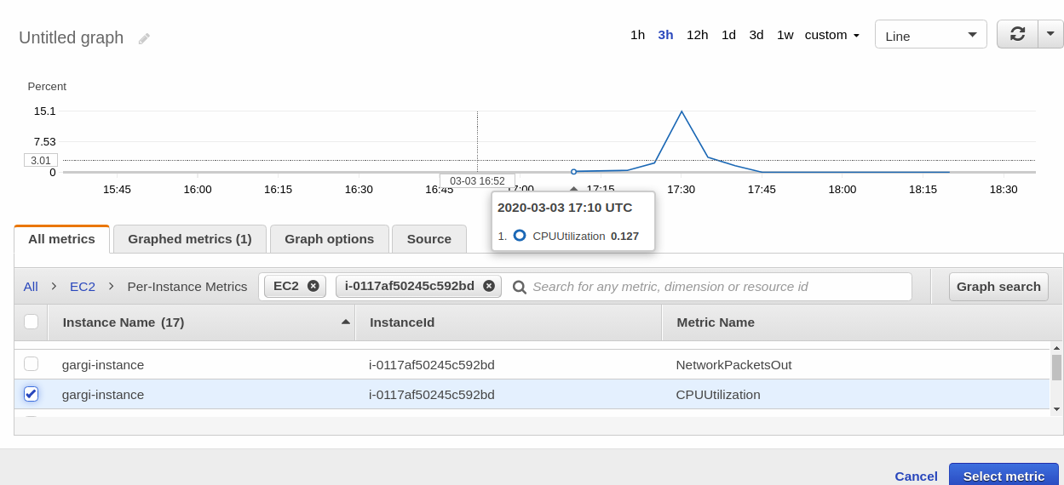

Specify metric condition and threshold value.

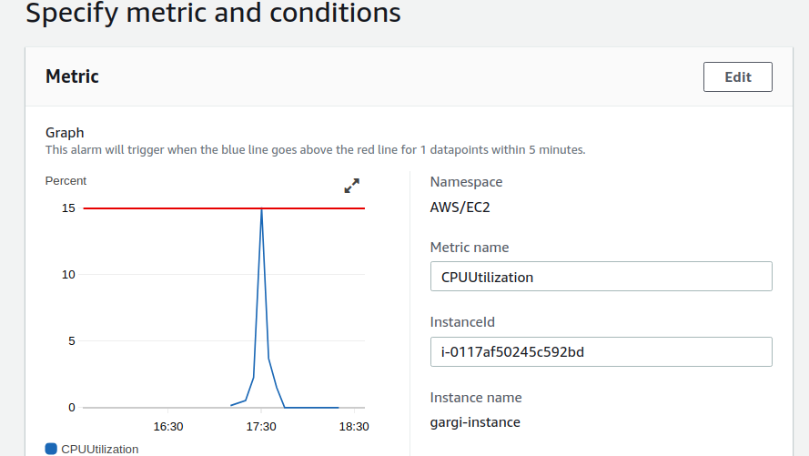

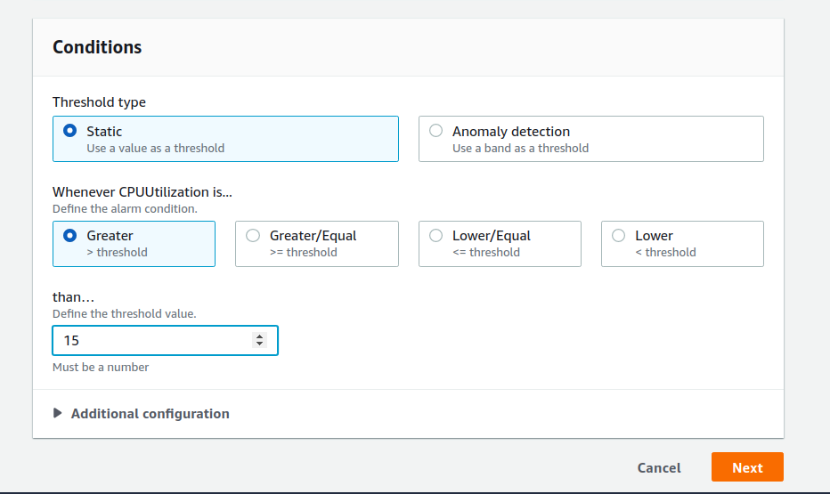

Configure actions->Create a topic

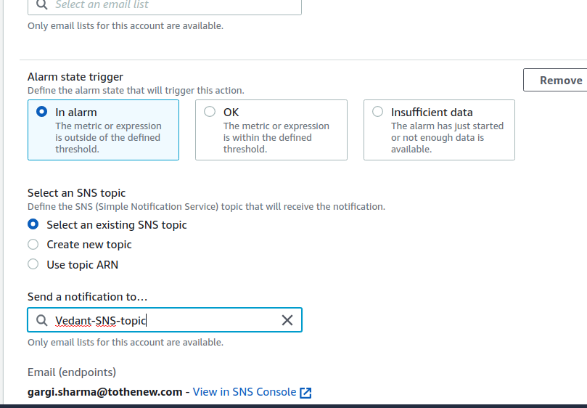

In EC2 Action -> select the desired action to be taken.

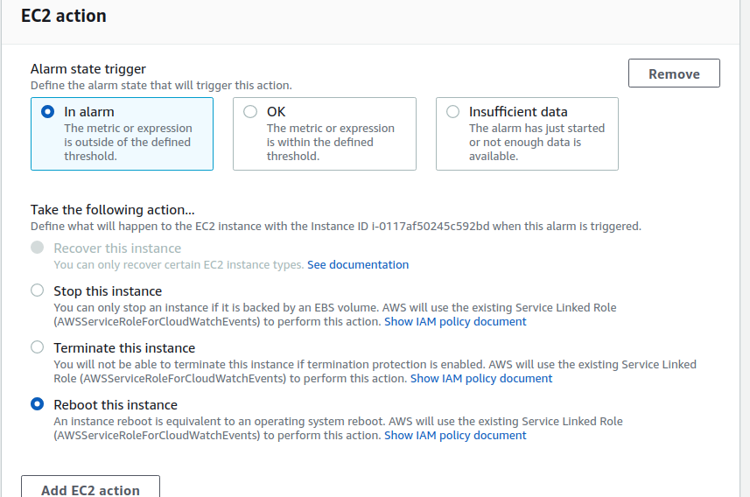

Now, create alarm.

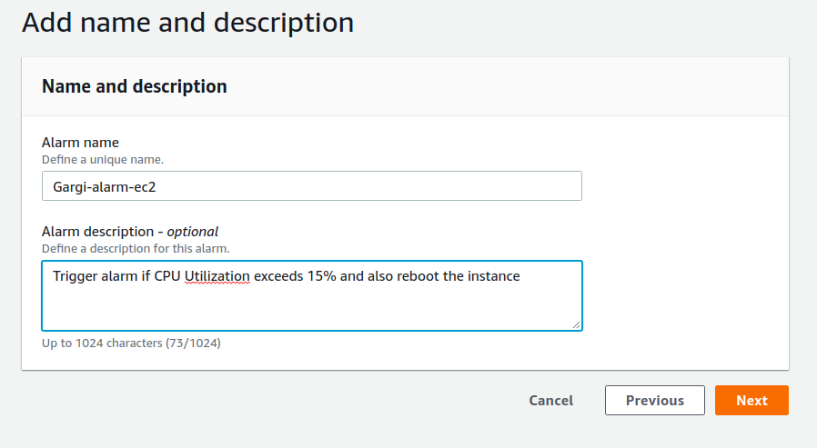

Alarm Created.



Now confirm for SNS topic from mail.

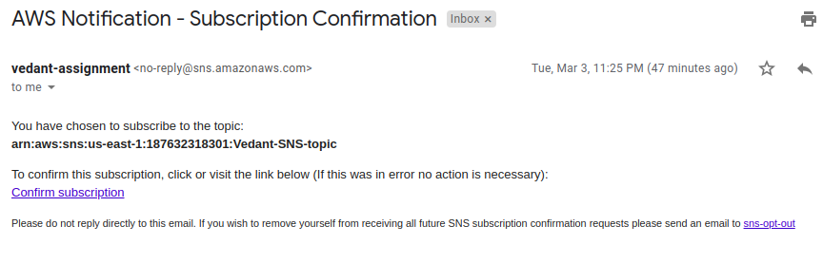

**2. Create a custom Memory metric in CloudWatch and set up an alarm at 80 % which will autoscale the instance in the autoscaling group.**

**Creating a policy for cloudwatch with PutmetricData**

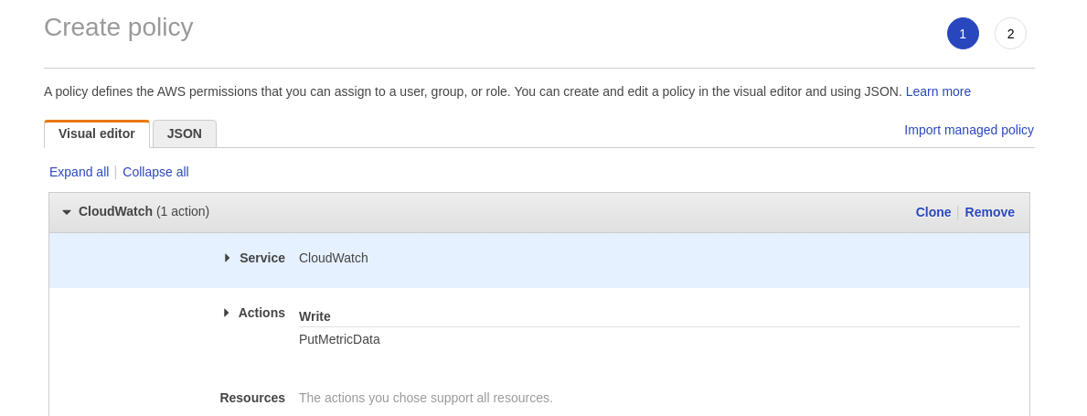



**Create a role and attach the policy to it.**

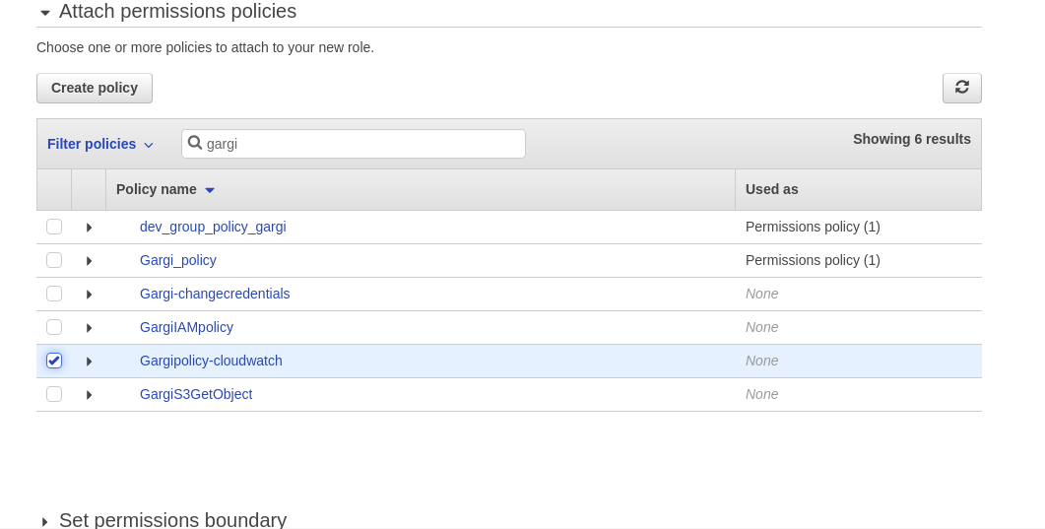

**Attach the role to the instance. Also create AMI of the instance and attach the AMI to the auto scaling group that would launch new instances when CPU utilisation crosses the threshold(trigger alarm).**

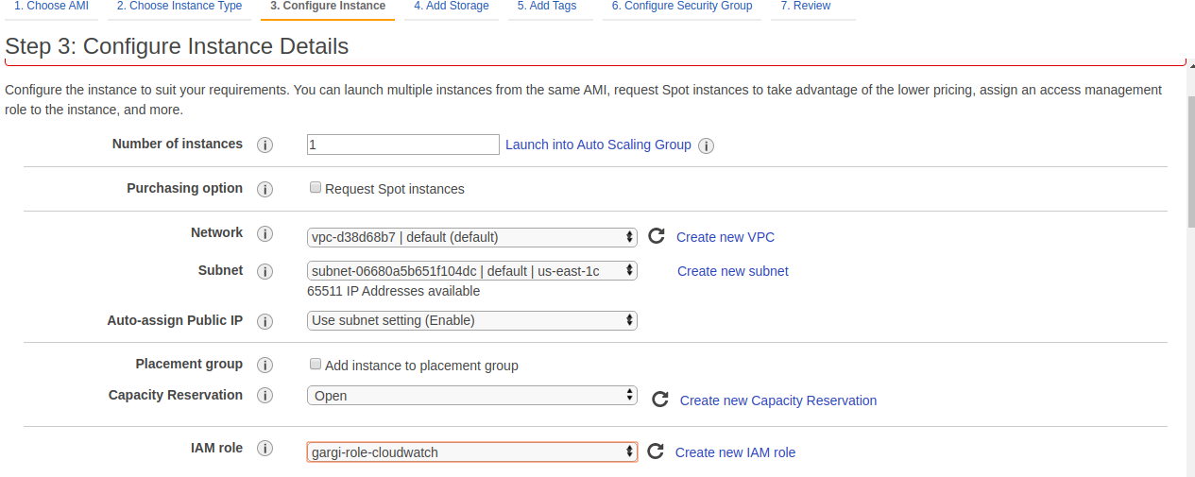

**Now SSH into the instance to create a script on EC2 instance to post metrics on cloudwatch:**

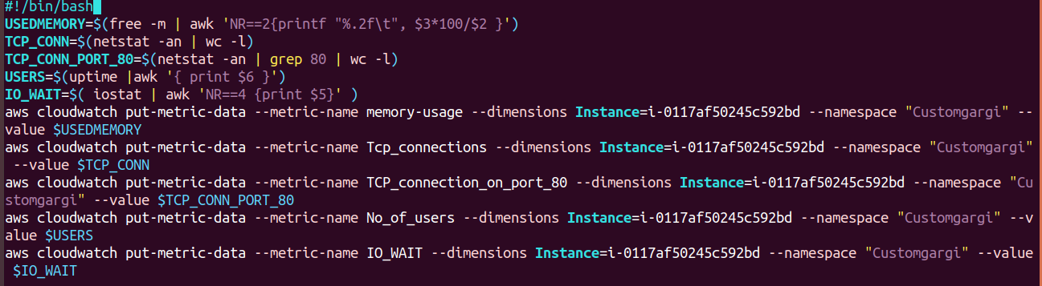

**Now give execute permission to the script and run the script and check metrics in cloudwatch.**

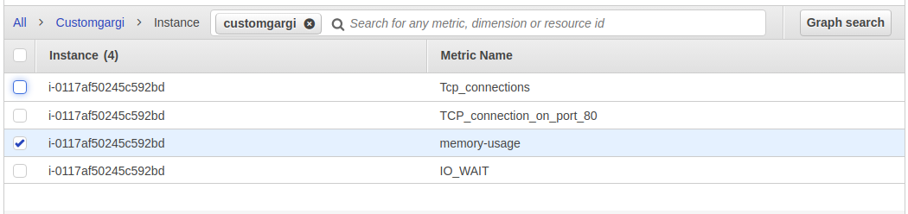

**Now set an alarm for 80% memory utilisation.**

**Now go to alarms->create alarms and select metric. Set threshold value to greater than 80.**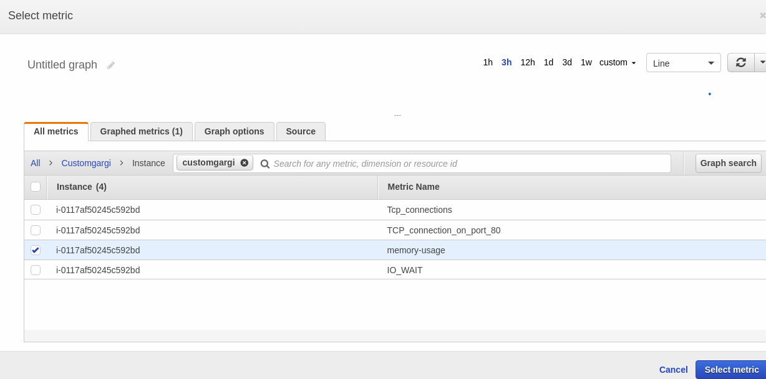

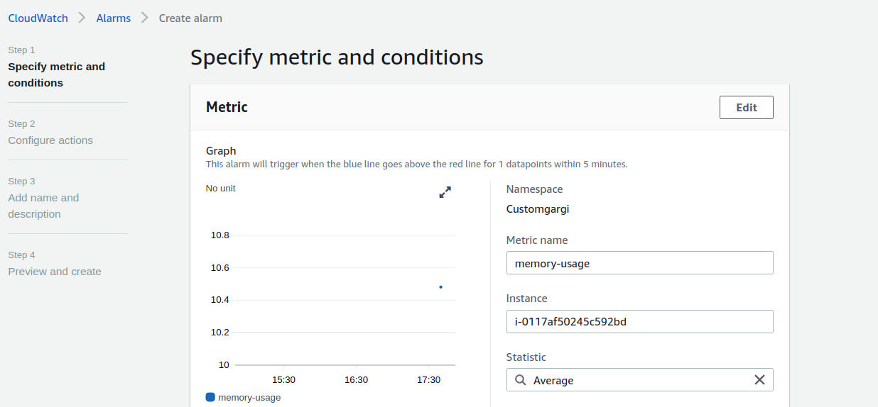

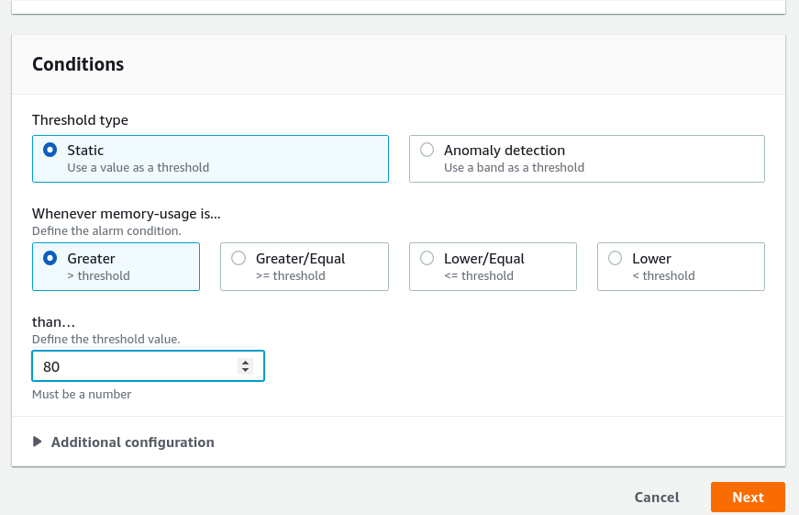

**Now create an auto scaling action. Attach the autoscaling group created earlier.**

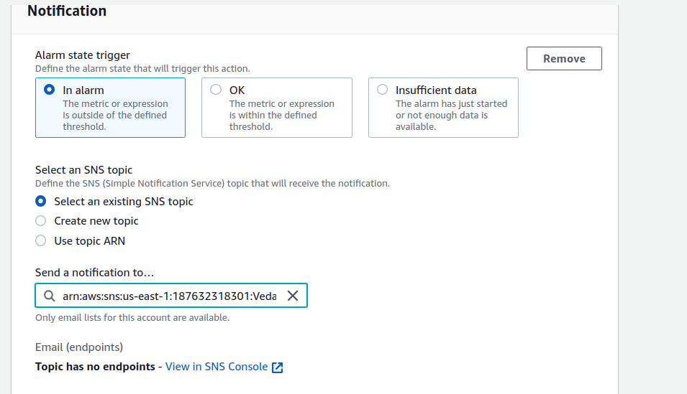

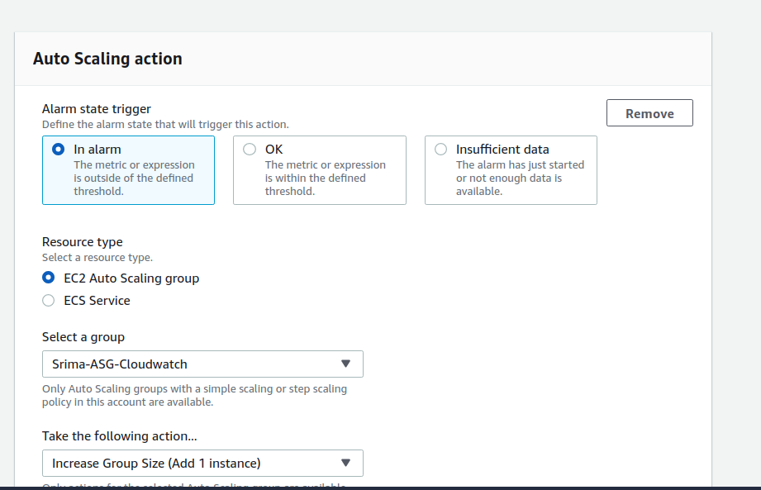

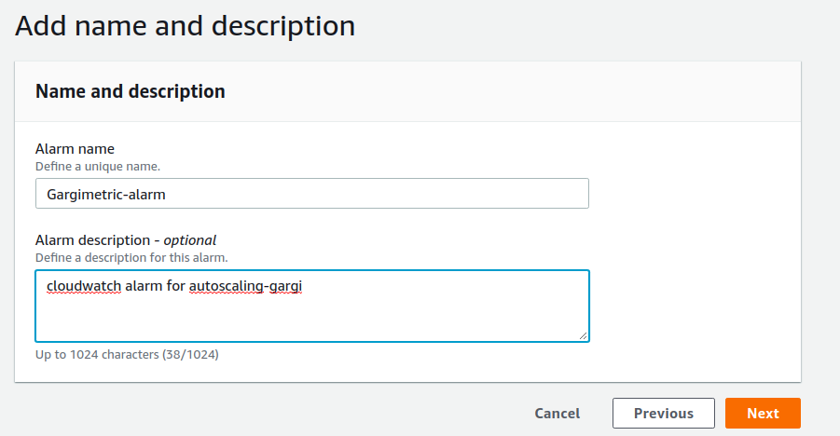

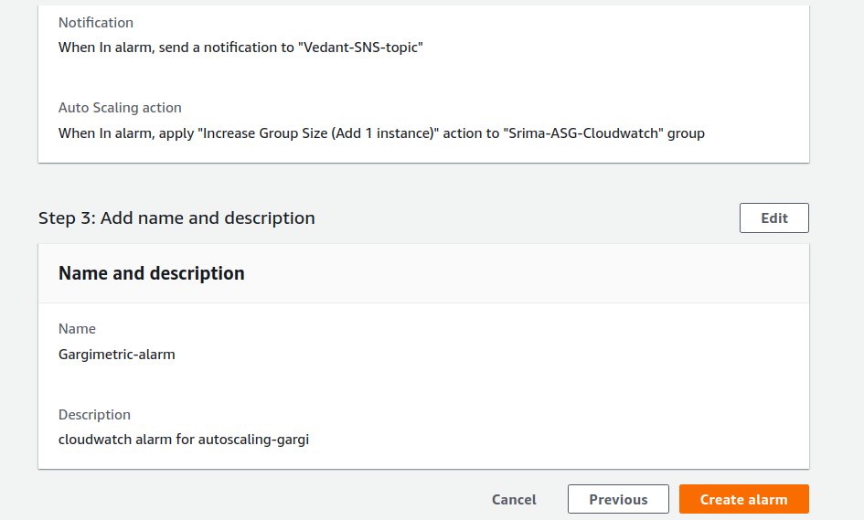



**3. Create SNS topic, subscribe to a topic, publish messages, unsubscribe the message and delete the topic.**

**SNS topic:**

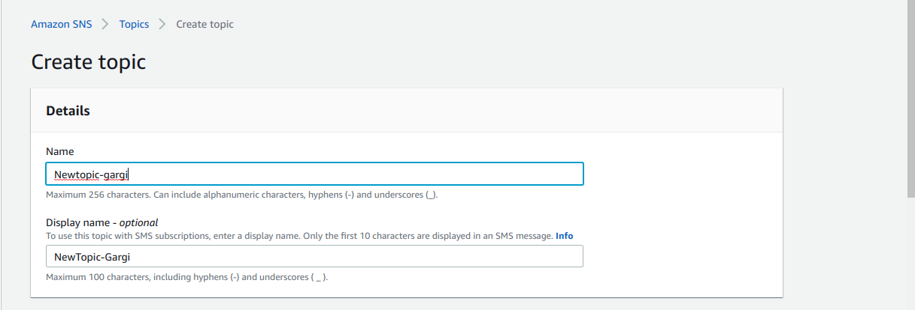

**Subscribe:**

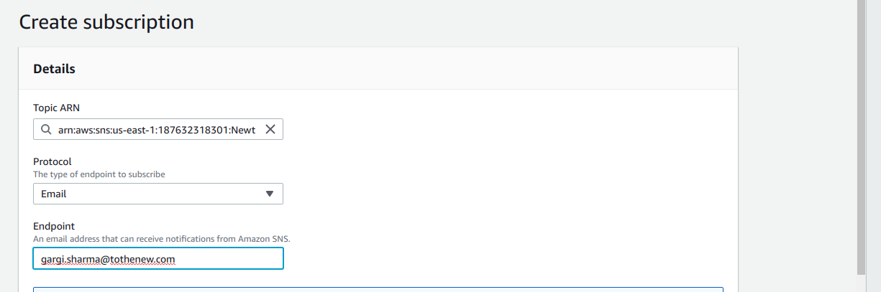

**Publish Message:**

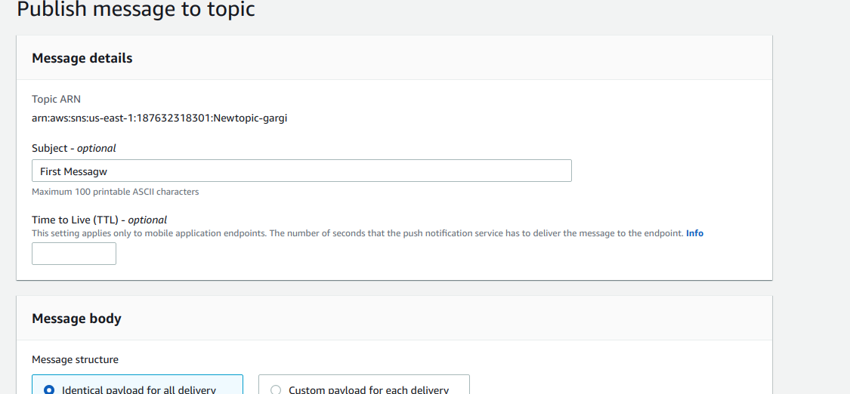

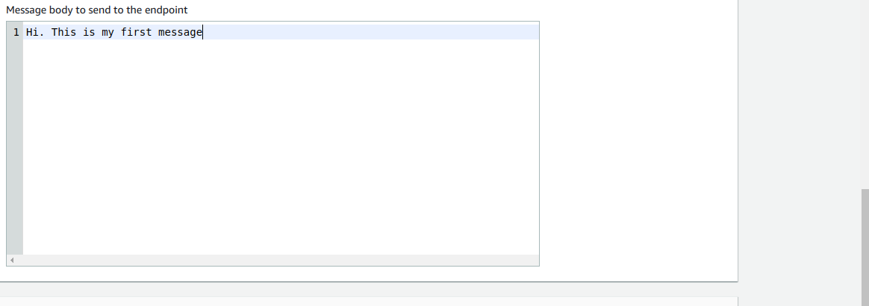

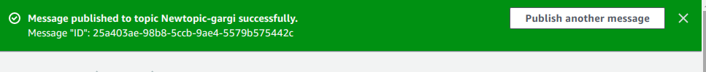

**The received mail.**

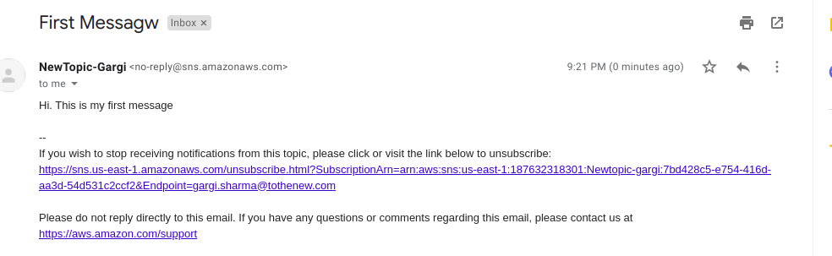

**Unsubscribe topic:**

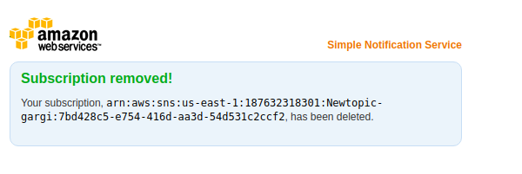

**Delete the topic:**

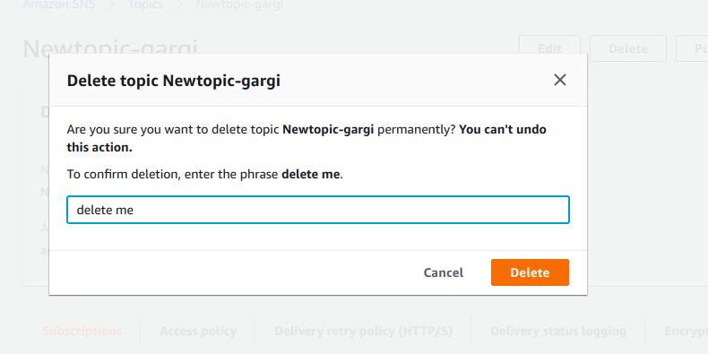

**4. Send a sample mail using SES**

No permission granted for SES

