# 

# **DOCKER**

Trainee Name : Chhavi Sharma

Newers ID : 4023

Mentor Name : Nishith Kulshrestha

College : UPES

1. Set the base image to Ubuntu
   * Add File Author / Maintainer
   * Install Nginx
   * Install necessary tools: vim wget curl net-tools
   * Remove the default Nginx configuration file
   * Copy a configuration file from the current directory
   * Expose ports (80)
   * Set the default command to execute Nginx when creating a new container

Ans.

DockerFile

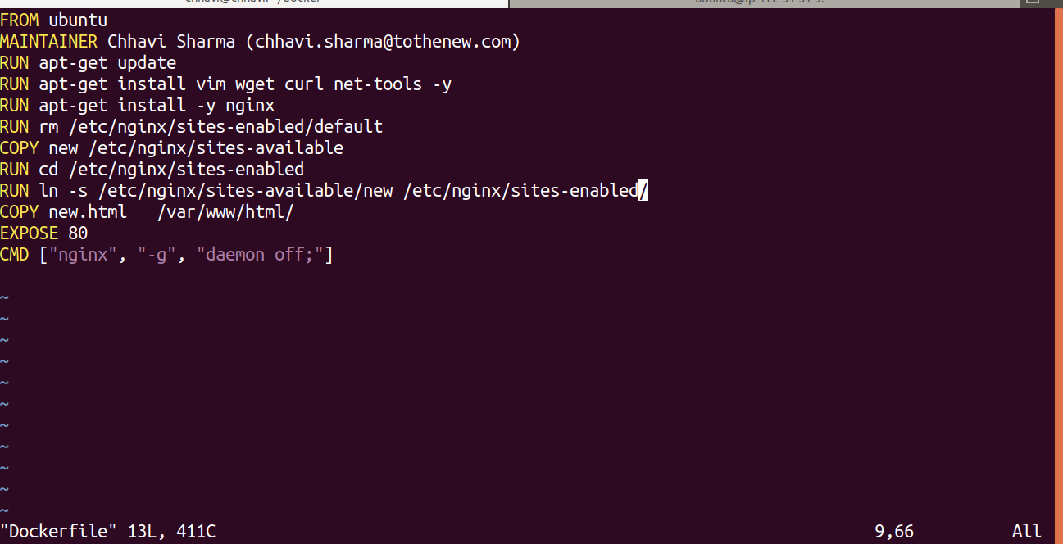

Build the Dockerfile

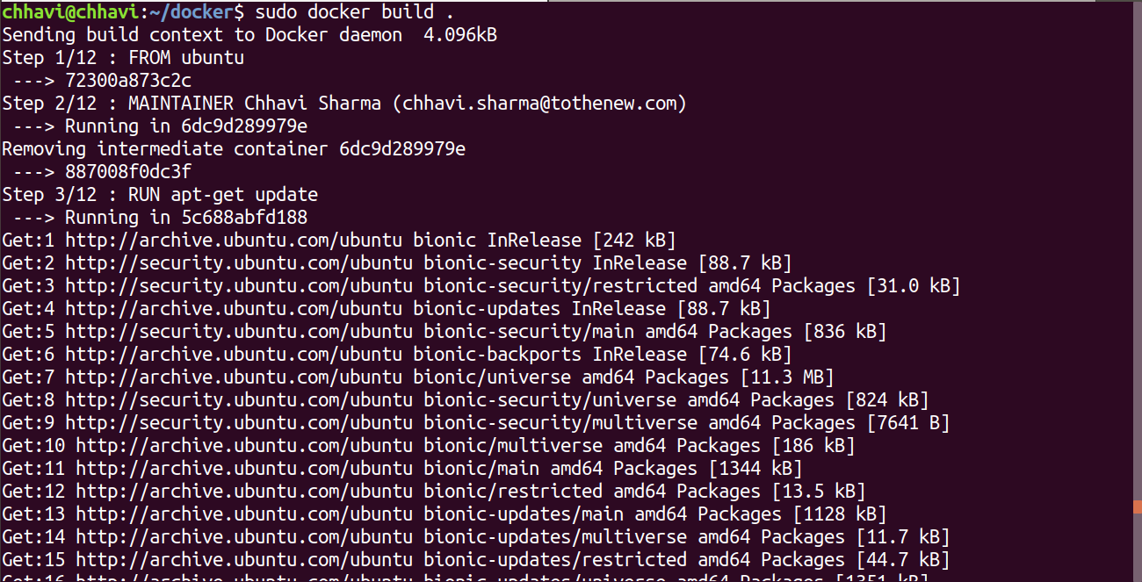

Run Image

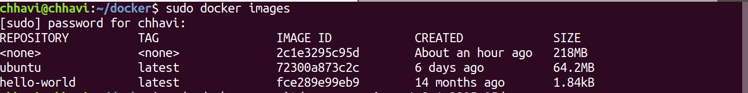



Enter into the container and curl localhost

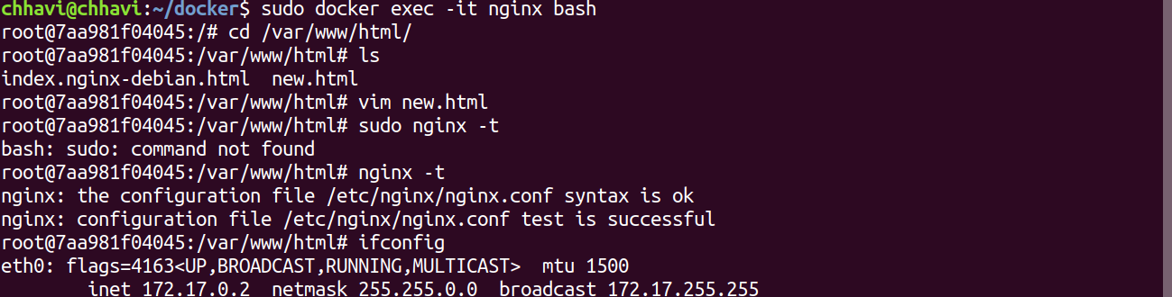

On host.

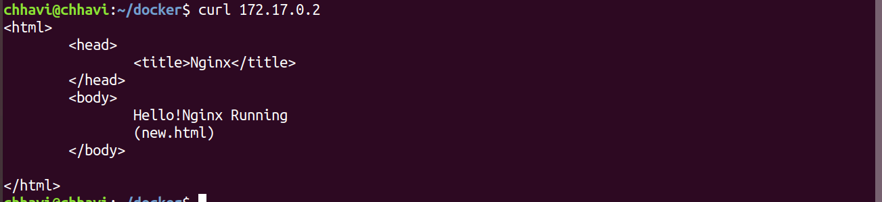

In container.

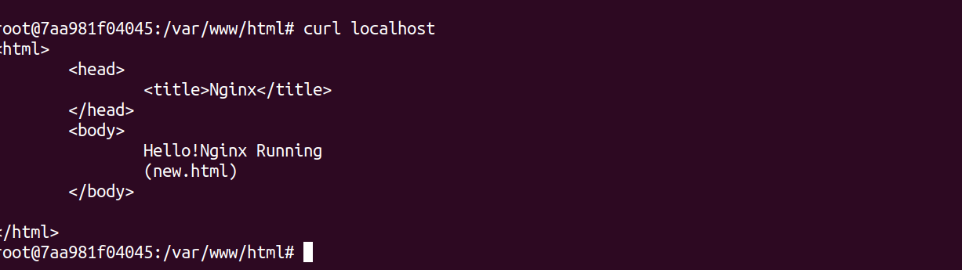

1. What is the difference between 'RUN', 'CMD', & 'ENTRYPOINT' in dockerfile?

Ans.

We choose CMD if we need to provide a default command and/or arguments that can be overwritten from command line when docker container runs.On the other hand we use ENTRYPOINT when building executable Docker image and we need a particular command always to be executed.And we use RUN instructions to build our image by adding layers on top of initial image.

1. How to connect a docker client to docker daemon running on another host?

Ans.